**Assignment-1**

**Suyash Damle**

**15CS10057**

***NOTE: This and all other R codes are coded to set the path of the source code as the working directory. So, the data files should be in same location as the code. Further, some codes require some installation to load .xlsx files. In case of errors, the following command is to be typed into the R console to complete the installations : install.packages("xlsx", dependencies = TRUE)

a) From a simple plot of **dist vs speed**, we see an generally increasing tendency of “dist” parameter as “speed” increases.:

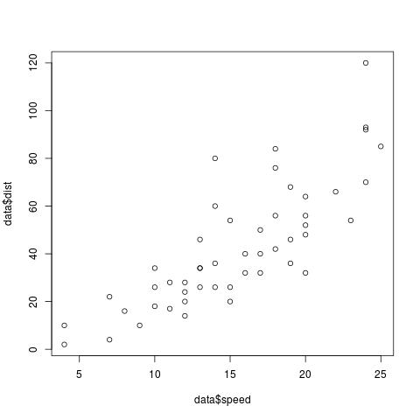

Thus, the data apparently represents the **stopping distance a vehicle covers at a given initial speed.** The variation over the dist for a specific speed may be attributed to the tyre, breaking system and road-surface variation across observations.

b) All the means are calculated using transorms and applying the default ***mean*** function.:

Geometric mean for distance 34.32615

**Geometric speed for distance 14.32501**

Harmonnic speed for distance 22.18214

Harmonic speed for distance 12.96153

Mean speed for distance 42.98

Mean speed for distance 15.4

**The geometric mean of distance is more imporant in this case**, as the data varies both in range and observations, and because the *speed is an independent variable* ( if the assumption rearding the subject of the dataset is valid).

c) The another measure that I would suggest is: **rate of increase of stopping distance with the speed.** This is done in steps:

* The mean dist required to halt for a certain speed is found. The plot of mean stopping distance vs speed:

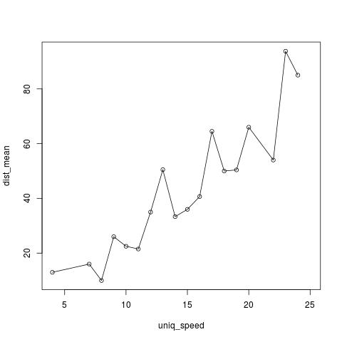

* Next, the ***rate of increase of stopping distance corresponding to each speed value*** could be determined by:

r [ i ] = (D [ i ] - D [ i-1 ]) (this is an approx measure of

S[i] – S[i-1] increase of dist per unit inc of speed for this speed)

The plot of **rate of increase of stopping distance vs speed :**

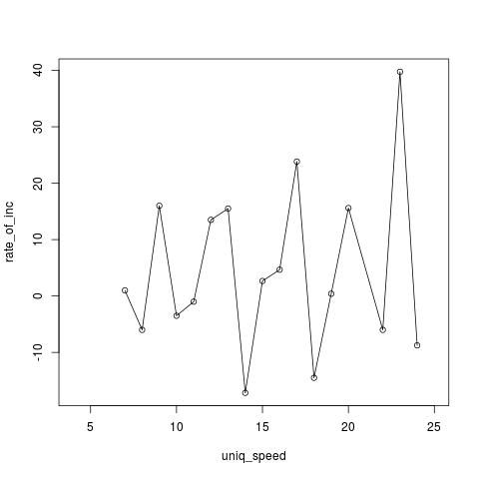

(Indeed, this plot appears to be inconclusive about rate of increase of stopping distance. However, this may be attributed to limited (~50) size of the dataset)