Project Report: Assignment 3

Customer Churn Prediction

Suyash Damle
15CS10057

Data Pruning/ Analysis of the attributes:

- The area code field is read into the data frame as numerical, where it should ideally be categorical. So, this field needs a change of type
- The data for phone numbers is more useful for the purpose of identification or verification of the provided data. Using it to train a classifier makes no sense, as it has unique values for each observation. This is verifiable by checking the number of level corresponding to the column “phone_numbers”. This column has 5000 levels, for 5000 data values. Hence, the values are unique and useless for the classification task at hand. Thus, it is dropped out.
- Further checks are made during model training phase and required changes are made.

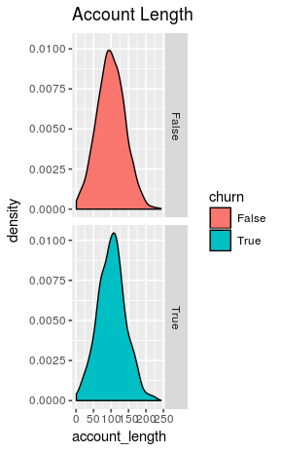
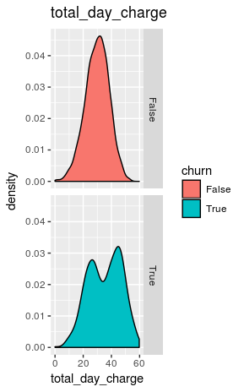
(Similar curves) (Significantly different for some values)
(Some samples of the type of curves obtained: attribute value densities for both churn types)

The curves are roughly bell-shaped. In the case of account length, visually, the graphs are similar for both positive and negative churns. This implies that the attribute account_length may not have much significance in the task of classification. The same pattern is followed by a number of other attributes: total_eve_charge, total_intl_charge.

Some other attributes, such as the total_day_charge, have distinctly different curves in True churn values than the False values. So, they are more likely to have some significance at some point for the task of classification at hand.

Division of dataset

The distiribution of data in the original data is as follows:
False True
4293 707

The train to test ratio is kept at 8 : 2
After proper symmetrical division of the data, with equal proportions of True and False values in both test and train sets:
( Using the createDataPartition() function from the caret package)

Train data: Test data:
False True False True
3435 566 858 141

Evaluation metrics

- The confusion metrics could be easily plotted and related information obtained, in each case, using the confusionMatrix() function.

- The parameters requied for this are the test data classification and the predictions from the model.

confusionMatrix ( predictions, dataTest_y)

- The function also returns the following important values:
  - Accuracy
  - Sensitivity – the Recall
  - Specificity (True negative rate) – this is what is important for us, as the True (churn) is being considered as the negative class
  - Pos. Predicted Value – the Precision

The Naive Bayes Classifier:

Issues:

The naive bayes model takes only categorical data. So, to deal with the continuous numerical data abundant in this dataset, one needs to divide them into discrete classes. Two soluntions exist:
- Manual discretization : Deciding some fixed values for each attribute and grouping data above and below (and between) these values separately.
- Considering a probability density : One could assume that the attribute follows certain prob. distribution and then proceed:
- assuming (say) gaussian distribution for all the attribute values in each class.
Eg: we may assume that the “total_eve_charge” in True and False class for all the observations follows normal distribution.
- from the training data, finding the mean and standard deviation of the distribution for both, True and False classes
- for each of the attribute to be considered henceforth, finding the probability density value at the observation data, corresponding to both True and False classes. The one with higher pdf value is considered to be the valid classification for the observation point.
So, if pdf is higher in False class, we put in category 1, else in category 2.
The used naiveBayes() function from e1071 uses this second approach to deal with this kind of situation.

Analysis from the Naive Bayes model

The naive bayes model, once trained could be used for obtaining further insight into the data attributes: the model begins with the calculations of posterior probabilities of the form: P(X|Y), which are further expected to be useful in the calculation of P(Y|X) during the process of prediction.

The P(X|Y) data could be printed as:

model $ tables:
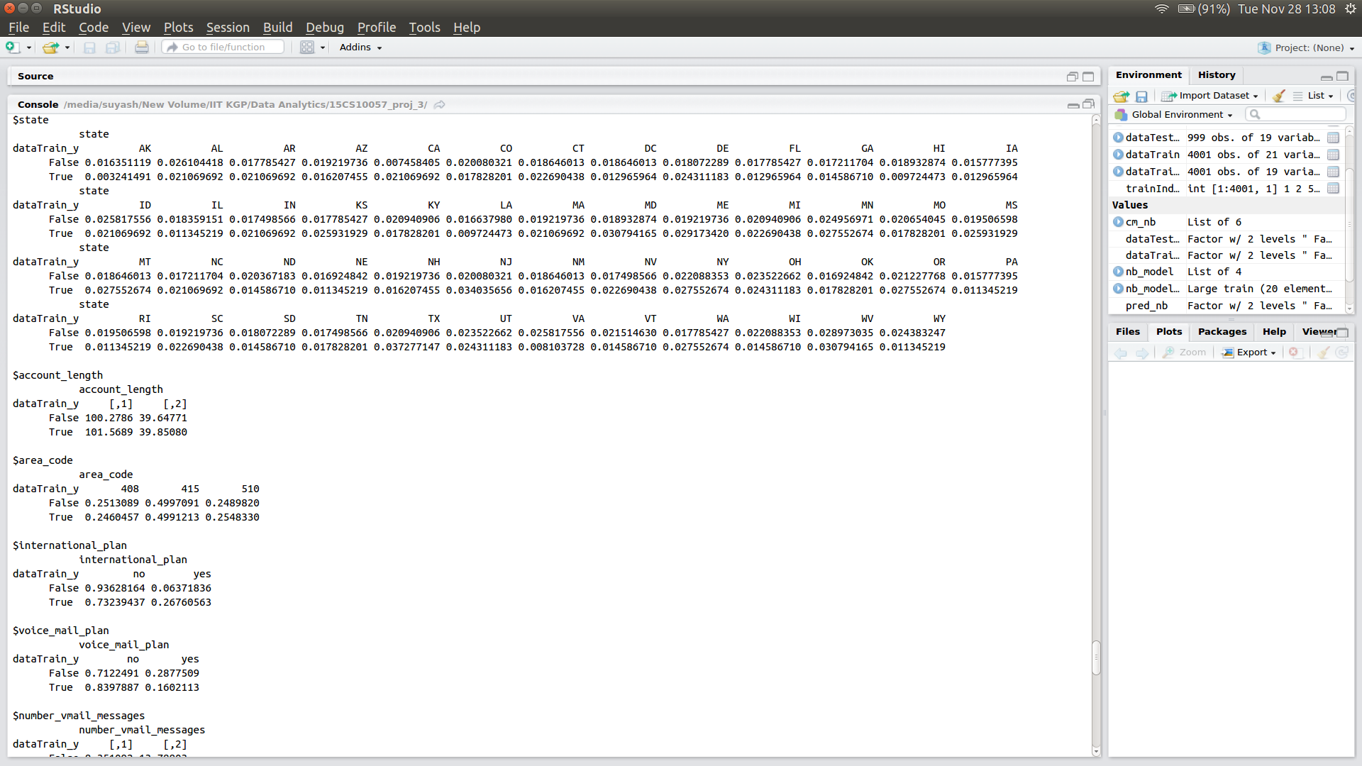
From this data, following conclusions are possible:
- The posterior probabilities, P(state| churn) for most states do not differ much
Eg: P ( state= AK | churn = False) ~ P( state=AR | churn = False)
This indicates that users of these states are all equally likely to remain with our services

    - In some states, the difference is significant
Eg: P ( state= AK | churn = True) >> P( state=AL | churn = True)
In such states, the user is more (or less) likely to continue with the /service as compared to other states

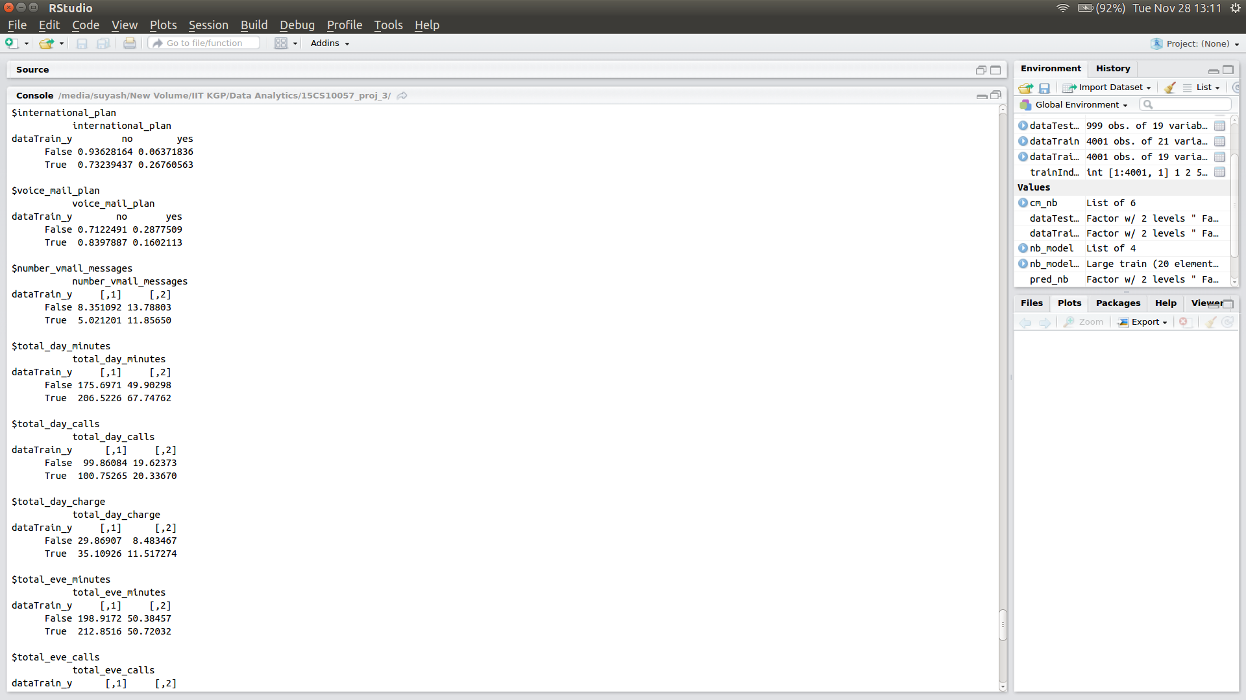
and so on...

Final result:

Confusion Matrix and Statistics

Reference
Prediction False True
False 829 75
True 29 66

Accuracy : 0.8959
95% CI : (0.8753, 0.9141)
No Information Rate : 0.8589
P-Value [Acc > NIR] : 0.0002898

Kappa : 0.5028
Mcnemar's Test P-Value : 1.021e-05

Sensitivity : 0.9662
Specificity : 0.4681
Pos Pred Value : 0.9170
Neg Pred Value : 0.6947
Prevalence : 0.8589
Detection Rate : 0.8298
Detection Prevalence : 0.9049
Balanced Accuracy : 0.7171

'Positive' Class : False

The Decision Tree Classifier

- The decision tree classifier is trained using the rpart() (CART algorithm) function from the e1071 package.
- Splitting is done on the basis of information gain and gini index – both

Using information gain as a heuristic for splitting:

Confusion Matrix and Statistics

Reference
Prediction False True
False 845 37
True 13 104

Accuracy : 0.9499
95% CI : (0.9345, 0.9626)
No Information Rate : 0.8589
P-Value [Acc > NIR] : < 2.2e-16

Kappa : 0.7778
Mcnemar's Test P-Value : 0.001143

Sensitivity : 0.9848
Specificity : 0.7376
Pos Pred Value : 0.9580
Neg Pred Value : 0.8889
Prevalence : 0.8589
Detection Rate : 0.8458
Detection Prevalence : 0.8829
Balanced Accuracy : 0.8612

'Positive' Class : False

Using Gini Index as heuristic:

Confusion Matrix and Statistics

Reference
Prediction False True
False 852 45
True 6 96

Accuracy : 0.9489
95% CI : (0.9334, 0.9618)
No Information Rate : 0.8589
P-Value [Acc > NIR] : < 2.2e-16

Kappa : 0.7619
Mcnemar's Test P-Value : 1.032e-07

Sensitivity : 0.9930
Specificity : 0.6809
Pos Pred Value : 0.9498
Neg Pred Value : 0.9412
Prevalence : 0.8589
Detection Rate : 0.8529
Detection Prevalence : 0.8979
Balanced Accuracy : 0.8369

'Positive' Class : False

So, information gain is the choice, as it offers better specificity, which is what we need.

- The created tree demonstrates which attributes give best result at the time of splitting. The visualization of the created tree has been attached with the codes and the report, in a pdf document.

The Support Vector Machine (SVM) Models:

Two different kernels were tried :

Linear

Confusion Matrix and Statistics

Reference
Prediction False True
False 858 129
True 0 12

Accuracy : 0.8709
95% CI : (0.8485, 0.891)
No Information Rate : 0.8589
P-Value [Acc > NIR] : 0.1477

Kappa : 0.1378
Mcnemar's Test P-Value : <2e-16

Sensitivity : 1.00000
Specificity : 0.08511
Pos Pred Value : 0.86930
Neg Pred Value : 1.00000
Prevalence : 0.85886
Detection Rate : 0.85886
Detection Prevalence : 0.98799
Balanced Accuracy : 0.54255

'Positive' Class : False

-> So, the linear SVM model (without scaling of attributes) performs quite poorly in terms of the specificity.

Polynomial

- The polynomial kernel, having a large number of parameters offers the option of tuning the parameters. This technique lets the user enter the range of values (or, discrete values) to be checked.
- The system itself checks the classifier over all the values (grid search) and determine the optimal values.
- Two distinct runs of optimization were performed, for different parameter combinations :

Optimizing the polynomial degree:

model_svm_poly=tune.svm(churn~.,data=(dataTrain[2:21]),cost=5,kernel="polynomial",
degree=c(2,3,4,5,6))

Optimal degree found : 2

Confusion Matrix and Statistics

Reference
Prediction False True
False 851 111
True 7 30

Accuracy : 0.8819
95% CI : (0.8602, 0.9012)
No Information Rate : 0.8589
P-Value [Acc > NIR] : 0.01866

Kappa : 0.2958
Mcnemar's Test P-Value : < 2e-16

Sensitivity : 0.9918
Specificity : 0.2128
Pos Pred Value : 0.8846
Neg Pred Value : 0.8108
Prevalence : 0.8589
Detection Rate : 0.8519
Detection Prevalence : 0.9630
Balanced Accuracy : 0.6023

'Positive' Class : False

Optimizing degree of polynomial and the “gamma” parameter:

model_svm_poly=tune.svm(churn~.,data=(dataTrain[2:21]),cost=5,kernel="polynomial",
degree=c(2,3,4),gamma=c(0.01,0.1,1))

Optimized parameters : degree = 3
gamma = 0.1

Confusion Matrix and Statistics

Reference
Prediction False True
False 817 61
True 41 80

Accuracy : 0.8979
95% CI : (0.8774, 0.916)
No Information Rate : 0.8589
P-Value [Acc > NIR] : 0.0001368

Kappa : 0.5523
Mcnemar's Test P-Value : 0.0599338

Sensitivity : 0.9522
Specificity : 0.5674
Pos Pred Value : 0.9305
Neg Pred Value : 0.6612
Prevalence : 0.8589
Detection Rate : 0.8178
Detection Prevalence : 0.8789
Balanced Accuracy : 0.7598

'Positive' Class : False

Decision Boundary visualization:

After the training of the classifier, the decision boundary could be visualized wrt the training data using the function:
plot(model_svm_poly$best.model,data=dataTrain[2:21],formula=total_day_calls~number_customer_service_calls)

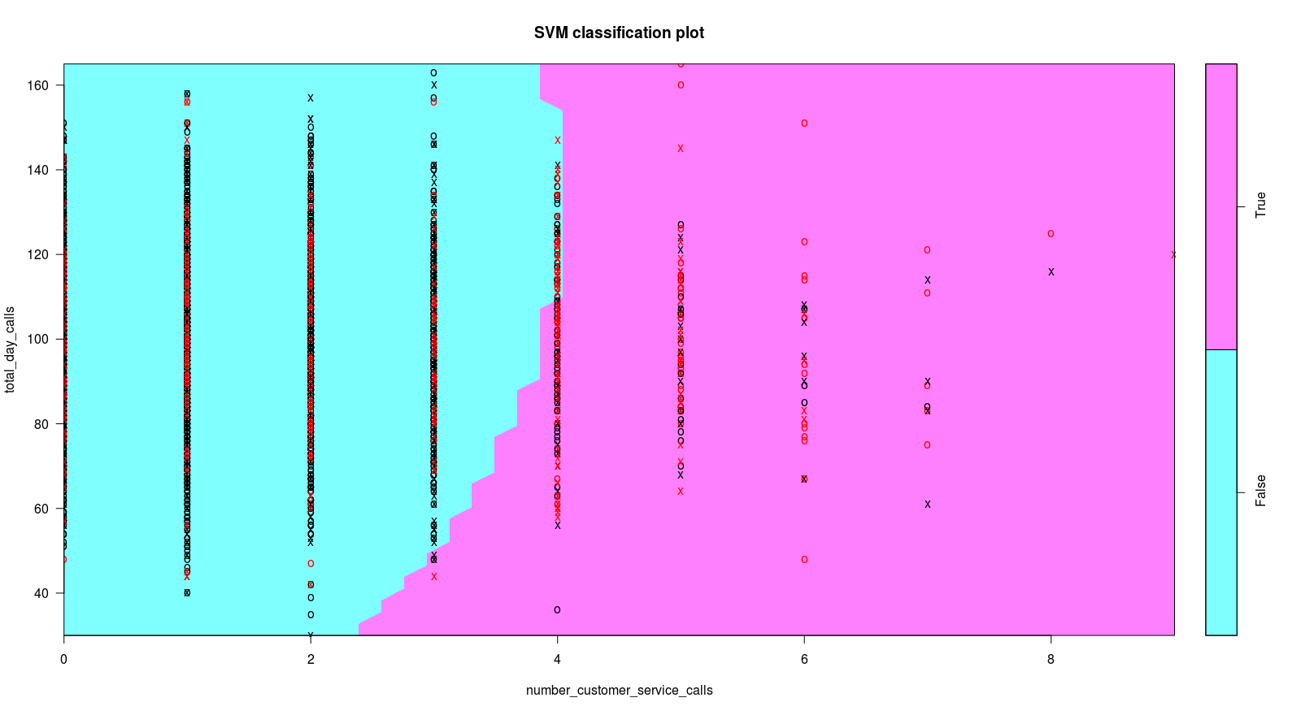

The variables in the x and y axis could be easily changed by simple replacement in the formula

- Running tuning process on more than 2 parameters takes a very long time to terminate and hence, SVM could not be checked and optimized any further. However, as the number of variations are large, some combination(s) may perform much better than the above results.

Conclusion

The performances of all the explored models could be summarized as below:

Based on the above data, one could conclude that the decision tree classifier with the information gain heuristic and the support vector machine with polynomial kernel perform the best and the performance of SVM (presently slighly lagging behind) may beat it; however careful tuning of the parameters is required for that purpose.

