**MGT7222: Human Resource Analytics**

Disclosing Trends: An Extensive Examination of Staff Attrition in a Pharmaceutical Company

WORD COUNT - 2194

Table of Contents

Attrition 3

Tableau 3

Literature based support 3

Business Understanding 4

Data Pre-Processing 4

Data Quality Issues 4

Attrition Count by Gender 5

Attrition by Job Satisfaction and Department 5

Stock options Wise Attrition 6

Attrition By Age 7

Department Wise Attrition 7

Years with the Current Manager V/s Attrition Count 8

DASHBOARD 9

ESOP (Employee Stock Ownership Plans) 10

Benefits 10

Limitations 10

APPENDIX A 12

Figure 1 13

Figure 2 13

Figure 3 14

Figure 4 14

Figure 5 15

INTRODUCTION / BACKGROUND

A major obstacle for the Pharmaceutical Company which is facing in the ever-changing pharmaceutical business is the high rate of employee turnover. It consists of one year of employee’s data extracted from the HRIS, which includes many variables relating to each individual employee. In order to better understand the underlying causes, evaluate the impact on Company’s condition and suggest strategic solutions, the management is interested and wants to know more about advanced dashboarding tools such as Tableau. This report will explore the potential of tableau in understanding details of high turnover.

# Attrition

The process of employees leaving an organization, either voluntarily or involuntarily, which then furthers creates vacancy or need of employees to fill those positions (Australian Customer Experience Professionals Association, 2023).

# Tableau

(Contributor , 2018) Tableau is an excellent data visualization and [business intelligence](https://www.simplilearn.com/what-is-business-intelligence-article) tool used for reporting and analysing vast volumes of data. There arises a need for data analysis and exploration of HRIS data, which has to be done through making visualisations and dashboards for Stake holders and HR Manager, to better understand the issues within organization, with the help of Tableau. The company may obtain actionable insights, make informed choices by integrating comprehensive data analysis with sophisticated dashboarding technologies in tableau.

The foremost challenge for the company is to deal with high levels of employee turnover. Another challenge would be to switch from traditional excel spreadsheet methods to advanced dashboarding tools and maintain the data quality of the HRIS data, just to ensure the outcomes are predicted accurate.

## Literature based support

1. Understanding the need to make transition from excel to advanced analytics tool (Komiskey, 2023).
2. Employee retention strategies.
3. (Tamhankar, 2020) Benefits of dashboarding tools in supporting decision.

METHODOLOGY

 The Excel file “employee.xlsx” has 1467 rows and 35 columns is the dataset is being used for the report. The target variable for this research is “Attrition” and it centre on the attrition rates within a Pharmaceutical Company. The Binary Representation of this variable is “Yes” or “No”. “Yes” in this case means that the employee has already left the company, but “No” means that the worker is still employed in the company. A Data Visualization software called Tableau was used to solve this problem.

The methodology is divided into sections:

# Business Understanding

For a Pharmaceutical Company to design and implement successful retention strategies, Business Understanding is Crucial when doing Attrition Analysis. The company can pinpoint and identify particular areas for development by knowing the underlying cause of Staff Turnover.

## Data Pre-Processing

(Press, 2023) did research for Forbes Magazine and found that the average Data Scientist spends about 80% of their time on data pre-processing. For this project data pre-processing is broken into three sections:

1. To check Tableau assigned labels to the variables are verified,
2. data quality concerns are handled and
3. additional calculated fields are constructed to provide information and modify the type of some variables.

First, the option to add data from an Excel file was chosen in order to add the data into Tableau. Tableau automatically identified the type of data for each column and assigned symbols to the variables based on the columns.

Secondly, following the data dictionary and column analysis, the following modifications were made.

To improve the final visualization’s, thoroughly more calculated fields have been added to the dataset and categorical vales have been derived from numerical values following this transformation.

* **Attrition_count** - Every “Yes” value is converted to 1 and every “No” value to 0 by creating a calculated field. In the final dashboard, this transformation makes it possible to see the amount of employee turnover.
* **Active_Emp** – The calculated field determines the number of Active Employees which is calculated by deducting the total count of the ‘ID’ feature, which indicates the total number of employees, from the total count of the Attrition_count feature, that indicates the total attrition of the organization.
* **Attrition_Rate** – This calculated field determines by subtracting the total Attrition count variable from the total number of employees yields the percentage of attrition that the company is facing.

# Data Quality Issues

* Age – By using summary function in R The minimum value in the Age Column was 7 and the maximum value was 85. So there are outliers in this column as we have a column in the dataset (Over 18) which states that all the employees are over 18 and the average value in which the employee gets retired is 60. So, we have filtered the data in tableau using data filter from 18 – 60 (Haapanen et al., 2020).
* Over 18 & Standard Hours – “Over 18” and “Standard Hours” share the same value “Y” and 40, so they can be excluded from the analysis.
* Performance Rating – Only 3 and 4 are observed in the dataset, despite the performance rating are having values ranging from 1 to 5. Upon checking no missing values were discovered for this variable. However, as this data suggests that every employee is regarded as Excellent and Outstanding, it has been decided to exclude it from the current research.
* Department – The Calculated field is used to determine some terminology and to avoid duplication. In particular, the terms “HR” and “R&D” can be combined with “Human Resources”, Research & Development & Research respectively. With relation to these departments, the goal is to improve clarity and prevent duplication of data.
* Years with Current Manager– There were Sixteen Null Values found in this column. A Tableau Filter has been used to eliminate the null values.
* Total Working Years – Sixteen Null Values were observed when the data was summarized, therefore it is suggested that null values should be eliminated to prevent a visualization issue.
* Department – The department column had various Duplicate values during data pre-processing stage where HR and Human Resources were combined into Human Resources Research and Development was the standardized label that was applied to the combination of “R&D” and Research and Development Entries.

FINDINGS

A careful selection of charts is used to ensure that they complemented the analytical goals and allowed for a more in depth of the insights being offered.

# Attrition Count by Gender

Figure 1 is a lollipop chart. It is an effective tool for identifying the patterns based on Gender related attrition count. Because of its efficiency it is a useful part in decision making and in the creation for HR strategies. This chart depicts the relationship between Attrition Count and Gender in the work-force. The chart conveys the distribution of attrition count among different genders. it is observed that there is a significant difference in employee retention as the attrition rate for Male employees (172) is higher than that of Female Employees (108) indicating a significant gender gap in workforce.

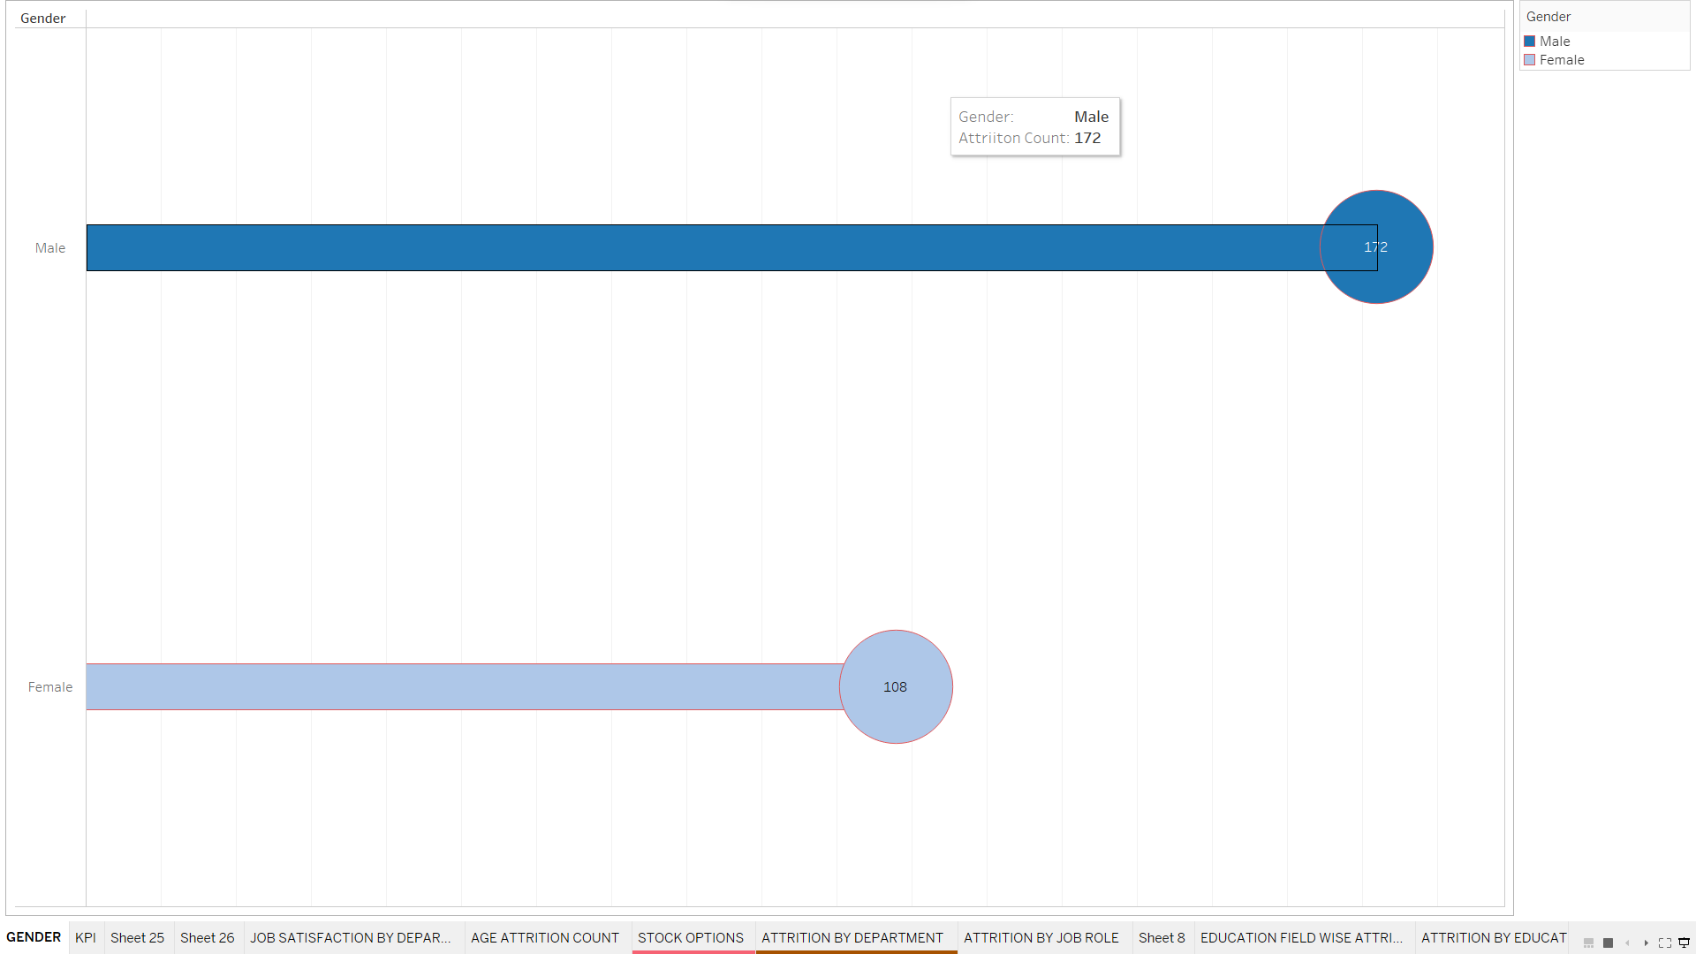

Figure 1: **Attrition Count by Gender**

# Attrition by Job Satisfaction and Department

Bar charts is a useful visualization tool for comparing categories. The bar length makes it simple to compare the values in different categories visually.

According to Figure 2, the research and sales divisions had the greatest work satisfaction levels, but these departments also had elevated rates of attrition. So, it demonstrates that problems with attrition may not always be resolved by Very High Job Satisfaction. To know more about the high levels of attrition different factors are involved.

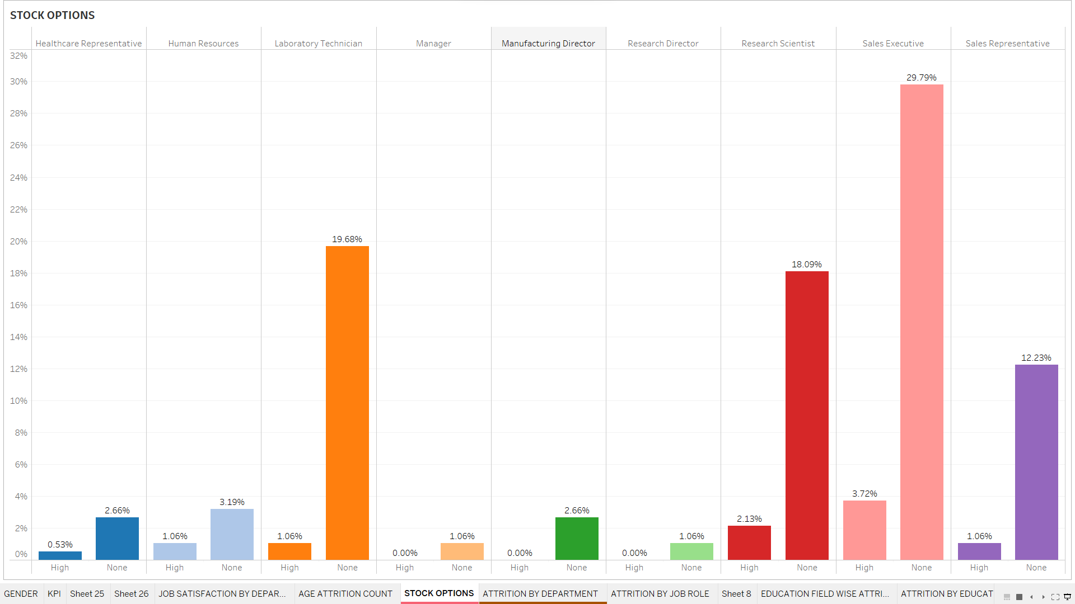

Figure 2: **Attrition by Job Satisfaction and Department**

# Stock options Wise Attrition

Figure 3 is a Stacked bar Graph which is an efficient tool for displaying the proportionate contributions of sub categories within a larger category as well as its hierarchical structure.

High Attrition is in areas where employees are provided none or low Stock Options such as Sales Executive and Research Scientist. The attrition rates of the following are 30% and 18% respectively. This correlation shows how stock options may affect the employee attrition.

According to the graph, there is a filter only for employees who have got high and none stock options. Employees with high stock options have correlation between attrition like Sales Executive and Research. The data emphasizes how stock options may plan an important role in reducing staff turnover and increasing retention.



**Figure 3: Stock options Wise Attrition**

# Attrition By Age

Figure 4 represents the employee Age by attrition are clearly correlated. The employees in the age group between 24-33 has the highest attrition rate (53.22%) with rates for older age groups gradually declining after that.

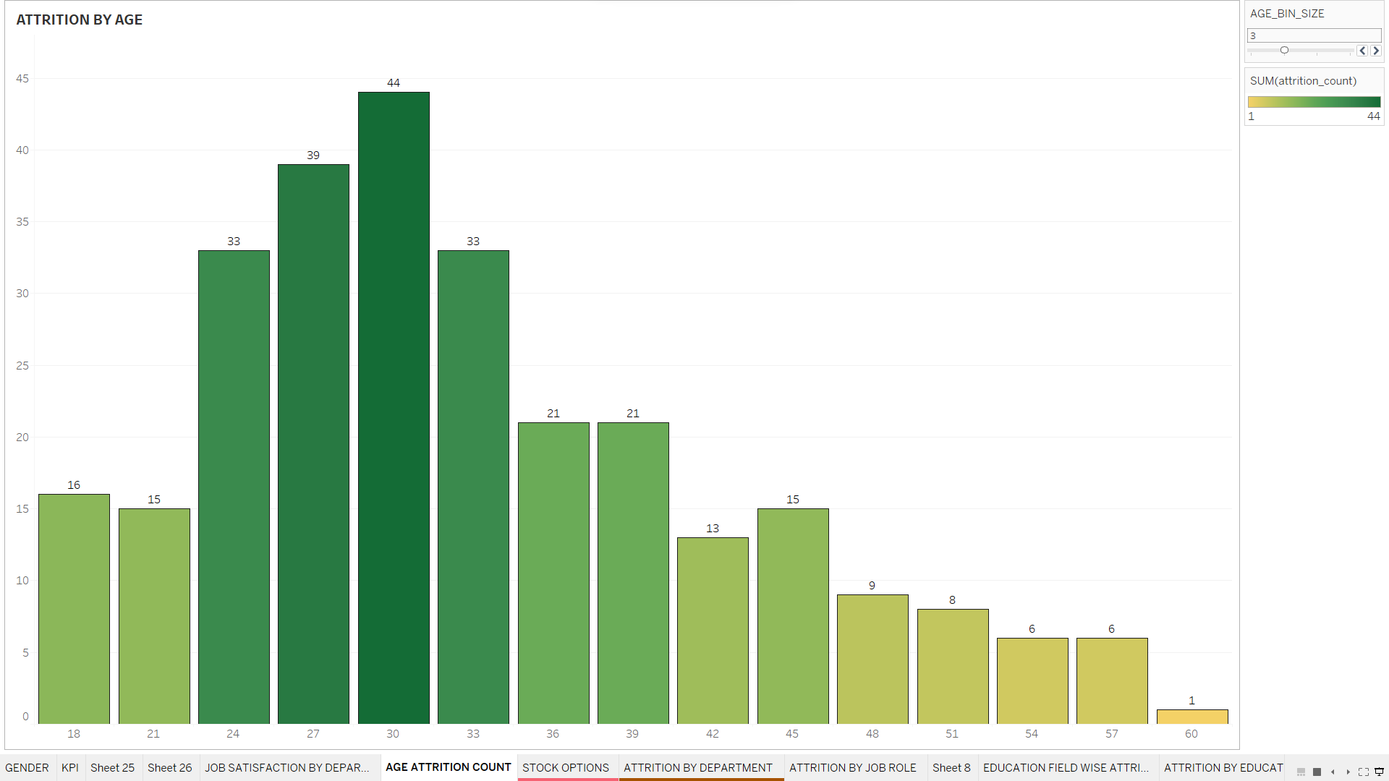

**Figure 4: Attrition By Age**

# Department Wise Attrition

Figure 5 represents the Pie Chart. The Pie chart helps complicated information in a clear and simple way by providing categorical distribution of data.

The Pie chart depicts the Attrition Rates by Department. It can be seen that Sales department has the highest attrition of (48%) followed by Research and development (47%). The results could be crucial to the HR Management to step in and reduce employee churn. Such high attrition rates will take the department to take strategic measures and focus on implement measures.

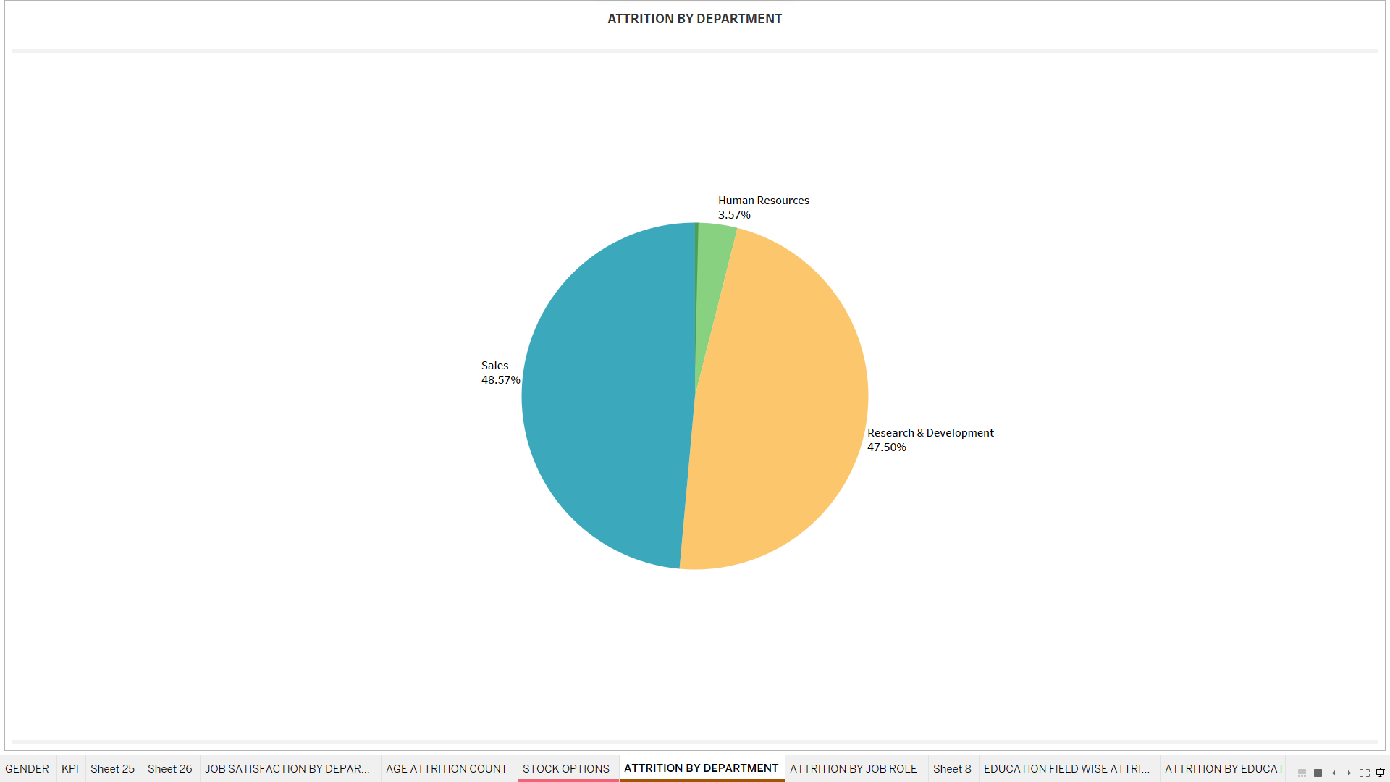

**Figure 5: Department Wise Attrition**

# Years with the Current Manager V/s Attrition Count

Figure 6 shows the Area chart. It is an effective chart for patterns and relations within the dataset that represents trends and variations in data across line.

Employees who have worked with their current manages for less than 2 years has the highest attrition rate from those with longer employment under the same managerial relationship.

There is a rise in employee turnover among those who have worked for less than 2 years. This results into possible correlation between staff retention and managerial tenure.

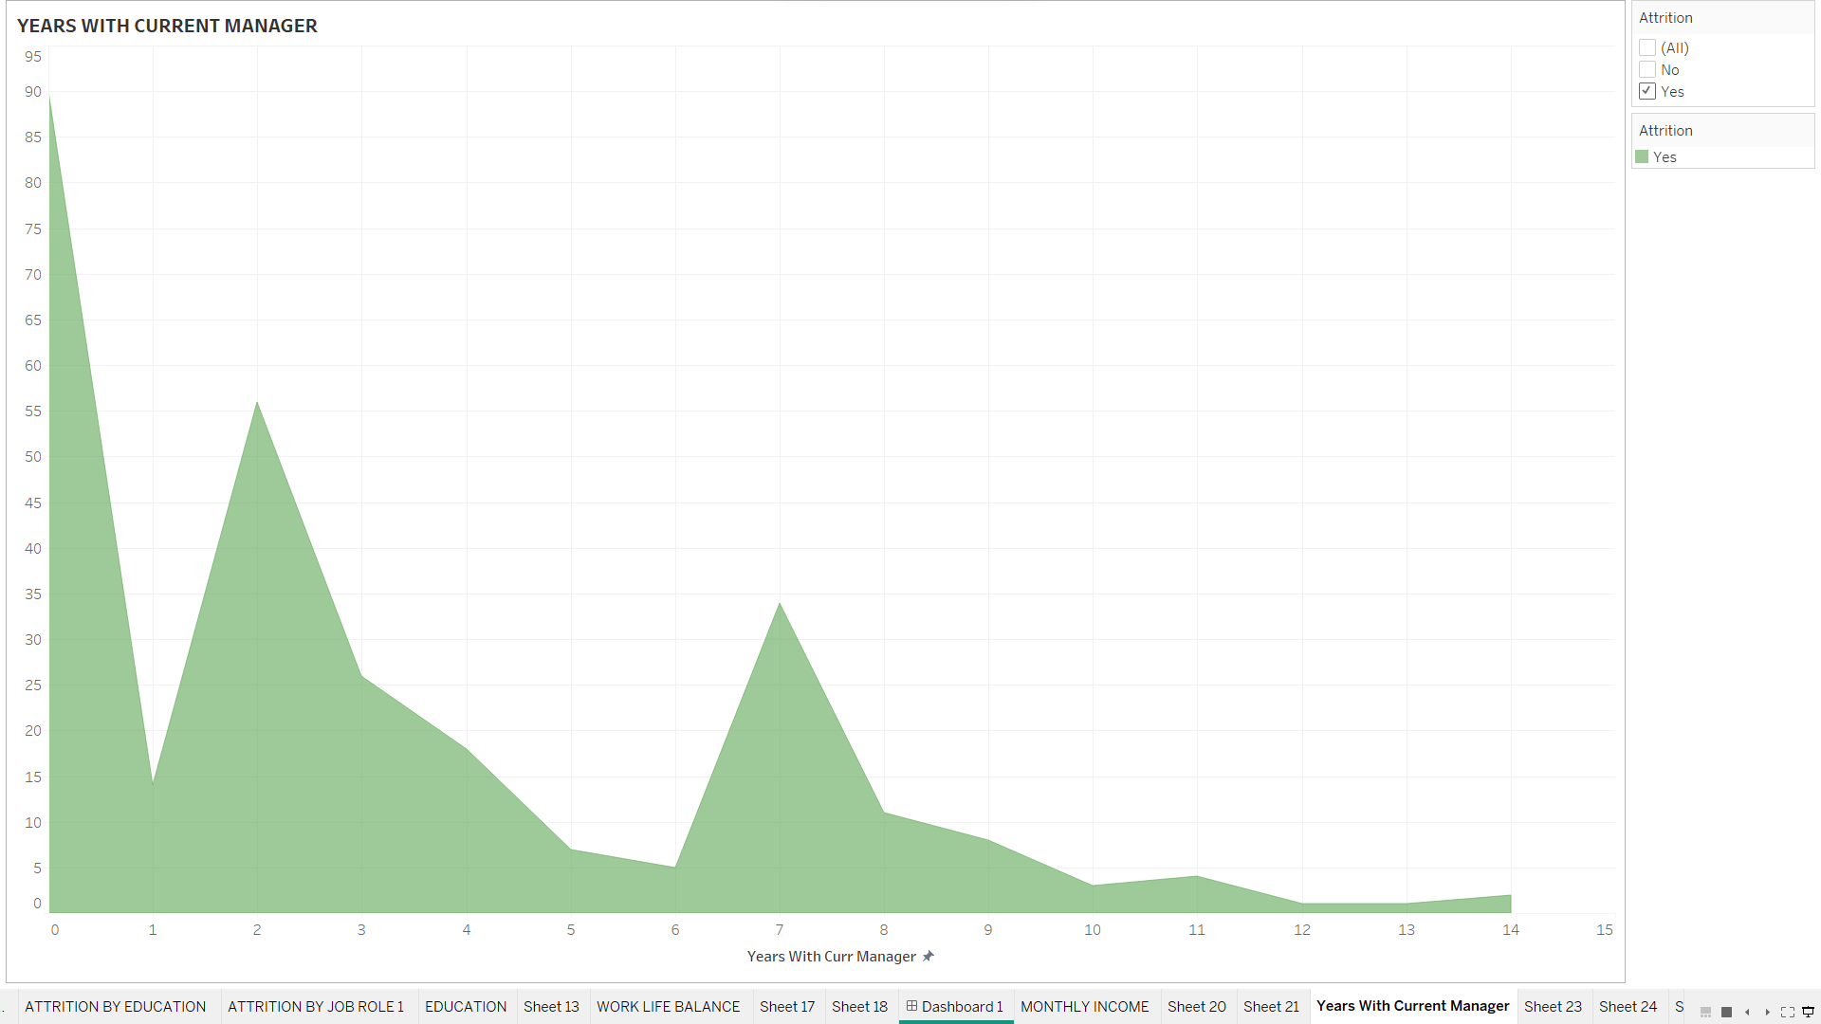

**Figure 6**: **Years with the Current Manager V/s Attrition Count**

# DASHBOARD

The aim of the Dashboard is to provide information on the cause of employee attrition, point out the opportunities for development and to put staff retention plans. In general, relatively High Attrition is problematic for a Pharmaceutical Company.

It can be seen that the Attrition rate within the company is 19%. The number represents the total employees worked and the attrition count. Analysis of attrition data shows that Male employees have great turnover than female employees. The attrition rate for male employees is (172) suggesting that there is a noticeable variation in the patterns of the gender. The department and Sales has the highest turnover rates in the company. Attrition rate in Sales is 48.57% while that of Research and Development is 47.5%. There appears to be a significant relationship between the availability of stock options and employee attrition. Further analysis shows those age between 24 -33 has the highest attrition rate. It is seen that employees are more inclined towards new opportunities outside the company. The employees with the highest turnover are the ones who did not obtain stock options. Employee tenure and turnover are significantly correlated as the largest attrition is found among employees who have worked for less than 2 years in the company.

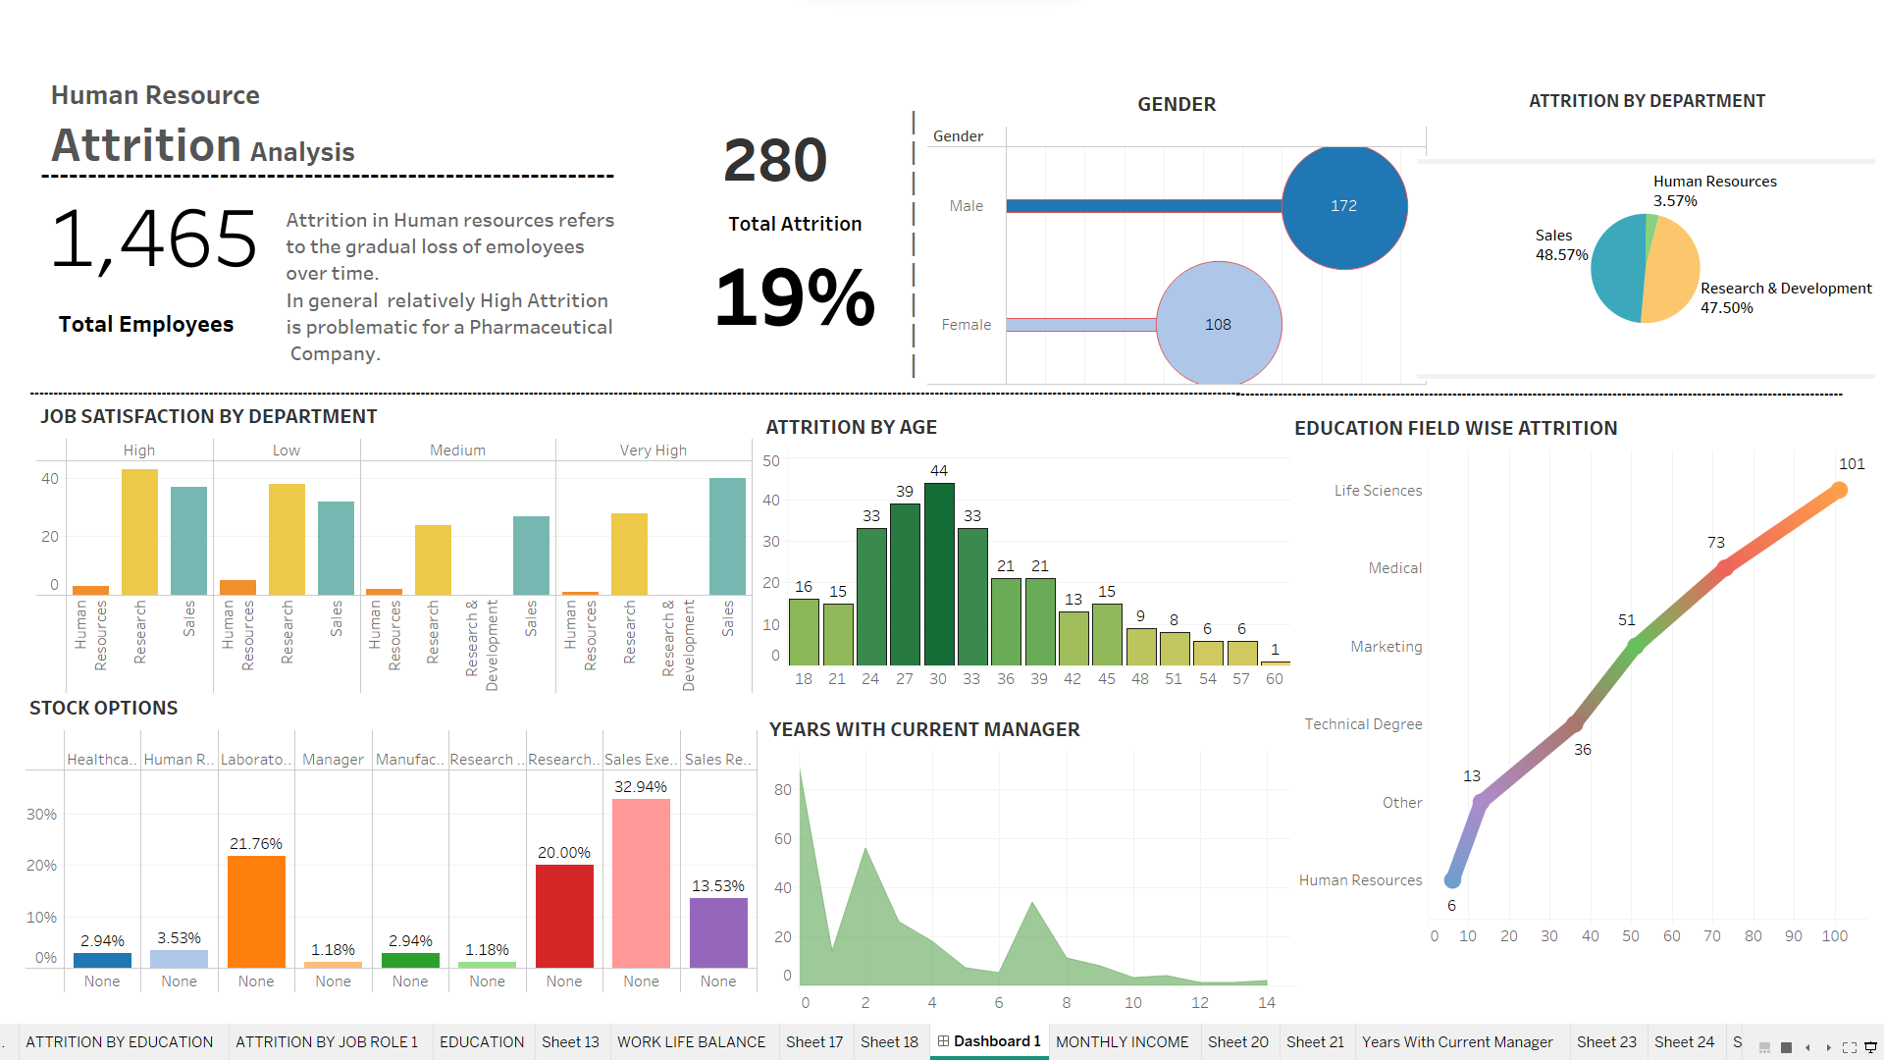

Recommendations & Suggestions

The main objective of the HR Managers is to find the root cause of attrition analysis. By identifying the causes, the company can be better equipped to handle a particular problem.

# ESOP (Employee Stock Ownership Plans)

From the findings it is observed that Employee who have not got the stock options tend to have the highest attrition rate. A benefit plan known as ESOP is the one in which the owners of the company sell all or part of their shares to an ESOP trust. The values of the shares granted to employees increases with the growth of the company (DeJong, 2023).

## Benefits

* Ownership Amount – By acquiring Business shares, the employee becomes a part of the company which can also promote a sense of pride and ownership.
* Monetarily Benefits – Employees can get the chance to accumulate and prosperity of the business. It aligns with the employee and shareholder interests.
* Retirement funds – ESOP’s act as a retirement savings for employees, enhancing their long-term financial security.

Lori L (2022) did research about employee retention and study shows that around 60% of the managers should get managerial training and 56% believe managers are promoted soon. It is suggested that one to one meeting is a good start to developing trust with the employees while honing management abilities. Additionally, it may reduce employee turnover by learning about problems that the employees are facing and can assist them in resolving and fundamental problems. Surveys should be done to determine the employee involvement. Establish a program and recognition to the efforts made by staff members. Provide a chance of flexible work alternatives that includes remote work and adjustable scheduling. Evaluate resource distributions and workload if the employee believe that they are underappreciated or overworked.

Benefits of Advanced Analytics

Deeper insights, predictive power and data driven decision making are possible through the use of advance analytics which is the application of complex methods and instruments to data analysis and interpretation.

Davenport, (2013) suggest decision making and workflow within the company should incorporate Analytics. The objective is to seamlessly integrate analytics into corporate process such that it becomes a necessary component of business run.

Prioritize competitive advantage and innovation – It is believed that innovation and establishing a competitive edge in addition to efficiency that use Prescriptive Analytics well and can set themselves apart from competitors

# Limitations

Data Quality and Availability (Marler, J.H. Boudreau, J.W. (2017) indicates that the availability and quality of data have a major impact on HR analytics efficacy. Incomplete or inaccurate data can result in faulty analysis and untrustworthy insights.

BIBLOGRAPHY

1. (2023) *Australian Customer Experience Professionals Association*. Available at: https://acxpa.com.au/ (Accessed: 15 November 2023).
2. (No date a) *An evidence-based review of HR Analytics - Taylor & Francis Online*. Available at: https://www.tandfonline.com/doi/full/10.1080/09585192.2016.1244699 (Accessed: 15 November 2023).
3. (No date b) *IEEE Xplore Full-text PDF:* Available at: https://ieeexplore.ieee.org/stamp/stamp.jsp?tp=&arnumber=9409047 (Accessed: 15 November 2023).
4. (No date c) *An analysis on employee-attrition in IT industry*. Available at: https://hmct.dypvp.edu.in/Documents/research-papers-publication/Resarch-publications/56.pdf (Accessed: 15 November 2023).
5. (No date d) *Factors influencing employee retention and ... - mahidol university*. Available at: https://archive.cm.mahidol.ac.th/bitstream/123456789/4895/1/TP%20GM.016%202022.pdf (Accessed: 15 November 2023).
6. *17 surprising statistics about employee retention* (no date) *TINYpulse*. Available at: https://www.tinypulse.com/blog/17-surprising-statistics-about-employee-retention (Accessed: 15 November 2023).
7. Author    Suhani Jain     A potterhead finding magic in words | Content Marketer @ RazorpayX, Jain, A.S. and A potterhead finding magic in words | Content Marketer @ RazorpayX (2022) *The Complete Guide to esops - razorpay payroll*, *Razorpay Learn*. Available at: https://razorpay.com/payroll/learn/esop-complete-guide/ (Accessed: 15 November 2023).
8. Contributor, T. (2018) *What is tableau?: Definition from TechTarget*, *WhatIs.com*. Available at: https://www.techtarget.com/whatis/definition/Tableau (Accessed: 15 November 2023).
9. DeJong, J. (2023) *How employees benefit from esops: Bankers Trust Education Center Center*, *Bankers Trust Education Center*. Available at: https://education.bankerstrust.com/how-employees-benefit-from-esops/ (Accessed: 15 November 2023).
10. Gartner_Inc (no date) *Are managers moot?*, *Gartner*. Available at: https://www.gartner.com/en/articles/are-managers-moot (Accessed: 15 November 2023).
11. Haapanen, M.J. *et al.* (2020) *Retirement age and type as predictors of frailty: A retrospective cohort study of older businessmen*, *BMJ open*. Available at: https://www.ncbi.nlm.nih.gov/pmc/articles/PMC7747567/ (Accessed: 15 November 2023).
12. Komiskey, L. (2023) *When to use tableau vs. Excel: Compare strengths and use cases*, *DataDrive*. Available at: https://godatadrive.com/blog/tableau-vs-excel (Accessed: 15 November 2023).
13. Patimes (2018) *The push for higher education: College attrition rates*, *PA TIMES Online*. Available at: https://patimes.org/the-push-for-higher-education-college-attrition-rates/ (Accessed: 15 November 2023).
14. Press, G. (2023) *Cleaning Big Data: Most time-consuming, least enjoyable data science task, survey says*, *Forbes*. Available at: https://www.forbes.com/sites/gilpress/2016/03/23/data-preparation-most-time-consuming-least-enjoyable-data-science-task-survey-says/?sh=2b84560a6f63 (Accessed: 15 November 2023).
15. Tamhankar, A. (2020) *How dashboards help in decision-making*, *Medium*. Available at: https://medium.com/@ashoktamhankar/how-dashboards-help-in-decision-making-e3047d6f0a5d (Accessed: 15 November 2023).

APPENDIXES

# APPENDIX A

The following Columns were changed using a Calculated field

|  |  |  |
| --- | --- | --- |
| COLUMN NAME | ORIGINAL VALUE | NEW VALUE |
| EDUCATON | 1,2,3,4,5 | ‘Below College’, ‘College’, ‘Bachelor’ , ‘Master’, ‘Doctor’ |
| JOB INVOLVEMENT | 1,2,3,4 | 'Low' ,'Medium' , 'High' ,'Very High' |
| JOB LEVEL | Junior, Senior | 1 = junior, 5 = senior |
| JOB SATISFACTION | 1,2,3,4 | 'Low', 'Medium' , 'High' ,'Very High' |
| STOCK OPTIONS LEVEL | 0,1,2,3 | ‘None’, ‘Low’, Medium’ ‘High’ |
| WORK LIFE BALANCE | 1,2,3,4 | 'Bad', 'Good' 'Better' , 'Best' |
| PERFORMANCE RATING | 1,2,3,4 | 'Low', 'Good', 'Excellent', 'Outstanding' |

APPENDIX B

# Figure 1

It is clearly seen that Majority of the Employees in the Company has Either Better or Best Work Life Balance. So it is not corelated to the employee attrition.

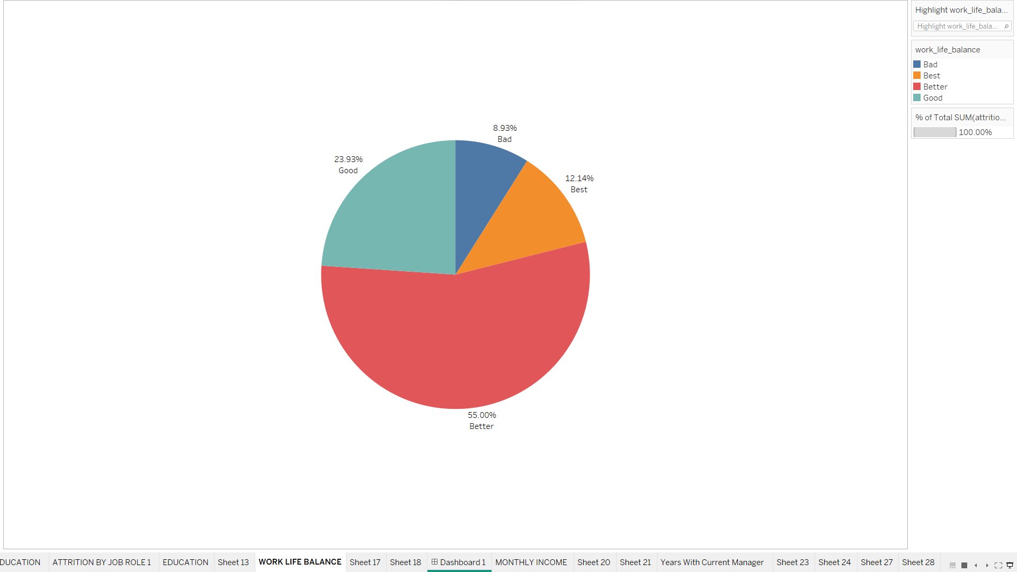

# Figure 2

Calculate field for Attrition

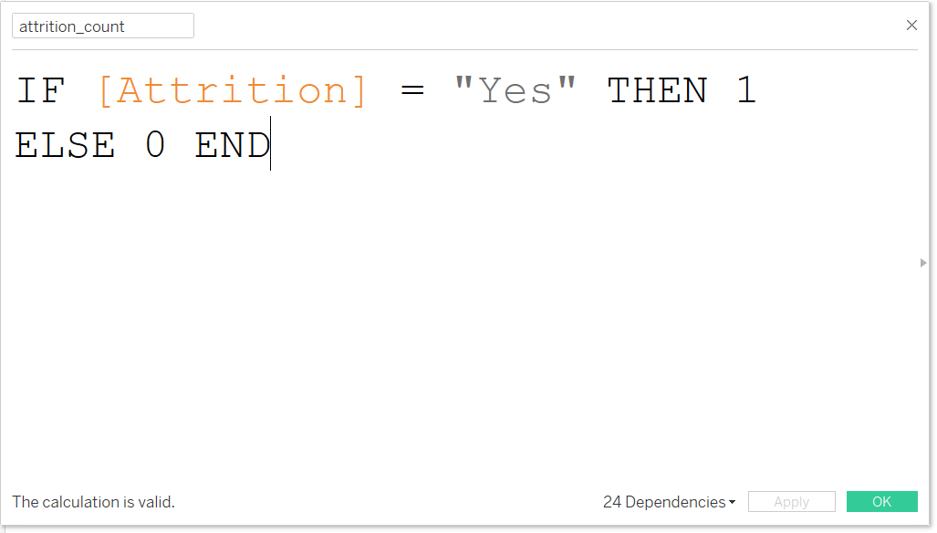

# Figure 3

ATTRITION RATE

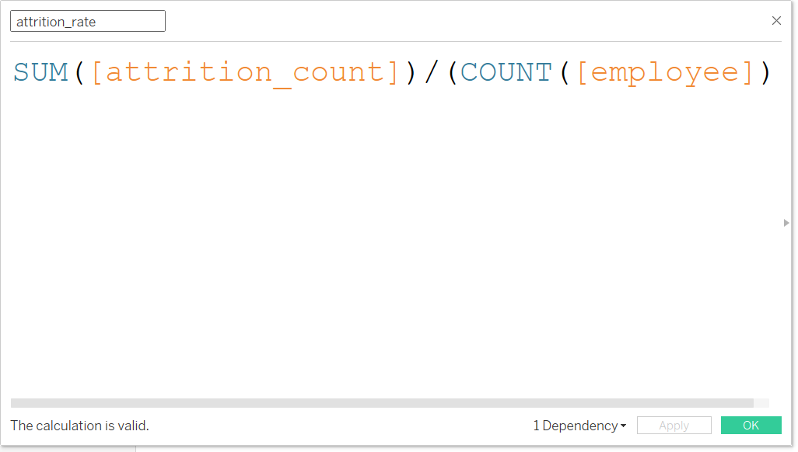

# Figure 4

EDUCATION

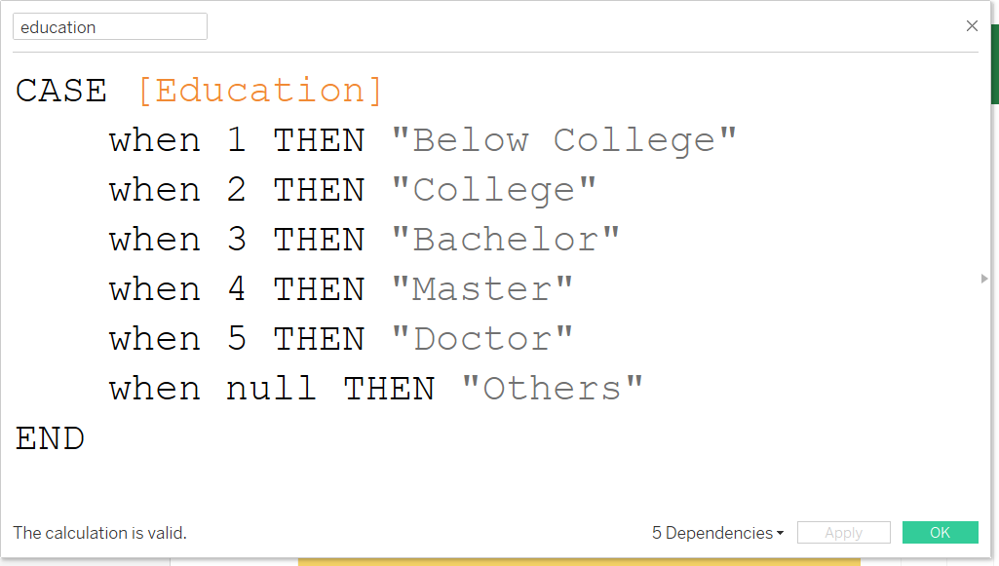

# Figure 5

STOCK OPTIONS

