**SQL PROJECT**

**HOSPITAL MANAGEMENT SYSTEM**

**NAME: SUYASH PRAMOD KALE**

**COURSE: DATA SCIENCE & ANALYTICS WITH AI**

**ABOUT THE DATASET:**

**DATASET SOURCE:** GITHUB

Hospitals interact with a lot of people in a day and there are various activities involved in day-to-day working of hospitals such as booking of doctors’ appointments, managing doctor schedules, patient diagnoses, patients’ medical history etc. This project aims to create and manage a Relational Database Management System which handles the hospital database system effectively.

**AVAILABLE TABLES:**

* Patient
* MedicalHistory
* Doctor
* Appointment
* PatientsAttendAppointments
* Schedule
* PatientsFillHistory
* Diagnose
* DocsHaveSchedules
* DoctorViewsHistory

**ENTITY-RELATIONSHIP DIAGRAM:**

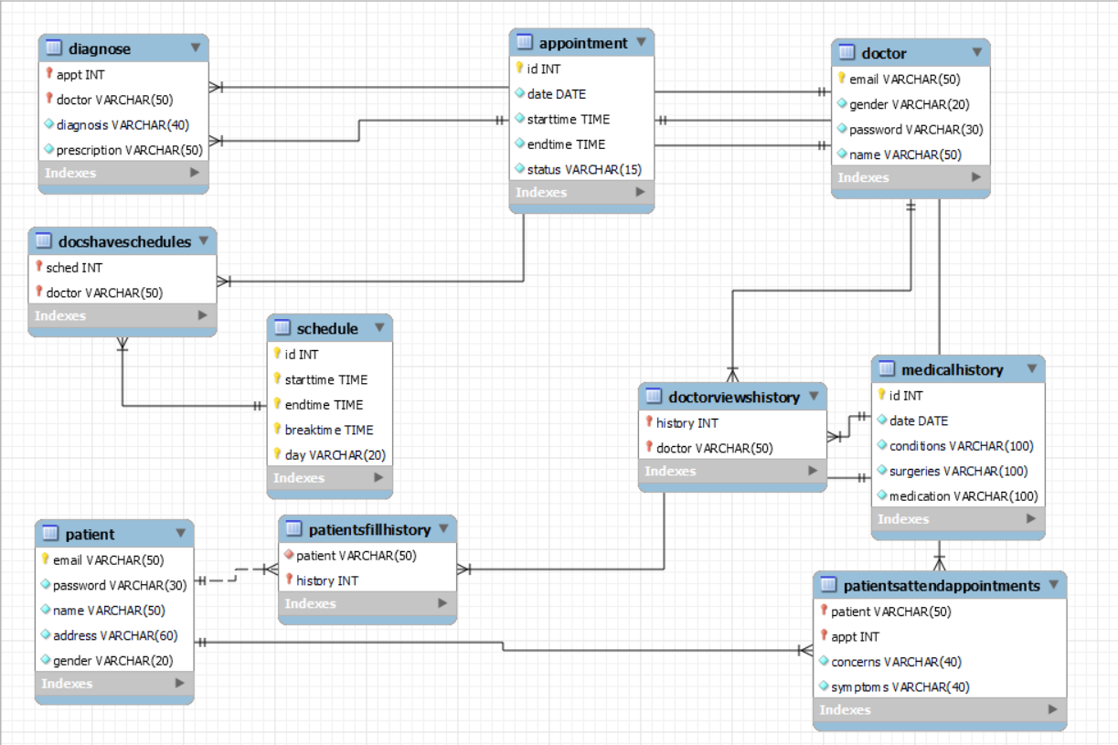

**Creating the Database and Tables:**



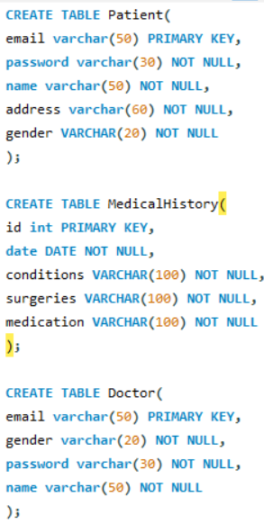

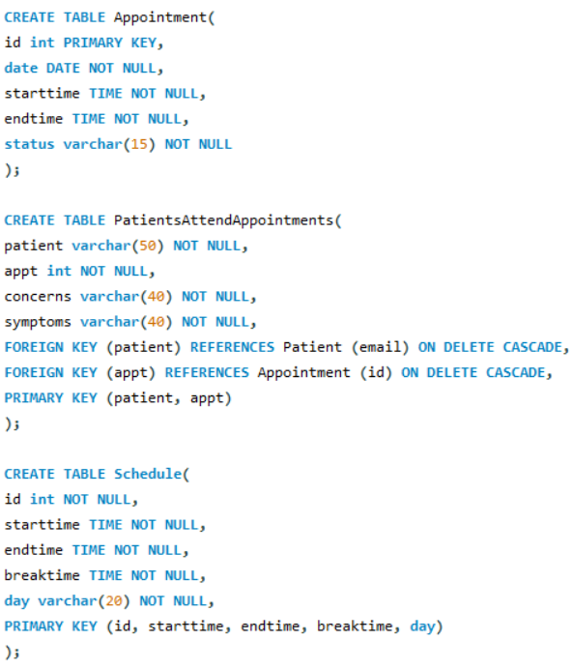

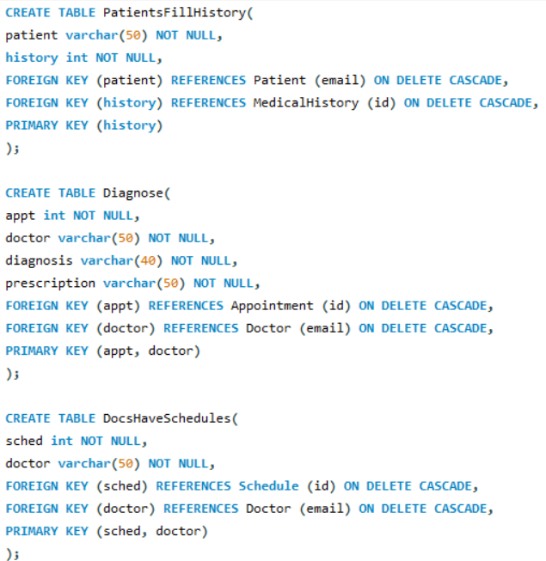

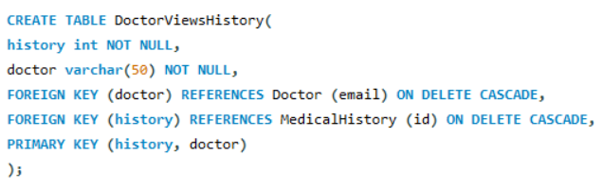

**Inserting the values in Tables:**

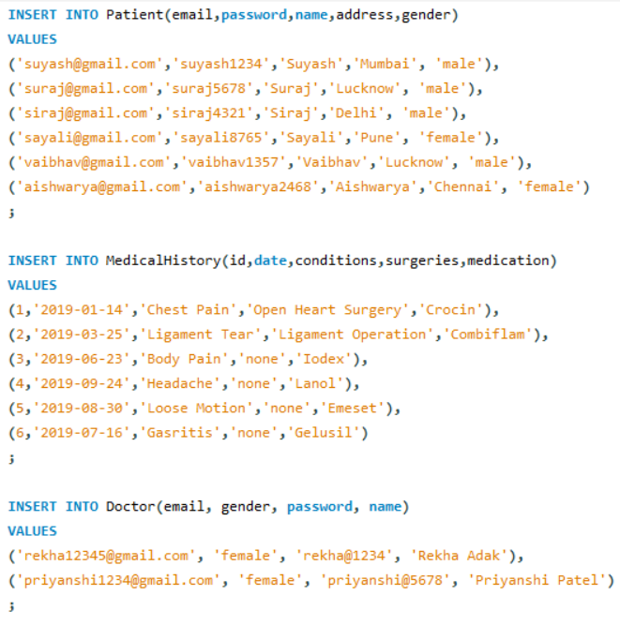

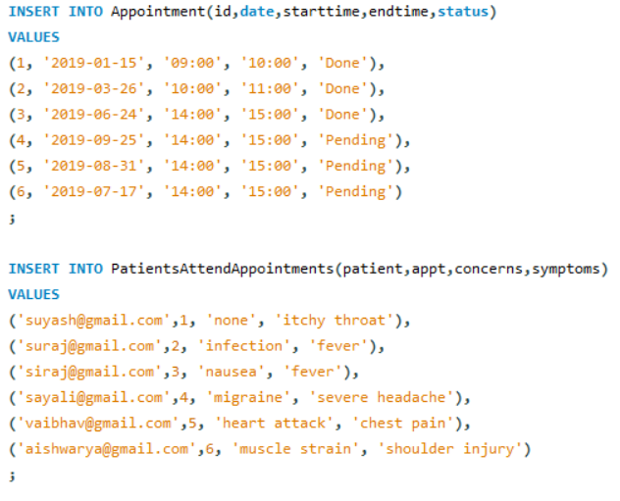

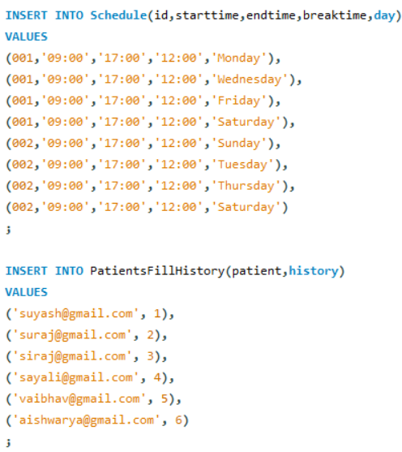

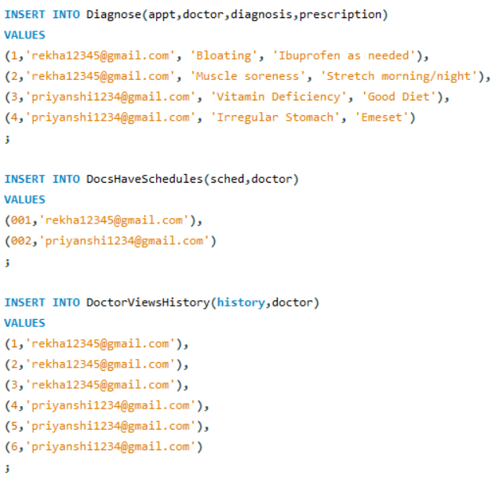

**QUERY 1: Display Structure and Data of Each Table**



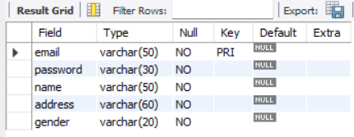 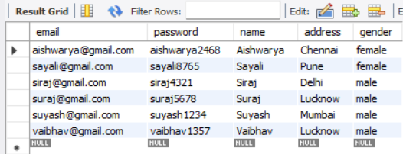



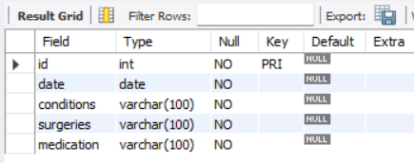

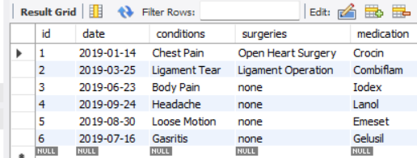



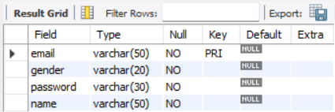

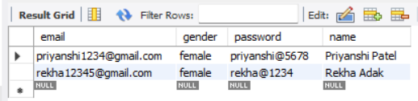

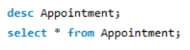

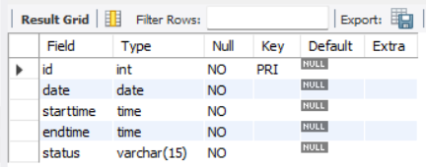

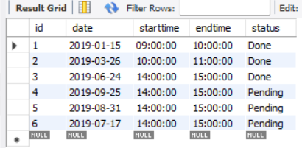

 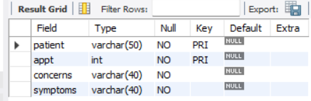

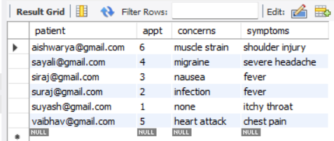



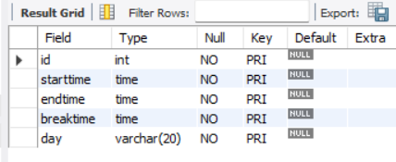

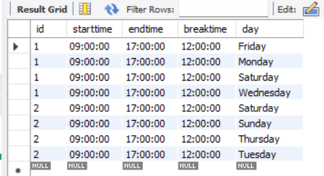



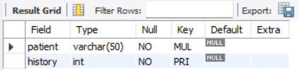

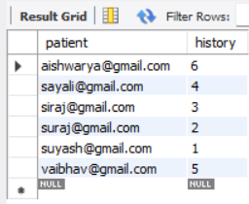



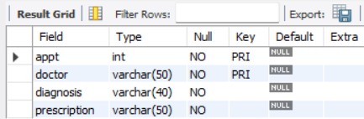

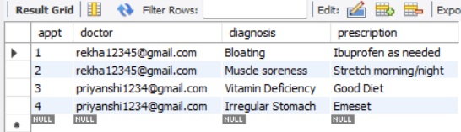



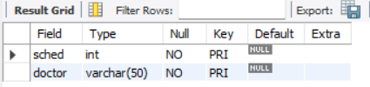

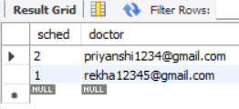



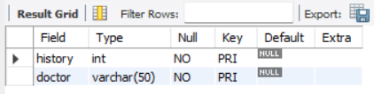

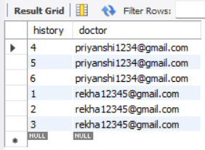

**QUERY 2: Resize column name from Patient**



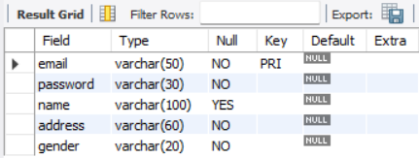

**QUERY 3: Rename table ‘MedicalHistory’ to ‘PatientMedicalHistory’**



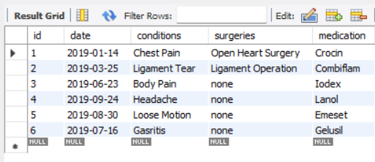

**QUERY 4: Update the value of status as ‘Done’ for appointment id 4**



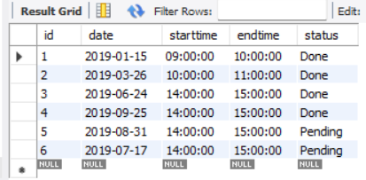

**QUERY 5: Show the records of Appointments handled by Rekha Adak (email – ‘rekha12345@gmail.com’) for Diagnosis**



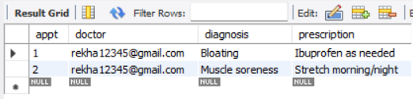

**QUERY 6: Show the Medical History of Patients between 1/1/2019 and 30/06/2019**



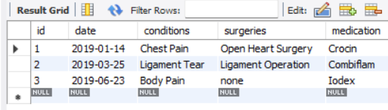

**QUERY 7: Show the Patients Medical History by Ascending order of Date**



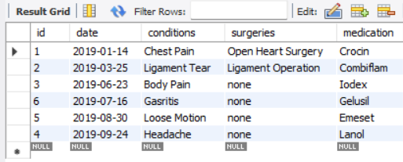

**QUERY 8: Show the Schedule of Rekha Adak**



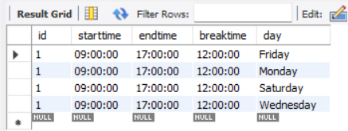

**QUERY 9: Show the Number of Days passed for each patient whose appointment status is ‘Done’**



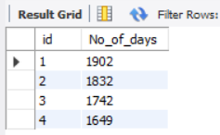

**QUERY 10: Count the Number of ‘Male’ Patients admitted**



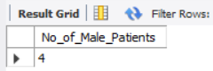

**QUERY 11: Find doctors who have attended more than 1 appointment**

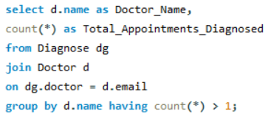

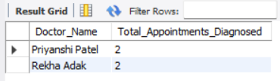

**QUERY 12: Find the patients who haven’t attended any appointments**

**Updated ‘Patient Table’ with new record.**



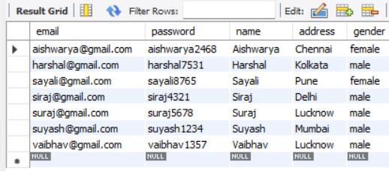

**Execution of QUERY 12**

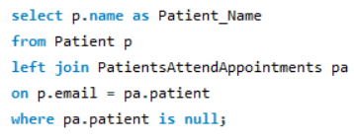

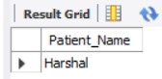

**QUERY 13: Retrieve All Patients Appointments which are Still ‘Pending’ to be attended**

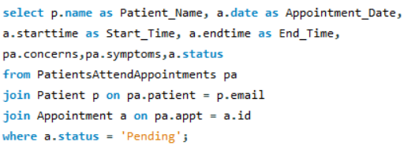

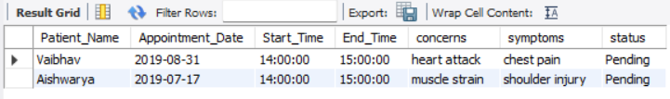

**QUERY 14: Find the Average Length of Appointments in minutes**

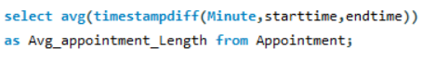

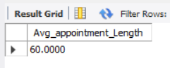

**QUERY 15: Retrieve all Doctors’ Details along with their Schedules**

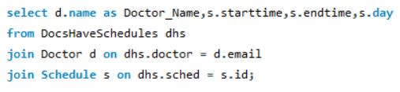

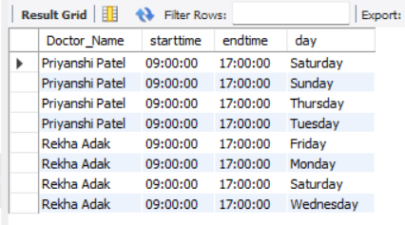

**QUERY 16: Retrieve All appointments (Done or Pending) for Doctor ‘Priyanshi Patel’**

**Inserting 2 new records in ‘Diagnose’ Table**

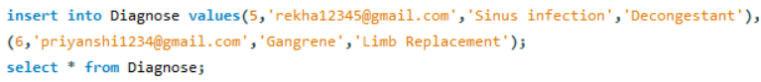

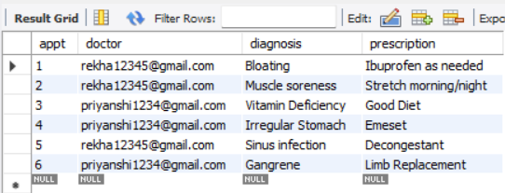

**Execution of QUERY 16**

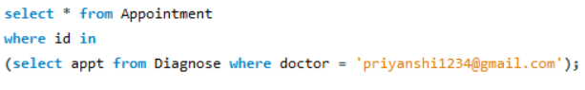

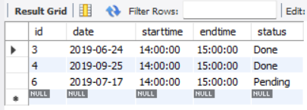

**QUERY 17: Retrieve Patient Name and Email whose Medical History is viewed by Doctor ‘Rekha Adak’**

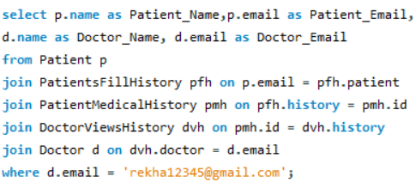

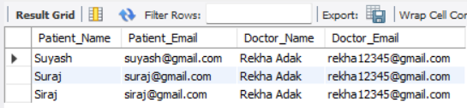

**QUERY 18: Retrieve Patients who have attended/ are attending appointments and their corresponding Doctors’ Details**

**Updating Corresponding Tables with new Records**



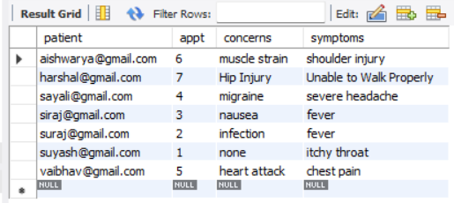



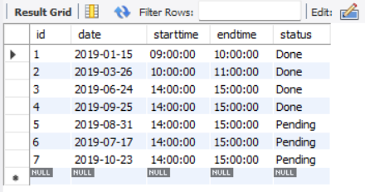



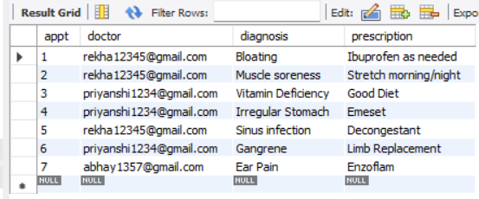



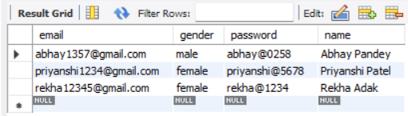

**Execution of QUERY 18**

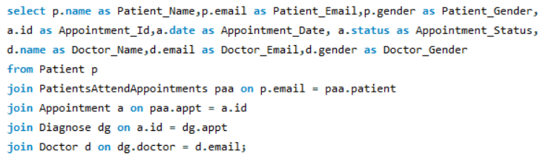

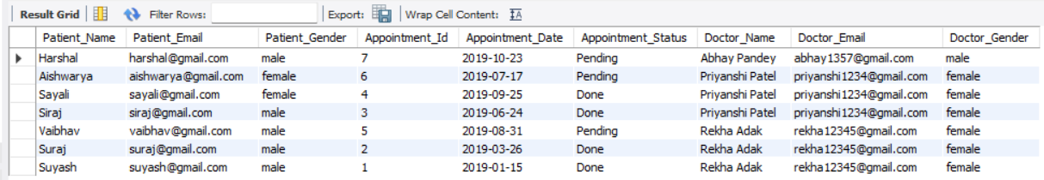

**QUERY 19: Retrieve details of Patients whose appointments are ‘pending’ and are scheduled in the second half of 2019 along with their scheduled appointment dates**

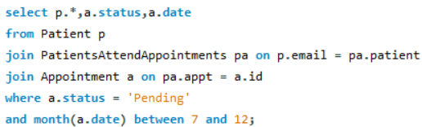

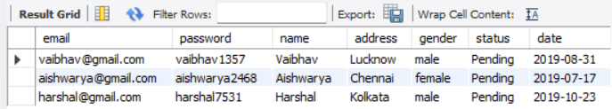

**QUERY 20: Retrieve details of Doctors who have Diagnosed Patients in the first half of 2019**

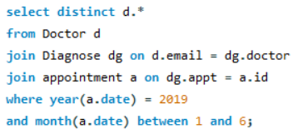

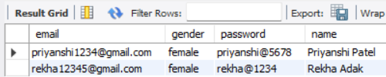

**QUERY 21: List all patients whose appointment has been scheduled but have not attended**

**Adding new Column ‘Attended’ in ‘PatientsAttendAppointments’ and Updating Values**

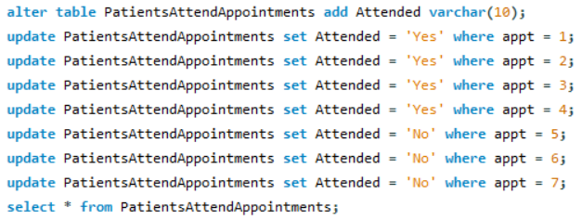

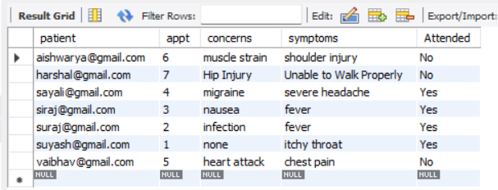

**Execution of QUERY 21**

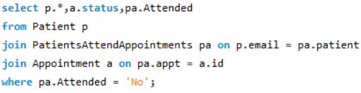

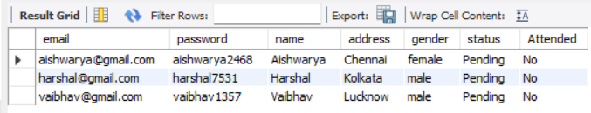

**QUERY 22: Retrieve Top 3 Appointments along with the latest dates, Appointment Status and the patient appointment attendance (Using Sub- Queries and Window Functions)**

