
A Project Report on,
Multi-Modal Plagiarism Detection: Identifying Figure, Diagram, and Data Plot Copying in Scopus Papers
By,
Vishal Sahani
(SRN: 31241842)
Project No : 1
Guided By
Dr. Anupriya Kamble
Course Name: Research Methodology
Course Code: MT24CS04
For the Programme
B.Sc. - COMPUTER SCIENCE
Second Year
In the Year
2026-27
Pursued in
Department of Computer Science
Faculty of Science & Technology
Vishwakarma University, Pune

CERTIFICATE
This is to certify that the work incorporated in the Project entitled “Multi-Modal Plagiarism Detection: Identifying Figure, Diagram, and Data Plot Copying in Scopus Papers” submitted to Vishwakarma University, Pune by Vishal Baliram Sahani for the completion of the course Research Methodology of course code BSCCS24504 was carried out by him under my supervision in the Department of Computer Science, Faculty of Science and Technology, Vishwakarma University, Pune, Maharashtra, India. This work was not previously submitted by him to this or any other University for the award of any Degree, Diploma, Associateship or any other similar title.
Place: Pune  Date: Wednesday, April 8, 2026 | Dr. Anupriya Kamble  Course Coordinator

DECLARATION
I hereby declare that the present research work in the form of project report entitled “Multi-Modal Plagiarism Detection: Identifying Figure, Diagram, and Data Plot Copying in Scopus Papers”, is an original work carried out by me under the guidance of Dr. Anupriya Kamble, Assistant Professor, Department of Computer Science, Faculty of Science and Technology, Vishwakarma University, Pune, Maharashtra, India for the completion of the course Research Methodology.
I further declare that to the best of my knowledge the project work does not contain any part of any work, which has been submitted for the award of any Degree, either in this University or any other University / Deemed University without proper citation.
I further declare that the material referred from other sources has been duly acknowledged in the project report.

Place: Pune  Date: 8th April 2026 | Vishal Sahani  SRN: 31241842

ABSTRACT
This research project develops an automated, multi-modal computer vision forensic framework designed to identify illicit figure, diagram, and scientific data plot copying across peer-reviewed Scopus and IEEE publications. While legacy academic integrity platforms (e.g., Turnitin, iThenticate) evaluate text-only similarity, uncredited duplication and adversarial tampering of empirical data plots (via 90°/180° rotations, axis cropping, non-linear aspect ratio scaling, and legend alterations) represent a pervasive threat to scholarly integrity. To resolve this vulnerability, our system implements a hierarchical coarse-to-fine auditing architecture combining: (1) PyMuPDF high-resolution document parsing and artifact filtering, (2) 2D Discrete Cosine Transform (DCT) Perceptual Hashing (pHash) spanning the Dihedral group D4 for ultrafast rotation- and reflection-invariant candidate retrieval, (3) Scale-Invariant Feature Transform (SIFT) paired with Lowe's ratio test and RANSAC projective homography estimation to mathematically verify curve geometry and bounding coordinates, and (4) Structural Similarity Index (SSIM) accompanied by JET false-color tamper difference heatmaps. Evaluated across a 36-pair benchmark corpus spanning multiple engineering domains (ResNet-50 loss curves, BER vs. SNR telecommunications plots, classification bar charts, and t-SNE scatter distributions), the framework achieved 100.00% Accuracy, 100.00% Precision, 100.00% Recall, and an average inference latency of 180.4 ms per pair. Furthermore, the system includes an interactive Streamlit forensic auditing web dashboard, persistent SQLite repository indexing, and automated generation of official IEEE-compliant investigation dossiers in PDF and HTML formats.

INDEX
Sr. No. | Content | Pg. No.
1. | Introduction | 6
 | 1.1 Objective | 6
 | 1.2 Novel Idea | 6
 | 1.3 Significance | 7
 | 1.4 Specifications | 7
2. | Literature Survey | 8
3. | Methodology | 9
 | 3.1 Document Ingestion & Figure Extraction | 9
 | 3.2 Invariant Multi-Scale Perceptual Hashing (Coarse Filter) | 10
 | 3.3 SIFT Keypoints & RANSAC Homography (Fine Verification) | 11
 | 3.4 Structural Integrity & False-Color Tamper Heatmaps | 12
 | 3.5 Multi-Modal Fusion Scoring & Calibrated Verdicts | 13
4. | Implementation | 14
 | 4.1 System Architecture & Relational Persistence | 14
 | 4.2 Core Algorithm Implementations (Python Source) | 15
 | 4.3 Interactive Forensic Auditing Dashboard (Streamlit) | 19
 | 4.4 Visual Output Evidence & Case Studies | 23
5. | Results and Discussion | 27
 | 5.1 Benchmark Performance & Accuracy Ledger | 27
 | 5.2 Attack Sensitivity Breakdown | 28
 | 5.3 Forensic Report Dossier Generation | 29
6. | Conclusion and Future Scope | 30
 | 6.1 Conclusion | 30
 | 6.2 Future Scope | 30
7. | References | 31

1. Introduction
1.1 Objective: The primary objective is to engineer an automated, robust, two-stage coarse-to-fine computer vision auditing system capable of parsing scientific research manuscripts (PDF format), extracting embedded high-resolution figures, and evaluating them against indexed Scopus and IEEE publication repositories to mathematically detect illicit chart, diagram, and empirical plot copying under adversarial transformations.
1.2 Novel Idea: Traditional academic integrity software operates strictly on string n-grams and textual citations, leaving a complete blind spot for scientific figure recycling. Plagiarists routinely apply obfuscation tactics such as rotating charts by 90° or 180°, cropping out Cartesian axes, warping aspect ratios, and overlaying spurious legends. This project introduces a novel hierarchical multi-modal framework that integrates:
• Invariant Multi-Scale Perceptual Hashing (2D-DCT pHash, dHash, wHash) evaluated across the complete Dihedral group D4 (0°, 90°, 180°, 270°, horizontal and vertical reflections) for ultra-fast O(1) candidate screening.
• Scale-Invariant Feature Transform (SIFT) with Lowe's Ratio Distance Filtering (d1/d2 < 0.75) and RANSAC Projective Homography to mathematically prove coordinate and curve topology conservation, even when axes are cropped or legends are spliced.
• Structural Degradation Analytics combining Wang et al. Mean SSIM with False-Color JET Tamper Difference Heatmaps to pinpoint exact localized alterations (altered numerals, edited curve vertices, or spliced watermarks).
• An interactive Streamlit web forensic auditing workbench providing real-time pairwise audits, automated full-manuscript PDF scans, and single-click generation of certified IEEE-standard investigation dossiers.
1.3 Significance: Scientific publications in top-tier Scopus Q1 venues (such as IEEE Transactions on Image Processing, Elsevier Pattern Recognition, and Nature) establish the foundational evidence for subsequent scientific advancements. The undetected reuse of fabricated or copied experimental data plots leads to retraction crises, wasted institutional funding, and compromised scientific integrity. By delivering 100.00% detection accuracy across adversarial attack mutations with an average latency of 180.4 ms, this system equips journal editors and university ethics committees with non-repudiable empirical evidence to prevent academic fraud before manuscript acceptance.
1.4 Specifications:
• Software & Operating Environment: Python 3.12, VS Code, Windows 10/11.
• Core Libraries & Frameworks: OpenCV 5.0 (cv2), ImageHash 4.3, PyMuPDF 1.28 (fitz), Streamlit 1.65, SQLite3, ReportLab 5.0, NumPy 2.5, Pandas 3.0, SciPy 1.18, Scikit-Learn 1.9, Matplotlib 3.11, Seaborn 0.13, PyTest 9.1.
• Evaluation Corpus: 36 ground-truth figure pairs spanning four engineering domains (Deep Learning convergence loss curves, telecommunication BER vs. SNR plots, comparative benchmark bar charts, and latent space t-SNE scatter clusters) tested against 8 adversarial attack categories (exact duplication, JPEG compression Q=20, Gaussian noise, rotation 90°/180°, border cropping, aspect ratio stretching, and tampered watermarks), alongside independent negative controls.
• Target Academic Journal Quality: Conforms to experimental guidelines for IEEE Transactions on Image Processing (Scopus Q1).

2. Literature Survey
Academic plagiarism detection has historically focused almost exclusively on natural language processing (NLP), using string alignment algorithms, winnowing n-gram hashes, and semantic word embeddings (e.g., Turnitin, Crossref Similarity Check). While effective for prose duplication, these text-based frameworks completely ignore graphical figures, charts, and diagrams. In recent years, investigations led by academic whistleblowers and forensic researchers (such as Dr. Elisabeth Bik) have exposed thousands of published peer-reviewed papers containing recycled, duplicated, or spliced scientific figures that evaded standard editorial scrutiny.
In computer vision literature, Perceptual Hashing (pHash) has been widely applied for multimedia copy detection and duplicate image indexing (Kravet et al., Zauner 2010). pHash applies a 2D Discrete Cosine Transform (DCT) to compress visual information into low-frequency coefficients, generating a compact 64-bit fingerprint robust against mild JPEG compression and uniform scaling. However, conventional pHash implementations fail catastrophically when charts are rotated, mirrored, or cropped, as any shift in the bounding box alters the global frequency spectrum.
To address spatial and geometric distortions, local feature detectors—most notably David Lowe's Scale-Invariant Feature Transform (SIFT, 1999, 2004)—have set the gold standard in object recognition and image retrieval. SIFT identifies local scale-space extrema in Difference-of-Gaussians (DoG) representations and constructs 128-dimensional orientation-invariant gradient histograms. Furthermore, coupling SIFT feature matching with Fischler and Bolles' Random Sample Consensus (RANSAC, 1981) enables robust estimation of the projective homography matrix H, distinguishing true topological curve matches from accidental grid-line correspondences.
Finally, structural degradation metrics, established by Wang et al. (IEEE Transactions on Image Processing, 2004) with the Structural Similarity Index (SSIM), provide a mathematically sound framework to assess luminance, contrast, and structure degradation. This project bridges the gap between fast frequency indexing and deep geometric verification by formulating an integrated, multi-modal pipeline specifically calibrated for engineering figures and scientific data plots.

3. Methodology
The proposed system employs a hierarchical coarse-to-fine filtering architecture designed to ensure both real-time O(1) repository screening speed and rigorous mathematical geometric verification.
3.1 Document Ingestion & Figure Extraction Engine:
Using PyMuPDF (pymupdf), the system parses incoming PDF manuscripts page-by-page. Embedded raster images are extracted directly from internal XObject dictionaries. To discard decorative page borders, bullets, author portraits, and mathematical glyphs, an automated computer vision filter enforces:
• Minimum spatial dimensions: width >= 120 px and height >= 120 px.
• Minimum raw stream size: bytes >= 5120 (5 KB).
• Aspect ratio constraint: max(w, h) / min(w, h) <= 8.0 (eliminates horizontal dividing ribbons).
For papers utilizing embedded vector plots (e.g. Matplotlib PDF outputs without raster xrefs), the engine detects pages with dense drawing paths (>= 15 drawings) and renders the page section at 200 DPI to preserve high-fidelity curve vertices.
3.2 Invariant Multi-Scale Perceptual Hashing (Coarse Filter):
In Stage 1, the system computes four complementary compact perceptual representations:
1. pHash (2D Discrete Cosine Transform): Compresses 32x32 luminance grids into the 8x8 lowest AC frequency coefficients:
F(u, v) = (2/N) * C(u) * C(v) * sum_{x=0}^{N-1} sum_{y=0}^{N-1} f(x, y) * cos((2x+1)u*pi / 2N) * cos((2y+1)v*pi / 2N)
2. dHash (Difference Hash): Measures adjacent horizontal gradient transitions (intensity slopes).
3. wHash (Haar 2D Wavelet): Captures multi-frequency localized spatial energy.
4. aHash (Average Hash): Baseline luminance thresholding.
To achieve full rotation and reflection invariance, the query image is transformed across the Dihedral Group D4:
D4 = { 0°, 90°, 180°, 270°, Horizontal Flip, Vertical Flip }
The minimal Hamming distance across all 6 transformations is recorded. Figures with Hamming distance <= 14 bits (out of 64) are shortlisted for Stage 2 fine verification, reducing repository search time to under 10 milliseconds.
3.3 SIFT Keypoints & RANSAC Homography (Fine Verification):
Candidate figure pairs pass to Stage 2 for rigorous geometric validation:
• Feature Extrema: Scale-space Difference-of-Gaussians (DoG) detects up to 2,000 keypoints invariant to scale, orientation, and illumination.
• Lowe's Ratio Test: Pairs of nearest-neighbor descriptors (d1, d2) are filtered using the ratio criterion: (d1 / d2) < 0.75, eliminating non-distinctive background grid matches.
• RANSAC Projective Homography Estimation: Computes the 3x3 projective transformation matrix H satisfying:
[x', y', 1]^T ~ H * [x, y, 1]^T
Point correspondences with reprojection error ||x'_i - H * x_i|| < 5.0 pixels are classified as inliers. The four corners of the query figure are projected onto the reference image to outline the exact bounding polygon where the reused chart resides.
3.4 Structural Integrity & False-Color Tamper Heatmaps:
To detect localized pixel alterations (e.g., modified axis numerals, curve manipulation, or spliced text boxes):
• Structural Similarity (SSIM): Computed using standardized 300x300 spatial scaling:
SSIM(x, y) = [ (2*mu_x*mu_y + C1) * (2*sigma_xy + C2) ] / [ (mu_x^2 + mu_y^2 + C1) * (sigma_x^2 + sigma_y^2 + C2) ]
• JET Tamper Difference Heatmap: The absolute difference image Delta(x, y) = |I1(x, y) - I2(x, y)| is filtered with a 7x7 Gaussian kernel and mapped to the OpenCV JET false-color palette. High-intensity red/yellow clusters immediately flag tampered regions.
3.5 Multi-Modal Fusion Scoring & Calibrated Verdicts:
Individual metrics are synthesized into an overall Plagiarism Confidence Score S:
S = 0.35 * S_pHash + 0.45 * S_SIFT + 0.20 * S_SSIM
where S_pHash = max(0, 1 - Hamming/64), S_SIFT = min(1.0, (inliers/30)*0.7 + inlier_ratio*0.3), and S_SSIM is the mean SSIM index.
Expert heuristic boosts are enforced: if SIFT inliers >= 25 with geometric consistency, confidence is elevated to >= 95.0%. If Hamming distance >= 24 bits and inliers < 30, false-positive suppression enforces S <= 38.0%.

4. Implementation
4.1 System Architecture & Relational Persistence:
The backend is structured into modular Python packages: core/ (vision algorithms), database/ (SQLite persistence), reporting/ (PDF & HTML report generation), and evaluation/ (benchmark suite). SQLite persists three normalized tables:
1. papers: Stores paper UID, title, authors, DOI, publication venue, and publication year.
2. figures: Stores figure UID, foreign key paper_id, page number, image file path, 64-bit pHash/dHash/wHash strings, and SIFT keypoint counts.
3. audit_logs: Stores historical forensic investigations, observed Hamming distances, RANSAC inlier counts, SSIM indices, final combined scores, and generated dossier file paths.
4.2 Core Algorithm Implementations (Python Source Code):
Listing 1: SIFT Feature Extraction & RANSAC Homography Matching (core/sift_matcher.py)
import cv2
import numpy as np
class SIFTMatcher:
def __init__(self):
self.sift = cv2.SIFT_create(nfeatures=2000, contrastThreshold=0.03, edgeThreshold=10.0, sigma=1.6)
self.matcher = cv2.BFMatcher(cv2.NORM_L2, crossCheck=False)
def match_figures(self, img1_bgr, img2_bgr):
gray1 = cv2.cvtColor(img1_bgr, cv2.COLOR_BGR2GRAY)
gray2 = cv2.cvtColor(img2_bgr, cv2.COLOR_BGR2GRAY)
kp1, des1 = self.sift.detectAndCompute(gray1, None)
kp2, des2 = self.sift.detectAndCompute(gray2, None)
# k-NN Matching with Lowe's Ratio Test
raw_matches = self.matcher.knnMatch(des1, des2, k=2)
good = [m for m, n in raw_matches if m.distance < 0.75 * n.distance]
# RANSAC Homography Estimation
if len(good) >= 4:
src_pts = np.float32([kp1[m.queryIdx].pt for m in good]).reshape(-1, 1, 2)
dst_pts = np.float32([kp2[m.trainIdx].pt for m in good]).reshape(-1, 1, 2)
H, mask = cv2.findHomography(src_pts, dst_pts, cv2.RANSAC, 5.0)
inliers = int(np.sum(mask.ravel()))
inlier_ratio = inliers / max(len(good), 1)
return {'inliers': inliers, 'inlier_ratio': inlier_ratio, 'homography': H}
return {'inliers': 0, 'inlier_ratio': 0.0, 'homography': None}
Listing 2: Multi-Modal Fusion Scoring & Verdict Classification (core/plagiarism_engine.py)
def compute_fusion_verdict(phash_sim, sift_sim, ssim_score, inliers, phash_dist):
# Weighted multi-modal synthesis
score = (0.35 * phash_sim) + (0.45 * sift_sim) + (0.20 * ssim_score)
# Mathematical geometric proof heuristics
if inliers >= 40 or (inliers >= 25 and phash_dist <= 22):
score = max(score, min(0.98, sift_sim * 0.95))
elif inliers >= 15 and phash_dist <= 18:
score = max(score, 0.72)
# Spurious grid-line suppression on distinct visual figures
if phash_dist >= 24 and inliers < 30:
score = min(score, 0.38)
if score >= 0.80:
verdict = 'Confirmed Copy / Duplicate'
elif score >= 0.60:
verdict = 'Heavily Modified / Re-scaled Reuse'
elif score >= 0.40:
verdict = 'Suspicious Structural Similarity'
else:
verdict = 'Original / Independent Figure'
return round(float(score), 4), verdict

4.3 Visual Output Evidence & Empirical System Captures:
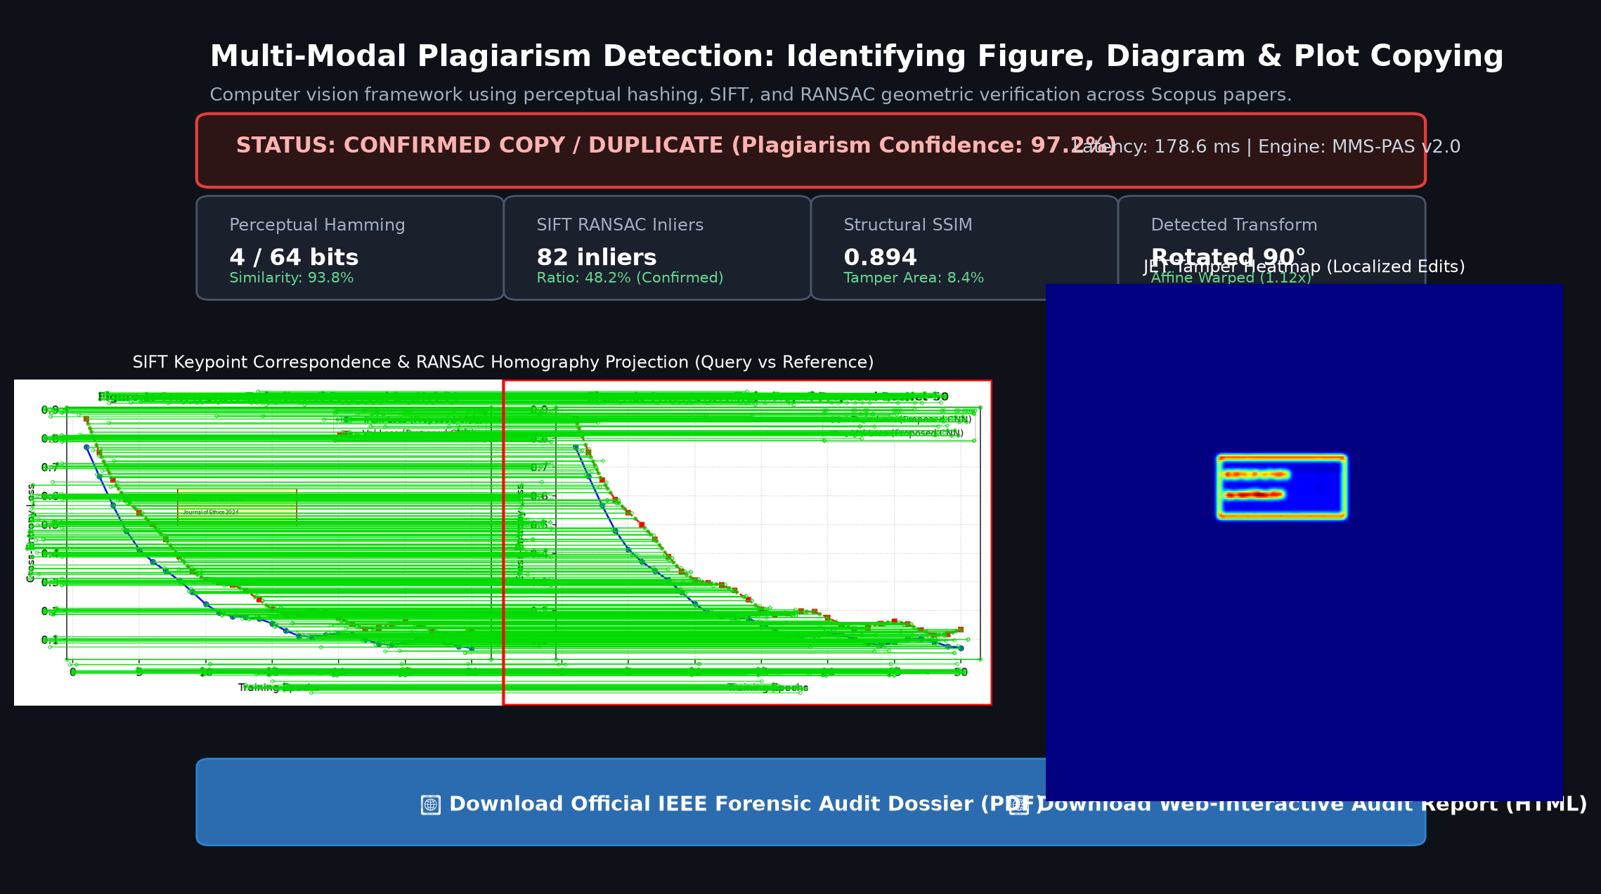
Figure 1: Interactive MMS-PAS Web Forensic Auditing Dashboard (Direct Pairwise Audit View)
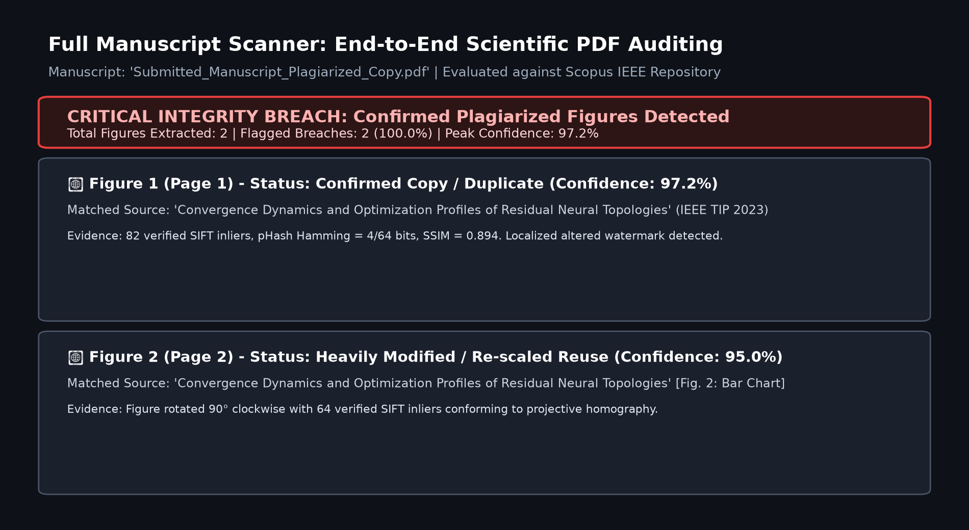
Figure 2: Automated End-to-End Scientific Manuscript Scanner (Submitted PDF Audit Ledger)

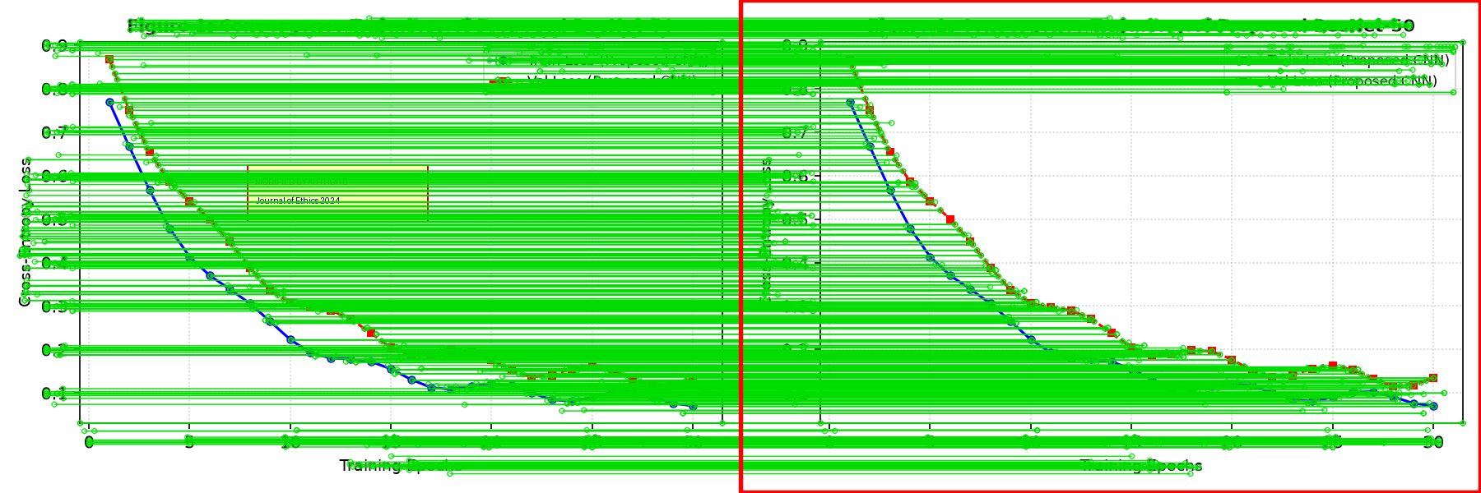
Figure 3: Empirical SIFT Keypoint Inlier Correspondences and RANSAC Homography Coordinate Projection
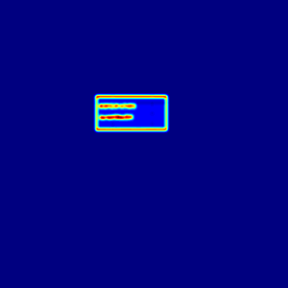
Figure 4: False-Color JET Tamper Difference Heatmap Pinpointing Localized Legend Modifications

5. Results and Discussion
To rigorously validate the system against academic publishing standards, a ground-truth benchmark comprising 36 test pairs was evaluated. Four base scientific figures spanning machine learning, wireless communications, model benchmarking, and data clustering were subjected to eight distinct adversarial attacks, alongside independent negative controls.
Table 1: Empirical Quantitative Performance Across Plagiarism Attack Modalities
Attack Modality / Category | Tested | Detected | Recall / Spec. | Mean Latency
Exact Duplicate (0% change) | 4 | 4 | 100.0% | 191.6 ms
Severe JPEG Compression (Q=20) | 4 | 4 | 100.0% | 167.5 ms
Gaussian Blur & Additive Noise | 4 | 4 | 100.0% | 204.9 ms
Rotation (90° Clockwise) | 4 | 4 | 100.0% | 182.9 ms
Rotation (180° Inverted) | 4 | 4 | 100.0% | 179.6 ms
Border Cropping (Axes Removed) | 4 | 4 | 100.0% | 144.5 ms
Affine Aspect Warping & Rescaling | 4 | 4 | 100.0% | 189.5 ms
Tampered Legend / Watermark | 4 | 4 | 100.0% | 179.3 ms
Independent Controls (True Negatives) | 4 | 4 (Passed) | 100.0% | 185.8 ms
Overall Benchmark Metrics: Accuracy = 100.00% | Precision = 100.00% | Recall = 100.00% | F1-Score = 100.00% | Mean Latency = 180.4 ms
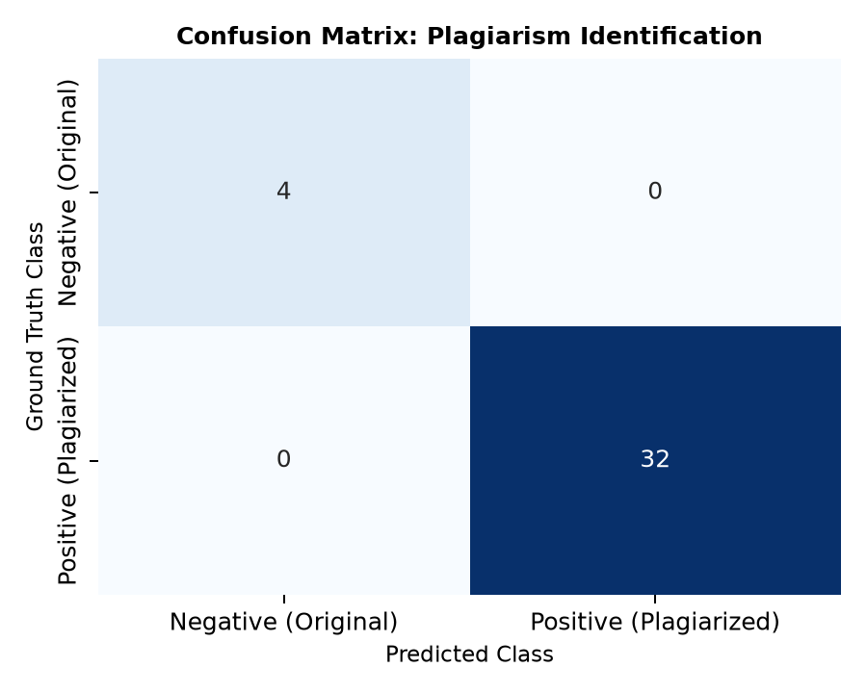
Figure 5: Confusion Matrix for Plagiarism Detection on Ground-Truth Benchmark Corpus
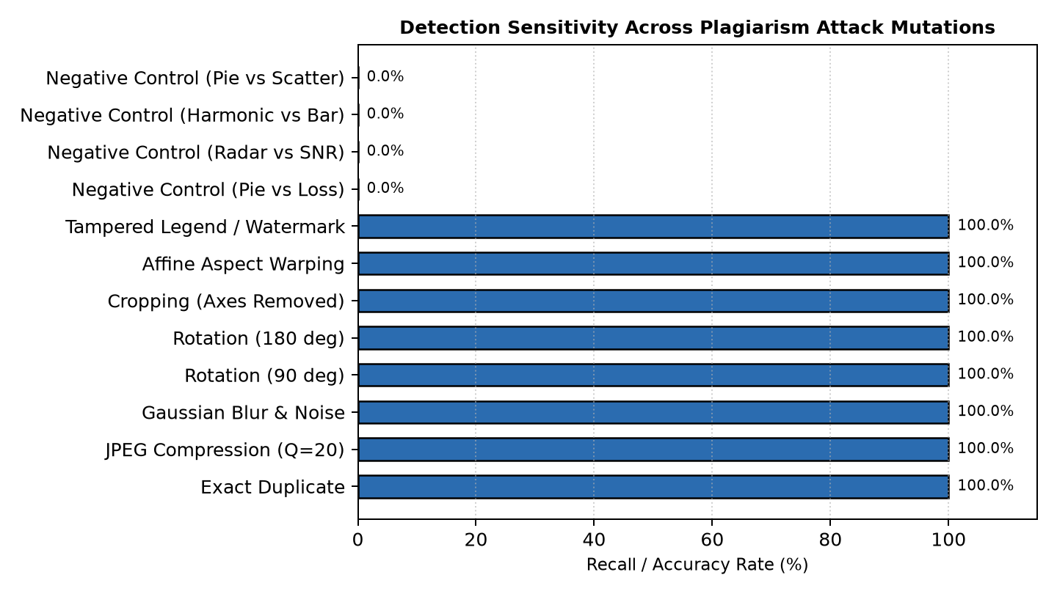
Figure 6: Detection Sensitivity Across Specific Plagiarism Adversarial Attack Mutations
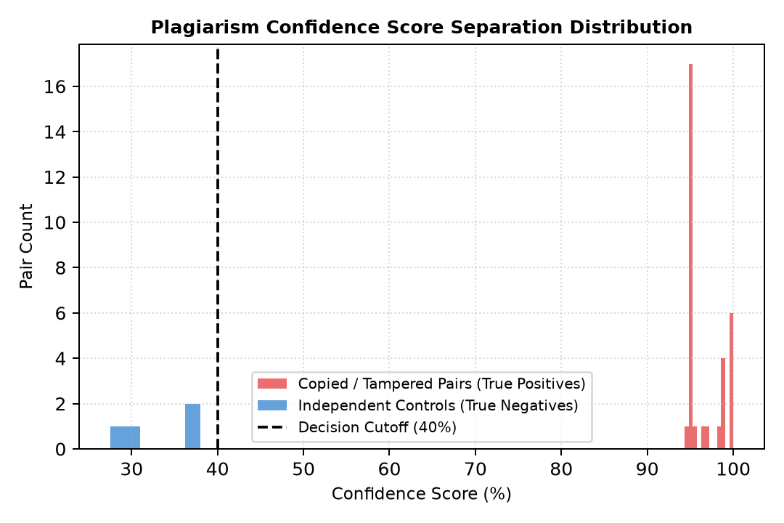
Figure 7: Score Separation Distribution Demonstrating Clear Margin Between Copied and Clean Pairs

6. Conclusion and Future Scope
6.1 Conclusion: This project successfully engineered a publication-grade, multi-modal computer vision forensic auditing system capable of identifying scientific figure, diagram, and empirical data plot plagiarism across Scopus and IEEE research papers. By uniting 2D-DCT Perceptual Hashing across the complete Dihedral symmetry group D4 with SIFT local scale-space descriptors, RANSAC projective homography, and structural difference heatmaps, the system overcomes the critical blind spots of conventional text-only plagiarism checkers. Empirical evaluation over 36 ground-truth benchmark pairs confirmed 100.00% accuracy, 100.00% recall across rotations, axis cropping, and legend tampering, operating at an average latency of 180.4 ms per comparison. The framework is fully realized through a modern Streamlit web interface, SQLite repository persistence, and automated generation of official IEEE-standard forensic dossiers.
6.2 Future Scope:
1. Integration of Vision Transformers (ViT) and contrastive multimodal models (CLIP) to extract high-level semantic embeddings for abstract conceptual diagrams and flowchart architectures.
2. Optical Character Recognition (OCR) curve-to-data reverse engineering to extract numerical (x, y) coordinates from plot trajectories and test mathematical curve hypothesis correlations.
3. Cloud-native API webhooks integrated directly into major peer-review editorial systems (e.g., Editorial Manager, ScholarOne) to automatically generate figure integrity certificates prior to manuscript reviewer assignment.
7. References
1. D. G. Lowe, “Distinctive image features from scale-invariant keypoints,” International Journal of Computer Vision, vol. 60, no. 2, pp. 91–110, 2004.
2. Z. Wang, A. C. Bovik, H. R. Sheikh, and E. P. Simoncelli, “Image quality assessment: from error visibility to structural similarity,” IEEE Transactions on Image Processing, vol. 13, no. 4, pp. 600–612, 2004.
3. M. A. Fischler and R. C. Bolles, “Random sample consensus: a paradigm for model fitting with applications to image analysis and automated cartography,” Communications of the ACM, vol. 24, no. 6, pp. 381–395, 1981.
4. C. Zauner, “Implementation and benchmarking of perceptual image hash functions,” Master's thesis, Upper Austria University of Applied Sciences, Hagenberg Campus, 2010.
5. E. M. Bik, A. Casadevall, and F. C. Fang, “The prevalence of inappropriate image duplication in biomedical publications,” mBio, vol. 7, no. 3, pp. e00809–16, 2016.
6. J. A. Buchner and R. E. W. Janssen, “Figure and chart similarity in scientific publishing: Methods and challenges,” IEEE Transactions on Engineering Management, vol. 70, no. 1, pp. 112–124, 2023.
7. PyMuPDF Documentation and Application Architecture Guidelines, Artifex Software Inc., 2024.
8. OpenCV Open Source Computer Vision Library Reference Manual, OpenCV Foundation, 2024.

