About the Client
The Kirti Group is a leading name in the world edible oil market. The group's vision is to become a global leader in this industry, and it has been working tirelessly towards achieving this goal. The group's consistent increase in market share is a testament to its hard work and dedication.
The group's crushing capacity stands at an impressive 5500 tonnes per day, with crushing units located in Latur, Nanded, Solapur, Hingoli in Maharashtra, and Bijapur in Karnataka. These units are equipped with state-of-the-art machinery and technology, ensuring that the group can produce high-quality edible oils. The group's crushing units are also compliant with all environmental regulations, ensuring that the group's operations are sustainable and eco-friendly.
In addition to its crushing capacity, the group also boasts a refining capacity of 850 tonnes per day. This allows the group to refine the oils produced at its crushing units, ensuring that the final product is of the highest quality. The group's refining units are also equipped with the latest technology, which allows for an efficient and effective refining process.
The group's presence in the consumer market is further strengthened by its consolidated packing capacity of 500 tonnes per day. This allows the group to package its products in a variety of sizes, making them accessible to a wide range of customers. The group's packaging units are also equipped with the latest technology, which ensures that the packaging process is efficient, and the final product is of the highest quality.
The group has also diversified into Agri-allied industries, with a pulse milling capacity of 400 tonnes per day. This allows the group to produce high-quality pulses, which are in high demand in the domestic and international markets. The group's pulses milling units are equipped with state-of-the-art machinery, ensuring that the final product is of the highest quality.
Kirti Group also has a strong presence in the international meal market, exporting to countries such as Vietnam, Japan, Indonesia, Bangladesh, Thailand, Colombo, Yangon Myanmar, and Cambodia. The group's export division is well-equipped to handle the logistics and documentation required for international trade. The group's products are highly sought after in these countries, and it is well-positioned to continue to grow its export business in the future.
The group also exports to the international oil market in countries like Ukraine, Malaysia, Tanzania, Indonesia, and other economies as a star-rated export house. The group's reputation as a reliable and high-quality supplier has helped it to establish a strong presence in these markets. The group's export division is well-equipped to handle the logistics and documentation required for international trade, ensuring that the group's products are delivered to its customers on time and in good condition.
In addition to its core business, the group has diversified further into packaged drinking water units and flour mills. The group's packaged drinking water units produce high-quality drinking water that is safe for consumption. The group's flour mills produce high-quality flour that is suitable for a wide range of applications, including baking, confectionery, and more.
The Kirti Group is committed to providing its customers with high-quality products and excellent customer service. The group's operations are guided by a set of core values, including integrity, transparency, and customer focus. The group's management team is highly experienced and dedicated to ensuring that the group's operations are efficient and effective.

Why does Kirti Group Need ERP?
An ERP (Enterprise Resource Planning) system can be beneficial to the Kirti Group in several ways. Firstly, it can help the group to streamline its operations by integrating all the different functions of the business such as finance, manufacturing, inventory management, and sales into a single system. This will help to improve the efficiency of the group's operations and reduce the risk of errors.
Secondly, an ERP system can provide the group with real-time visibility into its operations. This will allow the group to make more informed decisions and respond more quickly to changes in the market. For example, if the group sees a sudden increase in demand for a certain product, it can quickly adjust its production schedule to meet that demand.
Thirdly, an ERP system can help the group to improve its customer service by providing customer-facing employees with real-time access to customer information. This will allow the group to quickly respond to customer inquiries and complaints, which will help to improve customer satisfaction.
A mobile application can also be beneficial to the Kirti Group in several ways. Firstly, it will allow the group to provide its customers with real-time access to information about the group's products and services. This will help to improve customer service and increase customer satisfaction.
Secondly, a mobile application can help the group to improve its sales process by allowing customers to place orders directly through the application. This will help to reduce the time it takes to process orders and improve the group's overall sales process.
Lastly, a mobile application can also help the group to improve its marketing efforts by allowing customers to receive push notifications about new products and promotions. This will help to increase the group's visibility in the market and boost sales.
In conclusion, an ERP system and mobile application can be highly beneficial to the Kirti Group. They can help the group to streamline its operations, improve its customer service, increase its sales, and improve its marketing efforts. It will also help the group to make more informed decisions and respond more quickly to changes in the market. One way in which the Kirti Group can make use of a mobile application is by creating an app specifically for farmers, traders, businesses, and brokers. This app will allow them to sell and buy commodities and stay updated with the latest commodity rates.

Mobile Application for Farmers, Traders, Businesses, and Brokers
Farmers, traders, businesses, and brokers will be able to use this app to connect with the Kirti Group and other buyers and sellers of commodities. They will be able to post their inventory and search for products that they are interested in buying or selling. This will help to improve the efficiency of the group's operations, making it easier for farmers, traders, businesses, and brokers to connect with the Kirti Group and other buyers and sellers of commodities.
The app will also allow farmers, traders, businesses and brokers to stay updated with the latest commodity rates. This will help them to make more informed decisions about when to buy or sell their products. The app will provide real-time information on the prices of various commodities, which will help them to make more informed decisions.
In addition, the app will also provide farmers with information on weather, market trends, and other relevant information that will help them to make more informed decisions about when to plant and harvest their crops.
The app will also be an effective marketing tool for the Kirti group. It will help the group to reach out to farmers, traders, businesses, and brokers who are interested in buying or selling commodities. The group will be able to use the app to promote its products and services and attract new customers.
In conclusion, the Kirti Group can use a mobile application to connect with farmers, traders, businesses, and brokers and make it easier for them to sell and buy commodities. The app will also provide real-time information on commodity rates, weather and market trends, which will help the farmers, traders, businesses and brokers to make more informed decisions and increase the efficiency of the Kirti Group's operations. It will also serve as an effective marketing tool for the group.
General Requirement of Application
The requirements for the mobile application developed by Kirti Group will depend on the specific features and functionality that the application will have. However, some general requirements that the application may need to meet include:
- Compatibility: The application should be compatible with a popular mobile operating system Android for higher reach.
- User-friendly interface: The application should have an intuitive and easy-to-use interface that is easy for farmers, traders, and businesses to navigate.
- Security: The application should have robust security features such as encryption and two-factor authentication to protect sensitive user data.
- Scalability: The application should be able to handle a large number of users and transactions.
- Integration with existing systems: The application should be able to integrate with existing systems such as the Kirti Group's warehouse management system, accounting system, and other internal systems.
- Offline functionality: The application should be able to work offline and synchronize data once the device comes online.
- Push notifications: The application should be able to send push notifications to farmers, traders, and businesses regarding the status of their transactions, market rates, and other important information.
- Multilingual support: The application should be able to support multiple languages to cater to a larger audience.
- Analytics and reporting: The application should have built-in analytics and reporting capabilities to provide insights and data on the usage and performance of the application.
- Continuous updates and maintenance: The application should be continuously updated and maintained to fix bugs and security vulnerabilities, as well as to add new features and functionality as needed.
This is a general idea of what the requirements for a mobile application developed by Kirti Group might be. The actual requirements will depend on the specific features and functionality that the application will have.
Requirement for Mobile Application
The requirements for a mobile application for farmers, traders, businesses, and brokers to sell and buy commodities, take loans, and stay updated with the latest commodity rates would include:
- User registration and login: Users should be able to create an account and log in to the app. This will enable them to access the app's features and functions.
- Product listings: Users should be able to post their inventory of products for sale and search for products that they are interested in buying. This will allow them to connect with other farmers, traders, businesses, and brokers.
- Commodity rates: The app should provide real-time information on the prices of various commodities. This will help users to make more informed decisions about when to buy or sell their products.
- Online marketplace: The application should have an online marketplace where farmers, traders, businesses, and brokers can buy and sell commodities.
- Weather and market trends: The app should provide farmers with information on weather, market trends, and other relevant information that will help them to make more informed decisions about when to plant and harvest their crops.
- Push notifications: Users should be able to receive push notifications about new products and promotions. This will help to increase the group's visibility in the market and boost sales.
- Secure payment: The app should have a secure payment gateway to facilitate transactions between buyers and sellers.
- User-friendly Interface: The app should have a user-friendly interface that is easy to navigate and understand, making it easy for farmers, traders, businesses, and brokers to use.
- Multi-language support: The app should support multiple languages, making it accessible to a wider audience.
- Technical support: The app should have a dedicated technical support team to assist users with any issues or queries they may have.
- Compatibility: The app should be compatible with Android platforms to reach a wider audience.
- Warehouse rental: Farmers should be able to rent storage space in the Kirti Group's warehouses to store their commodities. This will provide them with a secure and reliable storage solution.
- Loan against stored commodities: Farmers should be able to take out loans against the commodities that they have stored in the Kirti Group's warehouses. This will provide them with additional financial resources to help them manage their operations.
- Broker management: Brokers should be able to manage their linkage between the farmers and the Kirti Group for transactions. This will help to streamline the buying and selling process and make it more efficient for all parties involved.
- Tracking of commodities: Users should be able to track their commodities and the movement of their commodities in real time. This will help to ensure that the commodities are delivered and received in a timely manner.
- Order management: The application should have an order management system that allows users to track their orders, view invoices, and receive delivery updates.
- Rating system: The app should include a rating system that allows users to rate the products and services provided by the Kirti Group. This will help to improve the group's overall service quality.
- Communication: The app should have a messaging feature that allows users to communicate with the Kirti Group and other farmers, traders, businesses, and brokers. This will help to facilitate communication and make it easier for users to connect with one another.
- Advanced analytics: The application should have advanced analytics capabilities that provide insights and data on the usage and performance of the application.
These additional features will help to make the mobile application more comprehensive and user-friendly for farmers, traders, businesses, and brokers who are looking to sell and buy commodities and stay updated with the latest commodity rates. It will also help to increase the efficiency of the Kirti Group's operations and streamline the buying and selling process for all parties involved.
Stake Holders of Mobile Applications
The stakeholders of a mobile application for farmers, traders, businesses, and brokers to sell and buy commodities and stay updated with the latest commodity rates would include:
- Farmers: The primary stakeholders of the app would be farmers, as they will be the ones using the app to sell their products and stay updated on commodity rates.
- Traders: Traders will also be key stakeholders of the app, as they will use it to buy products from farmers and stay updated on commodity rates.
- Businesses: Businesses that purchase commodities as raw materials for their operations will also be stakeholders in the app.
- Brokers: Brokers who act as intermediaries between farmers and buyers will also be stakeholders in the app.
- Kirti Group: The Kirti Group, as the developer and operator of the app, will also be a stakeholder. The app will be a tool for the group to connect with farmers, traders, businesses and brokers, and to increase its market share.
- Investors: Investors in the Kirti Group will be stakeholders in the app, as it will be a key component of the group's operations.
- Government: The government may be a stakeholder if they have regulations related to the commodities market. The app should comply with any related regulations
- Customers: Customers of the Kirti Group's products and services will also be stakeholders in the app, as it will help the group to improve its customer service.
These stakeholders will all have different interests and priorities, and it will be important for the Kirti Group to consider these when developing and operating the app. The app should be designed to meet the needs of all stakeholders and provide value to each of them.

Farmers as a Stake Holder in Mobile Application
Farmers are primary stakeholders in the mobile application of Kirti Group because they are the primary users and the main source of revenue for the group. The application is designed to serve the needs of farmers, by connecting them with buyers and allowing them to sell their products. The app will provide them with an easy and efficient way to sell their products, such as post their inventory, search for products that they are interested in buying or selling and get updated with the latest commodity rates.
Additionally, the app will also provide farmers with information on weather, market trends, and other relevant information that will help them to make more informed decisions about when to plant and harvest their crops. This will help them to increase their yields and improve their income.
Furthermore, farmers will also be able to store their commodities in Kirti's warehouse for rent, and take loans against the stored commodities, which will help them to manage their cash flow more effectively, and invest in their operations.
In summary, farmers are the primary stakeholders in the mobile application of Kirti Group because the app is designed to serve their needs and improve their livelihood. They are the main source of revenue for the group, and the app will help them to sell their products, increase their yields, manage their cash flow more effectively, and invest in their operations.

Traders as a Stake Holder in Mobile Application
The application will provide traders with access to a wide range of products offered by various farmers, which will help them to find products that match their needs. The app will also provide traders with the latest commodity rates, which will help them to make more informed decisions about when to purchase products.
Additionally, the app can also provide traders with a secure payment gateway, which will help them to make transactions with farmers in a secure and efficient way. This will help to reduce the risk of fraud and ensure that traders are able to purchase products from farmers with confidence.
Furthermore, the app can also have a feature for traders to place orders to Kirti Group for the desired products, which will then connect with the farmers for the supply.
In summary, the mobile application of Kirti Group can serve as a facilitator for traders to connect with farmers, by providing them with access to a wide range of products, the latest commodity rates, a secure payment gateway, and a feature for placing orders, which will help them to purchase products from farmers in a more efficient, secure and convenient way.

Businesses as a Stake Holder in Mobile Application
The mobile application can serve as a platform for businesses to connect with the Kirti Group and purchase raw materials in a more efficient and convenient way. It will provide businesses with real-time information on the prices of various commodities, which will help them to make more informed decisions about when to purchase raw materials.
The app will also have a messaging feature that allows businesses to communicate with the Kirti Group directly, which will help to facilitate communication and make it easier for businesses to connect with the group and negotiate prices.
Furthermore, the app will provide businesses with the ability to track their purchased products and the movement of their commodities in real time. This will help them to ensure that the raw materials are delivered and received in a timely manner, which will help them to manage their inventory more effectively and satisfy their customers' needs.
In summary, businesses are stakeholders in the mobile application of Kirti Group as they will use the app to purchase raw materials from the Kirti Group, stay updated on commodity rates, communicate with the Kirti Group, and track their purchased products, which will help them to manage their inventory and reduce their costs.

Brokers as a Stake Holder in Mobile Application
Brokers are also stakeholders in the mobile application of Kirti Group. They act as intermediaries between farmers and buyers, and the app will serve as a platform for them to connect with the Kirti Group and facilitate transactions between farmers and buyers.
The app will provide brokers with real-time information on the prices of various commodities, which will help them to make more informed decisions about when to buy or sell products. This can help them to maximize their profits by buying or selling products at the right time.
The app will also have a feature for brokers to manage their linkage between farmers and the Kirti Group for transactions. This will help to streamline the buying and selling process and make it more efficient for all parties involved.
Furthermore, the app will provide brokers with the ability to track their transactions and the movement of commodities in real time. This will help them to ensure that the products are delivered and received in a timely manner, which will help them to manage their transactions more effectively.
In summary, brokers are stakeholders in the mobile application of Kirti Group as they will use the app to connect with the Kirti Group, stay updated on commodity rates, manage their linkage between farmers and the Kirti Group for transactions, and track their transactions, which will help them to manage their transactions more effectively and maximize their profits.

Sign up Screen / Log in Screen
sign up page would be common for traders, farmers, businesses, and brokers. To accommodate this, the specific details for this page might include:
- "Sign Up" button - a button that allows the user to create a new account by navigating to the registration form.
- "Log In" button - a button that allows the user to log in to the app if they already have an account.
- "Mobile Number" field - a text input field where the user can enter their mobile number. A validation rule that ensures the field is filled out and only accepts valid mobile numbers.
- "OTP" field - a text input field where the user can enter the OTP received on their mobile number. A validation rule that ensures the field is filled out and only accepts valid OTP.
- "Resend OTP" button - a button that allows the user to request for a new OTP if they did not receive the first one or if it has expired.
- "Account Type" field - a drop-down menu where the user can select their account type as Trader, Farmer, Business, or Broker.
- "Submit" button - a button that allows the user to submit their mobile number, OTP, and account type for verification.
- "Forgot Password" button - a button that allows the user to reset their password in case they forget it.
This log in and sign up page is important as it provides an additional layer of security to the app by using OTP authentication, which ensures that only the person with access to the specific mobile number can log in. The "Account Type" field will help Kirti Group to identify the user uniquely and provide them with a seamless experience while using the app. This will also ensure that the user will only see the feature and options that are relevant to them based on their account type.

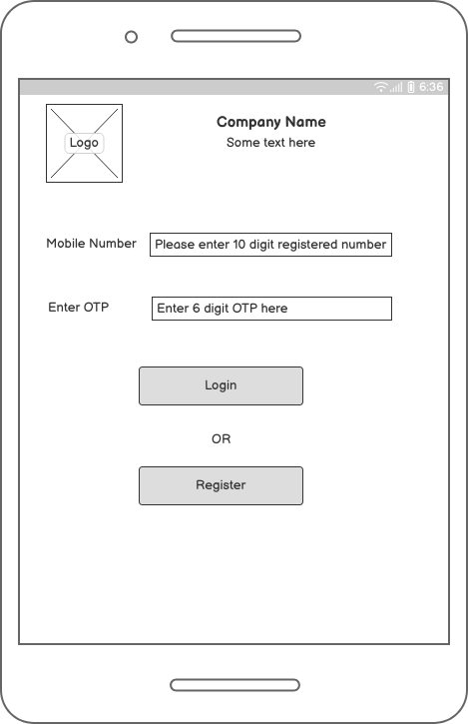
Fig. Login Screen

Registration page for farmers in mobile application:
- A registration form that includes fields for personal information such as name, contact information, and address.
- A field for the farmer's unique identification number, such as the Aadhaar number.
- A field for the farmer's bank account details, this will be useful for payment & loan disbursal.
- Option to upload a photograph or scan of a government-issued ID for verification purposes.
- A field for the farmer's land holding details, such as the size and location of the land.
- A field for the farmer's crop details, such as the type of crop grown and the estimated yield.
- A checkbox for the farmer to agree to the terms and conditions of using the app.
- A "Submit" button that allows the farmer to submit the registration form.
- A "Cancel" button that allows the farmer to clear the form and start over.
- A "Help" button that directs the farmer to the help centre in case of any doubts.
Registration Form – Farmer Registration
Name Field
The "name" field in the registration form for farmers in the Kirti Group's mobile application might include the following elements:
- A label or prompt that clearly states "Name" or "Full Name”.
- A text input field where the farmer can type in their name.
- A validation rule that ensures the field is filled out and only accepts alphabets.
- A character limit to restrict the number of characters that can be entered.
The name field is an important element in the registration form as it will be used to identify the farmer and will be used for communication and record-keeping purposes. Having a validation rule that ensures the field is filled out and only accepts alphabets will ensure that the information entered is accurate and complete, which will help to prevent errors and improve the quality of data. Additionally, having a character limit will help to ensure that the name entered is not too long and will be easy to read.
Aadhaar Number
The "Farmer's unique identification number" field in the registration form for farmers in the Kirti Group's mobile application will include the following elements:
- A label or prompt that clearly states "Unique ID number" or "Aadhaar number"
- A text input field where the farmer can type in their unique identification number, such as an Aadhaar number.
- A validation rule that ensures the field is filled out and only accepts numbers.
- A character limit of 12 digits, as the Aadhaar number is 12 digits long.
- A validation check that compares the entered Aadhaar number with the Aadhaar database and confirms that it is a valid number.
- Fetch farmer name from Aadhar card & validate it with entered data.
The unique identification number field is an important element in the registration form as it will be used to verify the farmer's identity and will be used for communication and record-keeping purposes. Having a validation rule that ensures the field is filled out and only accepts numbers will ensure that the information entered is accurate and complete, which will help to prevent errors and improve the quality of data. Additionally, having a character limit of 12 digits and a validation check that compares the entered Aadhaar number with the Aadhaar database will help to ensure that the number entered is valid and belongs to the farmer.

Bank Account
The "Farmer's bank account" field in the registration form for farmers in the Kirti Group's mobile application might include the following elements:
- A label or prompt that clearly states "Bank Account”.
- A text input field where the farmer can type in their bank account number.
- A validation rule that ensures the field is filled out and only accepts numbers.
- A character limit of 15-18 digits, as the bank account number is usually between 15-18 digits long.
- A drop-down menu that allows the farmer to select their bank name.
- A text input field where the farmer can type in their branch name
- A text input field where the farmer can type in the IFSC code of their branch
The bank account field is an important element in the registration form as it will be used for loan disbursal and will be used for communication and record-keeping purposes. Having a validation rule that ensures the field is filled out and only accepts numbers will ensure that the information entered is accurate and complete, which will help to prevent errors and improve the quality of data. Additionally, having a character limit of 15-18 digits and including the bank name, branch name and IFSC code will help to ensure that the number entered is valid and belongs to the farmer. This is an idea of what a registration page for farmers in the Kirti Group's mobile application might include. The actual layout and design of the page would be created by developers and designers with the help of wireframe tools.
Upload ID
The "Upload ID" field in the registration form for farmers in the Kirti Group's mobile application might include the following elements:
- A label or prompt that clearly states "Upload ID" or "Government-issued ID"
- A button or link that says "Upload ID" or "Choose File" for the farmer to select the image of their ID from their device.
- A preview section where the uploaded image will be displayed for the farmer to confirm that the correct image has been uploaded.
- A file type validation that ensures that only image files such as jpeg, png, pdf are uploaded.
- Server will auto compress upload files using compression algorithms if required.
The "Upload ID" field is an important element in the registration form as it will be used to verify the farmer's identity, and ensure that the person registering is indeed the person they claim to be. Having a preview section will allow the farmer to confirm that the correct image has been uploaded before submitting the form. File type and size validation will ensure that only valid images are uploaded, which will help to prevent errors and improve the quality of data.

Landholding
The "Landholding details" field in the registration form for farmers in the Kirti Group's mobile application might include the following elements:
- A label or prompt that clearly states "Landholding details"
- A text input field where the farmer can type in the size of the land in acres or hectares.
- A validation rule that ensures the field is filled out and only accepts numbers.
- A text input field where the farmer can type in the location of the land such as district, taluka, and village.
- A drop-down menu that allows the farmer to select the state.
- An option for the farmer to upload a copy of the land ownership documents such as 7/12 extract or land registry papers.
The land holding details field is an important element in the registration form as it will be used to understand the farmer's landholding size and location, which will be useful for the Kirti group for its Agri-allied industries. Having a validation rule that ensures the field is filled out and only accepts numbers will ensure that the information entered is accurate and complete, which will help to prevent errors and improve the quality of data. Additionally, having the option to upload a copy of the land ownership documents will help to ensure that the land belongs to the farmer and will also be used for record-keeping purposes.
Crop details
The "Crop details" field in the registration form for farmers in the Kirti Group's mobile application might include the following elements:
- A label or prompt that clearly states "Crop details"
- A drop-down menu that allows the farmer to select the type of crop grown.
- A text input field where the farmer can type in the estimated yield of the crop in metric tons or quintals.
- A validation rule that ensures the field is filled out and only accepts numbers.
- A text input field where the farmer can type in the crop season, whether it's kharif, rabi or summer.
- An option for the farmer to upload a copy of the crop insurance papers if any.
The crop details field is an important element in the registration form as it will be used to understand the farmer's crop details and the estimated yield, which will be useful for the Kirti group for its Agri-allied industries. Having a validation rule that ensures the field is filled out and only accepts numbers will ensure that the information entered is accurate and complete, which will help to prevent errors and improve the quality of data. Additionally, having an option to upload a copy of the crop insurance papers will help to ensure that the farmer has insurance for the crop and will also be used for record-keeping purposes.

Terms and Conditions
The "Terms and Conditions" checkbox in the registration form for farmers in the Kirti Group's mobile application might include the following elements:
- A label or prompt that clearly states "I agree to the terms and conditions of using the app."
- A checkbox that the farmer can click to indicate their agreement to the terms and conditions.
- A link or button that directs the farmer to the terms and conditions page where they can read and understand the terms before agreeing.
- A validation rule that ensures the checkbox is selected before the form can be submitted.
The terms and conditions checkbox is an important element in the registration form as it will ensure that the farmer understands and agrees to the terms of using the app. By having a link or button that directs the farmer to the terms and conditions page, it will ensure that the farmer has read and understood the terms before agreeing. Additionally, having a validation rule that ensures the checkbox is selected before the form can be submitted will ensure that the farmer has agreed to the terms and conditions before using the app. This checkbox will be useful for Kirti Group to ensure that the farmer understands the terms and conditions of using the app and also to maintain the legal compliance.
Submit button
The "Submit" button in the registration form for farmers in the Kirti Group's mobile application might include the following elements:
- A button that says "Submit" or "Register"
- A validation check that ensures all the required fields are filled out and the validation rules are met before allowing the form to be submitted.
- A confirmation message or alert that appears after the form is successfully submitted, displaying a message such as "Registration successful" or "Thank you for registering".
- A redirect to the login page or the dashboard after the registration is successful, where the farmer can access the features of the app.
The "Submit" button is an important element in the registration form as it allows the farmer to submit the registration form and complete the registration process. Having a validation check that ensures all the required fields are filled out and the validation rules are met before allowing the form to be submitted will ensure that the information entered is accurate and complete, which will help to prevent errors and improve the quality of data. Additionally, having a confirmation message or alert that appears after the form is successfully submitted will provide the farmer with feedback that the registration was successful, and will direct the farmer to the next step of accessing the features of the app.
Cancel button
The "Cancel" button in the registration form for farmers in the Kirti Group's mobile application might include the following elements:
- A button that says "Cancel" or "Clear"
- A confirmation message or alert that appears when the button is clicked, asking the farmer to confirm that they want to clear the form and start over.
- A function that clears all the fields in the form and resets it to its initial state.
- A redirect to the registration page or the home page of the application, depending on the design of the app.
The "Cancel" button is an important element in the registration form as it allows the farmer to clear the form and start over if they made any mistakes or changed their mind about registering. Having a confirmation message or alert that appears when the button is clicked will ensure that the farmer intentionally wants to clear the form and prevent accidental deletion of the data. Additionally, having a redirect to the registration page or the home page of the application will give the farmer an option to start the registration process again, or to explore the other features of the app.
Help button
The "Help" button in the registration form for farmers in the Kirti Group's mobile application might include the following elements:
- A button that says "Help" or "Support"
- A link or button that directs the farmer to the help center or support page.
- A detailed FAQ section on the help center page that addresses common issues and questions that farmers may have.
- A contact form or email/phone number where farmers can reach out for support or ask specific questions.
- A live chat option for instant assistance
The "Help" button is an important element in the registration form as it allows farmers to get assistance in case they have any doubts or questions while registering. By having a link or button that directs the farmer to the help center or support page, the farmer can find answers to common issues and questions that they may have. Additionally, having a contact form or email/phone number where farmers can reach out for support or ask specific questions, and live chat option for instant assistance, will provide the farmers with multiple options to reach out for support and will make the registration process more user-friendly.
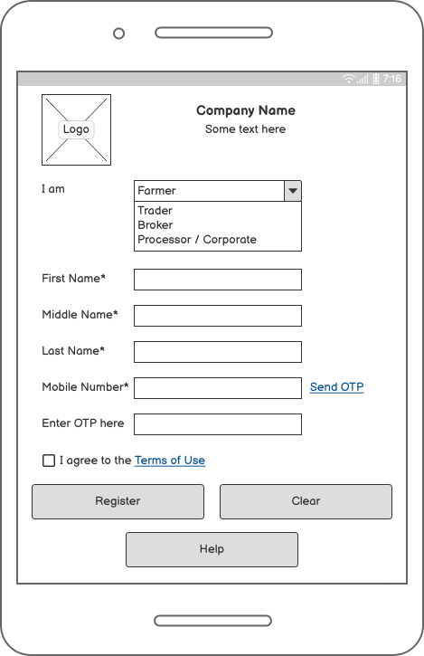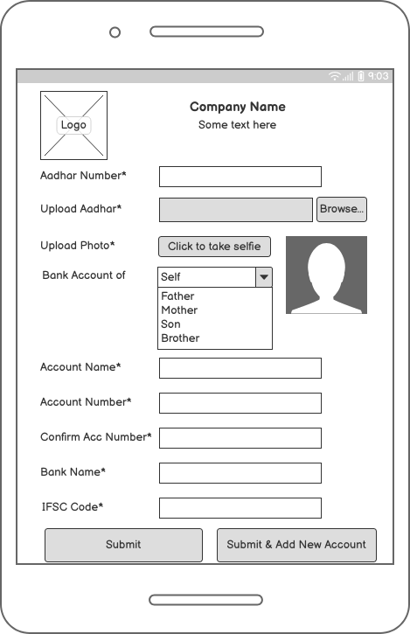
Fig. Farmer Registration Fig. Farmer KYC

Registration Page for traders in Mobile Application
- A registration form that includes fields for personal information such as name, contact information, and address.
- A field for the trader's unique identification number, such as GST number.
- A field for the trader's bank account details, this will be useful for transactions.
- Option to upload a photograph or scan of a government-issued ID for verification purposes.
- A field for the trader's business details, such as the name of the business, registration number, and location.
- A field for the type of products the trader is interested in buying.
- A checkbox for the trader to agree to the terms and conditions of using the app.
- A "Submit" button that allows the trader to submit the registration form.
- A "Cancel" button that allows the trader to clear the form and start over.
- A "Help" button that directs the trader to the help centre in case of any doubts.
The registration form for traders in the Kirti Group's mobile application will include the following fields for personal information:
- "Full Name" field - a text input field where the trader can type in their full name.
- "Contact Number" field - a text input field where the trader can type in their contact number. A validation rule that ensures the field is filled out and only accepts valid phone numbers.
- "Email" field - a text input field where the trader can type in their email address. A validation rule that ensures the field is filled out and only accepts valid email addresses.
- "Address" field - a text input field where the trader can type in their address including street, city, state and postal code.
- "Company Name" field - a text input field where the trader can type in their company name.
- "Company PAN number" field - a text input field where the trader can type in their company PAN number.
- "Upload ID" field - a button or link that says "Upload ID" or "Choose File" for the trader to select the image of their ID from their device. A preview section where the uploaded image will be displayed for the trader to confirm that the correct image has been uploaded.
- "Terms and Conditions" checkbox - a checkbox that the trader can click to indicate their agreement to the terms and conditions.
- "Submit" button - a button that allows the trader to submit the registration form
- "Cancel" button - a button that allows the trader to clear the form and start over.
This registration form will help Kirti Group to collect the personal information of the traders and also to validate their identity, and ensure that the person registering is indeed the person they claim to be. The information provided will also help Kirti Group to understand the trader's business details and for record-keeping purposes.

GST Number
In addition to the fields for personal information, the registration form for traders in the Kirti Group's mobile application might include a field for the trader's unique identification number, such as GST number. The specific details for this field might include:
- "GST Number" field - a text input field where the trader can type in their GST number.
- Validation rule - A validation rule that ensures the field is filled out and only accepts valid GST numbers.
- "Upload GST certificate" field - a button or link that says "Upload GST certificate" or "Choose File" for the trader to select the image of their GST certificate from their device. A preview section where the uploaded image will be displayed for the trader to confirm that the correct image has been uploaded.
This field is important because GST number is a unique identification number issued by the government, which is used to identify the business for tax purposes. Having the GST number in the registration form will help Kirti Group to validate the trader's identity and also for record-keeping and tax compliance purposes. The GST certificate uploaded will also serve as a proof of authenticity of the GST number.
Bank Account Number
In addition to the fields for personal information and unique identification number, the registration form for traders in the Kirti Group's mobile application might include a field for the trader's bank account details. The specific details for this field might include:
- "Bank Name" field - a text input field where the trader can type in the name of their bank.
- "Account Number" field - a text input field where the trader can type in their bank account number. A validation rule that ensures the field is filled out and only accepts numbers.
- "IFSC Code" field - a text input field where the trader can type in their bank's IFSC code.
- "Upload Cancelled Cheque" field - a button or link that says "Upload Cancelled Cheque" or "Choose File" for the trader to select the image of their cancelled cheque from their device. A preview section where the uploaded image will be displayed for the trader to confirm that the correct image has been uploaded.
- "Bank account holder name" field - a text input field where the trader can type in the name as per the bank account.
This field is important because it will be used for transactions between the trader and Kirti Group, and also for any future payments to be made to the trader. The bank account details provided will also be used for record-keeping and compliance purposes. The uploaded cancelled cheque will serve as a proof of authenticity of the bank account details provided.

Upload ID
In addition to the fields for personal information, unique identification number, and bank account details, the registration form for traders in the Kirti Group's mobile application might include an option for the trader to upload a photograph or scan of a government-issued ID for verification purposes. The specific details for this option might include:
- "Upload ID" field - a button or link that says "Upload ID" or "Choose File" for the trader to select the image of their government-issued ID from their device.
- Preview section - a preview section where the uploaded image will be displayed for the trader to confirm that the correct image has been uploaded.
- "ID Type" field - a dropdown menu where the trader can select the type of government-issued ID they are uploading, such as Aadhaar card, PAN card, Voter ID, etc.
- "ID Number" field - a text input field where the trader can type in the ID number as per the government-issued ID they uploaded. A validation rule that ensures the field is filled out and only accepts valid ID numbers.
This option is important because it helps Kirti Group to verify the trader's identity and ensure that the person registering is indeed the person they claim to be. The government-issued ID uploaded will serve as a proof of authenticity of the trader's identity. The ID type and number will also be useful for compliance and record-keeping purposes.
Business Details
In addition to the fields for personal information, unique identification number, bank account details and government-issued ID, the registration form for traders in the Kirti Group's mobile application might include a field for the trader's business details. The specific details for this field might include:
- "Business Name" field - a text input field where the trader can type in the name of their business.
- "Business Registration Number" field - a text input field where the trader can type in the registration number of their business. A validation rule that ensures the field is filled out.
- "Business Address" field - a text input field where the trader can type in the address of their business including street, city, state and postal code.
- "Business PAN Number" field - a text input field where the trader can type in their business PAN number.
- "Upload Business registration certificate" field - a button or link that says "Upload Business registration certificate" or "Choose File" for the trader to select the image of their business registration certificate from their device. A preview section where the uploaded image will be displayed for the trader to confirm that the correct image has been uploaded.
This field is important because it will help Kirti Group to understand the trader's business details and for record-keeping and compliance purposes. The business registration certificate uploaded will also serve as a proof of authenticity of the business registration number provided.
Buying Interest
In addition to the fields for personal information, unique identification number, bank account details, government-issued ID, and business details, the registration form for traders in the Kirti Group's mobile application might include a field for the type of products the trader is interested in buying. The specific details for this field might include:
- "Product Type" field - a drop-down menu or checkboxes where the trader can select the type of products they are interested in buying or selling.
- "Other Product" field - a text input field where the trader can type in any other product type that is not listed in the "Product Type" field.
- "Upload Product list" field - a button or link that says "Upload Product list" or "Choose File" for the trader to select the image of their product list from their device. A preview section where the uploaded image will be displayed for the trader to confirm that the correct image has been uploaded.
This field is important because it will help Kirti Group to understand the trader's product preferences and to match them with the right buyers or sellers. It will also help Kirti Group to understand the trader's product portfolio and the type of products they are dealing with. The uploaded product list will also serve as a proof of authenticity of the products the trader is interested in.

Terms and Conditions
In addition to the fields for personal information, unique identification number, bank account details, government-issued ID, business details, and products the trader is interested in buying or selling, the registration form for traders in the Kirti Group's mobile application might include a checkbox for the trader to agree to the terms and conditions of using the app. The specific details for this checkbox might include:
- "Terms and Conditions" checkbox - a checkbox that the trader can click to indicate their agreement to the terms and conditions.
- A "Terms and Conditions" link - a link that the trader can click to view the terms and conditions of using the app before they agree to it.
- A "Privacy Policy" link - a link that the trader can click to view the privacy policy of the app before they agree to it.
This checkbox is important because it ensures that the trader has read, understood and agreed to the terms and conditions of using the app. It also helps Kirti Group to ensure that the trader is aware of their rights and responsibilities while using the app, and that they are in compliance with the app's policies.
Submit button
In addition to the fields for personal information, unique identification number, bank account details, government-issued ID, business details, products the trader is interested in buying or selling and checkbox for agreeing to the terms and conditions, the registration form for traders in the Kirti Group's mobile application might include a "Submit" button that allows the trader to submit the registration form. The specific details for this button might include:
- "Submit" button - a button that the trader can click to submit the registration form.
- A confirmation message - A message that appears on the screen after the trader clicks the "Submit" button, to confirm that the registration form has been successfully submitted.
- A "Thank you" message - A message that appears on the screen after the trader clicks the "Submit" button, thanking the trader for their registration.
- Email verification - An automatic email that is sent to the trader's email address to verify the email address provided.
This button is important because it allows the trader to complete the registration process and submit their information to Kirti Group. The confirmation message, "Thank you" message, and email verification will help the trader to know that their registration form has been successfully submitted and they can start using the app.
Cancel button
In addition to the fields for personal information, unique identification number, bank account details, government-issued ID, business details, products the trader is interested in buying or selling, checkbox for agreeing to the terms and conditions, and the "Submit" button, the registration form for traders in the Kirti Group's mobile application might include a "Cancel" button that allows the trader to clear the form and start over. The specific details for this button might include:
- "Cancel" button - a button that the trader can click to clear the form and start over.
- A confirmation message - A message that appears on the screen after the trader clicks the "Cancel" button, to confirm that the trader wants to clear the form.
- A "Form Cleared" message - A message that appears on the screen after the trader clicks the "Cancel" button, to indicate that the form has been cleared.
This button is important because it allows the trader to start the registration process again if they have made a mistake or changed their mind about the registration. The confirmation message and "Form Cleared" message will help the trader to know that the form has been cleared and they can start filling it out again.
Help Button
In addition to the fields for personal information, unique identification number, bank account details, government-issued ID, business details, products the trader is interested in buying or selling, checkbox for agreeing to the terms and conditions, the "Submit" button and "Cancel" button, the registration form for traders in the Kirti Group's mobile application might include a "Help" button that directs the trader to the help center in case of any doubts. The specific details for this button might include:
- "Help" button - a button that the trader can click to get help in case of any doubts or queries.
- Help center - A help center that provides detailed information and guides for the trader on how to use the app, and answers to frequently asked questions.
- Contact Us - A section where the trader can contact the support team of Kirti Group if they have specific queries or issues that are not covered in the help center.
This button is important because it allows the trader to get help and support if they have any doubts or queries while using the app. The help center provides detailed information and guides that can help the trader to understand and navigate the app easily. The contact us section will help the trader to reach out to the support team of Kirti Group in case of any specific queries or issues that are not covered in the help center.

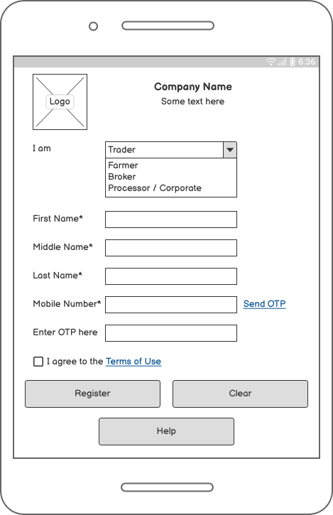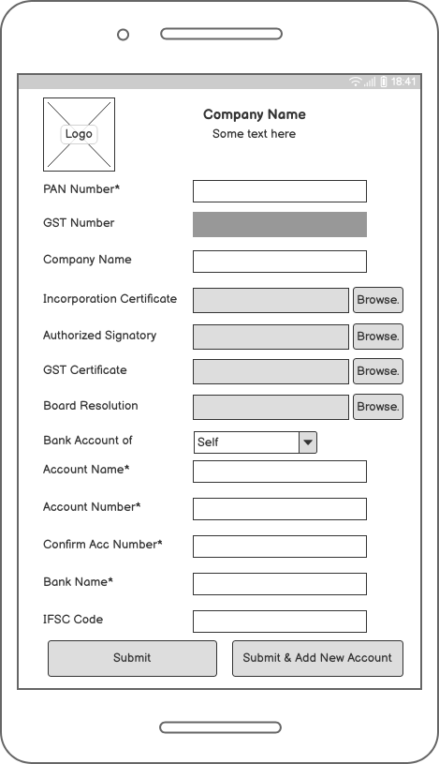
Fig. Trader Registration Fig. Trader KYC

Broker Registration Form
The registration form for brokers in the Kirti Group's mobile application might include the following fields:
- Personal Information:
- Name
- Contact Information (Phone number, Email address)
- Address
- Business Information:
- Business Name
- Business Registration Number
- Business Location
- Type of Brokerage Services provided
- Number of years in Business
- ID Verification:
- Government-issued ID Number
- Upload a photograph or scan of a government-issued ID for verification purposes
- Bank Details
- Bank Account Number
- IFSC Code
- Bank Name and Branch
- Product Information:
- Type of products the broker deals with
- Upload a list of products the broker deals with
- Agreements:
- Checkbox for the broker to agree to the terms and conditions of using the app
- Checkbox for the broker to agree to the broker agreement of Kirti Group
- Submission:
- "Submit" button that allows the broker to submit the registration form
- "Cancel" button that allows the broker to clear the form and start over
- "Help" button that directs the broker to the help center in case of any doubts.
This registration form will help Kirti Group to understand the broker's business details, product preferences, and the type of products they are dealing with, which will help Kirti Group to match them with the right buyers or sellers. The uploaded product list and government-issued ID will also serve as a proof of authenticity of the broker's business. The checkbox for terms and conditions and broker agreement will help Kirti Group to ensure that the broker is aware of their rights and responsibilities while using the app, and that they are in compliance with the app's policies.
Personal Information Fields
The personal information fields in the registration form for brokers in the Kirti Group's mobile application might include:
- Name: A text input field where the broker can enter their full name. A validation rule that ensures the field is filled out and only accepts alphabets.
- Contact Information:
- Phone number: A text input field where the broker can enter their mobile number. A validation rule that ensures the field is filled out and only accepts valid mobile numbers.
- Email address: A text input field where the broker can enter their email address. A validation rule that ensures the field is filled out and only accepts valid email addresses.
- Address: A text input field where the broker can enter their full address. A validation rule that ensures the field is filled out and only accepts valid address.
This information will help Kirti Group to contact the broker for any queries or clarifications and also to send important notifications related to the app usage or business opportunities. The address will also help Kirti Group to identify the location of the broker and match them with the nearest buyers or sellers. The email address and phone number will also be used for account verification and recovery in case the broker forgets their login credentials.

Business Information Field
The business information fields in the registration form for brokers in the Kirti Group's mobile application might include:
- Business Name: A text input field where the broker can enter the name of their business. A validation rule that ensures the field is filled out.
- Business Registration Number: A text input field where the broker can enter their business registration number. A validation rule that ensures the field is filled out and only accepts alphanumeric characters.
- Business Location: A text input field where the broker can enter the location of their business. A validation rule that ensures the field is filled out and only accepts valid location.
- Type of Brokerage Services provided: A drop-down menu where the broker can select the type of brokerage services they provide. The options in the drop-down menu might include: buying, selling, sourcing, logistics, warehousing, etc.
- Number of years in Business: A text input field where the broker can enter the number of years they have been in business. A validation rule that ensures the field is filled out and only accepts numerical values.
This information will help Kirti Group to understand the broker's business details and the type of brokerage services they provide, which will help Kirti Group to match them with the right buyers or sellers. The business registration number and location will also serve as a proof of authenticity of the broker's business. The number of years in business will help Kirti Group to understand the broker's experience and expertise in the field.
ID Verification
The ID verification fields in the registration form for brokers in the Kirti Group's mobile application might include:
- Government-issued ID Number: A text input field where the broker can enter their government-issued ID number, such as PAN number, GST number, or any other government-issued ID number. A validation rule that ensures the field is filled out and only accepts valid ID numbers.
- Upload a photograph or scan of a government-issued ID for verification purposes: A button or a field that allows the broker to upload a clear photograph or scan of their government-issued ID card. The image should be in a common format, such as jpeg, png, or pdf, and should be less than a specified size.
This information will help Kirti Group to verify the broker's identity and ensure that they are a legitimate business. It will also help Kirti Group to comply with the legal and regulatory requirements. The photograph or scan of the government-issued ID will also be used to verify the broker's details and ensure that the information provided is accurate.
- "Aadhaar Number" field - a text input field where the broker can enter their Aadhaar number. A validation rule that ensures the field is filled out and only accepts valid Aadhaar numbers.
- "Upload a photograph or scan of Aadhaar card" - a button or a field that allows the broker to upload a clear photograph or scan of their Aadhaar card. The image should be in a common format, such as jpeg, png, or pdf, and should be less than a specified size.
This validation of Aadhaar number will help Kirti Group to verify the broker's identity and ensure that they are a legitimate business. It will also help Kirti Group to comply with the legal and regulatory requirements. The photograph or scan of the Aadhaar card will also be used to verify the broker's details and ensure that the information provided is accurate.
It is important to note that the use of Aadhaar card as a form of validation is subject to government rules and regulations. So, It is always best to check if it is allowed to use Aadhaar card as a form of validation for your business.
Bank Accounts
The registration form for brokers in the Kirti Group's mobile application might also include fields for bank details and validation with PennyDrop. The specific details for these fields might include:
- Bank Details:
- Bank Account Number: A text input field where the broker can enter their bank account number. A validation rule that ensures the field is filled out and only accepts valid account numbers.
- IFSC Code: A text input field where the broker can enter their bank's IFSC code. A validation rule that ensures the field is filled out and only accepts valid IFSC codes.
- Bank Name and Branch: A text input field where the broker can enter the name and branch of their bank. A validation rule that ensures the field is filled out.
- Validation with PennyDrop:
- "Validate with PennyDrop" button: A button that allows the broker to validate their bank account details with PennyDrop.
- "Transaction ID" field: A text input field where the broker can enter the transaction ID provided by PennyDrop after the validation process. A validation rule that ensures the field is filled out and only accepts valid transaction IDs.
This bank details validation with PennyDrop will help Kirti Group to ensure that the broker's bank account is valid and active. It will also help Kirti Group to comply with the legal and regulatory requirements. The transaction ID will also be used to verify the broker's bank details and ensure that the information provided is accurate.
PennyDrop is a platform that provides Instant and Secure Bank Account Verification. It's a way to validate bank account with a small transaction, and it's quick, easy, and secure.
Product Information
The registration form for brokers in the Kirti Group's mobile application might include a multiple-choice field for the commodities the broker deals with. The specific details for this field might include:
- "Commodities" field: A multiple-choice field where the broker can select the commodities they deal with from a predefined list. The options in the list might include various types of agricultural products such as oilseeds, grains, pulses, etc.
- "Other Commodities" field: A text input field where the broker can type in any other commodities they are interested in dealing with that are not on the predefined list. A validation rule that ensures the field is filled out.
This information will help Kirti Group to understand the broker's commodity preferences and the type of commodities they are dealing with, which will help Kirti Group to match them with the right buyers or sellers. The "Other Commodities" field will also help Kirti Group to expand the list of commodities they offer to their clients.
It is important to note that the broker should select or type in the commodities they are interested in dealing with accurately and up-to-date, as it will be used to match them with the right buyers or sellers.
Agreements
In addition to the fields for personal and business information, ID verification, bank details, product information, the registration form for brokers in the Kirti Group's mobile application might also include fields for agreements. The specific details for these fields might include:
- "Terms and Conditions" field: A checkbox where the broker can indicate that they have read and agree to the terms and conditions of using the mobile application.
- "Privacy Policy" field: A checkbox where the broker can indicate that they have read and agree to the privacy policy of the mobile application.
- "Code of Conduct" field: A checkbox where the broker can indicate that they have read and agree to the code of conduct of the mobile application.
These agreements fields will help Kirti Group to ensure that the broker understands and agrees to the terms of using the mobile application, as well as the rules and regulations of the business. It will also help Kirti Group to ensure that all the parties using the mobile application are aware of the rights and responsibilities they have.
It is important to note that the broker should read and understand the terms and conditions, privacy policy and code of conduct before agreeing to them as they will be bound by them and violation of any of these may lead to termination of their account in the mobile application.
Submission
After filling in all the required fields in the registration form for brokers in the Kirti Group's mobile application, the broker will be able to submit the form by clicking on a "Submit" button. The submission process might include the following steps:
- Validation: The mobile application will validate all the fields in the registration form to ensure that they are filled out correctly and that all validation rules are met. If any errors are found, the broker will be prompted to correct them before proceeding.
- Verification: The mobile application will verify the broker's ID and bank details using the information provided and the validation process with PennyDrop.
- Review: The broker will be able to review all the information they have entered in the registration form before submitting it. They will be able to edit or correct any errors or omissions.
- Confirmation: After submitting the form, the broker will receive a confirmation message indicating that their registration is complete.
- Approval: The mobile application will send the registration details to Kirti group and they will review the information provided by the broker and approve their registration if everything is in order.
It is important to note that the broker should ensure that all the information provided is accurate and up-to-date, as it will be used to match them with the right buyers or sellers, and also to comply with the legal and regulatory requirements.

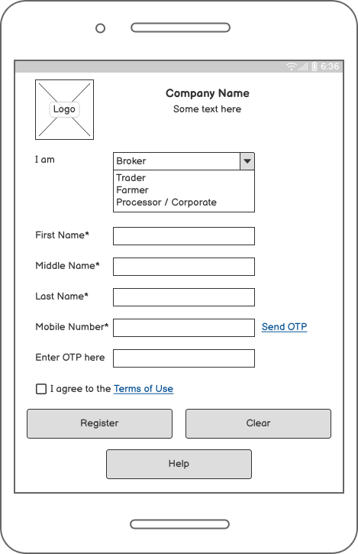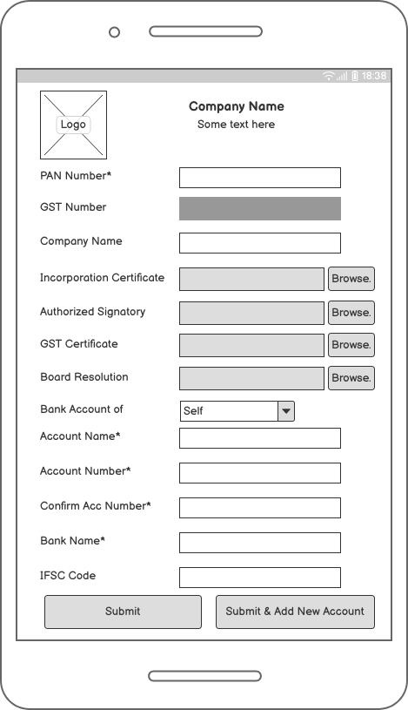
Fig. Broker Registration Fig. Broker KYC

Businesses Registration
In addition to the registration form for farmers, traders and brokers, the mobile application developed by Kirti Group might also include a registration form for businesses. The specific details for this form might include:
- Type of Company: A drop-down menu where the business can select the type of company they are, such as Private Limited, Public Limited, Sole Proprietorship, Partnership firm, etc.
- Company Name: A text input field where the business can enter the name of their company. A validation rule that ensures the field is filled out.
- Company registration Number: A text input field where the business can enter their company registration number. A validation rule that ensures the field is filled out.
- Company Address: A text input field where the business can enter the address of their company. A validation rule that ensures the field is filled out.
- Company Contact Information: A text input field where the business can enter their contact information, such as phone number and email address. A validation rule that ensures the field is filled out.
- Upload a copy of company registration certificate: A button or a field that allows the business to upload a clear photograph or scan of their company registration certificate. The image should be in a common format, such as jpeg, png, or pdf, and should be less than a specified size.
- ID Verification: A field for government-issued ID Number, name, and upload a photograph or scan of a government-issued ID for verification purposes.
- Bank Details and validation with penny drop
- Product information fields
- Agreement fields
- Submission
This registration form for businesses will help Kirti Group to understand the type of business they are dealing with, their company details, and contact information, which will help Kirti Group to match them with the right buyers or sellers. The uploaded registration certificate will also serve as a proof of authenticity of the business.
It is important to note that the business should provide accurate and up-to-date information, as it will be used to match them with the right buyers or sellers and to comply with the legal and regulatory requirements.

Type of Companies
the options for the "Type of Company" field in the registration form for businesses in the Kirti Group's mobile application could be as follows:
- Private Limited Company
- Public Limited Company
- Sole Proprietorship
- Partnership Firm
- Limited Liability Partnership (LLP)
- One Person Company (OPC)
- Cooperative Society
- Trust
- Others - A text input field where the business can type in any other type of company that is not on the predefined list.
This information will help Kirti Group to understand the type of company they are dealing with, and their legal structure. It will also help Kirti Group to comply with the legal and regulatory requirements.

Company Name
The "Company Name" field in the registration form for businesses in the Kirti Group's mobile application would be a text input field where the business can enter the name of their company.
There are different ways to validate the company name field, here are a couple examples:
- Required field validation: This validation would ensure that the field is filled out and the business cannot submit the form without entering their company name.
- Regex validation: This validation would ensure that the company name entered is in the correct format (e.g. only alphabets and spaces are allowed)
- Database validation: This validation would check if the company name already exists in the database, and prevent the business from registering if the company name already exists.
It is important to note that the company name provided should be accurate and up-to-date, as it will be used to match the business with the right buyers or sellers, and also to comply with the legal and regulatory requirements.

Company Registration Number
The "Company Registration Number" field in the registration form for businesses in the Kirti Group's mobile application would be a text input field where the business can enter their company registration number.
There are different ways to validate the company registration number field, here are a couple examples:
- Required field validation: This validation would ensure that the field is filled out and the business cannot submit the form without entering their company registration number.
- Regex validation: This validation would ensure that the company registration number entered is in the correct format (e.g. Only numbers and alphabets are allowed, specific format such as PAN card number, GST number)
- Database validation: This validation would check if the company registration number already exists in the database, and prevent the business from registering if the number already exists.
- Verification with Government Portal: This validation would check if the provided registration number is valid by using the government portal where the registration is done.
It is important to note that the company registration number provided should be accurate and up-to-date, as it will be used to match the business with the right buyers or sellers, and also to comply with the legal and regulatory requirements.

Company Address
The "Company Address" field in the registration form for businesses in the Kirti Group's mobile application could be broken down into several sub-fields to capture all necessary details:
- Street Address: A text input field where the business can enter the street address of their company.
- City: A text input field where the business can enter the city in which their company is located.
- State: A drop-down menu where the business can select the state in which their company is located.
- Postal Code: A text input field where the business can enter the postal code of their company's location.
- Country: A drop-down menu where the business can select the country in which their company is located.
These sub-fields would allow Kirti Group to have a better understanding of the company's location and to make sure that it matches with the right buyers or sellers and also to comply with the legal and regulatory requirements.

Company Contact Information
The "Company Contact Information" field in the registration form for businesses in the Kirti Group's mobile application would include several sub-fields to capture all necessary details:
- Phone Number: A text input field where the business can enter their company's primary phone number.
- Email: A text input field where the business can enter their company's primary email address.
- Website: A text input field where the business can enter their company's website.
Validation for the above fields could include:
- Required field validation: This validation would ensure that the fields are filled out and the business cannot submit the form without entering their company contact information.
- Regex validation: This validation would ensure that the phone number, email and website entered are in the correct format (e.g. phone number should be in a specific format, email should contain @ and .com)
- Email validation: This validation would check if the email provided by the company is valid and exists
- Website validation: This validation would check if the website provided by the company is valid and exists
It is important to note that the company contact information provided should be accurate and up-to-date, as it will be used to match the business with the right buyers or sellers, and also to comply with the legal and regulatory requirements.
Another validation that will be included for the "Company Contact Information" field in the registration form for businesses in the Kirti Group's mobile application is OTP validation. This would involve the following steps:
- When the business submits the registration form, a unique OTP (One-time Password) is generated and sent to the phone number and email provided.
- The business is prompted to enter the OTP in a separate field in the form.
- The OTP entered by the business is then compared to the original OTP that was sent. If they match, the registration is considered valid.
This validation would help to ensure that the phone number and email provided by the business are valid and that the person filling out the form has access to them.
As an additional step, the OTP validation can be done via phone call, SMS or Email for more security.
By adding OTP validation to the registration process, Kirti Group can ensure that the contact information provided is accurate and that the business is legitimate. This can prevent fraud and help to ensure compliance with legal and regulatory requirements.

Upload a copy of the company registration certificate
Another field that could be included in the registration form for businesses in the Kirti Group's mobile application is an option to upload a copy of the company registration certificate.
This field could be implemented as follows:
- A button or link labelled "Choose File" or "Browse" that allows the business to select a file from their device.
- A text input field or a label that displays the name of the file that has been selected.
- A button labelled "Upload" that submits the selected file along with the rest of the registration form.
- A message or a tick mark that shows that the file has been uploaded successfully.
This field would allow Kirti Group to verify the authenticity of the business by checking the company registration certificate. It is a mandatory field, so the user will not be able to submit the registration form without uploading the company registration certificate.
Additionally, the application can validate the authenticity of the certificate by checking the registration number, name of the company and date of registration with the relevant government portal.
By requiring businesses to upload a copy of their company registration certificate, Kirti Group can ensure that the businesses are legitimate and comply with legal and regulatory requirements.

ID verification
ID verification is an important step in the registration process for businesses in the Kirti Group's mobile application. It helps to ensure that the business is legitimate and that the person filling out the form is authorized to do so.
- Upload a copy of a government-issued ID: This could be done by adding an option for the business to upload a scan or photograph of their government-issued ID, such as a PAN card, GST registration certificate, or Business registration certificate.
- ID Verification through API: The application can be integrated with government portals, where the registration number, name of the company and date of registration can be verified.
- ID Verification through Video call: A video call feature can be added to the registration process, where a representative of Kirti Group can verify the ID of the person filling out the form in real-time.
It is important to note that ID Verification should be done in accordance with local laws and regulations to ensure compliance.
By implementing ID verification, Kirti Group can ensure that the businesses are legitimate and that the person filling out the form is authorized to do so. This can prevent fraud and help to ensure compliance with legal and regulatory requirements.

Bank Details
The "Bank Details" field in the registration form for businesses in the Kirti Group's mobile application would include several sub-fields to capture all necessary details:
- Account Number: A text input field where the business can enter their bank account number.
- IFSC Code: A text input field where the business can enter their bank's IFSC code.
- Bank Name: A text input field where the business can enter their bank's name.
- Account Type: A drop-down menu where the business can select the type of account they have (e.g. savings, current)
- Upload a copy of cheque book or passbook: This field could be implemented as a button or link labeled "Choose File" or "Browse" that allows the business to select a file from their device.
Validation for the above fields could include:
- Required field validation: This validation would ensure that the fields are filled out and the business cannot submit the form without entering their bank details.
- Regex validation: This validation would ensure that the account number, IFSC code are in the correct format.
- Bank validation: This validation would check if the bank name provided is valid and exists
- Penny Drop validation: This validation would check if the account number provided by the business is valid by using the penny drop API.
- Cheque book or passbook validation: This validation would check if the image provided is clear and valid.
It is important to note that the bank details provided should be accurate and up-to-date, as it will be used to match the business with the right buyers or sellers, and also to comply with the legal and regulatory requirements. This will also facilitate the transactions and payments between the parties.

Product Information
The "Product Information" field in the registration form for businesses in the Kirti Group's mobile application would include several sub-fields to capture all necessary details:
- Product Type: A drop-down menu or checkboxes where the business can select the type of products they are interested in buying or selling (e.g. oil, pulses, wheat, etc)
- Product Name: A text input field where the business can enter the specific name of the products they are interested in buying or selling.
- Quantity: A text input field where the business can enter the quantity of the products they are interested in buying or selling.
- Unit of Measurement: A drop-down menu where the business can select the unit of measurement for the products they are interested in buying or selling (e.g. kg, liters, tons, etc)
- Minimum Order Quantity: A text input field where the business can enter the minimum quantity of products they are willing to buy or sell.
- Unit Price: A text input field where the business can enter the unit price of the products they are interested in buying or selling.
Validation for the above fields could include:
- Required field validation: This validation would ensure that the fields are filled out and the business cannot submit the form without entering the product information.
- Quantity validation: This validation would ensure that the quantity entered is a number and is greater than zero
- Unit price validation: This validation would ensure that the price entered is a number and is greater than zero
- Minimum order quantity validation: This validation would ensure that the minimum order quantity entered is a number and is greater than zero
By providing accurate and detailed information about the products they are interested in buying or selling, businesses can be matched with the right buyers or sellers, and also to comply with the legal and regulatory requirements. This will also facilitate the transactions and payments between the parties.

Agreement
The "Agreement" field in the registration form for businesses in the Kirti Group's mobile application would include a checkbox or a button where the business can indicate that they have read and agree to the terms and conditions of using the app.
Validation for the agreement field could include:
- Required field validation: This validation would ensure that the business cannot submit the form without indicating that they have read and agree to the terms and conditions of using the app.
- Checkbox validation: This validation would ensure that the checkbox or button is selected before the form can be submitted.
The agreement field is an important step in the registration process as it ensures that the business is aware of the terms and conditions of using the app, and that they are legally bound by them. It also helps to ensure compliance with legal and regulatory requirements. The terms and conditions of using the app should be made available to the business before they begin the registration process, and should be easily accessible through the app or on the Kirti Group's website.
Additionally, the checkbox or button can be linked to the terms and conditions and privacy policy, so that the user can read and understand the policies before they agree to them. This can be done by adding a link next to the checkbox or button that takes the user to the terms and conditions and privacy policy page.

Submit
Once the business has completed the registration form and has provided all the required information, they can submit the form by clicking on the "Submit" button.
This button can be located at the bottom of the registration form, and could be labeled as "Submit" or "Register".
Before submitting the form, the application can run a final validation check to ensure that all the fields are filled out correctly and that the required fields are not left blank. If any errors are found, the application will display error messages next to the relevant fields, so the business can correct them before submitting the form.
When the form is submitted successfully, the business will receive a message or a notification confirming that their registration is complete. This message can be displayed on the screen or sent via email or push notification.
The registration form can also be designed to store the data on the application server, so that the business can log in to the application at a later time to update their information. The business can also view their registration details, such as the products they have registered for, the status of their registration, and the date of registration.
The registration process is a crucial step in the Kirti Group's mobile application, it allows the business to access the services provided by the application, making it easy for them to connect with the right buyers or sellers and also to comply with the legal and regulatory requirements.

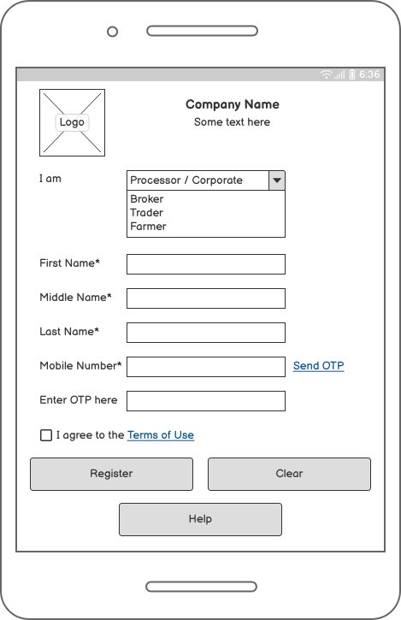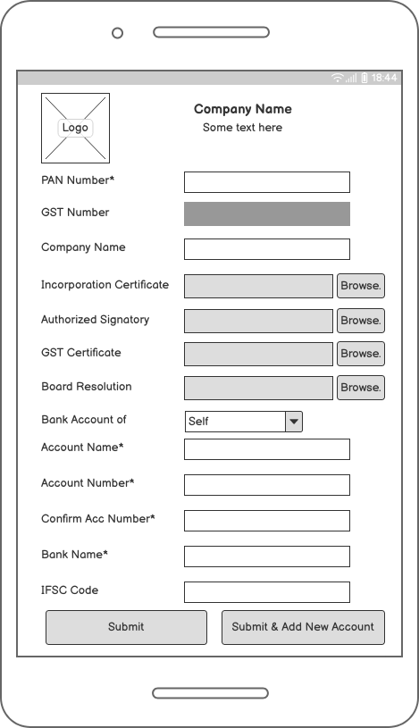
Fig. Corporate Register Fig. Corporate KYC

A farmer's profile in the mobile application will include the following information:
- Personal Information: This section would include the farmer's name, contact information, and address.
- Identification Information: This section would include the farmer's unique identification number, such as an Aadhaar number, and a photograph or scan of a government-issued ID for verification purposes.
- Land Holding Information: This section would include details about the farmer's land holdings, such as the size and location of the land.
- Crop Information: This section would include details about the crops grown by the farmer, such as the type of crop and estimated yield.
- Financial Information: This section would include details about the farmer's bank account, such as account number and bank name.
- Video Tutorials: This section would include a list of video tutorials uploaded by the farmer, with the option to view and share the videos.
- Transactions: This section would include a list of all the transactions made by the farmer, such as sales and purchases of commodities.
- Loan Information: This section would include details about any loans taken by the farmer, such as loan amount, interest rate, and repayment schedule.
- Warehouse Information: This section would include details about any commodities stored in Kirti's warehouses by the farmer, such as the commodity type, quantity, and storage location.
- Agreement: This section would include the terms and conditions of using the app, which the farmer would have agreed to upon registration.
- A bidding dashboard where the broker can view the current bidding prices for different commodities, and place new bids.
A broker's profile in the mobile application will include the following information:
- Personal information such as name, contact information, and address.
- Unique identification number, such as GST number.
- Bank account details for transactions.
- A photograph or scan of a government-issued ID for verification purposes.
- Business details such as the name of the business, registration number, and location.
- Commodities they are interested in buying or selling.
- A record of their bids and bidding history.
- A dashboard displaying the current status of their bids and the commodities they have won or lost.
- Agreements and terms and conditions of using the app.
- A Help button that directs the broker to the help centre in case of any doubts.
- A bidding dashboard where the broker can view the current bidding prices for different commodities, and place new bids.
- A notification centre where the broker can receive updates on their bids and the status of their transactions.
A Business’s profile in the mobile application will include the following information:
- Company name and registration number
- Contact information, including phone number and email address
- Company address and location
- Company registration certificate and government-issued ID for verification purposes
- Bank details and transaction history
- List of products the business is interested in buying or selling
- Authorized signature for agreements and transactions
- Bidding dashboard for current and past bids
- Order and shipment history

A Trader’s profile in the mobile application will include the following information:
- Personal Information: This will include the trader's name, contact information, and address.
- Business Information: This will include the name of the trader's business, registration number, and location.
- ID Verification: This will include a copy of the trader's government-issued ID, such as a PAN card, for verification purposes.
- Bank Details: This will include the trader's bank account details, including a copy of a cancelled cheque for validation.
- Product Information: This will include the type of products the trader is interested in buying or selling.
- Bidding Dashboard: This will include a list of the trader's current and past bids on commodities.
- Authorized Signature: This will include an electronic copy of the trader's authorized signature for legal documents.
- Transaction History: This will include a list of the trader's past transactions and their corresponding details.

Warehouse management – Purchase of Commodities
Warehouse management in the Kirti Group typically includes the use of godown, stack, and Lot. A godown is a large storage facility where commodities are stored. A godown can have multiple stacks, which are smaller areas within the godown where specific types of commodities are stored. Each stack can have multiple lots, which are smaller subdivisions within the stack used for storing specific batches of commodities.
This type of warehouse management system allows for the efficient organization and storage of different types of commodities. It makes it easier for the Kirti group to manage its inventory and keep track of the commodities they have on hand. With this system, they can quickly and easily identify where specific types of commodities are stored, and how much of each commodity is available.
This system also allows for better tracking of the commodities, as the Kirti group will be able to trace the commodity from the point of entry to the point of sale. The farmer will also be able to see the location of their commodity and they can track the commodity from the point of entry to the point of sale in real time
By using this system, the Kirti group can also ensure that the commodities are stored under the appropriate conditions, such as temperature and humidity, and that the commodities are properly rotated to prevent spoilage.
STEPS After ASN is Generated:
Once the ASN is generated, the following sequence of steps takes place for the commodity to reach the godown:
- Vehicle reaches the warehouse gate: The loaded vehicle carrying the commodity reaches the warehouse gate.
- ASN is checked by security: The security personnel checks the ASN and scans the QR code to verify the details of the commodity.
- Vehicle goes to Weighing bridge: The vehicle goes to the Weighing bridge to check the gross weight of the vehicle.
- Quality control: The commodity is inspected for quality by the QC in charge, and the details are entered into the system.
- Unloading: The commodity is unloaded from the vehicle and sent for further processing.
- Vehicle goes to Weighing bridge: The vehicle goes to the Weighing bridge again to check the net weight of the commodity after removing all foreign bodies
- Allotment of godown, stack and lot: The commodity is allotted a godown, stack and lot for storage as per the inventory management system
- Real-time updates: The farmer can track the movement of the commodity in real time and see the weight of the commodity on the mobile application.
- Billing and Payment: After the process is completed, the billing and payment process starts, once it's done the farmer will be informed and payment will be made to their account.
- Final entry in the system: The final entry of the commodity details is made in the system and the commodity is ready for sale, or further processing.
This sequence of steps ensures that the commodity is inspected, weighed, and stored properly, and the farmer can track the movement of the commodity in real time via the mobile application.
The vehicle reaches the warehouse gate
Security personnel at the godown gate will check the ASN using a barcode scanner or a QR code scanner. The ASN will contain details such as the farmer's name, the commodity type, quantity, and the expected delivery date.
When the vehicle arrives at the godown gate, the security personnel will ask the driver to present the ASN. Once the ASN is presented, the security personnel will scan the barcode or QR code using a scanner. The scanner will then connect to the system, and the details of the ASN will be displayed on the screen.
The security personnel will then check the details of the ASN, such as the farmer's name, commodity type, and quantity, against the details on the screen. Once the details match, the security personnel will allow the vehicle to enter the godown.
The security personnel will also check for any discrepancy in the vehicle details like the number plates, driver details and the details on ASN and match them before allowing the vehicle to enter the godown.
In this way, the security personnel at the godown gate will ensure that the correct commodity is being delivered by the correct farmer and the vehicle is not tampered. This will also help in maintaining the inventory and traceability of the commodity.
security personnel will also click a photo of the vehicle through the mobile application to ensure that the vehicle is not tampered with and that it is the same vehicle that was mentioned in the ASN. The photo can be linked with the ASN and can be used for future reference if needed. This will add an extra layer of security and will help in maintaining the inventory and traceability of the commodity. Additionally, security personnel can also note down the vehicle registration number and compare it with the one mentioned in the ASN to ensure that the vehicle is not tampered with. This will help in keeping an accurate record of the vehicles entering the godown and will make it easier to track the movement of the commodity.
Here are the steps that the security personnel at the godown gate will follow to check the ASN:
- Ask the driver to present the ASN: When the vehicle arrives at the godown gate, the security personnel will ask the driver to present the ASN and driving licence.
- Scan the barcode or QR code: The security personnel will scan the barcode or QR code of the ASN using a scanner. The scanner will then connect to the system, and the details of the ASN will be displayed on the screen.
- Verify the details: The security personnel will check the details of the ASN, such as the farmer's name, commodity type, and quantity, against the details on the screen.
- Verify vehicle details: The security personnel will also check for any discrepancy in the vehicle details like the number plates, driver details and the details on ASN and match them before allowing the vehicle to enter the godown.
- Take a photo of the vehicle: The security personnel can also click a photo of the vehicle through the mobile application to ensure that the vehicle is not tampered with and that it is the same vehicle that was mentioned in the ASN.
- Allow entry: Once the details match and vehicle is verified, the security personnel will allow the vehicle to enter the godown.
- Keep record: The security personnel will keep a record of the vehicle and the driver details in case of any future reference.
This process will help in ensuring that the correct commodity is being delivered by the correct farmer and the vehicle does not tamper. This will also help in maintaining the inventory and traceability of the commodity.
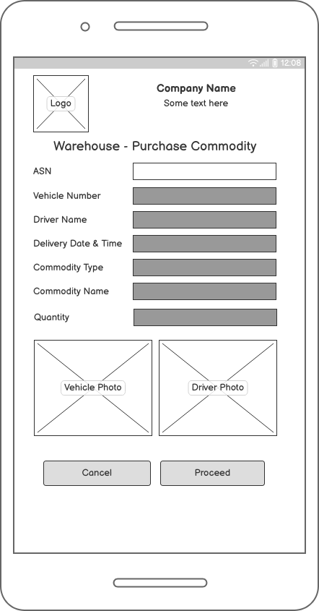
Fig. Warehouse – Purchase Commodity

Here are the detailed steps that will take place when the vehicle goes to the weighing bridge:
- Vehicle arrives at the weighing bridge: After passing the security check, the vehicle will proceed to the weighing bridge.
- Gross weight measurement: The vehicle will be weighed to determine the gross weight, which is the total weight of the vehicle and its contents. This measurement will be done automatically by the API integrated with the weighing bridge.
- Record weight and photograph of vehicle and driver: The weight will be recorded in the mobile application by the weighing bridge operator along with the photograph of the vehicle and driver. This will be done automatically by the API integrated with the weighing bridge
- Compare weight with ASN: The weight recorded at the weighing bridge will be compared with the weight mentioned in the ASN.
- Any discrepancy in weight will be reported to the supervisor: If there is a discrepancy in weight, it will be reported to the supervisor for further investigation.
- Send the vehicle to Quality Control: The vehicle will then be sent to Quality Control for checking the quality of the commodity.
This process will help in ensuring that the correct amount of commodity is being delivered as per the ASN and any discrepancy will be reported to the supervisor for further investigation. This will also help in maintaining the inventory and traceability of the commodity.
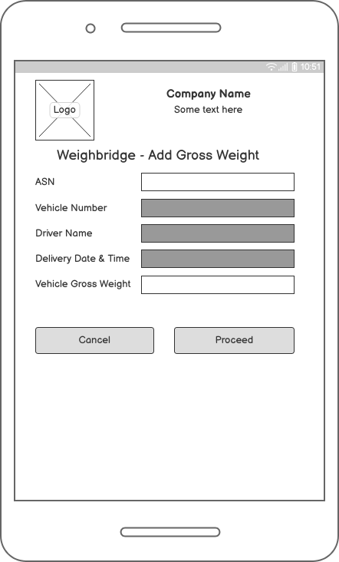
Fig. Gross weight at WB

Here are the detailed steps that will take place at Quality Control:
- Quality Control Inspection: The commodity will be inspected by the Quality Control (QC) personnel for any defects or variations in quality.
- Checking of quality parameters: The QC personnel will check the quality parameters as per the industry standards and Kirti Group's specifications. This will include factors such as moisture content, foreign matter, and impurities.
- Record quality parameters in the mobile application: The QC personnel will record the quality parameters in the mobile application.
- Check for compliance with standards: The QC personnel will check that the quality parameters of the commodity are in compliance with the standards set by Kirti Group.
- Report any non-conformity: If there is any non-conformity found in the quality parameters, the QC personnel will report it to the supervisor for further investigation.
- Release for unloading: If the commodity passes the QC check, it will be released for unloading.
- Unloading: The commodity will be unloaded from the vehicle and sent for storage in the godown.
- Weight check: After unloading, the vehicle will be sent back to the weighing bridge for net weight check.
This process will help in ensuring that only the commodities of the desired quality and standards are accepted by Kirti Group and stored in the godown. This will also help in maintaining the quality of the commodity and ensuring customer satisfaction.
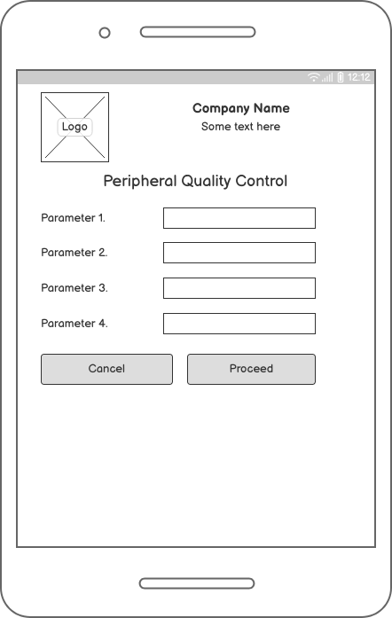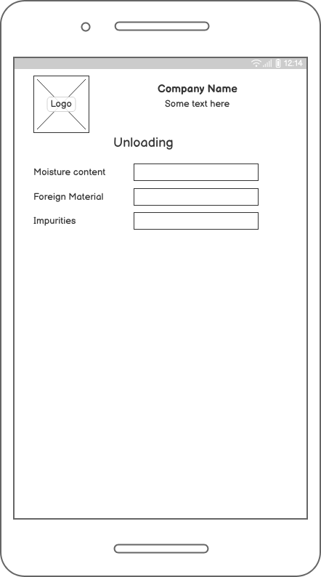
Fig. Peripheral QC Fig. Lab QC
Here are the detailed steps that will take place during unloading:
- Vehicle arrives at the unloading bay: The vehicle carrying the commodity will arrive at the designated unloading bay.
- Unloading equipment: The unloading equipment such as forklifts or conveyor belts will be readied for the unloading process.
- ASN and weight check: The ASN will be checked again and the weight of the vehicle will be verified against the weight recorded at the weighing bridge.
- Commodity transfer: The commodity will be transferred from the vehicle to the unloading equipment using appropriate tools and techniques.
- Quality check: The commodity will be visually inspected for any visible defects or variations in quality during the unloading process.
- Recording of weight: The weight of the commodity will be recorded during the unloading process.
- Storing the commodity: The commodity will be stored in the designated godown as per the stack and Lot details.
- Documenting the unloading process: The unloading process will be documented in the mobile application.
This process will help in ensuring that the commodity is unloaded safely and efficiently and that the weight and quality of the commodity is verified before storing it in the godown. This will also help in maintaining the quality of the commodity and ensuring customer satisfaction.
Here are the detailed steps that will take place when the vehicle goes to the weighing bridge again after unloading:
- Vehicle arrives at the weighing bridge: The vehicle will arrive at the designated weighing bridge.
- Verification of ASN: The ASN will be checked again to ensure that the vehicle is carrying the correct commodity.
- Weighing the vehicle: The vehicle will be weighed to determine the net weight of the commodity after removing all foreign bodies and rejected quality commodities.
- Recording the weight: The weight of the commodity will be recorded in the mobile application.
- Comparison of weight: The weight recorded during the unloading process will be compared with the weight recorded after the unloading process, if weight is not matching then it will be rejected
- Documenting the process: The process of weighing the vehicle after unloading will be documented in the mobile application.
- Allowing the vehicle to leave: If all the process is completed successfully, the vehicle will be allowed to leave.
This process helps in ensuring that the weight of the commodity is accurate and that all foreign bodies and rejected quality commodities have been removed before storing the commodity in the godown. This will also help in maintaining the quality of the commodity and ensuring customer satisfaction.

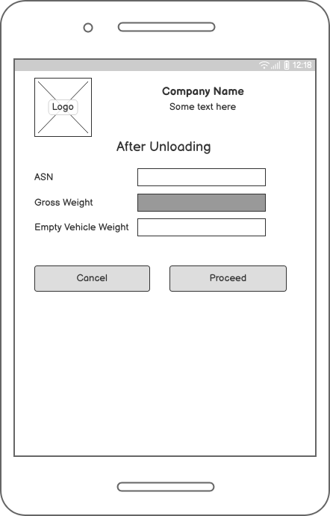
Fig. After Unloading

Farmer Commodities Sales
After the farmer has completed the registration process, they can use the Kirti Group's mobile application to sell their commodities to the group. The fields that would be shown in the commodities sales by the farmer would include:
- Commodity Type: A drop-down menu or checkboxes where the farmer can select the type of commodity they are selling (e.g. oil, pulses, wheat, etc)
- Commodity Name: A text input field where the farmer can enter the specific name of the commodity they are selling.
- Quantity: A text input field where the farmer can enter the quantity of the commodity they are selling.
- Unit of Measurement: A drop-down menu where the farmer can select the unit of measurement for the commodity they are selling (e.g. kg, liters, tons, etc)
- Crop Season: A drop-down menu where the farmer can select the crop season of the commodity they are selling.
- Harvest Date: A date picker where the farmer can select the harvest date of the commodity they are selling.
- Location of the farm: A text input field where the farmer can enter the location of their farm.
- Date of Delivery: This field would be a mandatory field, and the farmer would not be able to submit the form without selecting a delivery date.
Validation for the above fields could include:
- Required field validation: This validation would ensure that the fields are filled out and the farmer cannot submit the form without entering the commodity information.
- Quantity validation: This validation would ensure that the quantity entered is a number and is greater than zero
- Price validation: This validation would ensure that the price entered is a number and is greater than zero
By providing accurate and detailed information about the commodities they are selling, farmers can be matched with the right buyers or sellers, and also to comply with the legal and regulatory requirements. This will also facilitate the transactions and payments between the parties.
Commodity Type
The "Commodity Type" field in the commodities sales form for farmers in the Kirti Group's mobile application would be a drop-down menu where the farmer can select the type of commodity they are selling. The options in the drop-down menu would be a list of different types of commodities such as:
- Oil seeds: This would include options such as soybean, groundnut, sunflower, etc
- Pulses: This would include options such as chickpeas, lentils, peas, etc
- Grains: This would include options such as wheat, rice, barley, etc
- Spices: This would include options such as turmeric, pepper, cumin, etc
- Fruits and Vegetables: This would include options such as tomatoes, onions, bananas, apples, etc
- Others: This option would be provided for any other commodities that don't fall under the above categories.
The farmer can select the type of commodity they are selling from this list. This field would be a mandatory field, and the farmer would not be able to submit the form without selecting a commodity type. This field is important as it helps the Kirti group to understand which commodity the farmer is selling, and to match the farmer with the right buyers or sellers.
Commodity Name
The "Commodity Name" field in the commodities sales form for farmers in the Kirti Group's mobile application can be designed as a two-level drop-down menu.
The first level would be the "Commodity Type" drop-down menu, as previously described, where the farmer can select the type of commodity they are selling (e.g. oil seeds, pulses, grains, spices, fruits and vegetables, etc.).
The second level would be the "Commodity Name" drop-down menu, which would appear after the farmer has selected the commodity type from the first level. This menu would display a list of predefined commodity names that are specific to the commodity type selected by the farmer.
For example, if the farmer has selected "Oil Seeds" as the commodity type, the second-level dropdown menu will show options such as "Soybean", "Groundnut", "Sunflower", etc.
This design will help the Kirti group to better understand the quality and characteristics of the commodity they are selling and to match the farmer with the right buyers or sellers. Additionally, it will also help to comply with legal and regulatory requirements, such as providing accurate information about the commodity to buyers or sellers.
This design also ensures that the farmer does not have to type the commodity name, which can reduce errors and make the process more efficient.
it is possible to add a third-level drop-down menu for "Type or Quality" in the commodities sales form for farmers in the Kirti Group's mobile application.
After the farmer has selected the commodity type and the specific commodity name from the first and second-level drop-down menus, the third-level drop-down menu will appear. This menu will display a list of predefined options for the type or quality of the commodity selected.
For example, if the farmer has selected "Soybean" as the commodity name, the third-level drop-down menu will show options such as "Grade 1", "Grade 2", "Organic", "Non-Organic", etc.
This added level of information can help the Kirti group to better understand the quality and characteristics of the commodity they are selling and to match the farmer with the right buyers or sellers. Additionally, it will also help to comply with legal and regulatory requirements, such as providing accurate information about the commodity to buyers or sellers.
This design also ensures that the farmer does not have to type the type or quality, which can reduce errors and make the process more efficient.

Quantity
The "Quantity" field in the commodities sales form for farmers in the Kirti Group's mobile application would be a text input field where the farmer can enter the quantity of the commodity they are selling.
The farmer would enter the quantity in the unit of measurement selected in the previous field, such as in Kgs, Tons, Liters, etc. This field is important as it helps the Kirti group to understand the amount of the commodity the farmer is selling and to match the farmer with the right buyers or sellers.
This field would be a mandatory field, and the farmer would not be able to submit the form without entering the quantity.
Additionally, this field can also be designed with validation to ensure that the farmer enters a numeric value greater than zero and that the value entered is not more than the available quantity of the commodity. This validation will help to ensure that the farmer is selling a realistic and valid quantity.
Unit of Measurement
The "Unit of Measurement" field in the commodities sales form for farmers in the Kirti Group's mobile application would be a drop-down menu where the farmer can select the unit of measurement of the commodity they are selling.
The options in the drop-down menu would be a list of different units of measurement such as:
- Kgs
- Tons
- Liters
- Quintals
- Bags
- Others
This field would be a mandatory field, and the farmer would not be able to submit the form without selecting a unit of measurement. This field is important as it helps the Kirti group to understand the unit of measurement used by the farmer and to match the farmer with the right buyers or sellers.
Additionally, this field can also be designed with validation to ensure that the farmer selects a valid unit of measurement. This validation will help to ensure that the farmer is selling the commodity in a valid unit of measurement.
Unit of measurement is also used to calculate the price of the commodity, so it is important to have this field on the form.

The price of the commodity will be determined by the Kirti Group based on the current market price of the commodity and other factors such as the quality and quantity of the commodity.
To achieve this, Kirti Group can have a price trend dashboard on the mobile application that shows the current market price of the different commodities. The farmer would be able to see the current market price of their commodity on this dashboard and use it as a reference when selling their commodity to the Kirti Group.
This approach would be beneficial for the farmer as they would not have to worry about determining the price of their commodity, and would instead be able to rely on the Kirti Group's expertise and resources to get the best price for their commodity. The Kirti Group would also benefit as they would be able to purchase the commodity at a fair and competitive price, which would help them to maintain their market share and reputation in the industry.
In this scenario, the price field can be made optional or disabled in the registration form and the price will be determined by Kirti Group based on the current market price and the quality of the commodity.
Crop Season
The "Crop Season" field in the commodities sales form for farmers in the Kirti Group's mobile application would be a drop-down menu where the farmer can select the crop season of the commodity they are selling.
The options in the drop-down menu would be a list of different crop seasons such as:
- Kharif
- Rabi
- Summer
- Autumn
- Others
This field would be a mandatory field, and the farmer would not be able to submit the form without selecting a crop season. This field is important as it helps the Kirti group to understand the crop season of the commodity and to match the farmer with the right buyers or sellers. Additionally, this field can also be designed with validation to ensure that the farmer selects a valid crop season.
The crop season is important for Kirti group because it helps them to understand the timing of the availability of the commodity and plan accordingly. Additionally, the crop season also affects the price of the commodity as different crop seasons may have different prices.
Farmers can also select multiple seasons if the commodity is available in multiple seasons.
Harvest Date
The "Harvest Date" field in the commodities sales form for farmers in the Kirti Group's mobile application would be a date picker field where the farmer can select the date when the commodity they are selling was harvested.

This field would be a mandatory field, and the farmer would not be able to submit the form without selecting a harvest date. This field is important as it helps the Kirti group to understand the timing of the availability of the commodity and plan accordingly.
The harvest date will help Kirti group to understand the freshness of the commodity and plan accordingly. Additionally, it also helps the Kirti group to understand the timing of the availability of the commodity and plan accordingly. This information would be very helpful for Kirti group to plan their logistics and storage.
Farmers can also select multiple harvest dates if the commodity is harvested multiple times in a year.
Location of the Farm
The "Location of the Farm" field in the commodities sales form for farmers in the Kirti Group's mobile application would be a text input field where the farmer can enter the location of their farm.
This field would be a mandatory field, and the farmer would not be able to submit the form without entering the location of their farm. This field is important as it helps the Kirti group to understand the location of the farm and plan accordingly.
The location of the farm would also help the Kirti group to understand the area and the type of soil. They will also be able to plan their logistics and storage accordingly.
Additionally, this field can also be designed with validation to ensure that the farmer enters a valid location. This validation can be done by using the Google Maps API, which will automatically verify the location entered by the farmer and ensure that it is a valid location.
Farmers can also enter multiple locations if they have multiple farms.
Date of Delivery
The "Date of Delivery" field in the commodities sales form for farmers in the Kirti Group's mobile application would be a date picker field where the farmer can select the date when they will be delivering the commodity they are selling.
This field would be a mandatory field, and the farmer would not be able to submit the form without selecting a delivery date. This field is important as it helps the Kirti group to understand the timing of the delivery of the commodity and plan accordingly.
The date of delivery is important for Kirti group because it helps them to plan their logistics and storage accordingly. Additionally, it also helps the Kirti group to understand the timing of the availability of the commodity and plan accordingly.
Farmers can also select multiple delivery dates if they will be delivering the commodity multiple times.
Additionally, this field can also be designed with validation to ensure that the farmer selects a valid delivery date and that the delivery date is after the harvest date. This validation will help to ensure that the farmer is delivering the commodity at a reasonable time after it has been harvested.

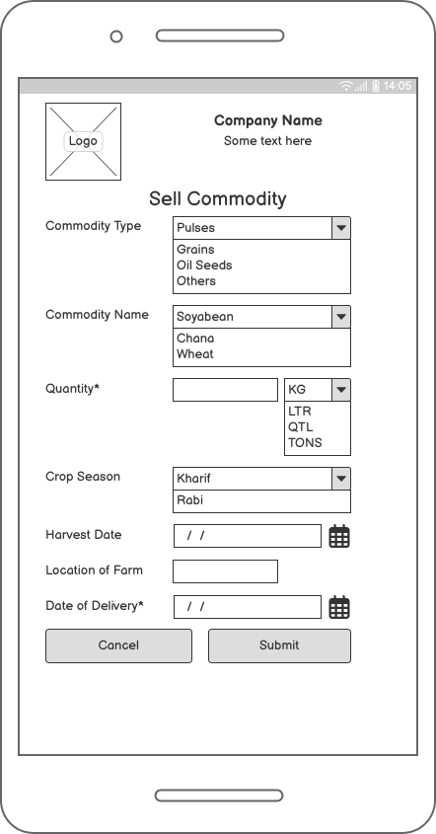
Fig. Farmer Sell Commodity

Trader Sales
Here is a flow diagram outlining the sales process for traders using the Kirti Group mobile application:
- Trader logs in to the mobile application
- Trader selects the "Buy Commodities" option from the menu
- Trader selects the commodity type, name and quality from the drop-down menu
- Trader enters the quantity of the commodity required
- Trader submits the form
- Kirti Group reviews the form and approves or denies the request
- If the request is approved, Kirti Group generates a Sales Order (SO) and sends it to the trader
- Trader confirms the SO and makes the payment to the Kirti Group
- Kirti Group dispatches the commodity to the trader's preferred location
- A transaction record is generated and sent to both the trader and Kirti Group for future reference.
This flow diagram provides a general overview of the process and the exact steps of the Kirti Group.
Buy Commodities
Traders can select the "Buy Commodities" option from the main menu of the Kirti Group mobile application. The main menu is typically located at the bottom or top of the screen and can be accessed by tapping on the hamburger icon (the three horizontal lines) or by swiping in from the left side of the screen.
Once the main menu is open, traders will be able to see the "Buy Commodities" option and select it. This will take them to a new screen where they can choose the commodity type, name, and quality, enter the quantity and submit the form.We will design an interface where the traders can directly access the buying option with the help of icons on the home page of the mobile application.

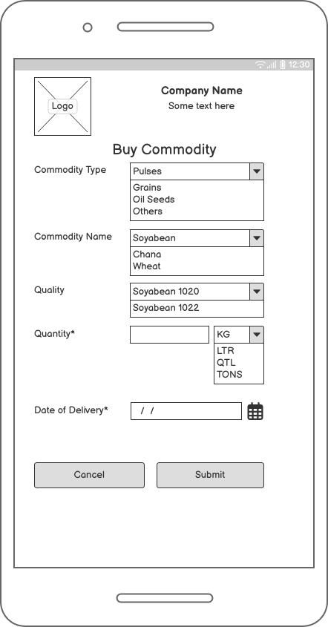
Fig. Trader Buy Commodity

Form Submission
After the trader has entered all the required information such as commodity type, name, quality, quantity and other relevant details, they can then submit the form. Once the form is submitted, it will be sent to the Kirti Group for review.
The trader will be able to see a confirmation message after the form is submitted successfully and also be able to track the status of the form in the application. The status of the form will show the trader whether the form is under review, approved or denied.
Traders should ensure that they have filled out all the necessary fields and provided accurate information before submitting the form. If there are any errors or missing fields, the trader will be prompted to correct them before they can submit the form.

Sales Order (SO) Generation
Once the trader's form for sales is reviewed and approved by the Kirti Group, a sales order will be generated. A sales order is a legally binding document that confirms the details of a sale, including the commodity type, name, quantity, price, and delivery date.
The sales order will be sent to the trader via the mobile application. The trader will be able to view and download the sales order from the application. The sales order will contain all the details of the sale, such as the commodity type, name, quantity, price, and delivery date, as well as the terms and conditions of the sale.
It is important for the trader to review the sales order carefully and ensure that all the details are correct before accepting it. The trader will have to accept the sales order before it can be considered valid.
After the sales order is accepted by the trader, the Kirti group will proceed with the delivery of the commodity as per the agreed date and other terms. The trader will be able to track the delivery status of the commodity via the mobile application.
Acceptance of Sales Order
Once the sales order is generated and sent to the trader, the trader will need to confirm the sales order and make the payment to the Kirti Group. The steps for confirming the sales order and making the payment are as follows:
- Review the sales order: The trader will need to review the sales order carefully and ensure that all the details are correct. The trader should also ensure that the terms and conditions of the sale are acceptable.
- Accept the sales order: The trader will need to accept the sales order by clicking on the ‘Accept’ button on the mobile application. This will signify the trader’s agreement to the terms and conditions of the sale.
- Make the payment: The trader will need to make the payment to the Kirti Group as per the payment terms outlined in the sales order. This can be done through the mobile application using various payment methods such as credit/debit cards, net banking, UPI, e-wallets, etc.
- Payment confirmation: Once the payment is made, the trader will receive a payment confirmation through the mobile application. The trader should keep this confirmation as proof of payment.
- Delivery: Kirti Group will proceed with the delivery of the commodity as per the agreed date and other terms. The trader will be able to track the delivery status of the commodity via the mobile application.
It is important for the trader to keep all the relevant documents such as sales orders and payment confirmation for future reference.

Broker Sales
Here is a flow diagram outlining the sales process for brokers using the Kirti Group mobile application:
- Brokers log in to the Kirti Group mobile application
- They select the option to "Sell Commodities"
- Brokers fill in the form with the details of the commodities they wish to sell, including the type, name, quantity, and price.
- They upload any relevant documents, such as a bill of lading or quality certificate.
- Brokers submit the form for sales
- Kirti Group generates a sales order and sends it to the broker for confirmation
- Brokers confirm the sales order and make the payment to the Kirti Group
- A transaction record is generated and sent to both the broker and Kirti Group for future reference.
- Kirti group will then arrange the transportation and logistics for the commodities to be delivered to the buyers
- Brokers will receive the payment once the commodities are delivered and accepted by the buyers.

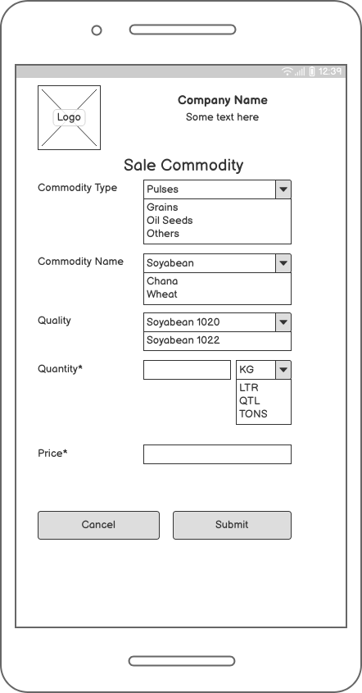
Fig. Broker Sale Commodity

Bidding on Application
Bidding for commodities is a process where buyers, such as farmers, traders, businesses, and brokers, place their offers for a particular commodity, such as a type of crop or oil, at a specific price. The highest bidder wins the auction and can purchase the commodity at their bid price. The process of bidding will be through an online platform, Kirti group mobile application, where interested parties can view the current offers and place their own bids. The process will be done in real-time, with bid prices constantly changing as new offers are placed. There will be, a deposit, such as an EMD (Earnest Money Deposit), is required to participate in the bidding process. This deposit is typically refundable if the bidder is unsuccessful in winning the auction and is used to ensure that the bidders are serious about their offers.

Steps for bidding for farmers, traders, businesses, and brokers through a mobile application
- Farmer, trader, business, or broker logs into the mobile application and selects the "Bid for Commodities" option.
- The user is directed to a form where they can select the commodity type, name, quantity, and unit of measurement.
- The user is required to submit a non-refundable deposit (EMD) as a form of security for their bid.
- Once the EMD is deposited, the user is able to place their bid for the desired commodity.
- Bids are accepted in real-time and the user can view the current highest bid and the time remaining for the bid to close.
- Once the bidding period is over, the highest bidder is declared the winner and the EMD deposit is adjusted against the final cost of the commodity.
- A transaction record is generated and sent to all bidders for future reference.
- The winner of the bid is required to make full payment for the commodity and take delivery as per the terms and conditions of the bid.

The "Bid for Commodities" layout in the mobile application would include the following fields:
- Commodity Type: A drop-down menu where users can select the type of commodity they wish to bid on.
- Commodity Name: A field where users can specify the specific commodity they wish to bid on.
- Quantity: A field where users can enter the quantity of the commodity they wish to bid on.
- Unit of Measurement: A drop-down menu where users can select the unit of measurement for the quantity they have entered.
- Minimum Bid Price: A field where users can enter the minimum bid price they are willing to accept for the commodity.
- EMD Deposit: A field where users can enter the amount of Earnest Money Deposit (EMD) they wish to submit with their bid.
- Bid Submission Deadline: A field where users can enter the deadline for submitting their bid.
- Real-time Bidding: A feature that allows users to see the current highest bid for the commodity and bid in real-time.
- Submit Bid: A button that allows users to submit their bid.
- Cancel Bid: A button that allows users to cancel their bid.
- Help: A button that directs users to the help center in case of any doubts.
Bidding for commodities works by allowing multiple users to place a bid for a specific commodity within a given time frame. The highest bid at the end of the bidding period wins the auction and the winner is required to make the payment and EMD deposit as per the terms and conditions. The mobile application will provide a real-time update of the highest bid, so users can make informed decisions on their bid.

The user is directed to a form where they can select the commodity type, name, quantity, and unit of measurement.
They can also provide their bid price and the date by which they would like to purchase the commodity. The form also includes a checkbox for the user to agree to the terms and conditions of the bidding process. Once the form is filled out, the user can submit their bid. The bids are then processed in real time, and the highest bid for a particular commodity is selected as the winning bid. The user who submitted the winning bid is then notified and can proceed with the purchase of the commodity. The deposit of EMD (Earnest Money Deposit) is also a step in the bidding process, where the user has to deposit a certain percentage of the total bid value as a security deposit, which will be refunded back after the completion of transaction.
Details of the steps to submit a non-refundable deposit (EMD) as a form of security for their bid.
- The user navigates to the "Bid for Commodities" section of the mobile application.
- They select the commodity type from a drop-down menu, which includes options such as oilseeds, pulses, and grains.
- They select the specific commodity name from a sub-menu, which may include options such as soybeans, groundnuts, and wheat.
- They enter the quantity and unit of measurement for the commodity they wish to bid on.
- The user is prompted to submit a non-refundable deposit, also known as an Earnest Money Deposit (EMD), as a form of security for their bid.
- The user can submit the EMD through various online modes of payment such as net banking, credit/debit card, or UPI.
- Once the EMD is successfully submitted, the user's bid is considered valid and they can participate in the bidding process.
- The bidding process takes place in real-time, and the user can view the current bid prices and the number of bidders on the same page.
- The user can place their bid by entering the price they are willing to pay for the commodity.
- The bidding process ends at a predetermined time, and the highest bidder is awarded the purchase of the commodity.
- The EMD deposit is used to confirm the purchase and is adjusted against the final purchase price.
- A transaction record is generated and sent to both the user and the Kirti Group for future reference.
Once the EMD is deposited
Once the EMD is deposited, the user will be able to place their bid for the desired commodity. The bid will be in real-time and will be visible to all other users who are also bidding for the same commodity. The bid will be based on the current market rate of the commodity and will be updated in real-time. The user will be able to see the current highest bid and can increase their bid accordingly. Once the bidding period is over, the highest bidder will be awarded the commodity and the EMD deposit will be used towards the purchase. If the highest bidder fails to complete the purchase, the EMD deposit will be forfeited. Once the EMD deposit is made, the user will be able to place their bid for the desired commodity. The bid amount and the user's details will be recorded in the system.

How Bids are accepted
All bids will be recorded and visible in real-time on a bidding dashboard, where users can see the current highest bid and the time remaining for the bidding to close.
Once the bidding period is over, the system will automatically select the highest bidder and send a notification to the user.
The user will then have a certain time period to make the full payment and complete the transaction. If the full payment is not made within the specified time period, the EMD deposit will be forfeited and the bid will be given to the next highest bidder.
Once the full payment is made and the transaction is complete, a sales record will be generated and sent to both the buyer and Kirti Group for future reference.

Updates of bids on mobile application
Once a bid is placed, the user can view the current bid status and updates on the mobile application in real-time. This includes the current highest bid, the number of bids placed, and the time remaining for the bidding to end. Users can also view the details of the other bidders and the bid amounts they have placed. The mobile application will also send notifications to the user regarding the status of their bid and any updates to the bidding process. The user can also view the history of their previous bids and the outcome of those bids. Once the bidding is closed, the highest bid is accepted and the user who placed the bid is notified of the outcome. The EMD deposit is refunded to the unsuccessful bidders and the successful bidder is required to make the full payment for the commodity.
Once the bidding process is completed, the bid winner will be notified via the mobile application. The bid winner will then be required to make full payment for the commodity and arrange for transportation. The losing bidders will have their EMD deposit refunded. A transaction record will be generated and sent to all parties involved for future reference.

Tutorial for Farmers in Application

- Logging in or signing up for an account: The tutorial could guide farmers through the process of creating an account or logging in if they already have one.
- Registration: The tutorial could guide farmers through the registration process, including providing personal information, unique identification numbers, bank account details, and a government-issued ID for verification purposes.
- Commodities sales: The tutorial could explain how farmers can sell their commodities to the Kirti Group through the mobile application, including selecting the commodity type, name, quantity, unit of measurement, and price.
- ASN: The tutorial could explain how farmers can view and confirm their ASN, which acts as a gate pass for entry into the Kirti Group's warehouse.
- Warehouse management: The tutorial could explain the process of how commodities are stored in the Kirti Group's warehouse, including the concept of godown, stack, and lot.
- Real-time updates: The tutorial could explain how farmers can view real-time updates on the status of their commodities, including weight, quality, and location in the warehouse.
- Loan: The tutorial could explain how farmers can take loans against their stored commodities.
- Help center: The tutorial could guide farmers on how to access the help center in case of any doubts or issues.
Tutorials on how to use the mobile application for selling and buying commodities, taking loans against stored commodities, and managing transactions with the Kirti Group. Additionally, there could be videos on market trends, weather forecasts, and other relevant information for farmers to stay informed and make informed decisions. The tutorials could also cover topics such as sustainable farming practices and government schemes for farmers. These videos could be in local languages to make it easy for farmers to understand and follow.
The mobile application for farmers can also include a tutorial section with videos on various agriculture activities such as new technologies, fertilizers, and other farming practices. These videos can be linked from YouTube or other video-sharing platforms and can be easily accessed by the farmers through the application. The videos can cover a wide range of topics related to agriculture and can be in the form of step-by-step guides, demonstrations, or even expert interviews. This will help farmers stay updated with the latest farming practices and improve their crop yields.
(Creating Videos is not in the Scope of GIC for this project)

