IMP changes

- CDR logo update since 1974

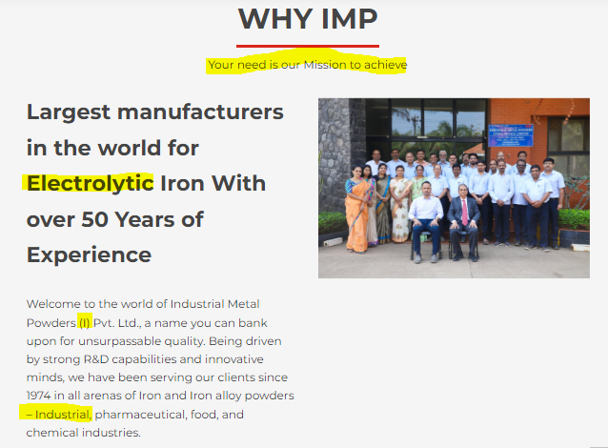
- Change the tagline to your trusted partner for High purity Iron powder
- Change the heading text from electrolytic to high-purity iron powder
- Remove (I) from everywhere and add India on the complete website
- Change the Industrial application to the Engineering application on the complete website.

Footer
Rename EIP to Products (Quick link)
Move oxygen absorbers from industrial to pharma
Add pre-alloyed powder product to industrial application

Change the blue background on every banner
Remove the industrial application banner

4th banner add s after powder(s)
change certification banner
HOME>Application> change descriptions
Add pre-alloyed iron and pre-alloyed both to the DCT application description
Update awards and titles (add new ones too) Suhas will share.

add auto-play to the home page video

about us:
add a roadmap banner above the vision
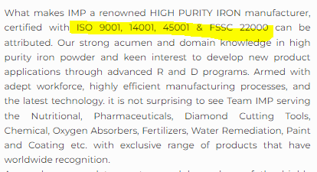
add ISO to every

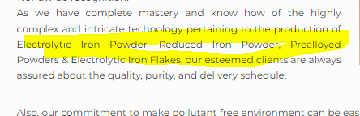
add atomized powders and add s to every

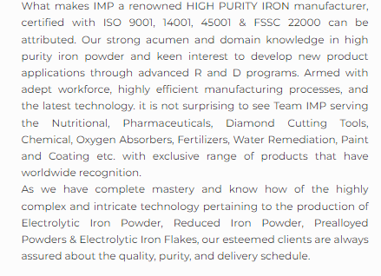
add powder metallurgical applications
Ecovadis company. (above CSR in bold)
add a button to CSR

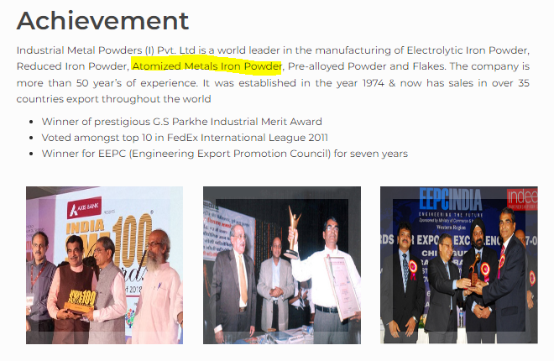
Atomized Iron Powders (add s to powders)
electrolytic iron Flakes.

add certifications too.

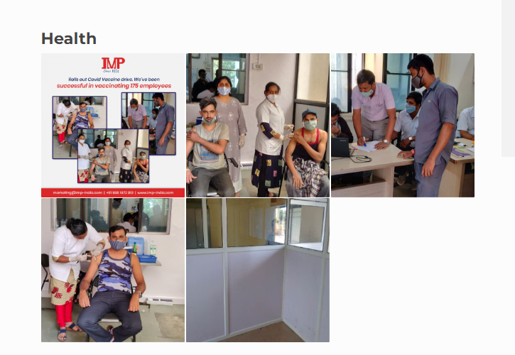Add blood donation photo
Remove the last image

remove repeat images from social

remove quality landing page 9#)
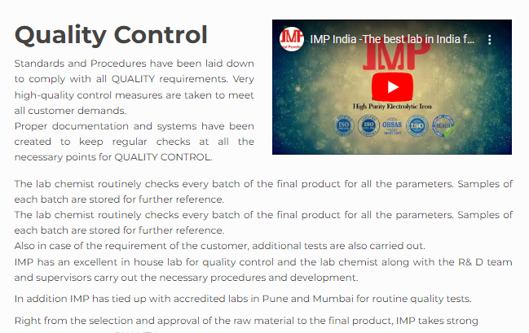
increase video size and auto-play
Update safety policy design.

remove close up yellow image from the lab instrument
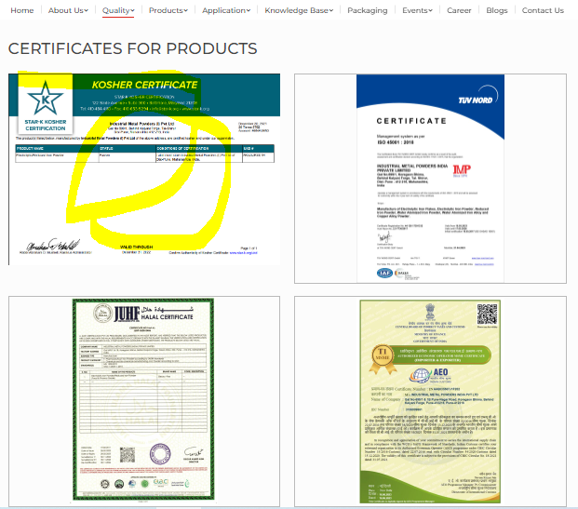
Update kosher and alt text
9001, 14 45 fssc, kosher, halal, reach, AEO, Patent (both), PDFs, quality policies. follow this order

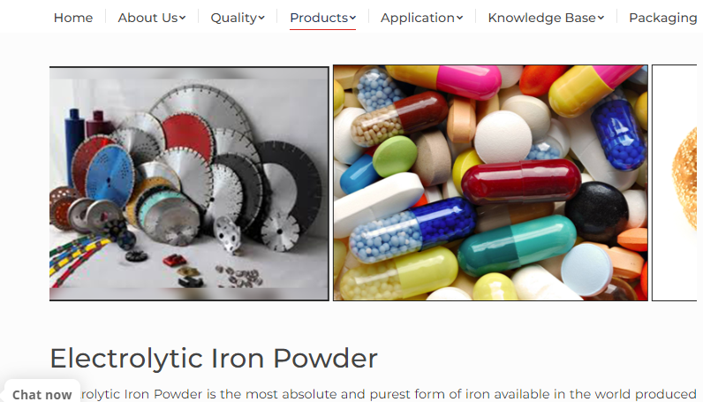
change the DCT image and move it to the last.
check internal linking
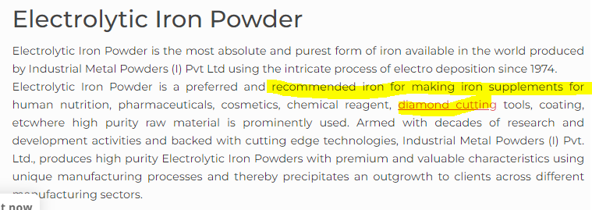

recommended iron for food fortifications.

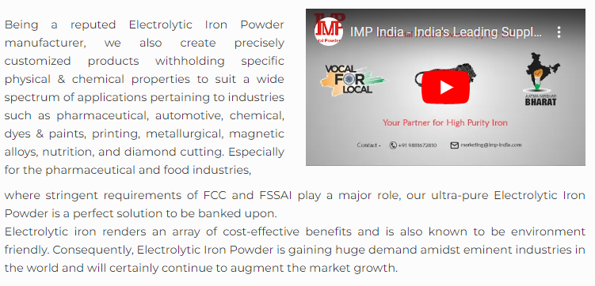
make the video full-size and auto-play

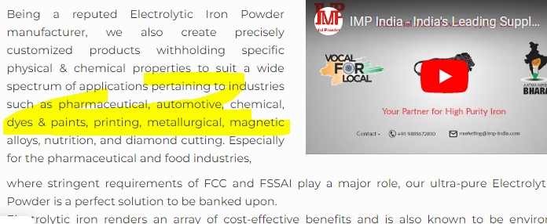
mention major applications first then go with others
(printing and all)

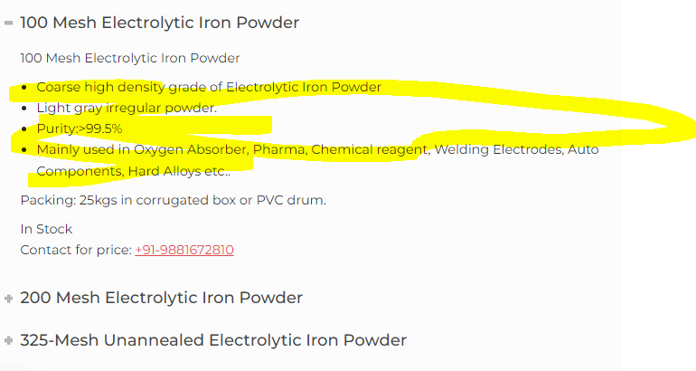

remove yellow text (from all points)

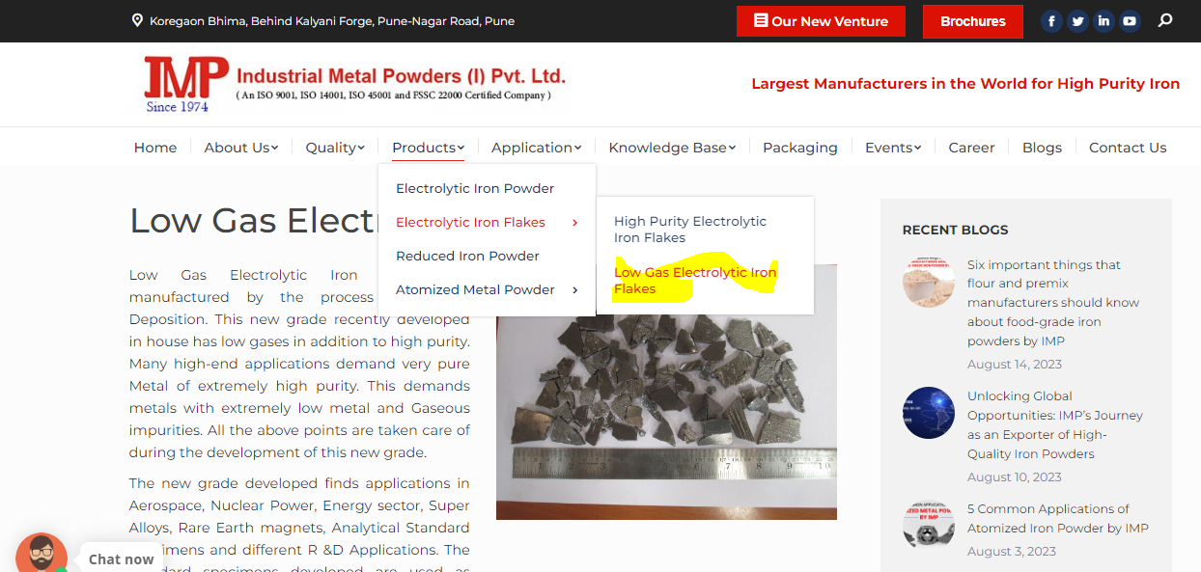
remove the low gas page.

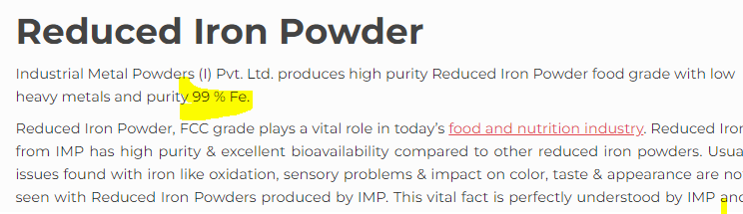
99.5%
on the whole page

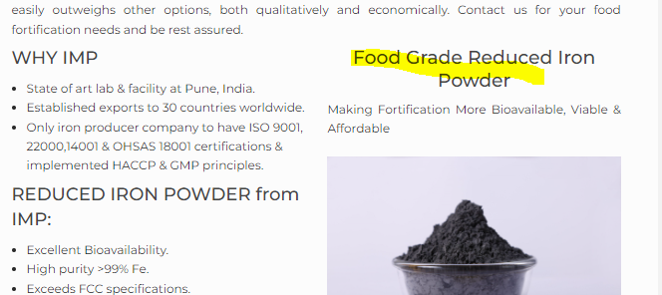

Add a dropdown option and shift the highlighted section in food. make new for pharma
use for pharma (active Pharmaceutical ingredient, Cosmetic, Oxygen, Chemical)
In food, add food data

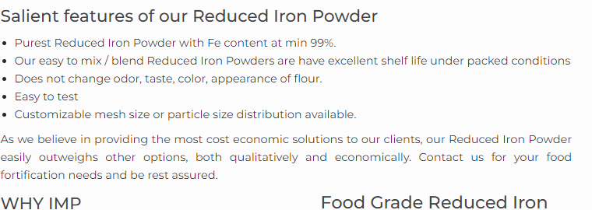
oxidation, sensory problems & impact on color, taste & appearance are not seen with Reduced Iron Powders
Add a banner for this, below silent features.

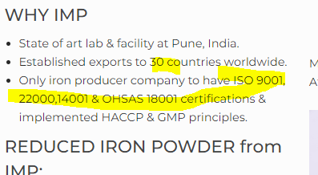
35+ correcet ISO certificates
slow banner movement on top.

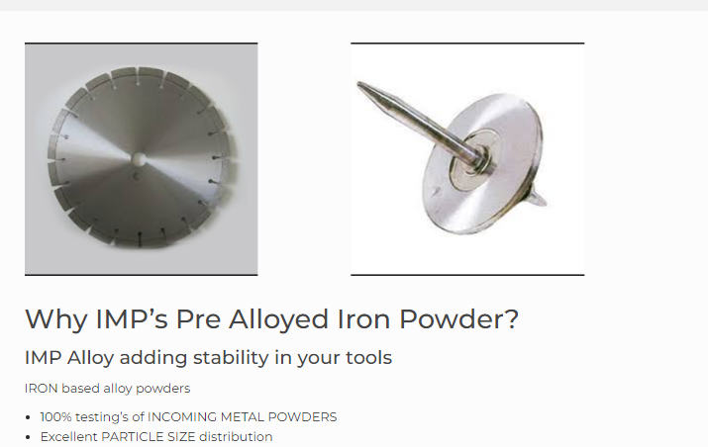
recreate banner

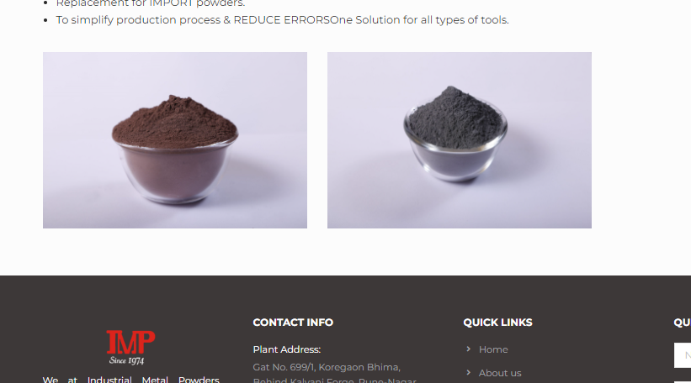
brown IMPALLOY and ELECTRO-FINE add brand name under the respective image.

add import substitute video is to be added on this page.( Check Youtube)
https://www.youtube.com/watch?v=V2NVB6zebqY

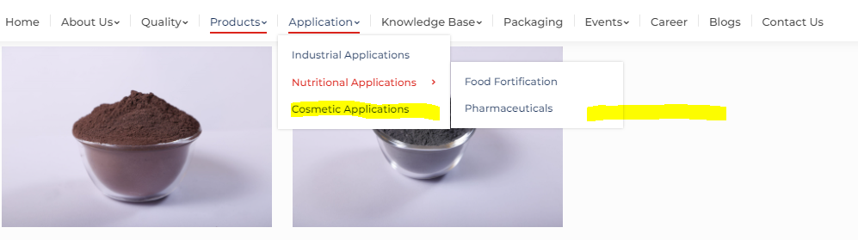
remove cosmatic from manin sub menu
Application -
Nutritional - FOOD Fortification
Pharma - Tio2, oxygen absorber, cosmetic, chemical (makepages for each.) (add # to pharma)
Engineering - DCT, Sintered PM, Magnetic wedges, Non-destructive testing, Paint, Electrical Conductors

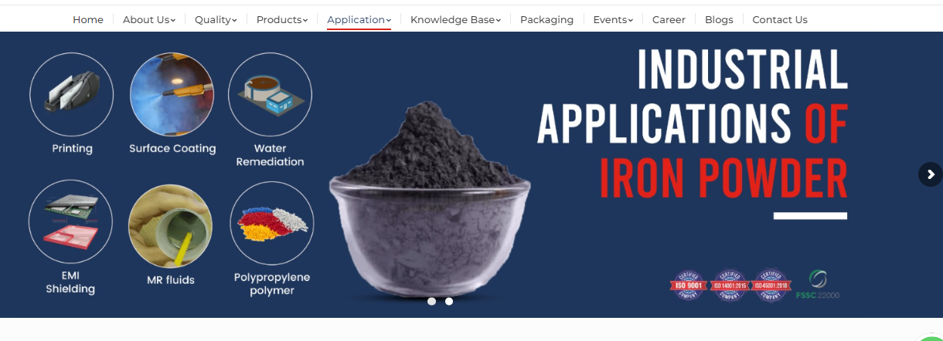

atomised, Electrolytic Iron and alloy product photo
and remove fssc22000

full-size video,banner background change, autoplay.

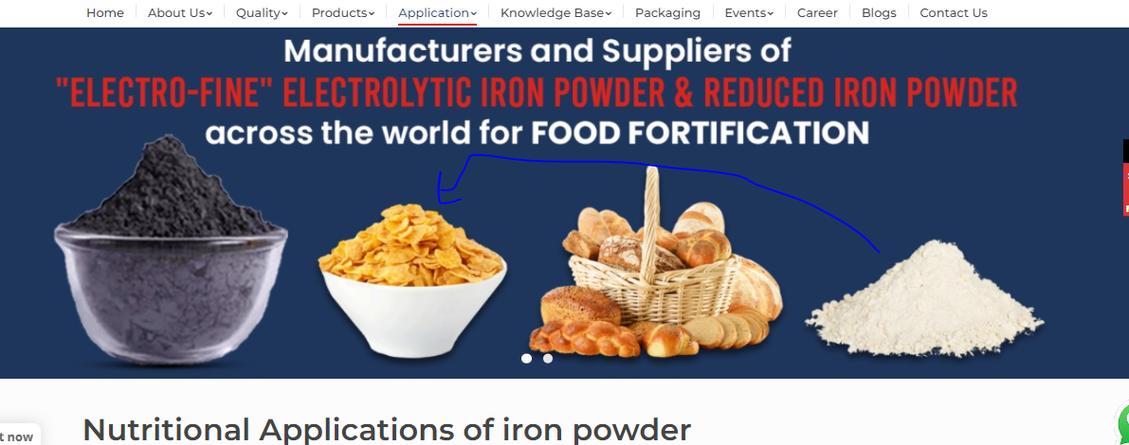
change iron powder phto to reduced iron powder, change position change background.
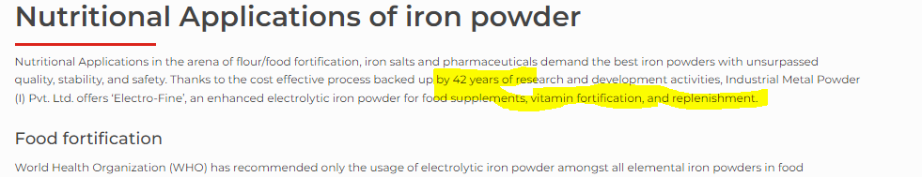
end with food fortification. remove highlighted text from the end.
50 years
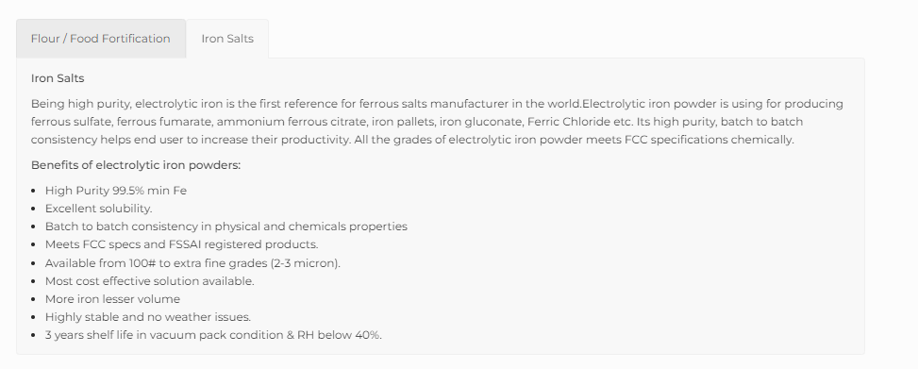
make dropdown. remove this pattern (same for reduced)

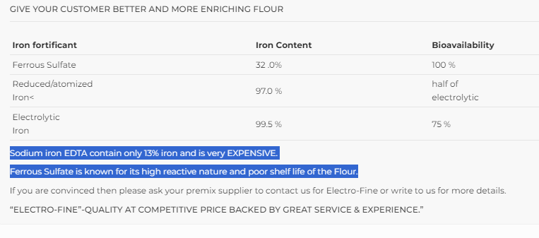
remove highlighted lines

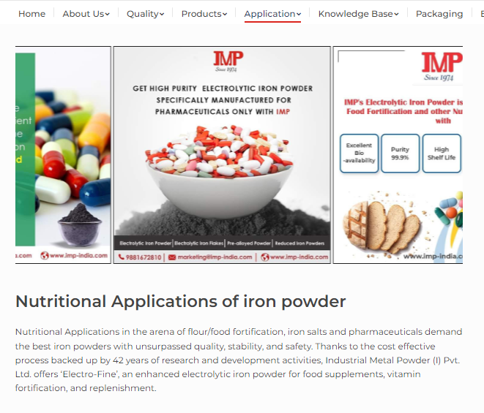
reference banner for size on all pages (excluding home page)
50 years*
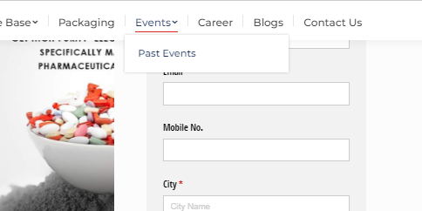

add Up Coming Event
EPHI Nov, 2023
stonemart 2024.
GIC will add data

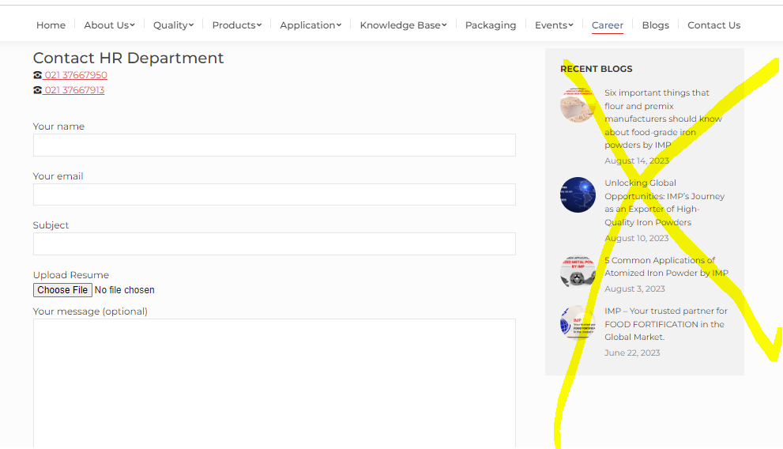
replace with company information (summary )
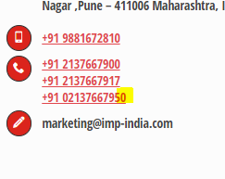
remove 0 add / 13

blog images not visible after page 2

