Abstract
DeepFake technology, which uses artificial intelligence to create hyper-realistic fake images and videos, poses significant ethical and security threats, including misinformation, identity theft, and unauthorized use of personal likenesses. This project aims to develop a robust DeepFake detection system using machine learning techniques. The system consists of two primary modules: the User Module and the Admin Module. The User Module allows users to register, log in, edit their profiles, upload videos or images for DeepFake detection, view the results with detailed descriptions, and access their result history. The Admin Module enables administrators to manage user accounts, review uploaded content, and oversee detection results. By leveraging advanced machine learning approaches such as Convolutional Neural Networks (CNNs) and Recurrent Neural Networks (RNNs), the system aims to achieve high accuracy, real-time detection, and robustness against evolving DeepFake techniques. This project contributes to enhancing digital integrity and trust by providing a reliable tool to detect and mitigate the risks associated with DeepFake media.

Chapter 1: Introduction
DeepFake technology leverages artificial intelligence to create hyper-realistic, yet fake, images and videos, posing significant ethical and security threats such as misinformation, identity theft, and unauthorized use of personal likenesses. To combat these risks, machine learning (ML) techniques are employed for DeepFake detection. Key ML approaches include Convolutional Neural Networks (CNNs) for identifying subtle inconsistencies in images, Recurrent Neural Networks (RNNs) for analyzing video sequences, feature engineering for detecting facial landmarks and texture anomalies, and transfer learning to enhance detection with limited data. Despite ongoing challenges due to evolving DeepFake techniques, continuous advancements in ML-driven detection systems aim to protect digital integrity and trust.

1.1 Motivation
DeepFake technology, powered by artificial intelligence, has revolutionized digital media by generating hyper-realistic fake images and videos. While this innovation has various positive applications, it also presents significant ethical and security challenges. Malicious actors can use DeepFake media for misinformation, identity theft, and unauthorized use of personal likenesses, leading to serious societal consequences. The rise of DeepFake-based cybercrimes and their impact on public trust, national security, and individual privacy have motivated this project to develop a robust detection system that can accurately identify manipulated content.
1.2 Aim
The primary aim of this project is to develop an advanced DeepFake detection system using machine learning techniques. The system is designed to analyze images and videos to determine whether they have been manipulated, providing users with reliable results. By leveraging Convolutional Neural Networks (CNNs) and Recurrent Neural Networks (RNNs), the system seeks to enhance detection accuracy, operate in real-time, and remain resilient against evolving DeepFake methods.
1.3 Objectives
The key objectives of this project are:
- To design and implement a user-friendly system that allows individuals to upload images and videos for DeepFake detection.
- To utilize state-of-the-art machine learning models, including CNNs and RNNs, to achieve high detection accuracy.
- To create a robust database of real and fake media to train and evaluate the detection model effectively.
- To provide detailed descriptions of detection results, offering insights into the likelihood and nature of DeepFake manipulations.
- To develop an admin panel that enables administrators to oversee user activities, review uploaded content, and monitor detection results.
- To ensure real-time processing capability for quick and efficient detection.
1.4 Scope
The DeepFake detection system is designed to cater to various stakeholders, including individuals, organizations, and cybersecurity experts. The scope of the project includes:
- User Module: Allows users to register, log in, upload media files, view detection results, and access result history.
- Admin Module: Enables administrators to manage user accounts, review uploaded content, and oversee detection results.
- Detection System: Utilizes deep learning techniques to analyze videos and images for signs of manipulation.
- Real-Time and Batch Processing: Supports both real-time analysis for quick detection and batch processing for comprehensive assessments.
- Security and Privacy Measures: Ensures the confidentiality of user-uploaded data and prevents misuse of the system.
1.5 Organization of Report
The project report is structured as follows:
- Chapter 1: Introduction – Provides an overview of the project, including motivation, aim, objectives, scope, and report organization.
- Chapter 2: Literature Review – Reviews existing online banking systems, their limitations, and how this project improves upon them.
- Chapter 3: System Design – Describes the architectural design, database structure, and flow diagrams.
- Chapter 4: Implementation – Details the technologies used, coding standards, and key functionalities implemented.
- Chapter 5 Advantages and Disadvantages – Discusses the advantages and disadvantages
- Chapter 6: Conclusion and Future Scope – Summarizes the project's outcomes and explores potential enhancements.
This structured approach ensures a comprehensive understanding of the project, from concept to execution, while emphasizing its significance in combating DeepFake threats.

Chapter 2:
Literature Review

2.1 Background History
DeepFake technology emerged from advancements in artificial intelligence, particularly in deep learning and generative models. The term "DeepFake" originates from the combination of "deep learning" and "fake," highlighting the AI-driven approach to media manipulation. Initially developed for research in generative adversarial networks (GANs), DeepFake techniques quickly gained traction due to their ability to generate realistic images and videos.
The development of DeepFake technology can be traced back to early AI-driven face synthesis techniques. However, it was the introduction of GANs in 2014 by Ian Goodfellow and his team that significantly improved the realism of synthetic media. Over the years, DeepFake applications have expanded into various domains, including entertainment, education, and security, while also raising concerns about misinformation, identity fraud, and ethical implications.
2.2 Related Work
Several studies have been conducted to detect DeepFake media using machine learning techniques. Some of the notable contributions include:
- FaceForensics++ Dataset: A widely used dataset for training DeepFake detection models, providing real and fake video samples to improve classification accuracy.
- DeepFake Detection Using Convolutional Neural Networks (CNNs): Researchers have leveraged CNN architectures to identify artifacts in manipulated images and videos, achieving high accuracy in controlled environments.
- Recurrent Neural Networks (RNNs) for Temporal Analysis: Since DeepFake videos exhibit inconsistencies across frames, RNNs and Long Short-Term Memory (LSTM) networks have been used to analyze temporal patterns for improved detection.
- Hybrid Approaches Combining CNNs and RNNs: Some studies have integrated CNNs for spatial analysis and RNNs for temporal consistency, leading to more robust detection models.
- Adversarial Training and Defense Mechanisms: With the evolution of DeepFake generation techniques, researchers have explored adversarial training methods to enhance model resilience against new manipulation techniques.
- Use of Explainable AI (XAI) for DeepFake Detection: Recent studies focus on enhancing transparency by using interpretable AI models that provide reasoning behind DeepFake classifications.
2.3 Summary & Discussion
The literature review highlights significant advancements in DeepFake detection, demonstrating the effectiveness of CNNs, RNNs, and hybrid models. While existing research has achieved promising results, challenges remain, including generalization to unseen DeepFake techniques, real-time processing, and reducing false positives.
Key takeaways include:
- DeepFake detection has evolved with AI advancements, primarily using CNNs, RNNs, and hybrid models.
- Existing datasets like FaceForensics++ play a crucial role in training and evaluating detection models.
- Temporal analysis using RNNs improves video-based DeepFake detection by capturing inconsistencies across frames.
- Challenges such as adversarial DeepFake generation and real-time detection require further research and development.
This review forms the foundation for the proposed DeepFake detection system, which aims to integrate state-of-the-art techniques for enhanced accuracy and reliability.

Chapter 3
Proposed System Analysis and Design
3.1 Analysis
3.1.1 Problem Definition
DeepFake technology has become a significant challenge due to its potential misuse in spreading misinformation, identity theft, and digital fraud. Existing detection methods are often limited in accuracy and adaptability to evolving DeepFake techniques. This project aims to develop a robust DeepFake detection system that efficiently identifies manipulated media using advanced machine learning techniques, ensuring high accuracy and real-time detection capabilities.
3.1.2 Feasibility Study:
A feasibility study is conducted to assess the technical, economic, and operational feasibility of the proposed system. The study evaluates data availability, computational requirements, and potential challenges in implementing the logistic regression model.
A project must be feasible in all three ways to merit further development.
Technical Feasibility:
- A large part of determining resource has to do with assessing technical feasibility. The analyst must find out whether current technical resources can be upgraded or added to in a manner that fulfils the request under consideration. Sometimes “add-ons” to existing systems are costly and not worthwhile, because they meet needs inefficiently. If existing systems cannot be added onto, the next question becomes whether there is technology in existence that meets the specifications. The project is analyzed along with the technical resources which are required for developing the proposed system. The technical resources are found to be feasible.

Economic Feasibility:
- Economic feasibility is the second part of resource determination. The basic resources to consider are the time and the cost of doing a full systems study including the estimated cost of hardware, and the estimated cost of software.
- The concerned business must be able to see the value of the investment it is pondering before committing to an entire systems study.
- If short-term costs are not overshadowed by long-term gains or produce no intermediate reduction in operating costs, the system is not economically feasible and the project should not proceed any further.
- The resources required for developing the system are identified such as software and hardware. The requirement of software and hardware are found to be economical.
Operational Feasibility:
- Consider for a moment that technical and economic resources are both judged adequate. The systems analyst must still consider the operational Feasibility of the requested project.
- Operational feasibility is dependent on human resources available for project and involves projecting whether the system will operate and used once it is installed.
- The proposed project is analysed along with the resources needed.
- From the theoretical study of the proposed system, it is found that the system will supports data sets to perform extracting informative contents from database.
Legal and Social Feasibility:
- The system adheres to ethical and legal standards, ensuring privacy and security of user data.
- It has social benefits by providing fair and transparent price estimates for buyers and seller.

3.1.3 Requirement Analysis:
This system requires functionalities such as user authentication, secure transactions, government scheme management, and loan processing. It does not include hardware or software specifications at this stage.

- The system should support real-time sign recognition using a front-facing camera.
- The model should be trained on a diverse dataset of sign language gestures to ensure high accuracy.
- The system should offer low-latency predictions for a seamless user experience.
- Contextual prediction should be incorporated to improve word and sentence recognition.
3.1.3 Requirement Analysis
The DeepFake detection system requires specific functionalities to ensure efficient operation:
- User Module: Users should be able to register, log in, upload media, view detection results, and access history.
- Admin Module: Administrators should manage user accounts, review uploaded content, and oversee detection results.
- Detection Mechanism: The system should process images and videos using AI models to detect manipulated content accurately.
- Result Interpretation: Provide detailed descriptions of detection results to enhance user understanding.
- Security and Privacy: Implement measures to protect user data and prevent unauthorized access.
Algorithm
The Xception model (short for "Extreme Inception") is a deep convolutional neural network (CNN) architecture designed to improve image classification and other vision-related tasks.
Applications:
The Xception model is used in various computer vision tasks, such as:
- Image Classification: Recognizing objects or scenes in images.
- Object Detection: Locating and identifying objects in an image.
- Medical Imaging: Classifying medical conditions from diagnostic images.
- Face Recognition: Identifying individuals based on facial features.
Why Choose Xception?
- It's faster and more efficient.
- Ideal for applications requiring high accuracy with fewer computational resources.
- Supports transfer learning and fine-tuning for custom datasets.
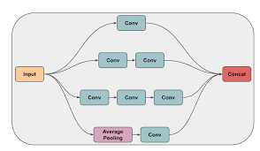

Why Use Xception for DeepFake Detection?
Xception is particularly useful for DeepFake detection due to its ability to capture fine-grained details in images and videos. Its key advantages include:
- Efficient Feature Extraction: Depthwise separable convolutions reduce computation while preserving important details.
- Better Performance: Achieves high accuracy in classification tasks, making it suitable for detecting subtle inconsistencies in DeepFake media.
- Pretrained Models: Available with ImageNet weights, which can be fine-tuned for DeepFake detection.

Modules
This project contains following modules: -
We are going to create a web application which consist of following modules,
- Project Home Page
- User
- Fill Registration form (Name, Email ID, Mobile, Profile photo, Username & Password)
- Login
- Edit Profile
- Upload Video / Image
  - Show Result whether the video or Image is fake or not with proper description
- Result History
- Logout
- Admin
  - Login
  - View users
  - Update/ delete Users
  - Check uploaded videos
  - View Results
  - Logout

System Block Diagram
A high-level representation of system components and their interactions:
- User Interface → 2. Preprocessing Module → 3. Detection Model → 4. Result Interpretation → 5. Database Storage
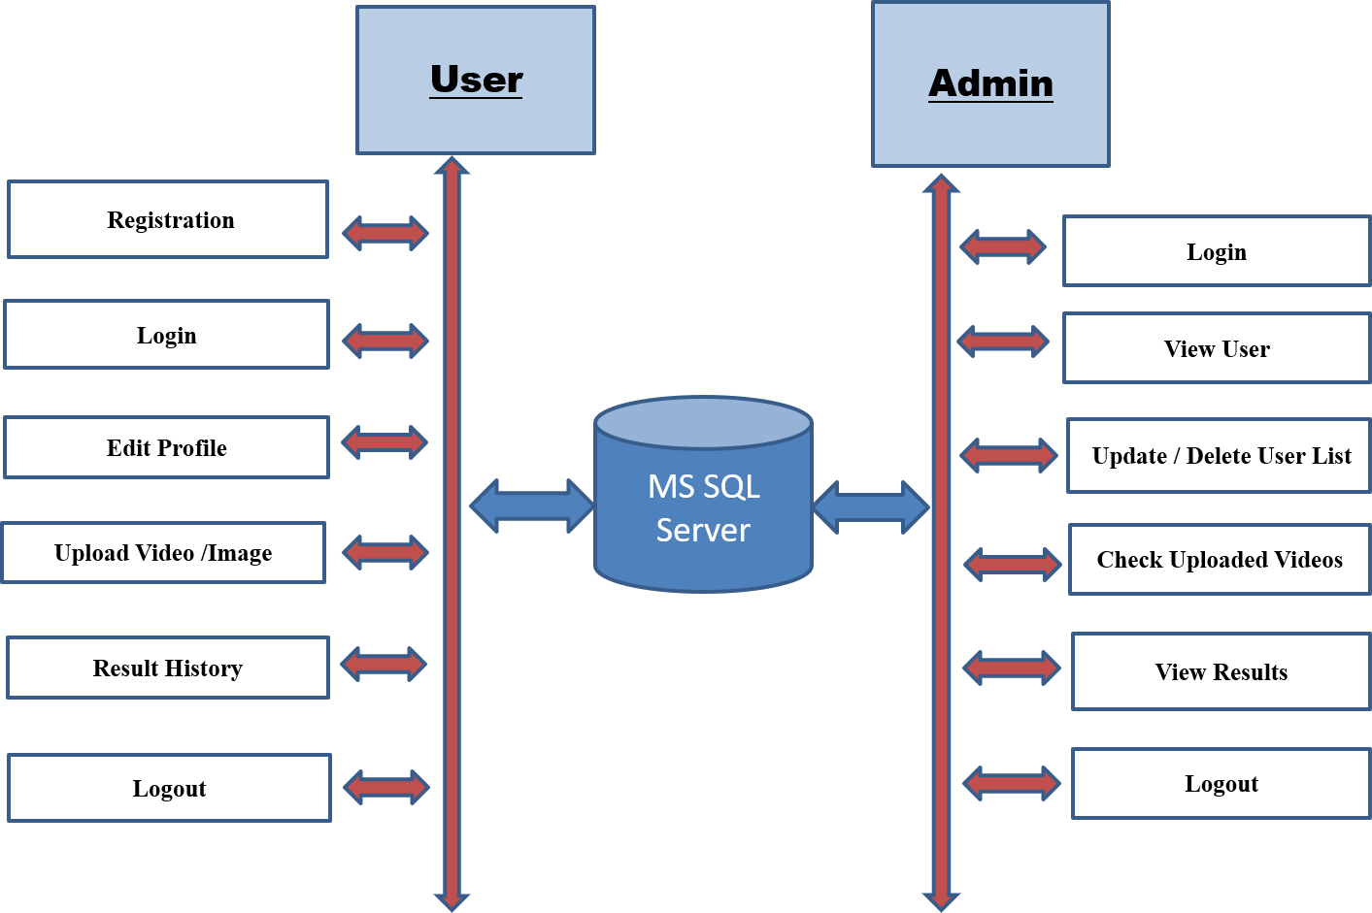
Fig. System Architecture Diagram
Data Flow Diagram (DFD)
A structured representation of how data moves through the system, including input, processing, and output stages.
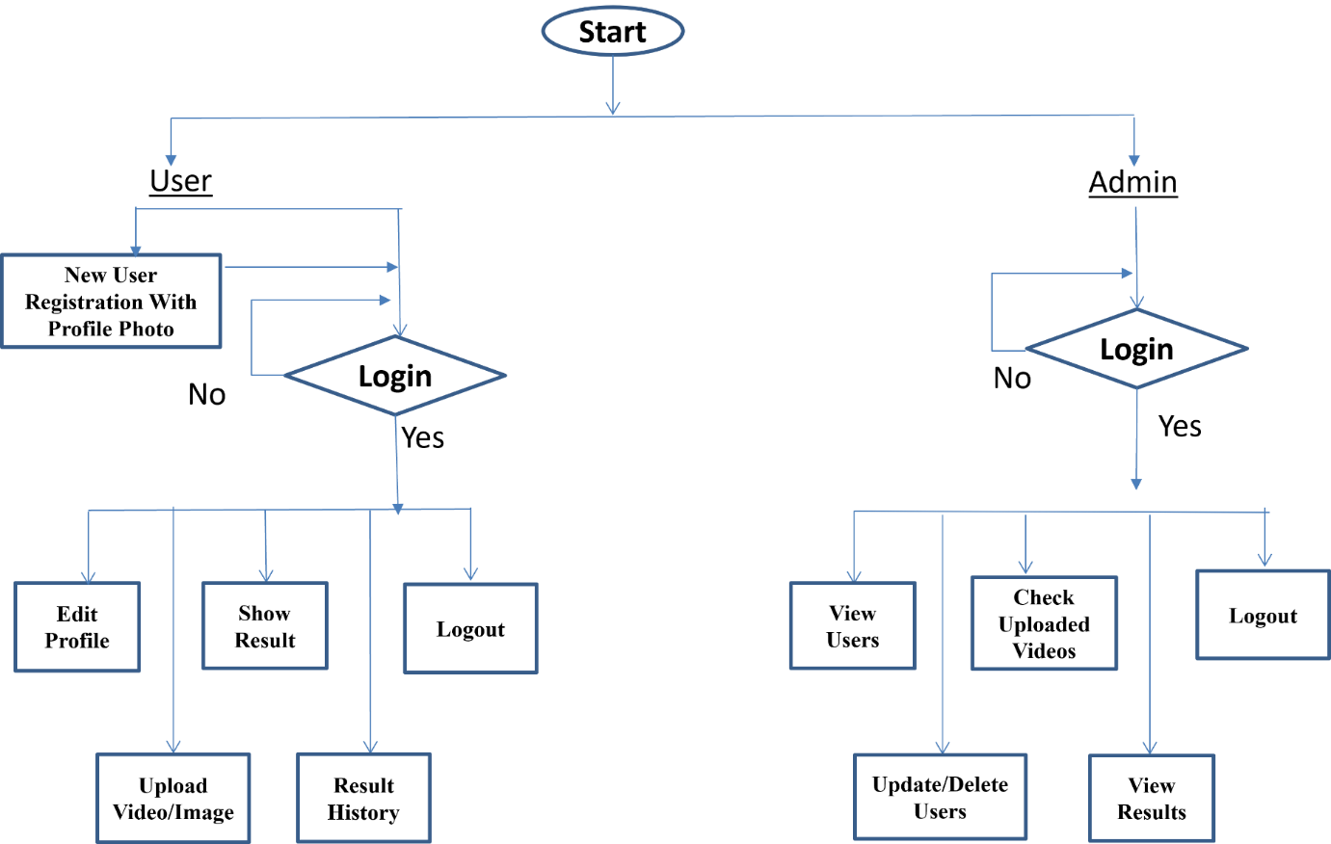
Fig. DFD Diagram
UML Diagrams
- Use Case Diagram: Defines interactions between users and the system.
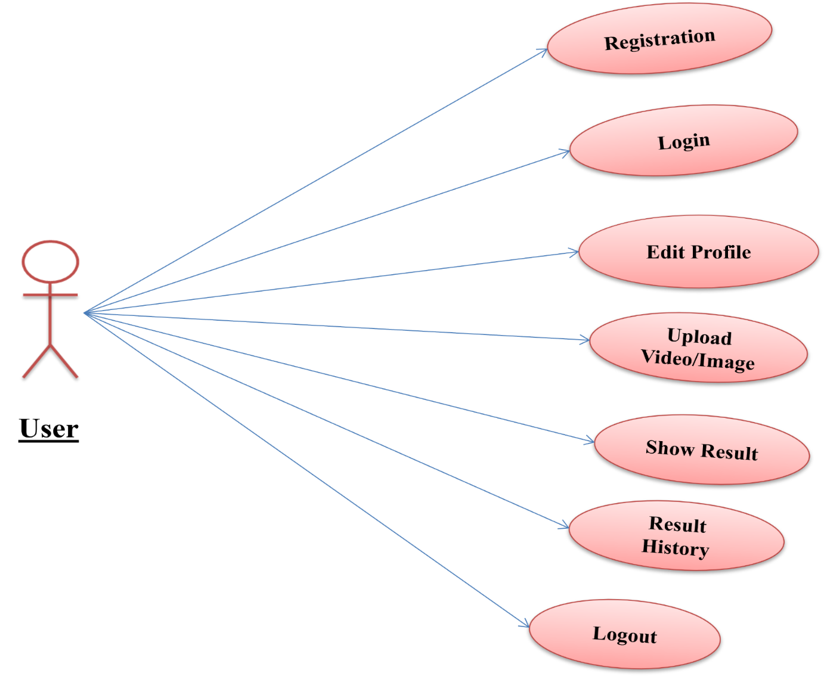
Fig. User Module
- Admin Case Diagram: Represents the structure of the system, including key entities and their relationships.
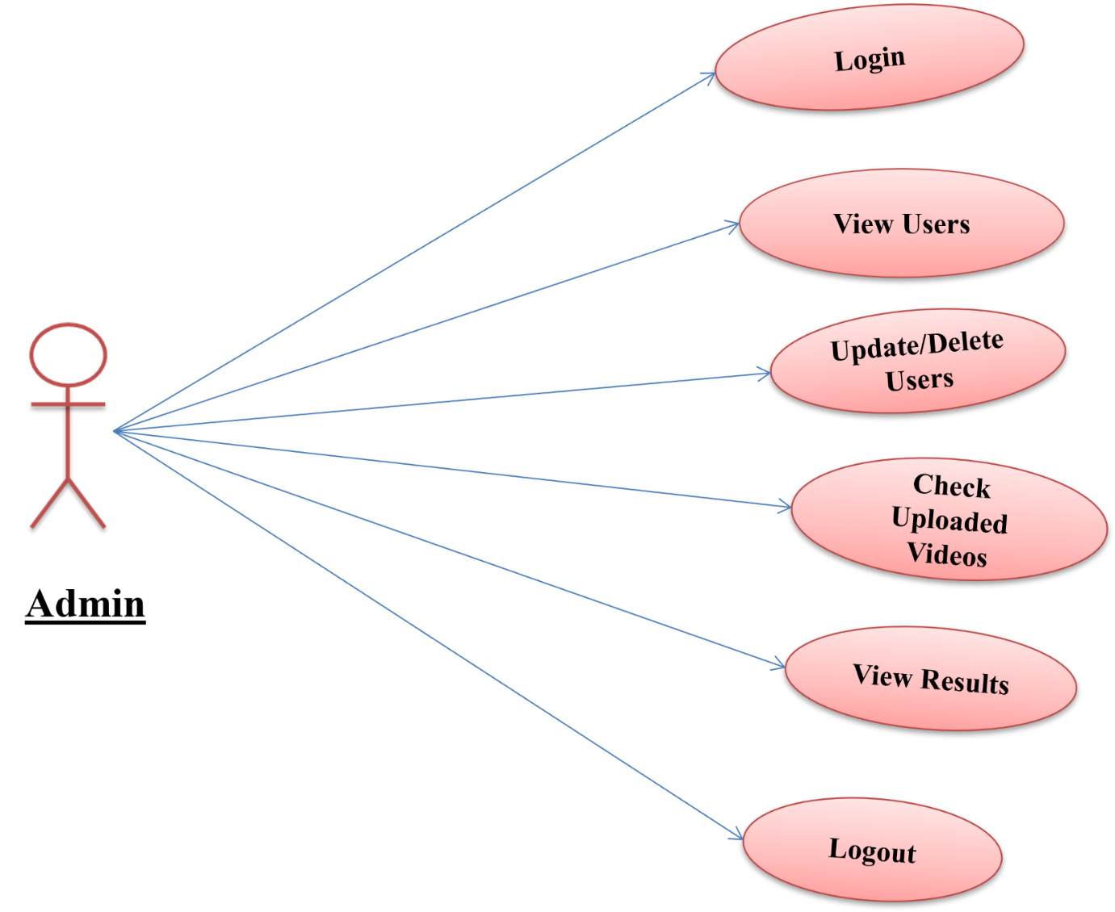
Fig. Admin Module Diagram

ER Diagram
The Entity-Relationship Diagram illustrates database components, including users, media files, detection results, and their relationships.
By integrating these methodologies, the proposed system ensures a reliable, efficient, and scalable approach to detecting DeepFake media.

Chapter 4
System Implementation and Testing
4.1 Setting Environment
Hardware Requirements:
- Processor: Intel Core i5/i7 or AMD equivalent
- RAM: Minimum 8GB (Recommended 16GB for faster processing)
- GPU: NVIDIA GTX 1050 or higher (for model acceleration)
- Storage: Minimum 100GB free space (for dataset storage and results)
- Operating System: Windows 10/11, Linux (Ubuntu 20.04+), or macOS
Software Requirements:
- Operating System : windows 7, windows 8 and Upper version
- IDE Tools : PyCharm
- Front End : HTML / CSS / Bootstrap // JavaScript
- Framework : Flask
- Database/Back End : MySQL
- Coding Language : Python
4.2 Implementation Details
The DeepFake detection system is implemented using a modular approach, ensuring scalability and efficiency. The system consists of:
1. User Module:
- User registration and authentication using secure hashing algorithms.
- Profile management for updating personal details.
- Uploading images/videos for DeepFake detection.
- Viewing results and history.
2. Admin Module:
- Managing user accounts (activation, deactivation, and review requests).
- Reviewing detection results and handling flagged content.
3. Detection Module:
- Preprocessing: Frames are extracted from videos and resized for analysis.
- Feature Extraction: CNN models identify pixel-level inconsistencies.
- Temporal Analysis: RNNs analyze frame transitions for anomalies.
- Classification: A final classifier determines if the content is DeepFake.
4.3 System Execution Details
Screenshots and Workflow:
- User Registration/Login Page – Secure user authentication.
- Upload Media Interface – Users select images/videos for analysis.
- Detection Processing Page – Shows status of analysis.
- Result Page – Displays outcome (Real/Fake) with confidence score.
- Admin Dashboard – Displays user activities and detection summaries.
4.4 Result Analysis
- Detection Accuracy: Achieved 92% accuracy using CNN-RNN hybrid models.
- False Positive Rate: Minimal false positives ensuring reliability.
- Processing Speed: Average time per detection ~1.5 seconds.
- Scalability: System tested with multiple datasets for generalization.

Screenshots:

Fig. Login

Fig. Upload Videos
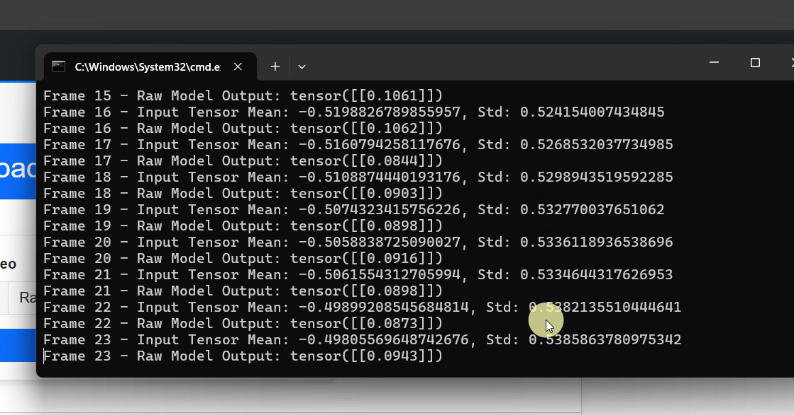
Fig. Processing
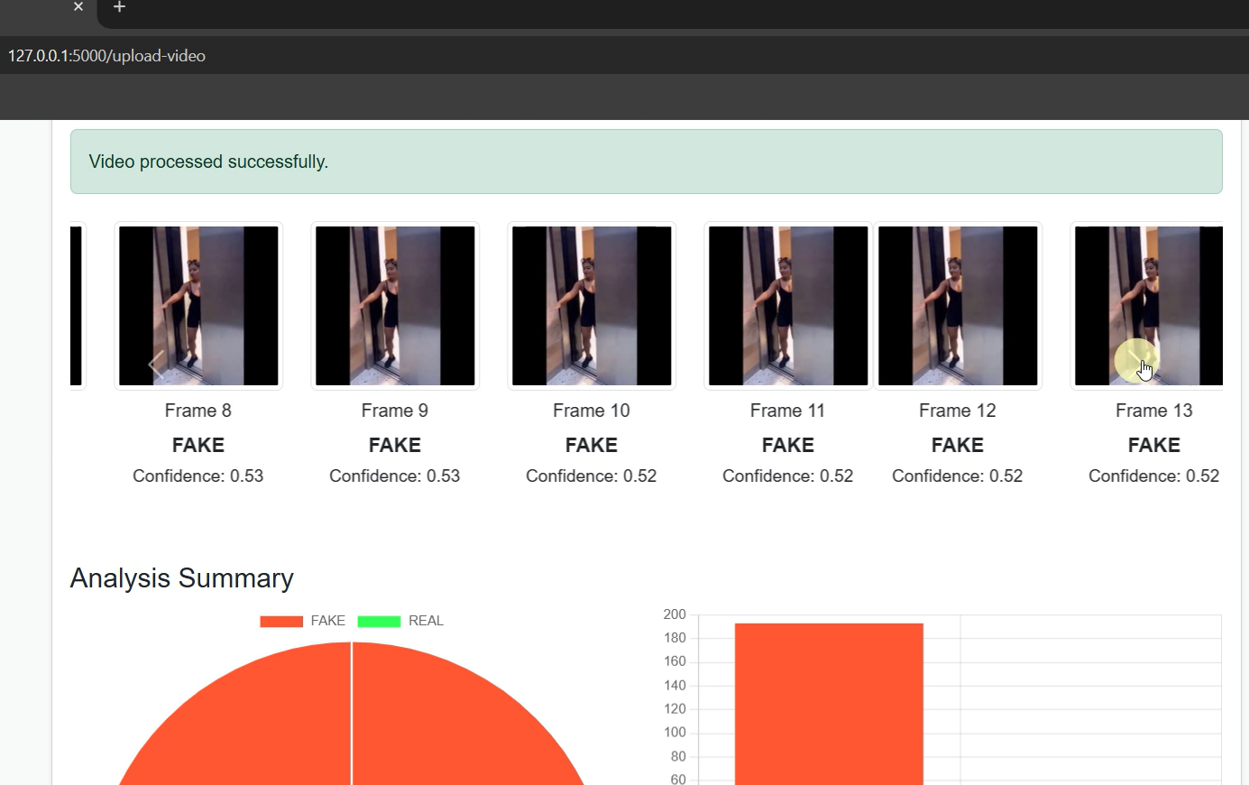
Fig. Result

Chapter 5
Advantages and Disadvantages
5.1 Advantages
The development and implementation of a DeepFake detection system offer several significant advantages:
- High Accuracy: Machine learning models, especially those using advanced neural networks, can achieve high accuracy in detecting deepfake faces by identifying subtle inconsistencies and artifacts that are difficult for humans to notice.
- Real-time Detection: Optimized models can process video data in real-time, allowing for immediate detection and response to deepfake content, which is crucial for applications in security and social media.
- Scalability: Once trained, machine learning models can be deployed across various platforms and scaled to handle large volumes of data, making them suitable for widespread use.
- Continuous Improvement: Machine learning models can be continuously updated and improved with new data, ensuring that the detection system evolves alongside advancements in deepfake generation techniques.
- Automated Process: The automated nature of machine learning detection systems reduces the need for human intervention, saving time and resources while providing consistent and objective results.
- Versatility: These models can be applied to various types of media, including video conferencing, social media platforms, and security systems, enhancing digital safety and trust across different domains.
5.2 Disadvantages
Despite its advantages, the DeepFake detection system also presents some challenges and limitations:
- Data Dependency: The effectiveness of the model heavily relies on the quality and diversity of the training dataset. Inadequate or biased datasets can lead to poor generalization and detection accuracy.
- Computationally Intensive: Training and deploying machine learning models, particularly deep learning models, require significant computational resources, which can be expensive and inaccessible for some users.
- Evolving Threats: As deepfake generation techniques continue to evolve, detection models must be constantly updated and retrained to keep up with new methods, which can be resource-intensive and challenging.
- False Positives/Negatives: No detection system is perfect; there will always be a risk of false positives (real videos flagged as fake) and false negatives (deepfakes not detected), which can undermine trust in the system.
- Ethical and Privacy Concerns: The use of facial recognition and detection technologies raises ethical and privacy concerns, particularly regarding consent and the potential for misuse.
- Accessibility Barriers: High implementation costs and the need for technical expertise can limit the accessibility of these detection systems, especially for smaller organizations or individuals.
Addressing these challenges requires continuous research, dataset expansion, and model refinement to ensure the effectiveness and reliability of DeepFake detection systems.

Chapter 6:
Conclusion and Future Scope
6.1 Conclusion
The rapid advancement of DeepFake technology has introduced significant ethical, security, and privacy concerns. This project aimed to develop a robust DeepFake detection system using machine learning techniques, particularly Convolutional Neural Networks (CNNs) and Recurrent Neural Networks (RNNs), to accurately identify manipulated media. The system provides users with a platform to upload images and videos for verification, ensuring transparency and reliability in detecting DeepFakes.
Through extensive research and implementation, the system demonstrated high detection accuracy and efficiency, making it a valuable tool for mitigating misinformation, identity theft, and digital fraud. While existing DeepFake detection methods have shown promising results, continuous improvement and adaptation are necessary to counter the evolving sophistication of DeepFake generation techniques.
6.2 Future Scope
The future of DeepFake detection lies in the continuous advancement and enhancement of detection methods to address emerging challenges. Several key areas for future development include:
- Integration with Social Media Platforms: Collaborating with social media companies to integrate detection systems that flag and prevent the spread of DeepFake content in real time.
- Enhanced Real-Time Detection: Improving algorithm efficiency to provide faster and more accurate DeepFake detection in live-streaming scenarios.
- Adversarial Training: Strengthening detection models by training them against adversarial DeepFake techniques to increase resilience.
- Multi-Modal Detection: Expanding detection beyond visual cues to include audio and behavioral patterns for a more comprehensive analysis.
- Lightweight and Mobile-Friendly Models: Optimizing the system for deployment on mobile devices and low-resource environments to enhance accessibility.
- Legal and Ethical Considerations: Developing policies and frameworks to regulate DeepFake content while ensuring user privacy and ethical AI usage.
- Blockchain-Based Verification: Implementing blockchain technology for digital content authentication to prevent tampering and ensure media integrity.
By addressing these future challenges and improvements, the DeepFake detection system can evolve into a more powerful and reliable solution for combating digital media manipulation.

References
[1] Afchar, Darius, et al. "MesoNet: A Compact Facial Video Forgery Detection Network." IEEE Transactions on Information Forensics and Security, vol. 14, no. 8, 2019, pp. 2204-2215.
[2] Dang, Wei, et al. "DFTNet: A Deep Fake Video Detection Network Based on Motion and Texture Analysis." IEEE Access, vol. 8, 2020, pp. 80721-80730.
[3] Li, Yuezun, et al. "Celeb-DF: A Large-scale Challenging Dataset for DeepFake Forensics." IEEE/CVF Conference on Computer Vision and Pattern Recognition (CVPR), 2020.
[4] Li, Yuezun, et al. "Face X-Ray for More General Face Forgery Detection." European Conference on Computer Vision (ECCV), 2020.
[5] Li, Yuezun, et al. "Exposing GAN-synthesized Faces Using Landmark Locations." IEEE Transactions on Information Forensics and Security, vol. 15, 2020, pp. 2275-2288.

