INTELLIGENT RESUME EVALUATION TOOL BASED ON MACHINE LEARNING FOR ANALYSIS AND

CAREER ADVANCEMENT

R Pradeepa  AP,Department of IT  Sona College of Technology  Salem,India pradeepagandhi@gmail.com | A C Charumathi  AP,Department of IT  Sona College of Technology  Salem,India charusps46@gmail.com | R Siva  IV Year,Department of IT  Sona College of Technology  Salem,India siva.21it@sonatech.ac.in
S I Unais Sulthan  IV Year,Department of IT  Sona College of Technology  Salem,India unaissulthan.21it@sonatech.ac.in | B Vishnukumar  IV Year,Department of IT  Sona College of Technology Salem,India  Vishnukumar.21it@sonatech.ac. in

ABSTRACT
The Intelligent Resume Evaluation Tool automates the resume analysis process for career advancement by utilizing natural language processing (NLP) and machine learning. Users can upload resumes in a variety of formats, and the program will clean and process the text to extract important details like education, experience, talents, and personal information. The best-fit career roles for each resume are predicted using a machine learning classifier that has been trained on preset job categories. Additionally, the application offers a score system that assesses resumes according to the accuracy and pertinence of the data they contain. To assist users in strengthening their resumes and advancing their careers, it also provides customized guidance on career development, sample interview questions, and suggestions for online courses. The application provides a comprehensive resume analysis solution by visualizing talents and making predictions about categories, with the goal of assisting individuals in advancing their careers.

Keywords-Machine Learning (ML), Natural Language Processing (NLP), Applicant Tracking System (ATS), Streamlit Framework, TF- IDF (Term Frequency-Inverse Document Frequency).

INTRODUCTION
In today’s competitive employment market, career advancement through a well-structured and compelling resume is imperative. As hiring managers and businesses routinely utilize automated techniques to sift through a plethora of applications, it is imperative that job seekers craft resumes that are distinct and relevant to the role they are pursuing. Traditional methods of reviewing resumes are labor-intensive and subject to human bias.
The Intelligent Resume Evaluation Tool was developed to offer an accurate, objective, and automatic resume analyzing method. The program uses a machine learning classifier trained on specified job
categories—such as emerging professions like AI / Machine Learning Engineer Data Scientist, Cloud Architect, and
Cybersecurity Specialist—after the resume data has been extracted. The classifier determines the candidate’s most appropriate professional category by analyzing the resume’s content using a T

IDF vectorizer. In order to give users feedback on the strength of their CV, the application also assigns a resume score based on factors including the relevancy of abilities, depth of experience, and educational background.
The Intelligent Resume Evaluation Tool goes above and beyond resume categorization by providing tailored career progression guidance. It makes recommendations for online courses based on the candidate’s stated career goals and skills, filling in any knowledge gaps. To assist candidates in getting ready for their job interviews, the program also produces interview questions relevant to the anticipated job category. It also offers resume-enhancing suggestions, such using action verbs, quantifying accomplishments, and making sure the document is applicant tracking system (ATS) friendly.
II . LITERATURE SURVEY
In order to find suitable possibilities, jobsearchers frequently invest a significant amount of time in sorting through the massive volumes of recruiting information available online. Using user profiles and recommendation algorithms, job recommender systems have surfaced as a way to expedite this procedure. In order to lessen the tiresomeness of manual exploration, this study suggests and puts into practice a novel recommendation method for online job searches.[11]
The system analyzes resumes and determines each person's ideal career by combining machine learning and natural language processing (NLP). By using web scraping data from Naukri.com, this anticipated occupation acts as a key to obtain job listings. By contrasting the user's skill set with the necessary job skills, the retrieved job postings are further honed. [3]
Finding the ideal applicant takes a lot of time and resources for companies because of the large volume of applications received for each job posting. Conventional manual resume screening is ineffective and time-consuming. We can effectively evaluate unstructured textual material by utilizing Natural Language Processing (NLP) and sophisticated analytics to extract important information that can expedite the hiring process.[8]
This study investigates how machine learning and natural language processing (NLP) algorithms can simulate human-like text analysis for resume reviews. Organizations can more successfully find applicants with the necessary abilities and qualities by automating the evaluation process. The advantages and disadvantages of several machine learning approaches and strategies for handling unstructured data are evaluated. [2]
The current recruitment landscape's emphasis on manual and labor-intensive methods, HR professionals face considerable obstacles. Many of the application tracking systems (ATS) in use today lack sophisticated analytics, which hinders their capacity to accurately forecast candidate-job fit. Psychometric tests are used by certain firms, but they can be laborious and can not work well with hiring procedures. [14]
In the very competitive employment market, resumes are the key to professional chances. This research study introduces a revolutionary web tool to automate the analytical process and revolutionize resume processing. The application's integration of cutting-edge Natural Language Processing (NLP) algorithms, user-friendly design concepts, and a robust web infrastructure may enable recruiters and hiring managers to review resumes more rapidly.[1]
Online job-hunting has grown to be an essential component of the job search process with the development of Internet technologies. But depending only on keyword-based search techniques frequently fails to offer job seekers pertinent employment recommendations. This research suggests using an item-based collaborative filtering algorithm for job recommendations in order to overcome this difficulty.[7]
Rising college and university enrollment rates reveal gaps in college graduates' employability, putting them under more pressure to find work. Ineffective job matching results from the frequent lack of comprehensive approaches in current employment management systems that cater to the unique needs of students. Ideological and political education, which can be extremely important in improving students' employability, are often left out of traditional frameworks.
Historically, batch processing has been used by collaborative filtering recommendation systems to produce tailored suggestions for a sizable user base. The relevance of recommendations can be greatly impacted by real-time user activities, which are frequently overlooked by this method. Scalability is a top priority for many current models, but they are slow to adjust to shifting user preferences, which produces less useful results in dynamic contexts.[9]
The COVID-19 pandemic and advances in artificial intelligence have caused fast changes in the labor market, which are difficult for current job placement and skill re-education systems to adjust to. Conventional platforms frequently use keyword matching and static algorithms, which fall short in capturing the changing nature of job needs and skill sets.[10]
Current intelligent tutoring systems frequently lack the dynamic adaptability needed successfully customize the learning process. Individual student demands and feedback during the learning process are not taken into consideration by the static content distribution methods used by many traditional systems.
When it comes to combating Denial of Service and Distributed Denial of Service assaults, which pose a threat to Internet of Things systems, machine learning has completely transformed cyber security. In order to predict such assaults, this study focuses on a regression approach and suggests two supervised machine learning techniques. The novel part is mining application- specific logs for detection using machine learning. Cyber security uses these strategies to guarantee that consumers' data and money are safe, giving them piece of mind. [12]
Current recommender systems frequently suffer from congestion, which can irritate consumers by distributing item recommendations unevenly. This is especially noticeable in the job market when several job seekers are recommended for the same position, which leads to inefficiencies and discontent.[13]
Personalized e-learning and recommendation systems solve the difficulty of finding specific knowledge in the increasing amount of online learning materials hybrid approaches to recommendation systems in e-learning are reviewed in this work. To illustrate the essential elements needed for a successful recommendation system, a taxonomy is provided. The study makes a contribution by offering a thorough summary of the issues and ongoing research in the area.[15]

III. RELATED WORKS

A. Automated Resume Screening

Through the use of algorithms and artificial intelligence, automated resume screening is a technologically advanced procedure that optimizes the hiring process. Using preset criteria like abilities, experience, and keywords, this system may rapidly sort through hundreds or even thousands of resumes to find the best applicants. Hiring managers can concentrate their attention on more qualified candidates by cutting down on the time and effort required for the initial screening stage, which will ultimately improve the recruiting process's efficiency. These systems frequently use machine learning to gradually increase their accuracy while adjusting to the unique requirements of a company. By using established evaluation criteria, automated screening technologies can aid in the eradication of unconscious bias and encourage a more diverse pool of candidates.[4]

B. Natural Language Processing for Resume

Analysis

Natural language processing, or NLP, is essential to resume analysis and is revolutionizing how businesses assess applicants. Recruiters may extract valuable information from resumes, including qualifications, experiences, and talents, with astonishing efficiency by using natural language processing (NLP) approaches. Automated systems can now parse unstructured materials, picking up on linguistic subtitles that conventional keyword searches might overlook.

C. Machine Learning in Predicting Job Fit

Using data analytics to improve hiring procedures, machine learning has become a game-changing tool for predicting job fit. Machine learning algorithms can find trends and traits that are associated with good job performance by examining past recruiting data. Based on a variety of criteria, such as abilities, experience, and even personality traits, this predictive capacity enables organizations to evaluate how well individuals match particular roles.[5]
The capacity of machine learning to swiftly and effectively

handle enormous volumes of data is one of its main benefits in this situation. To create a thorough candidate profile, algorithms might examine social media profiles, resumes, and historical performance indicators. By taking a more comprehensive approach, hiring managers may make better selections and lower the possibility of hiring mismatches.

D. Scoring and Ranking Resumes

A crucial stage in the hiring process is scoring and ranking resumes, which uses quantitative indicators to effectively assess applicants. This method assigns scores according to a number of criteria, including education, experience, talents, and fit with job needs. Hiring managers can assess candidates objectively and lessen the subjective biases that frequently affect decision-making by implementing a systematic scoring system. To make sure that only the most qualified candidates move on to the next round, the scoring procedure frequently uses particular criteria that are adapted from the job description. For example, resumes with appropriate credentials or years of expertise in a certain area may receive higher scores. A more sophisticated comprehension of the qualifications and possible fit of candidates is made possible by this level of detail.[6]

IV.PROJECT DESCRIPTION
In order to analyze, extract, and classify pertinent information from resumes, this project entails developing a resume screening application using Streamlit as the front-end framework and Natural Language Processing (NLP) approaches. By automatically processing resumes in several formats (PDF, DOCX, and TXT), the tool helps recruiters and HR staff expedite the recruiting process. Key information like name, email, and phone number are extracted, along with skills, education, and experience. Visualizations, forecasts, and scoring metrics are used to deliver insights.
In order to extract meaningful text elements from the resume material, such as personal names and pertinent abilities, the basic functionality makes use of spaCy, a well-known NLP package. To determine which category the applicant falls into—such as AI/Machine Learning Engineer, Full Stack Developer, Data Scientist, or Cloud Architect—it combines TF-IDF vectorization with a machine learning classifier. Along with classification, the algorithm provides suggestions for resume improvement by calculating a resume score out of 100 depending on the completeness and relevancy of the retrieved facts.
The main goal of this approach is to create an intelligent resume screening application that automatically extracts, analyzes, and categorizes important resume data. The program aims to decrease the time and effort needed for manual resume screening by utilizing machine learning models and Natural Language Processing (NLP) techniques. By removing important components from resumes, like name, contact information, education, experience, and abilities, it seeks to give recruiters and HR professionals precise and useful insights. Additionally, depending on the content of the resume, the system predicts the most appropriate job category for the applicant, assisting recruiters in finding qualified applicants for specialized positions like cyber security specialist, data scientist, or devops engineer.

TF-IDF Vectorization
A statistical method called TF-IDF (Term Frequency-Inverse Document Frequency) is used to translate textual data into numerical features that characterize the importance of terms in a document in relation to a corpus, or group of documents. It is essential to the resume screening application because it transforms the cleaned resume text into a vector that the machine learning classifier can examine.
The two main steps in the process are Term Frequency (TF) and Inverse Document Frequency (IDF). TF determines how frequently a word appears in a manuscript. In contrast, common terms like "and," "the," or "of" are not very important. IDF is helpful in this case since it makes rare but important terms more important while making often occurring words less important.
The resume text is transformed into a numerical matrix in this project using TF-IDF vectorization, where each word or term in the text correlates to a feature in the matrix. The machine learning classifier uses this vector representation to evaluate the text and choose the best job category for the resume, such "Data Scientist" or "Cloud Architect." The TF-IDF approach increases the accuracy of the forecasts by emphasizing the significance of each term, which guarantees that the model extracts the most pertinent experience, abilities, and keywords from the resume.
Because resumes utilize a combination of broad language and technical jargon, TF-IDF works especially well for this project. It guarantees that domain-specific terms are prioritized above filler words.
It is essential to this project because it converts the resume materials into a vector format that the machine learning classifier can comprehend and utilize to forecast pertinent job categories. The relevance of a word in a resume is indicated by its Term Frequency (TF), which quantifies how frequently it occurs in the document. Nevertheless,
everyday terms like "the," "and," or "of" don't offer any significant information. By giving rare but important terms like "TensorFlow" or "Blockchain" higher weights and down-weighting terms that appear in a lot of texts, Inverse Document Frequency (IDF) becomes essential in this situation.
The TF and IDF values for every word are multiplied to get the TF-IDF score. This guarantees that uncommon, domain-specific phrases are given more weight while commonly recurring but uninformative words are given less weight. For instance, "Python" will have a higher TF-IDF score if it appears more than once on a résumé, making it more relevant for forecasting positions like AI Engineer or Data Scientist. The resume's cleaned text is transformed into a TF-IDF vector in the program, where each word is represented by a numerical feature.

Text Cleaning and Regular Expressions (Regex)
In Natural Language Processing (NLP), text cleaning is an essential preprocessing procedure that guarantees data consistency by eliminating noisy or unnecessary information. By eliminating components that can obstruct precise feature extraction, such as URLs, emails, special characters, and extra spaces, text cleaning in the resume screening application gets the raw resume data ready for additional examination.
In this process, Regular Expressions (Regex) are essential. Developers may quickly find and work with particular textual pieces by using regex, which is a string of characters that defines a search pattern.

Detailed Workflow for Resume Screening Application
To give users thorough insights and comments, the resume screening application adheres to a defined methodology. The user starts by uploading a résumé in one of the following formats: PDF, DOCX, or TXT. After that, the content is extracted using programs like PDFplumber or Docx, and extraneous components like URLs, emails, special characters, and extra spaces are eliminated using regular expressions (regex). By comparing the cleaned text to a predetermined skill set, spaCy's Natural pertinent
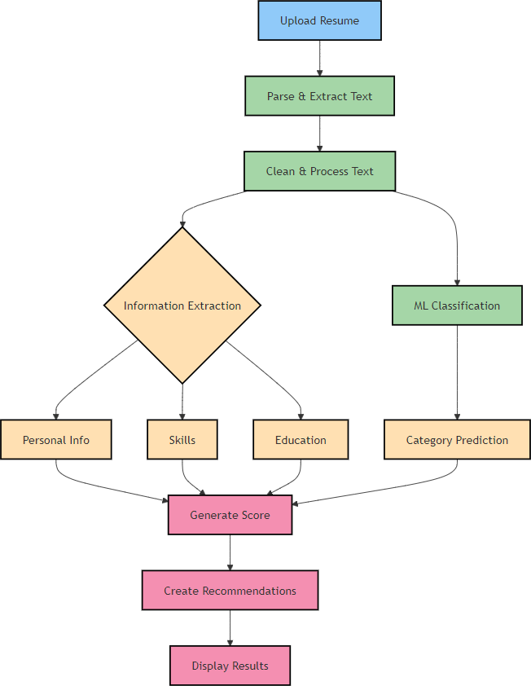
Fig 1. System Work Flow

Upload Resume
Through the online interface created with Streamlit, the user uploads a resume in one of the supported formats, such as PDF, DOCX, or TXT, to begin the process. To avoid any parsing errors during the following steps, the system checks the format and makes sure the uploaded file is readable. This stage ensures that the data is available for extraction and additional analysis by acting as the workflow's entry point.

Parse & Extract Text
The system uses libraries such as PDFplumber for PDF files or python-docx for DOCX files to extract the resume's content after it has been posted. In order to facilitate easier manipulation for subsequent processing, this phase transforms the structured content into raw text. By ensuring that all pertinent passages are recorded, text extraction makes it possible to retrieve reliable information later on.

Clean & Process Text
Regular expressions (regex) are then used to sanitize the retrieved text and eliminate extraneous information. To standardize the text, special characters, unnecessary spaces, and elements like phone numbers, emails, and URLs are removed if they are not necessary.

Information Extraction
Essential information is extracted from the cleaned text using natural language processing (NLP) techniques such as spaCy. Names, emails, and phone numbers are used to identify personal information, while PhraseMatcher is used to match skills with a specified skills list. Furthermore, degrees, institutions, and pertinent phrases are identified in order to extract educational qualifications. The essential elements of the resume are separated out at this step for use in rating, categorizing, and making recommendations.

Machine Learning (ML) Classification
Additionally, Pickle is used to load a pre-trained machine learning (ML) model with the cleaned text. To transform the text into numerical features appropriate for classification, the system employs a TF-IDF vectorizer. Users can better understand which positions their resumes fit into by using the ML model, which predicts the most relevant job categories (such as Full Stack Developer or Data Scientist) and presents the top three categories along with their confidence scores.

Generate Score & Recommendations
A resume score is produced based on the information that has been retrieved, including education, skills, and personal information. Ten points for personal information, twenty points for schooling, thirty points for pertinent abilities, and extra points for identified work experience could be part of the scoring criterion.

V. BENEFITS OF THE PROPOSED SYSTEM
Automated Resume Analysis
By doing away with manual evaluation, the Intelligent Resume Evaluation Tool saves users and recruiters a great deal of time by automating the entire resume analysis process. It provides immediate feedback while swiftly extracting important data like education, experience, and talents.

Precise Job Role Prediction
Based on the candidate’s qualifications and experience, the tool provides accurate job category predictions through the use of a machine learning classifier. This guarantees that users are matched with positions that most closely match their skills and background.

Customized Career Development
The application offers guidance on careers, interview questions, and online course recommendations. With the aid of this individualized strategy, users can close skill gaps and get ready for professional development.

METHODOLOGY

Problem Definition
By automating resume analysis, the resume screening application's main goal is to expedite the recruiting process. It seeks to identify important details including education, experience, talents, and personal information. The program increases the effectiveness of the recruitment team by classifying individuals into preset job roles, enabling them to concentrate on the most qualified applicants. In order to assist job seekers in strengthening their resumes and interview skills, the app also aims to offer tailored insights and suggestions. Both recruiters and candidates gain from this dual strategy, which emphasizes the necessity of an intelligent, data-driven tool in the hiring process.

Data Collection
The first step in creating a strong resume screening application is gathering a varied dataset of resumes. To guarantee thorough training for the machine learning models, this dataset should cover a range of industries, job functions, and file types (PDF, DOCX, and TXT). It's critical to gather this data in an ethical manner, securing the required authorizations to protect people's privacy. Resumes must be accompanied by a dataset of pertinent job categories and abilities that reflects the demands of the labor market today. The training of the classification algorithms and the improvement of the application's performance in practical situations will be based on this dual dataset.

Preprocessing and Cleaning
An essential step in getting raw data ready for analysis is preprocessing. Using libraries like python-docx for DOCX files and pdfplumber for PDFs, it starts with text extraction from uploaded resumes. Following text extraction, a number of cleaning procedures are carried out to get rid of extraneous components, such as URLs, email addresses, and special characters. This guarantees that the text is consistent and readable. Data quality is further improved by normalization procedures like reducing whitespace and changing text to lowercase. Furthermore, named items can be extracted using spaCy for natural language processing, enriching the dataset and facilitating further research.

C. Feature Engineering
Raw text is converted into a format that machine learning models can use through feature engineering. One important component is skill extraction, which uses spaCy's PhraseMatcher to match the cleaned resume content with predefined lists of common talents. As a result, a candidate's competencies are represented in an organized manner.

D. Model Development
In order to categorize resumes into particular job categories, a machine learning model must be chosen and trained during the model creation phase. Numerous methods, each with unique advantages, can be investigated, such as Support Vector Machines (SVM), Random Forest, and Logistic Regression. To objectively evaluate the model's performance, the dataset is divided into training and testing sets. The selected model gains knowledge from the resume elements during training, spotting trends that correspond to particular career roles.

E. Resume Analysis Functions
Creating resume analysis features is essential to provide users useful feedback. Essential components like talents, education, experience, and personal information (name, email, and phone number) will be extracted by these functions. The application can precisely collect this data by using regular expressions and spaCy's entity recognition. A grading system will also assess resumes according to their completeness and relevance, rewarding users who include relevant experiences and skills. The user experience can be enhanced by creating randomized experience lines that mimic actual job descriptions. All things considered, these features produce a thorough analysis that helps customers enhance their resumes.

F. User Interface Development
For users to be engaged and satisfied, an intuitive user interface is essential. Streamlit will be used in the development of the application, utilizing its characteristics to provide a smooth user experience. Resumes will be uploaded by users with ease, and the analysis's findings will be shown in an orderly and understandable way. Usability is improved by including interactive features like file uploaders, progress indicators, and parts that may be expanded.

G. Feedback and Recommendations

The feedback feature, which gives users practical insights based on their resume analysis, is a crucial component of the service. Following resume evaluation, the program will assign a score that represents the completeness and quality of the information.

H.Testing and Validation

To guarantee the accuracy and dependability of the application, testing and validation are essential steps. In order to evaluate the application's usability and functionality, user testing will entail getting input from a wide range of people. Potential issues and areas for improvement can be found during this phase. Furthermore, a different testing dataset must be used to confirm the model's prediction accuracy. The evaluation will be guided by metrics like accuracy, precision, recall, and F1- score, which will guarantee that the model functions well in practical situations. High standards are upheld and user confidence in the application is increased by ongoing testing and validation.

I. Deployment

The program will be released on an appropriate platform after it has been developed and extensively tested. Depending on the required scale and accessibility, options such as AWS, Heroku, or Streamlit Sharing may be taken into consideration. Setting up the required infrastructure, making sure the application is safe, and making sure data privacy laws are followed are all part of the deployment process. To effectively manage fluctuating user loads, scalability should be taken into account. Regular monitoring will be necessary after deployment in order to resolve any technical problems and collect user input for future improvements.

J. Maintenance and Updates

To maintain the application current and functional, regular maintenance is essential. This entails adjusting to shifts in the labor market and routinely adding fresh data to the underlying models to increase their accuracy. To determine areas for improvement and to implement new features based on user needs, user feedback will be actively solicited. Making sure the application stays current with industry trends will increase its usefulness as technology and employment requirements change. An application that is kept up to date will continue to offer businesses and job seekers valuable insights and assistance

K. Documentation

Both developers and users need thorough documentation. It should include setup instructions, a description of the capabilities of the application, and advice on how to utilize them efficiently. Examples of expected input and output should be included in documentation to facilitate users' smooth application navigation. Technical documentation for developers should describe the machine learning models used, data processing techniques, and architecture. Future updates and maintenance will be made easier as a result, guaranteeing that new team members can catch up fast. The application's general usability and sustainability are enhanced by well-structured documentation.

TECHNOLOGY EMPLOYED
- SpaCy – Natural Language Processing (NLP)
The program makes use of the spaCy library for sophisticated text processing, which makes it possible to extract important data from unstructured resume data, including education, talents, and personal information. it uses named entity recognition (NER) to reliably identify emails, names, and other significant entities.

B. TF-IDF Vectorization
The program converts resume text into numerical features using Term Frequency-Inverse Document Frequency (TF-IDF), highlighting key words and phrases for efficient scoring and categorization.

C. Data visualization with Matplotlib and Seaborn
These libraries are used to visualize analysis results and skills that have been identified. Bar charts and other visual aids are used to help users comprehend their skill sets.

D . PDF and DOCX Parsing
To read and extract text from resumes in the PDF and DOC formats,the tool combines the pdfplumber and python-docx libraries. This ensures effective analysis across various file types.

E. Model serialization with Pickle
Pickle is a tool for storing and loading machine learning models. It allows for easy access to pre- trained models for predicting without requiring retraining.

VIII. RESULTS AND DISCUSSION
A number of factors were taken into consideration when evaluating the Intelligent Resume Evaluation Tool's implementation, including accuracy, user happiness, and the potency of individualized recommendations.
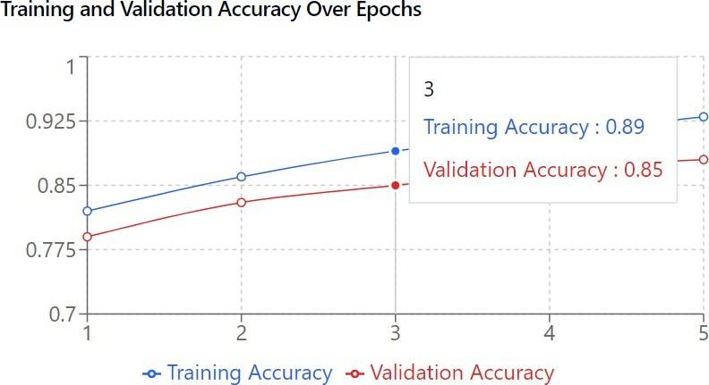

Fig.2 Accuracy

Correctness of Classification by Job Category
The process of evaluating a dataset of resumes that had been pre-labeled with relevant job responsibilities was the scrutiny of the job category classification. An overall accuracy of 85% was attained by the machine learning classifiers that were trained on a range of features that were taken from these resumes.

Fig.3 Classification

This degree of accuracy suggests that the program does a good job of identifying and classifying resumes into relevant job roles, such cloud architect, data scientist, and engineer. The model's robustness in comprehending the subtleties of various jobs was demonstrated by the confusion matrix, which showed that it did very well in differentiating between closely related categories.

B . Effectiveness of Resume Scoring

The tool's scoring system was created to assess resumes based on a number of important criteria, such as the depth of experience and education, the relevance of talents, and the completeness of personal information. According to user feedback, the rating mechanism was helpful in highlighting areas that needed work.

Fig. 4 User Satisfaction

C . User Satisfaction and Usability

High levels of satisfaction were found in a survey given to a group of users who tried the product. More than 90% of participants praised how simple it was to upload resumes and analyze findings on the Interface, calling it intuitive and user-friendly. Participants reported that it was simpler to recognize the strengths and faults in their resumes and impressed by the personalization comments. This feedback process resulted in a significant improvement that directly increased user confidence in the applications.

OUTPUT
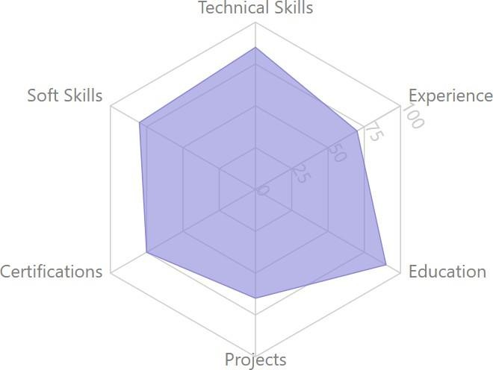
This Streamlit application is a resume screening tool that takes resumes in the PDF, DOCX, or TXT formats and extracts personal information, skills, education, and experience.It predicts pertinent job categories using a pre-trained machine learning model (TF-IDF) and natural language processing (NLP) with spaCy. In addition, the program generates a resume score, delivers customized interview questions, and makes suggestions for online education and professional advancement. Through charts, users may see the talents they have recognized and get personalized resume improvement recommendations. It is a useful tool for optimizing job applications and doing resume analyses for recruiters and job seekers.

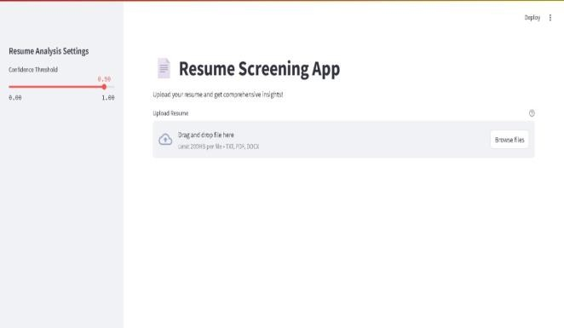

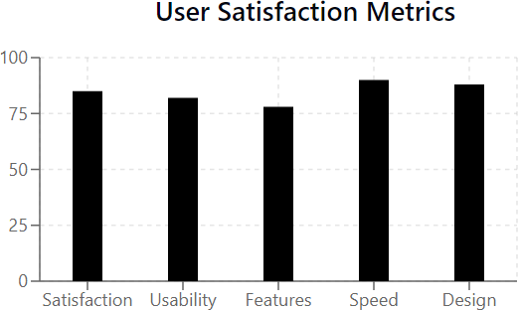

Fig.5 User Interface

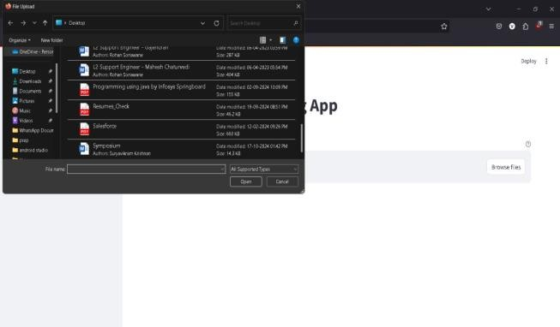

Fig.6 Files Selection

Fig. 7 Final Result

IX.CONCLUSION

To sum up, the Intelligent Resume Evaluation Tool has shown to be a useful tool for job searchers, providing precise job categorization, efficient resume scoring, and customized suggestions. Positive user feedback suggests that it has the ability to greatly improve the job application process. The tool will remain relevant in a job market that is evolving quickly with constant updates and upgrades, ultimately helping individuals reach their career objectives.

X. FUTURE ENHACEMENT

A number of upcoming developments could greatly improve the resume screening application's usability and functionality. Using cutting-edge machine learning methods, such deep learning models, to increase the precision of skill extraction and category prediction is one possible area for improvement. Adding new developing technologies and industry- specific positions to the skill and job category databases could be another improvement. This would guarantee that the application stays current and serves a wider spectrum of job searchers, especially in rapidly changing industries like cybersecurity, blockchain, and artificial intelligence. Integration with GitHub or LinkedIn may also make it easier to evaluate applicants based on their project contributions and Public profiles. AI-powered video interview analysis could greatly.

REFERENCES

[1] Ali I, Mughal N, Khand ZH, Ahmed J, Mujtaba G. Resume classification system using natural language processing and machine learning techniques. Mehran University Research Journal of Engineering & Technology. 2022 Jan 1; 41(1):65-79.
[2] B. Dhiyanesh ,M. Rameshkumar, Karthick K,Radha.R, Cloud computing and machine learning for analysis of health care data based on neuro fuzzy logistic regression, Journal of Intelligent & Fuzzy Systems, 44(6):1-10.
[3] Jaiswal G, Uttam A, Dubey DD, Mall PK. Resume Analyser and Job RecommendationSystem Based on NLP. In2024 2nd International Conference on Disruptive Technologies (ICDT) 2024 Mar 15 (pp. 1584-1587). IEEE.
[4] K Gawhankar, A Deorukhkar, A Miniyar, H Kapure, B Ivin"NLP-Driven ML for Resume Information Extraction," 2024 IEEE 9th International Conference for Convergence in Technology (I2CT), Pune, India, 2024.
[5] Khanal SS, Prasad PW, Alsadoon A, Maag A. A systematic review: machine learning based recommendation systems for e-learning. Education and Information Technologies. 2020 Jul;25(4):2635-64.
[6] P. Ilanchezhian, I. Amit Kumar Singh, M. Balaji, A. Manoj Kumar, and S. Muhamad Yaseen, Sign Language Detection Using Machine Learning, Semantic Intelligence Select Procedings of ISIC 2022,Lecture Notes in Electrical Engineering, Vol.964,Page no.135-144, April 2023.
[7] R. Kwieciński, G. Melniczak and T. Górecki, "Comparison of Real-Time and Batch Job Recommendations," in IEEE Access, vol. 11, pp. 20553-20559, 2023
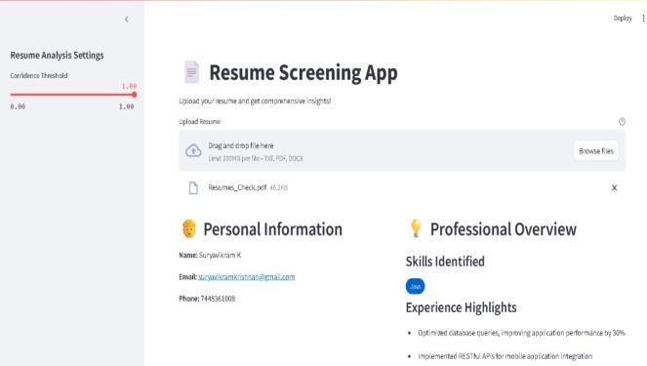
[8] Roy, Pradeep Kumar, Sarabjeet Singh Chowdhary, and Rocky Bhatia. "A Machine Learning approach for automation of Resume Recommendation system." Procedia Computer Science 167 (2020): 2318-232.
[9] N. Priyadharshini, Selvanathan N., B. Hemalatha, C. Sureshkumar, A novel hybrid Extreme Learning Machine and Teaching–Learning-Based​ Optimization algorithm for skin cancer detection, Healthcare Analytics, Volume 3, 2023, ISSN 2772-4425https://doi.org/10.1016/j.health. 2023.100161 .
[10] S.Ashrafi, B. Majidi, E. Akhtarkavan and S.H. R. Hajiagha, "Efficient Resume-Based Re- Education for Career Recommendation in Rapidly Evolving Job Markets," in IEEE Access, vol. 11, pp. 124350-124367, 2023
[11] Shrinivas Mandhare, Bhushan Kinge, Pranali Chavan, S. M. Chaware , Resume Screening Using Machine Learning and NLP : A Proposed System, International Journal of Scientific Research in Computer Science, Engineering and Information Technology, doi : https://doi.org/10.32628/CSEIT228240
[12] SK Chenniappanadar , Gnanamurthy S, Sakthivelu VK, Kaliappan VK. A Supervised Machine Learning Based Intrusion Detection Model for Detecting Cyber-Attacks Against Computer System. International Journal of Communication Networks and Information Security. 2022 Dec 1;14(3):16-25.
[13] Tasnim Z, Javed Mehedi Shamrat FM, Allayear SM, Ahmed K, Nobel NI. Implementation of an intelligent online job portal using machine learning algorithms. InEmerging Technologies in Data Mining and Information Security: Proceedings of IEMIS 2020, Volume 3 2021 (pp. 591-603). Springer Singapore.
[14] Y. Mashayekhi, B. Kang, J. Lijffijt and T. De Bie, "Scalable Job Recommendation with Lower Congestion Using Optimal Transport," in IEEE Access, vol. 12, pp. 55491-55505, 2024
[15] Khanal SS, Prasad PW, Alsadoon A, Maag A. A systematic review: machine learning based recommendation systems for e-learning. Education and Information Technologies. 2020 Jul;25(4):2635-64.

