1. **INTRODUCTION**

* What are open-source technologies?

Technologies referred to as "open-source" are programmes or devices whose source code is publicly accessible and available for anyone to see, use, change, and distribute. The phrase "open-source" means that the source code of the programme is available to the public and that it can be improved by the community. Increasingly more people are using open-source technology because of its adaptability, transparency, and affordability.

Recent years have seen a major expansion of the open-source movement, leading to the availability of a large number of software programmes and tools. The fact that open-source technologies are frequently more economical than their proprietary versions is one of their key advantages. Anyone with access to the source code can alter and change the software to suit their own requirements without paying exorbitant licencing fees.

What are hardware and software?

Hardware and software are two essential components of a computer system. Hardware refers to the physical components that make up a computer, such as the central processing unit (CPU), memory, storage devices, input/output devices, and other peripherals. In other words, hardware encompasses all the tangible, physical parts of a computer that you can touch and see.

Software, on the other hand, refers to the intangible components of a computer system, including programs, applications, and operating systems. Software is a set of instructions that tell the hardware what to do and how to do it. Without software, the hardware would not be able to perform any useful tasks or functions. There are two main categories of software: system software and application software. System software includes the operating system, device drivers, and other tools that enable the computer to run, manage hardware resources, and provide a platform for other software applications. Application software includes programs that perform specific tasks, such as word processing, web browsing, or gaming.

In summary, hardware and software are the two critical components that work together to make a computer system function. Hardware provides the physical infrastructure and resources, while software provides the instructions and programs that utilize those resources to perform specific tasks and functions.

* 1. Objective of the project

Suppose you are a network analyst, working in the Infotech department of LPU. You have been assigned the responsibility of inspecting HTTP Traffic and retrieving usernames and passwords from the BSNL website, using an appropriate tool.

* 1. Description of the project

Analyzing the information sent between a client and a server via the HTTP protocol is part of inspecting HTTP traffic. Network analysts can learn more about the magnitude, content, and destination of the data being transmitted through this process. Network analysts can spot potential security holes in the network, including malware infections or cyberattacks, by examining HTTP traffic. They can also assess how well web apps are doing and find any potential problems or bottlenecks that might be interfering. Overall, examining HTTP traffic is a crucial activity for network analyzers because it contributes to the efficiency and security of networks and web services.

In order to retrieve usernames and passwords from the BSNL website, one must first extract the login information that users use to access their accounts there. To check the website's security and find any potential flaws, network analysts often perform this method. A network packet analyzer or password cracking programme that can intercept and decode network traffic may be useful for recovering usernames and passwords. It is crucial to remember that it is illegal and immoral to retrieve usernames and passwords without the right authorization or approval. As a result, this procedure should only be carried out by authorised individuals who have undergone the appropriate training and have the required permission.

* 1. Scope of the project

Examining HTTP traffic has a wide range of applications in network analysis and security. Using HTTP traffic inspection, network researchers can find performance hiccups, security flaws, and other network-related problems. The purpose of HTTP traffic inspection specifically is examining HTTP requests' and answers' contents to find potential security threats like malware, online attacks, or data breaches. Additionally, it can be used to assess the effectiveness of online apps and spot any potential problems. Additionally helpful for analysing network traffic patterns, spotting suspect activity, and ensuring adherence to security regulations is HTTP traffic inspection.

The scope of obtaining usernames and passwords from the BSNL website includes evaluating the site's security measures and locating any weaknesses, assuming that the retrieval is authorised. This procedure can be included in a thorough security audit that aims to determine how well the website's security features work and how well user data is safeguarded. Additionally, if a user has forgotten or lost their login information and needs assistance, recovering usernames and passwords may be helpful. Overall, only authorised staff should be able to retrieve usernames and passwords from a website, and it must adhere to all ethical and regulatory requirements.

2.) System Description

The system has 8 GB of RAM installed, but only 7.83 GB is available for use. The processor is an Intel Core i5-10300H CPU running at a clock speed of 2.50 GHz. The graphics processing unit (GPU) is an integrated Intel UHD Graphics, which has a total available graphics memory of 4139 MB. The dedicated video memory of the GPU is 128 MB, while the shared system memory is 4011 MB. This information provides a summary of the hardware specifications of the computer, including the RAM, CPU, and GPU details.

3.) System Snapshots and full Analysis Report

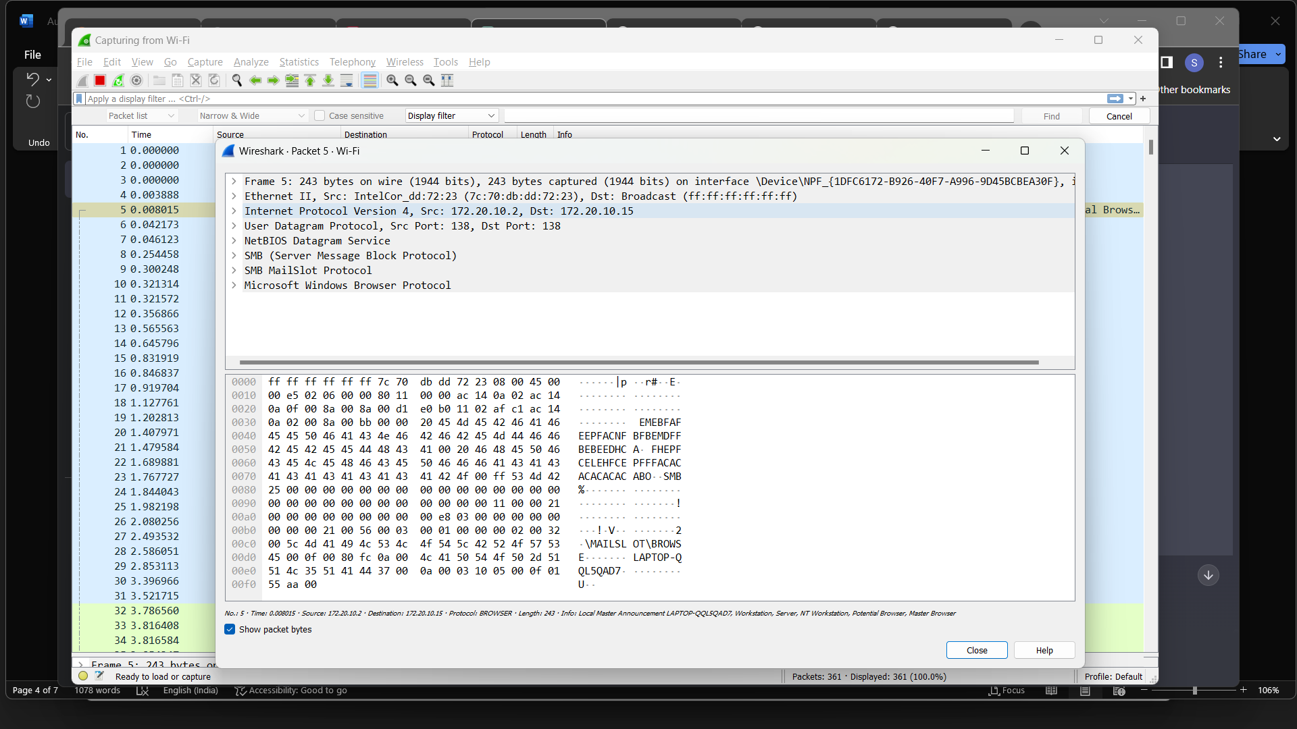

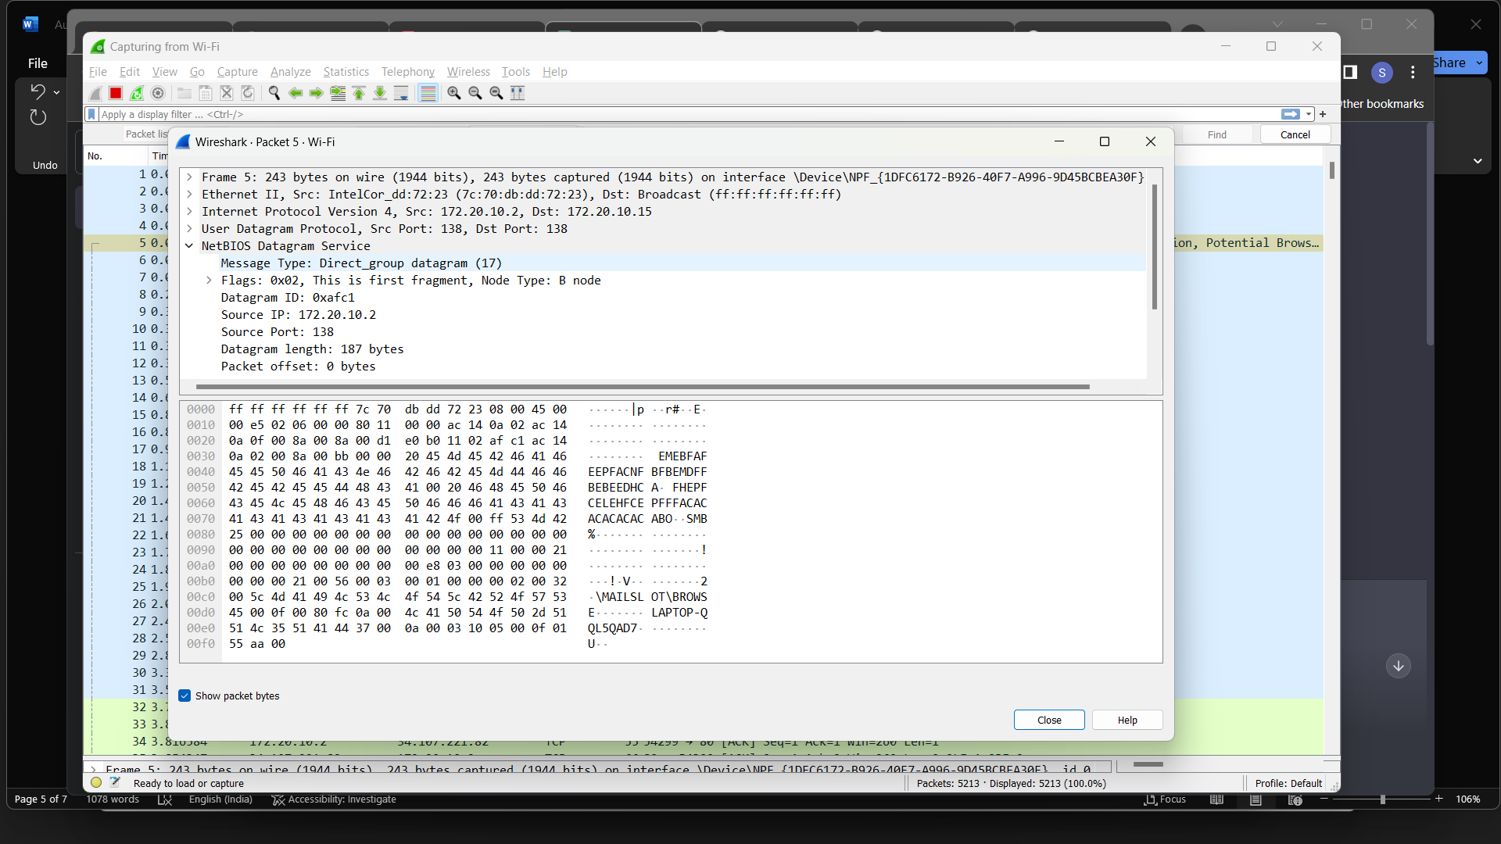

This packet is likely part of a NetBIOS name resolution process, commonly used in Windows networking.

The packet is being sent from the IP address 172.20.10.2 to the broadcast address 172.20.10.15. The source MAC address belongs to an Intel Corporation device and the destination MAC address is the broadcast address. This indicates that the packet is being sent to all devices on the local network.

The UDP source and destination port numbers are both 138, which is the NetBIOS datagram service port number.

The NetBIOS datagram packet contains a message type of Direct_group datagram (17), which indicates that the packet is being sent to a group of nodes on the network. The flags field has a value of 0x02, indicating that this is the first fragment of a larger message, and the node type is B node.

The Source name field contains the name of the sending device, which is LAPTOP-QQL5QAD7<20> (Server service), and the Destination name field contains the name of the destination, which is WORKGROUP<1e> (Browser Election Service).

The SMB protocol is also present in the packet, which is used for file and printer sharing in Windows networks. The SMB MailSlot Protocol and Microsoft Windows Browser Protocol are also included in the packet, which are used for browser elections and browsing the network respectively.

Overall, this packet is part of a process used to discover and communicate with devices on a Windows network.

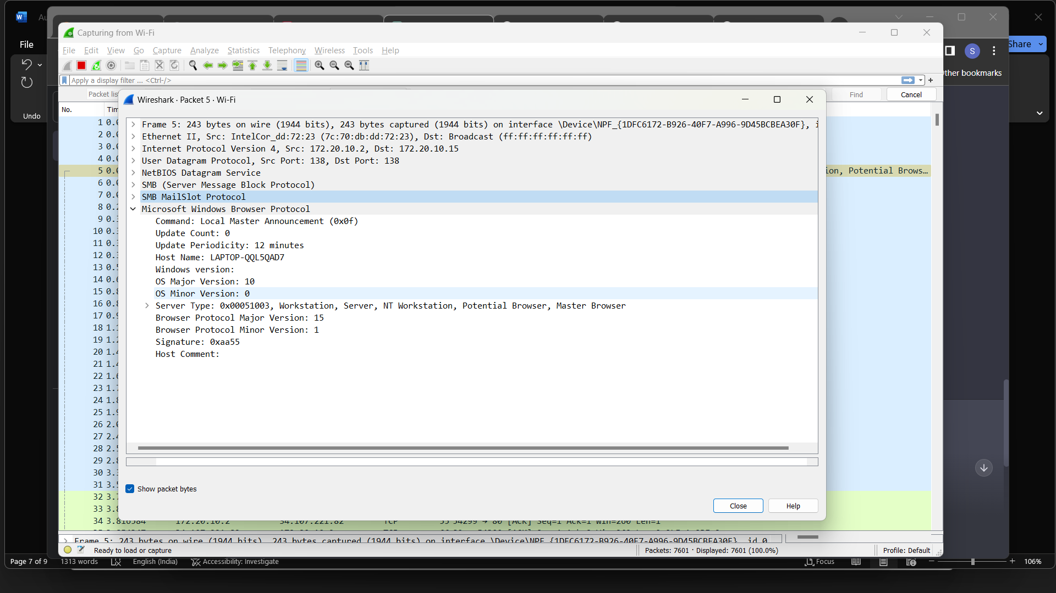

This network capture appears to be a broadcast message from a device with source IP address 172.20.10.2 and MAC address 7c:70:db:dd:72:23, using the User Datagram Protocol (UDP) on port 138 to communicate with destination IP address 172.20.10.15.

The message is using the NetBIOS Datagram Service and the SMB (Server Message Block Protocol) to communicate with the Microsoft Windows Browser Protocol. Specifically, it is a Local Master Announcement (command 0x0f) message, which is used by devices running the Browser service in Windows networking to advertise their role and availability to other devices on the network.

The message contains information about the device sending the message, including its hostname (LAPTOP-QQL5QAD7), operating system version (Windows 10), and the fact that it is a potential browser, master browser, and workstation/server. It also includes a host comment field, which appears to be empty in this case.

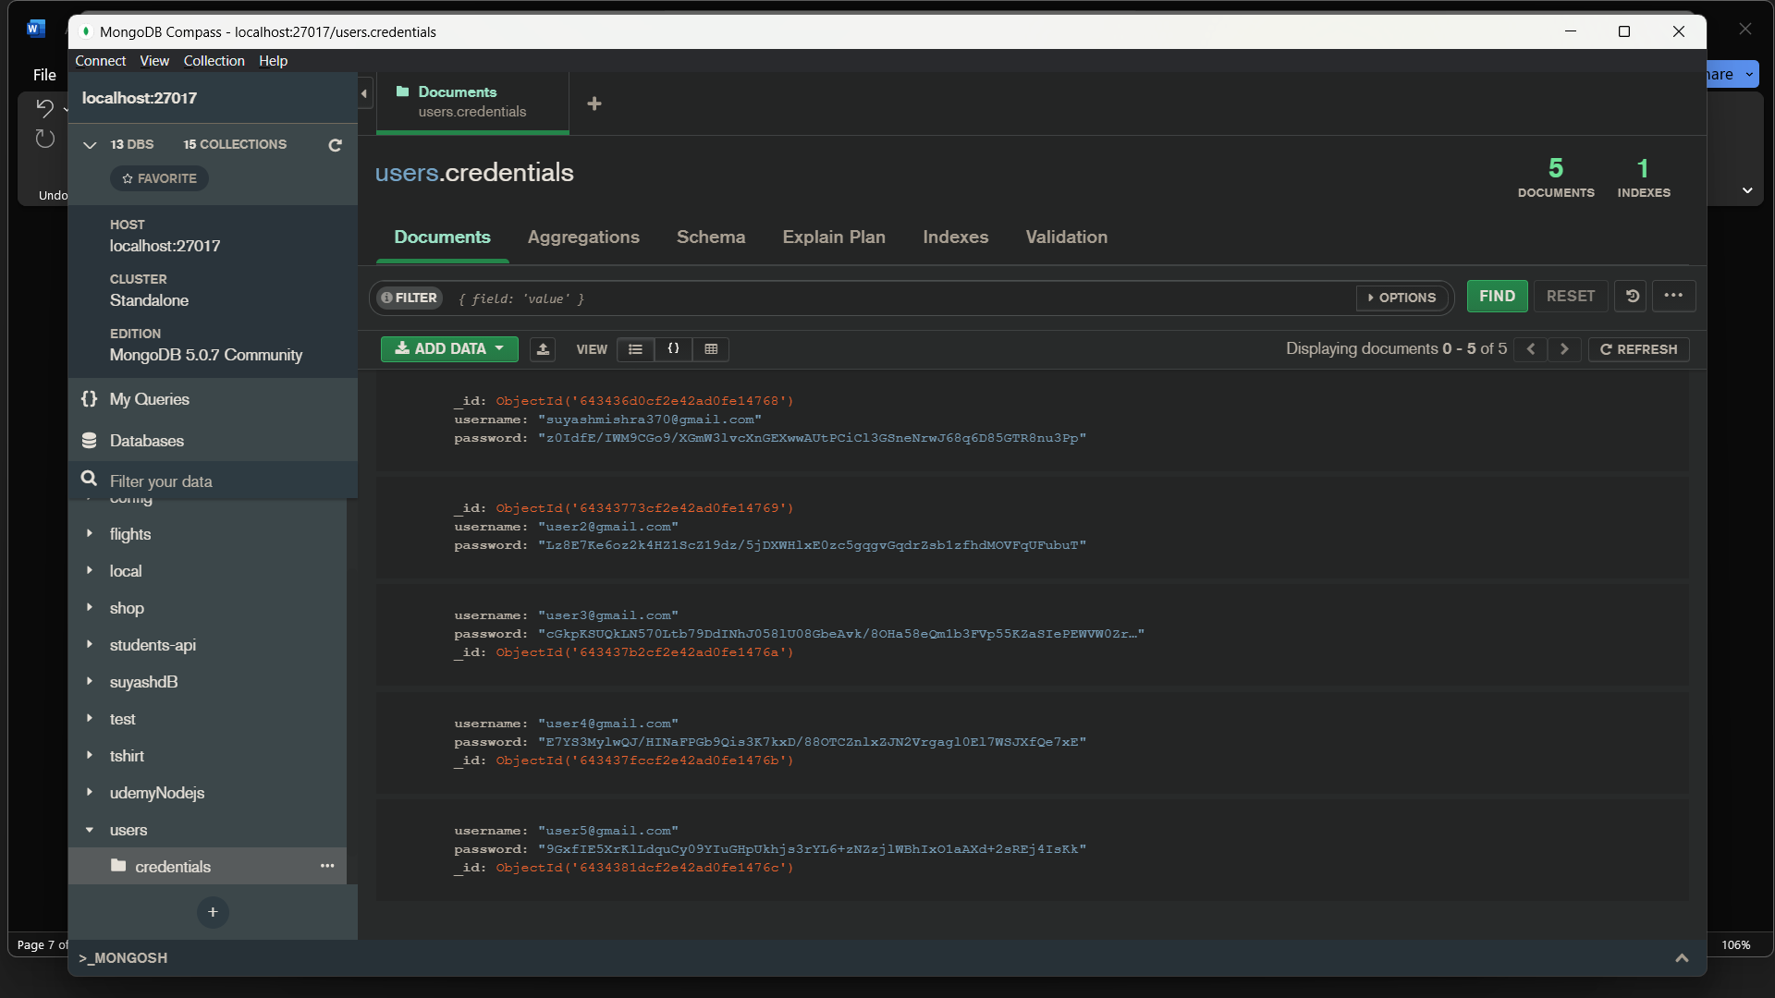

MongoDB schema with 2 fields "username" and "password" defines a user's login credentials.

MongoDB query to retrieve the "username" and "password" fields in Node.js:

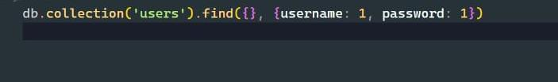

This query will retrieve all documents from the "users" collection and return only the "username" and "password" fields. You can then handle the query result in your Node.js code as needed.

4.) References

* "Inspect network activity" from the Google Chrome Developer Tools documentation - https://developer.chrome.com/docs/devtools/network/
* "How to intercept HTTP traffic using Fiddler" from the Telerik documentation - https://docs.telerik.com/fiddler/Configure-Fiddler/Tasks/InterceptHTTPS
* "Inspecting network activity" from the Mozilla Developer Network documentation - https://developer.mozilla.org/en-US/docs/Tools/Network_Monitor
* "Using Wireshark to inspect HTTP traffic" from the Wireshark documentation - <https://www.wireshark.org/docs/wsug_html_chunked/ChAdvHTTPCapture.html>
* MySQL - A popular open-source relational database management system (RDBMS) that is widely used for web applications. Website: https://www.mysql.com/
* PostgreSQL - Another popular open-source RDBMS known for its stability, scalability, and support for advanced SQL features. Website: https://www.postgresql.org/
* MongoDB - An open-source NoSQL document-oriented database that is designed for scalability, flexibility, and performance. Website: https://www.mongodb.com/
* Apache Cassandra - An open-source NoSQL distributed database that is designed for high availability, scalability, and fault tolerance. Website: https://cassandra.apache.org/
* Redis - An open-source in-memory data structure store that is used as a database, cache, and message broker. Website: https://redis.io/
* Apache HBase - An open-source NoSQL distributed database that is built on top of Apache Hadoop and is designed for big data applications. Website: https://hbase.apache.org/