# Three Dimensional Transformations

The geometric transformations play a vital role in generating images of three Dimensional objects with the help of these transformations. The location of objects relative to others can be easily expressed. Sometimes viewpoint changes rapidly, or sometimes objects move in relation to each other. For this number of transformation can be carried out repeatedly.

## Translation

It is the movement of an object from one position to another position. Translation is done using translation vectors. There are three vectors in 3D instead of two. These vectors are in x, y, and z directions. Translation in the x-direction is represented using Tx. The translation is y-direction is represented using Ty. The translation in the z- direction is represented using Tz.

If P is a point having co-ordinates in three directions (x, y, z) is translated, then after translation its coordinates will be (x1 y1 z1) after translation. Tx Ty Tz are translation vectors in x, y, and z directions respectively.

          x1=x+ Tx  
          y1=y+Ty  
          z1=z+ Tz

Three-dimensional transformations are performed by transforming each vertex of the object. If an object has five corners, then the translation will be accomplished by translating all five points to new locations. Following figure 1 shows the translation of point figure 2 shows the translation of the cube.

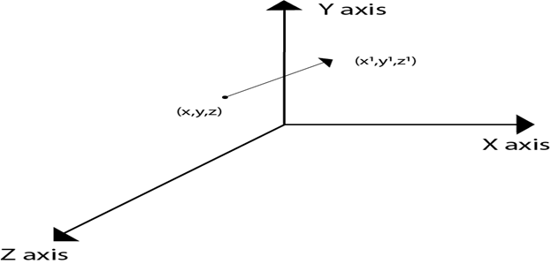  
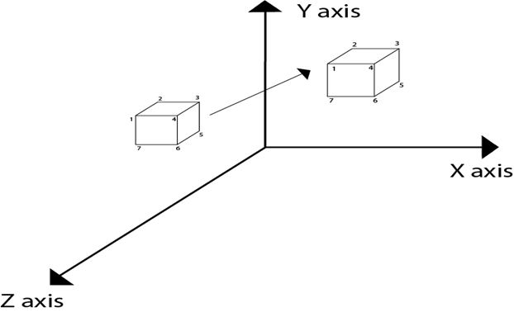

## Matrix for translation

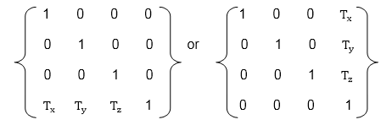

## Matrix representation of point translation

Point shown in fig is (x, y, z). It become (x1,y1,z1) after translation. Tx Ty Tz are translation vector.

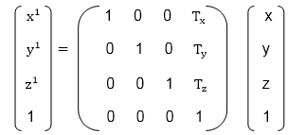

**Example:** A point has coordinates in the x, y, z direction i.e., (5, 6, 7). The translation is done in the x-direction by 3 coordinate and y direction. Three coordinates and in the z- direction by two coordinates. Shift the object. Find coordinates of the new position.

**Solution:** Co-ordinate of the point are (5, 6, 7)  
                 Translation vector in x direction = 3  
                 Translation vector in y direction = 3  
                 Translation vector in z direction = 2  
                 Translation matrix is  
                 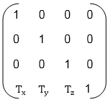

Multiply co-ordinates of point with translation matrix

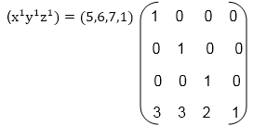

                 = [5+0+0+30+6+0+30+0+7+20+0+0+1] = [8991]

x becomes x1=8  
y becomes y1=9  
z becomes z1=9

# Three Dimensional Transformations

The geometric transformations play a vital role in generating images of three Dimensional objects with the help of these transformations. The location of objects relative to others can be easily expressed. Sometimes viewpoint changes rapidly, or sometimes objects move in relation to each other. For this number of transformation can be carried out repeatedly.

## Translation

It is the movement of an object from one position to another position. Translation is done using translation vectors. There are three vectors in 3D instead of two. These vectors are in x, y, and z directions. Translation in the x-direction is represented using Tx. The translation is y-direction is represented using Ty. The translation in the z- direction is represented using Tz.

If P is a point having co-ordinates in three directions (x, y, z) is translated, then after translation its coordinates will be (x1 y1 z1) after translation. Tx Ty Tz are translation vectors in x, y, and z directions respectively.

          x1=x+ Tx  
          y1=y+Ty  
          z1=z+ Tz

Three-dimensional transformations are performed by transforming each vertex of the object. If an object has five corners, then the translation will be accomplished by translating all five points to new locations. Following figure 1 shows the translation of point figure 2 shows the translation of the cube.

  


## Matrix for translation



## Matrix representation of point translation

Point shown in fig is (x, y, z). It become (x1,y1,z1) after translation. Tx Ty Tz are translation vector.



**Example:** A point has coordinates in the x, y, z direction i.e., (5, 6, 7). The translation is done in the x-direction by 3 coordinate and y direction. Three coordinates and in the z- direction by two coordinates. Shift the object. Find coordinates of the new position.

**Solution:** Co-ordinate of the point are (5, 6, 7)  
                 Translation vector in x direction = 3  
                 Translation vector in y direction = 3  
                 Translation vector in z direction = 2  
                 Translation matrix is  
                 

Multiply co-ordinates of point with translation matrix



                 = [5+0+0+30+6+0+30+0+7+20+0+0+1] = [8991]

x becomes x1=8  
y becomes y1=9  
z becomes z1=9

# Scaling

Scaling is used to change the size of an object. The size can be increased or decreased. The scaling three factors are required Sx Sy and Sz.

Sx=Scaling factor in x- direction  
Sy=Scaling factor in y-direction  
Sz=Scaling factor in z-direction

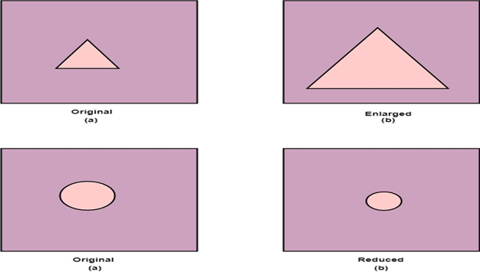

## Matrix for Scaling

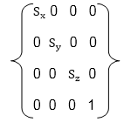

## Scaling of the object relative to a fixed point

Following are steps performed when scaling of objects with fixed point (a, b, c). It can be represented as below:

1. Translate fixed point to the origin
2. Scale the object relative to the origin
3. Translate object back to its original position.

#### Note: If all scaling factors Sx=Sy=Sz.Then scaling is called as uniform. If scaling is done with different scaling vectors, it is called a differential scaling.

In figure (a) point (a, b, c) is shown, and object whose scaling is to done also shown in steps in fig (b), fig (c) and fig (d).

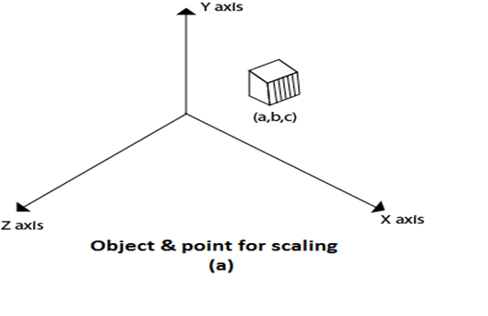  
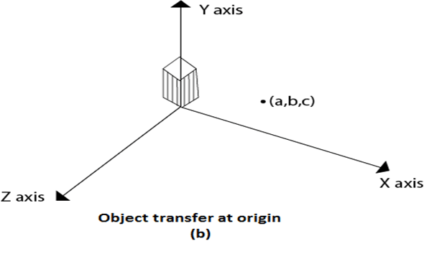  
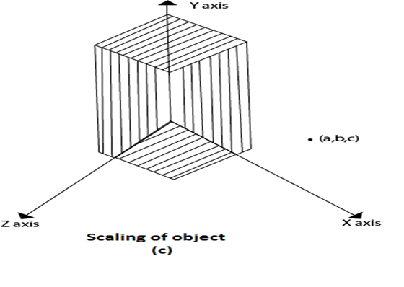  
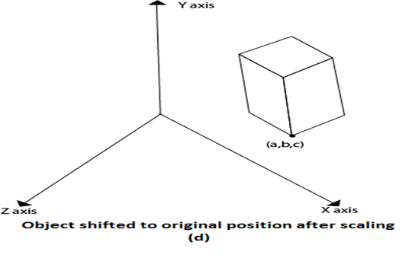

# Rotation

It is moving of an object about an angle. Movement can be anticlockwise or clockwise. 3D rotation is complex as compared to the 2D rotation. For 2D we describe the angle of rotation, but for a 3D angle of rotation and axis of rotation are required. The axis can be either x or y or z.

**Following figures shows rotation about x, y, z- axis**

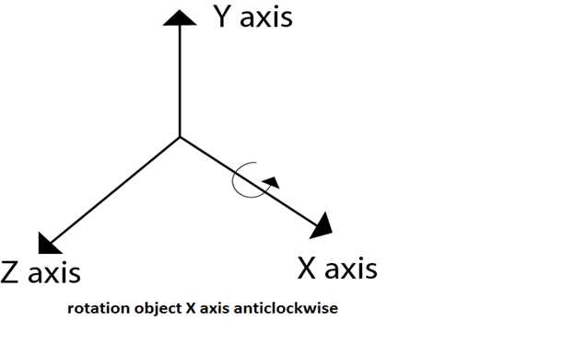  
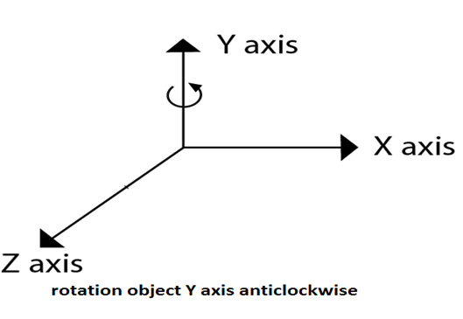  
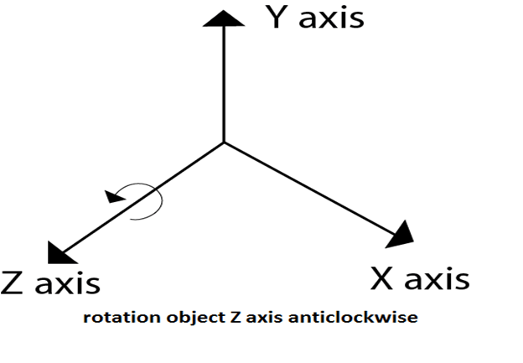  
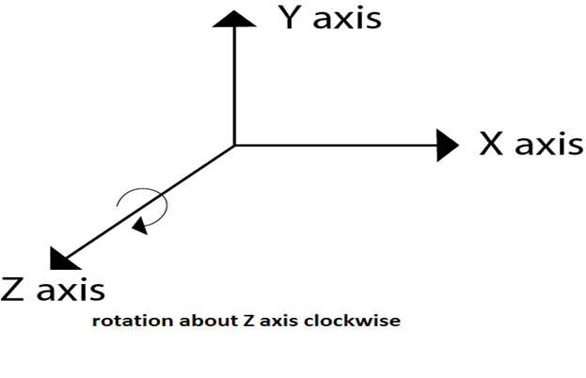  
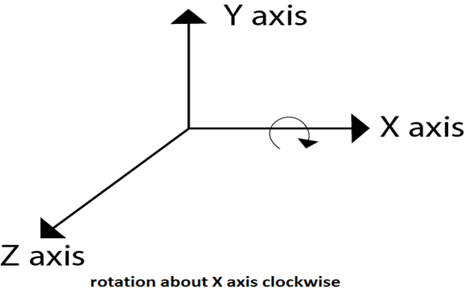

Following figure show rotation of the object about the Y axis

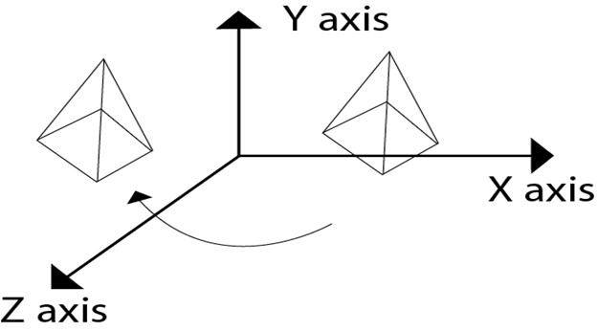

Following figure show rotation of the object about the Z axis

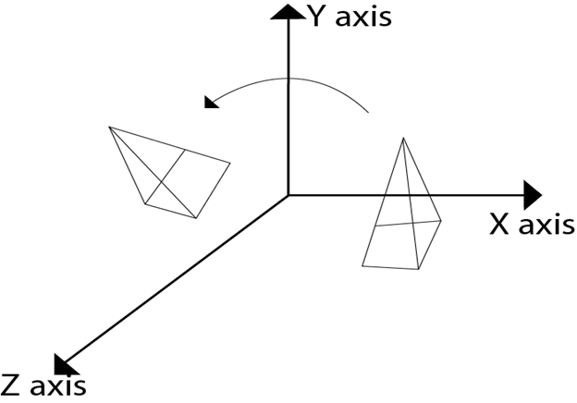

# Rotation about Arbitrary Axis

When the object is rotated about an axis that is not parallel to any one of co-ordinate axis, i.e., x, y, z. Then additional transformations are required. First of all, alignment is needed, and then the object is being back to the original position. Following steps are required

1. Translate the object to the origin
2. Rotate object so that axis of object coincide with any of coordinate axis.
3. Perform rotation about co-ordinate axis with whom coinciding is done.
4. Apply inverse rotation to bring rotation back to the original position.

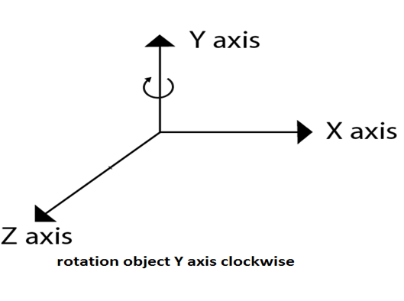

## Matrix for representing three-dimensional rotations about the Z axis

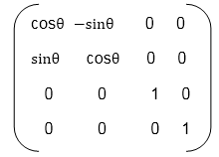

## Matrix for representing three-dimensional rotations about the X axis

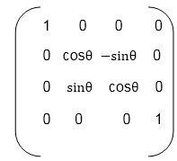

## Matrix for representing three-dimensional rotations about the Y axis

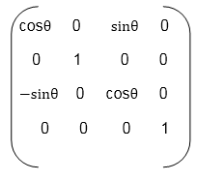

**Following figure show the original position of object and position of object after rotation about the x-axis**

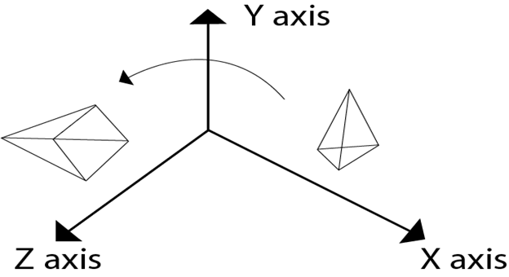

5. Apply inverse translation to bring rotation axis to the original position.

For such transformations, composite transformations are required. All the above steps are applied on points P' and P".Each step is explained using a separate figure.

**Step1:** Initial position of P' and P"is shown

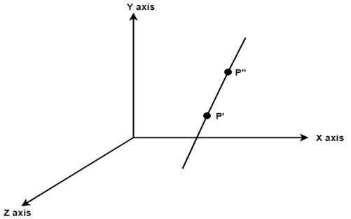

**Step2:** Translate object P' to origin

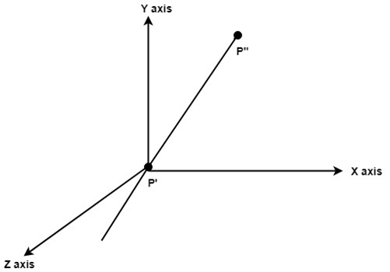

**Step3:** Rotate P" to z axis so that it aligns along the z-axis

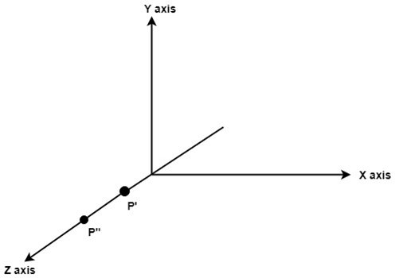

**Step4:** Rotate about around z- axis

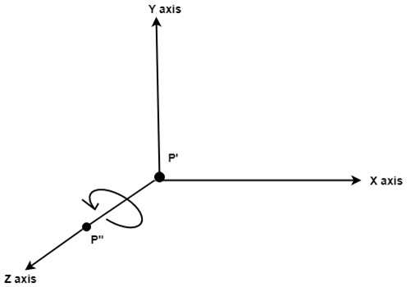

**Step5:** Rotate axis to the original position

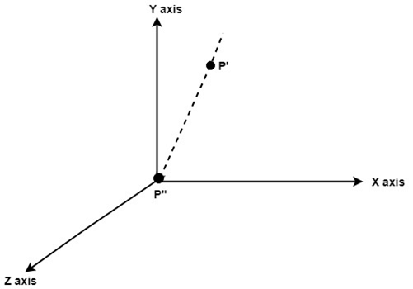

**Step6:** Translate axis to the original position.

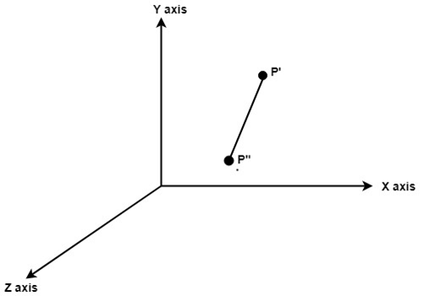

## Inverse Transformations

These are also called as opposite transformations. If T is a translation matrix than inverse translation is representing using T-1. The inverse matrix is achieved using the opposite sign.

**Example1:** Translation and its inverse matrix

**Translation matrix**

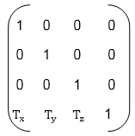

**Inverse translation matrix**

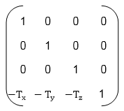

**Example2:** Rotation and its inverse matrix

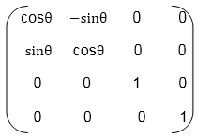

**Inverse Rotation Matrix**

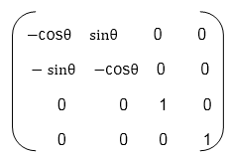

# Reflection

It is also called a mirror image of an object. For this reflection axis and reflection of plane is selected. Three-dimensional reflections are similar to two dimensions. Reflection is 180° about the given axis. For reflection, plane is selected (xy,xz or yz). Following matrices show reflection respect to all these three planes.

**Reflection relative to XY plane**

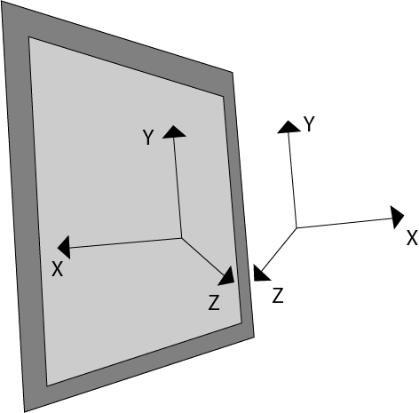  
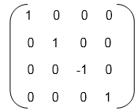

**Reflection relative to YZ plane**

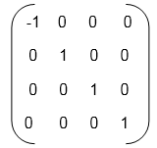

**Reflection relative to ZX plane**

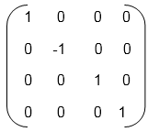

# Shearing

It is change in the shape of the object. It is also called as deformation. Change can be in the x -direction or y -direction or both directions in case of 2D. If shear occurs in both directions, the object will be distorted. But in 3D shear can occur in three directions.

**Matrix for shear**

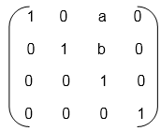  
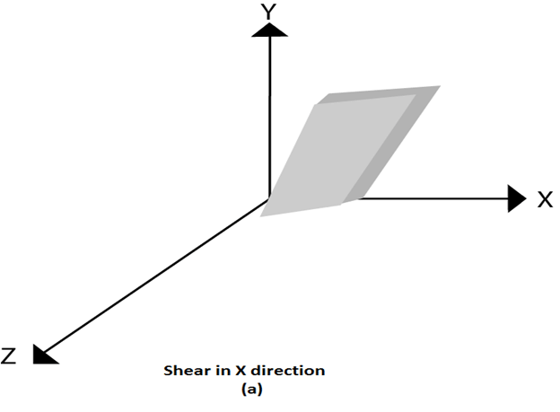  
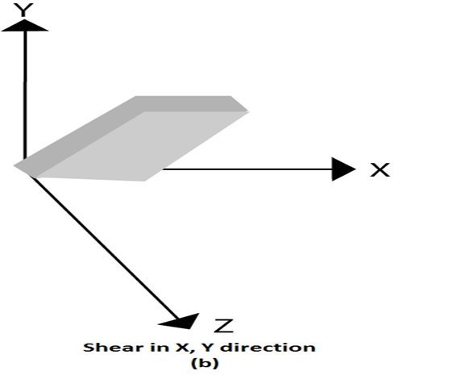  
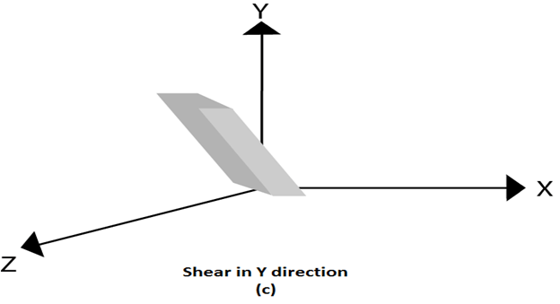

Animation Functions

1. **Morphing:** Morphing is an animation function which is used to transform object shape from one form to another is called Morphing. It is one of the most complicated transformations. This function is commonly used in movies, cartoons, advertisement, and computer games.

### ****Morphing****

Image morphing is a special form of image warping which is a simple and smooth transition between two or more images. In simple words, its like a transformation of one image to another. This is mostly seen in movies and animations.

**For example:**Suppose we want to transform one face into another face. So, the first step would be to select the corresponding features like eyes, nose, and mouth in both images. Then, we would create a smooth transition between these features to create a morphing effect. This is similar to an age filter.

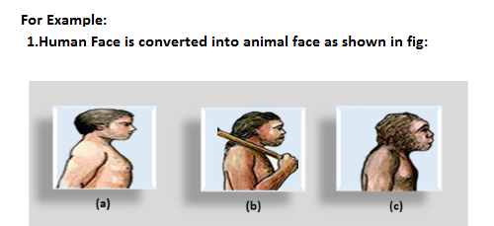  
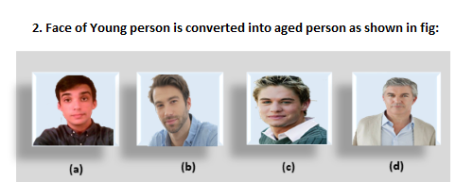

**The process of Morphing involves three steps:**

1. In the first step, one initial image and other final image are added to morphing application as shown in fig: Ist & 4th object consider as key frames.
2. The second step involves the selection of key points on both the images for a smooth transition between two images as shown in 2nd object.

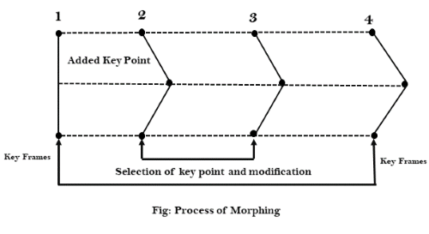

3. In the third step, the key point of the first image transforms to a corresponding key point of the second image as shown in 3rd object of the figure.

2. **Wrapping:** Wrapping function is similar to morphing function. It distorts only the initial images so that it matches with final images and no fade occurs in this function.

3. **Tweening:** Tweening is the short form of 'inbetweening.' Tweening is the process of generating intermediate frames between the initial & last final images. This function is popular in the film industry.

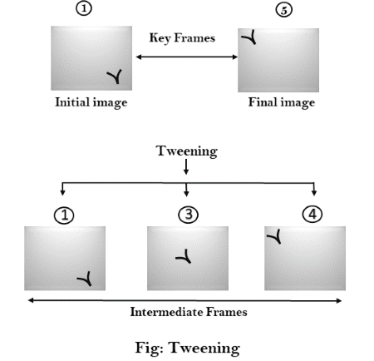

4. **Panning:** Usually Panning refers to rotation of the camera in horizontal Plane. In computer graphics, Panning relates to the movement of fixed size window across the window object in a scene. In which direction the fixed sized window moves, the object appears to move in the opposite direction as shown in fig:

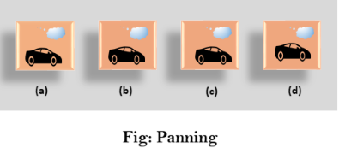

If the window moves in a backward direction, then the object appear to move in the forward direction and the window moves in forward direction then the object appear to move in a backward direction.

5. **Zooming:** In zooming, the window is fixed an object and change its size, the object also appear to change in size. When the window is made smaller about a fixed center, the object comes inside the window appear more enlarged. This feature is known as **Zooming In**.

When we increase the size of the window about the fixed center, the object comes inside the window appear small. This feature is known as **Zooming Out**.

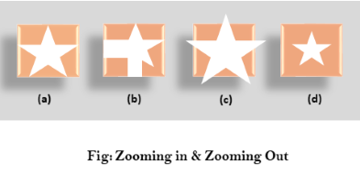

6. **Fractals:** Fractal Function is used to generate a complex picture by using Iteration. Iteration means the repetition of a single formula again & again with slightly different value based on the previous iteration result. These results are displayed on the screen in the form of the display picture.

**Computer Graphics | The RGB color model**

The RGB color model is one of the most widely used color representation method in computer graphics. It use a color coordinate system with three primary colors:

R(red), G(green), B(blue)

Each primary color can take an intensity value ranging from 0(lowest) to 1(highest). Mixing these three primary colors at different intensity levels produces a variety of colors. The collection of all the colors obtained by such a linear combination of red, green and blue forms the cube shaped RGB color space.

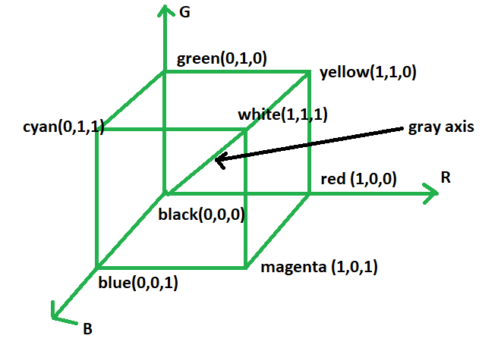

The corner of RGB color cube that is at the origin of the coordinate system corresponds to black, whereas the corner of the cube that is diagonally opposite to the origin represents white. The diagonal line connecting black and white corresponds to all the gray colors between black and white, which is also known as **gray axis**.

In the RGB color model, an arbitrary color within the cubic color space can be specified by its color coordinates: (r, g.b).

**Example:**

(0, 0, 0) for black, (1, 1, 1) for white,

(1, 1, 0) for yellow, (0.7, 0.7, 0.7) for gray

Color specification using the RGB model is an **additive process**. We begin with black and add on the appropriate primary components to yield a desired color. The concept RGB color model is used in **Display monitor**. On the other hand, there is a complementary color model known as **CMY color model**. The CMY color model use a **subtraction process** and this concept is used in the **printer**.

In CMY model, we begin with white and take away the appropriate primary components to yield a desired color.

**Example:**  
If we subtract red from white, what remains consists of green and blue which is cyan. The coordinate system of CMY model use the three primaries’ complementary colors:

C(cray), M(magenta) and Y(yellow)

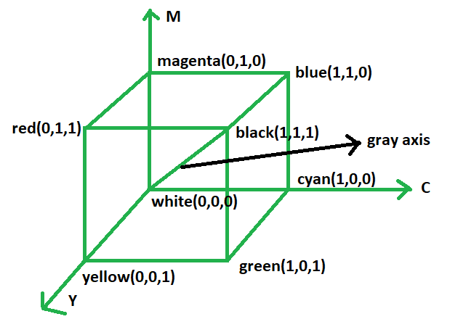

The corner of the CMY color cube that is at (0, 0, 0) corresponds to white, whereas the corner of the cube that is at (1, 1, 1) represents black. The following formulas summarize the conversion between the two color models:

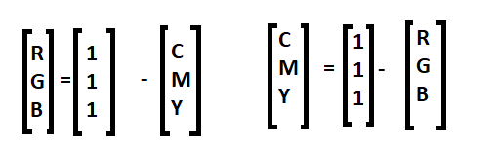

## WHAT IS A COLOR MODEL?

A color model is a system that helps us to define and describe colors through numerical values. There are many types of color models that use different mathematical systems to represent colors, although most color models typically use a combination of three or four values or color components.

Some popular color models used across the design industry are:

RGB (Red, Green, Blue)

HSL (Hue, Saturation, Lightness)

CMYK (Cyan, Magenta, Yellow, Black)

## WHAT IS A COLOR MODEL?

A color model is a system that helps us to define and describe colors through numerical values. There are many types of color models that use different mathematical systems to represent colors, although most color models typically use a combination of three or four values or color components.

Some popular color models used across the design industry are:

RGB (Red, Green, Blue)

HSL (Hue, Saturation, Lightness)

CMYK (Cyan, Magenta, Yellow, Black)

**What are the properties of light?**

**Light**: It is a form of energy which helps in the sense of vision.

We are able to see objects when light falls on the object and some of light falls reflected back to our eyes.

**Properties of Light:**

* **Rectilinear propagation of light** is the property of light due to which it travels in a straight line.
* **Shadows** are formed because light rays travel in a straight line, and they cannot bend around the corners of the objects. The shape of the shadow is also the same as the shape of the object because light travels in a straight-line path.
* **Reflection of light:** Every light follows the law of reflection which states that the angle of incidence is equal to the angle of reflection.
* **Refraction of light:** Refraction of light takes places when the light ray changes its velocity it passes from one medium to another. Index of refraction is used as a means to measure how much light refracts.
* **Dispersion:** Dispersion of light is defined as the process in which the white light separates into different colours based on their wavelength when passed through a glass prism.