## Deploying Super Mario on Kubernetes.

Step 1: launch one instance like created in following images:

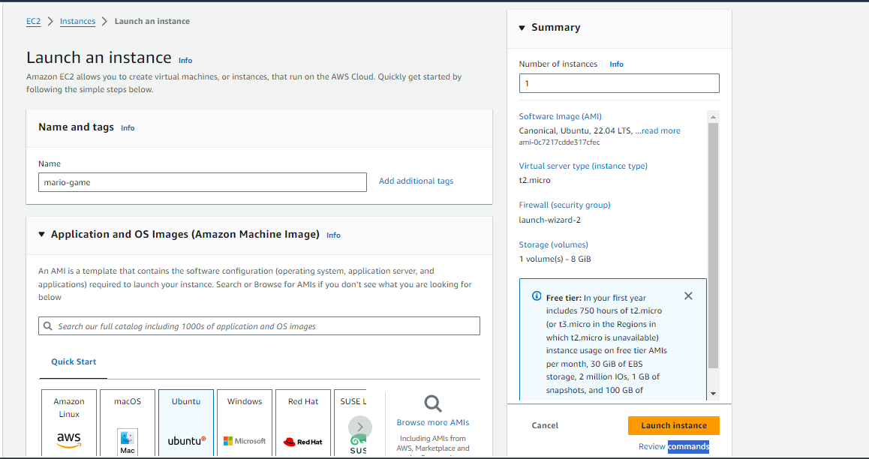

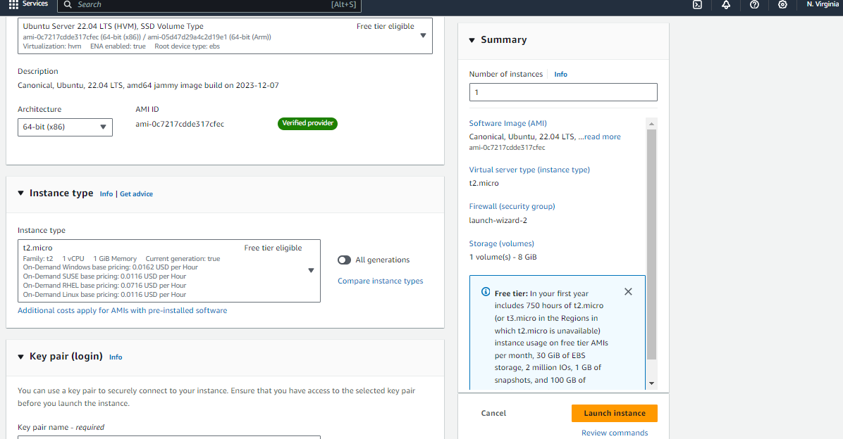

Select your own key pair:

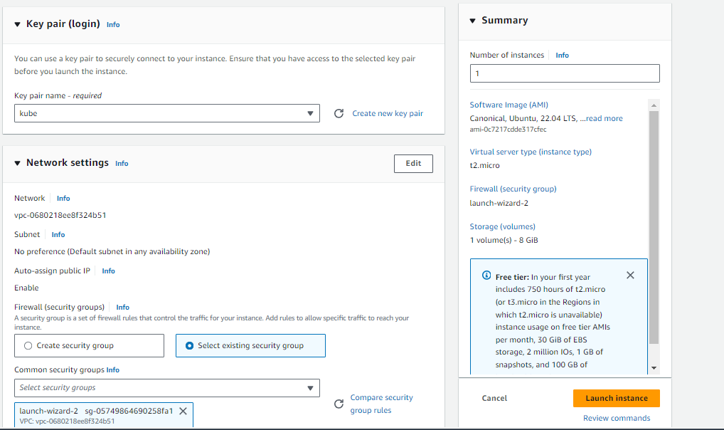

SG(Own):

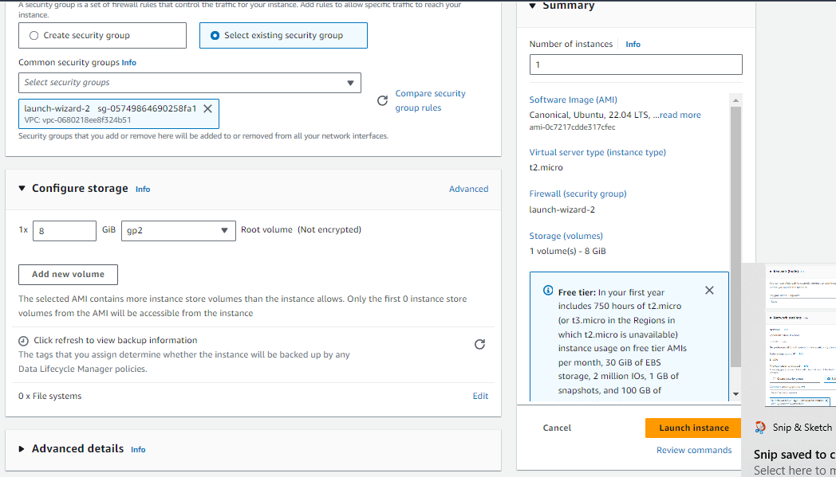

Click on launch instance after all the configurations:

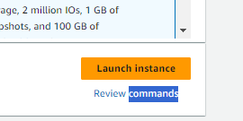

Connect to your VM through either aws console or cmd ssh or putty or any other ssh remote connect utility and the update your VM:

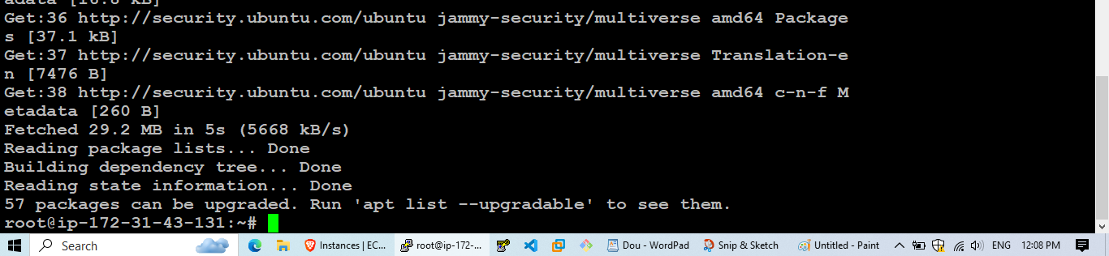

Step 2:Open new AWS console window and,

Search for iam--- Roles---create a new role--

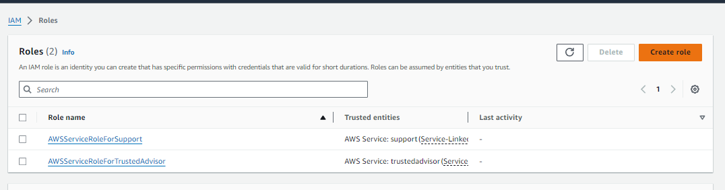

Select AWS Service as entity and EC2 as a use case: Likewise in the screenshot then hit next: 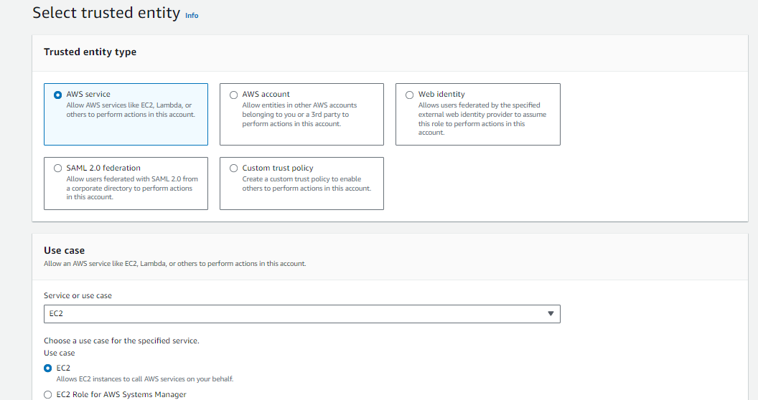

Select [AdministratorAccess](https://us-east-1.console.aws.amazon.com/iam/home?region=us-east-1#/policies/details/arn%3Aaws%3Aiam%3A%3Aaws%3Apolicy%2FAdministratorAccess) policy which is a aws managed job function and then click next:

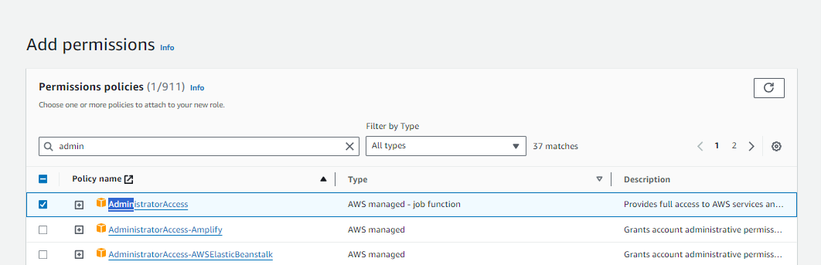

Policy details:

{

"Version": "2012-10-17",

"Statement": [

{

"Effect": "Allow",

"Action": "*",

"Resource": "*"

}

]

}

Provide name to you iam role and then click create role:

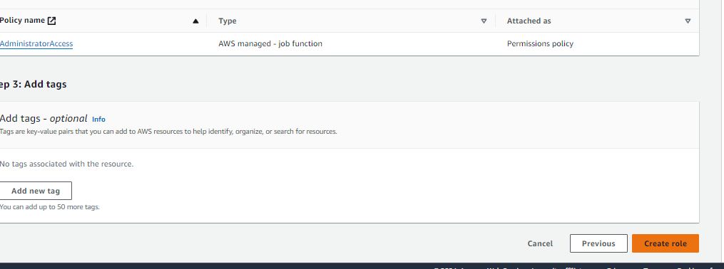

Step 3: Attach the same role with you ec2-server:

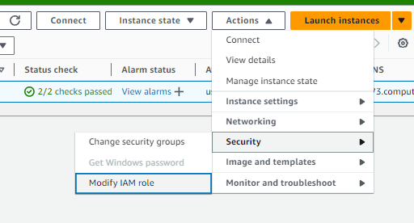

Select the IAM Role and then click on update IAM Role

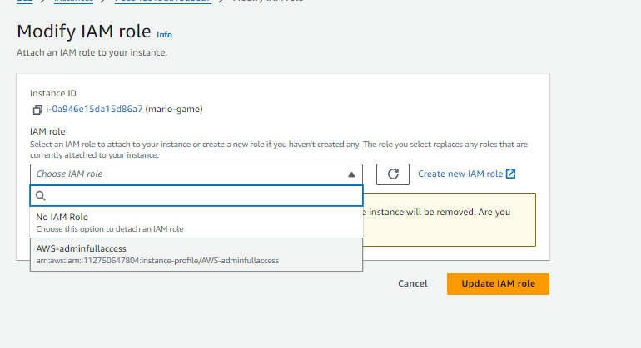

Step 4: Do clone of a repo with packages:

git clone https://github.com/Aj7Ay/k8s-mario.git

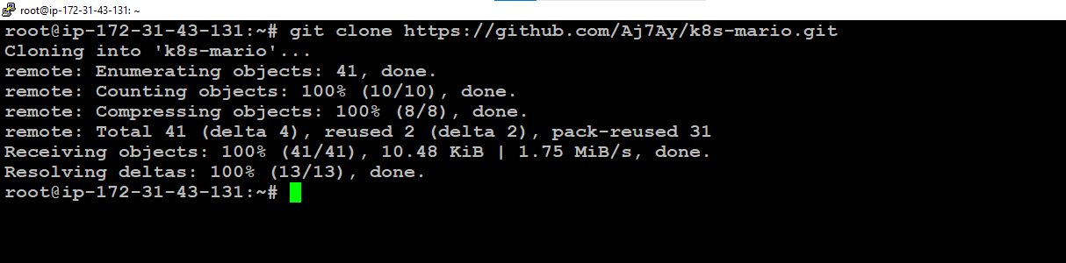

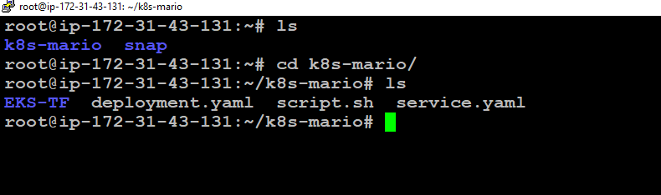

Then do these two:

chmod 777 script.sh----changes user permission for script.sh file

./script.sh ---- executes shell script.

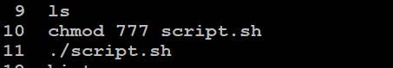

Content of shell script :

#!/bin/bash

# Install Terraform

sudo apt install wget -y

wget -O- https://apt.releases.hashicorp.com/gpg | sudo gpg --dearmor -o /usr/share/keyrings/hashicorp-archive-keyring.gpg

echo "deb [signed-by=/usr/share/keyrings/hashicorp-archive-keyring.gpg] https://apt.releases.hashicorp.com $(lsb_release -cs) main" | sudo tee /etc/apt/sources.list.d/hashicorp.list

sudo apt update && sudo apt install terraform -y

# Install kubectl

sudo apt update

sudo apt install curl -y

curl -LO https://dl.k8s.io/release/$(curl -L -s https://dl.k8s.io/release/stable.txt)/bin/linux/amd64/kubectl

sudo install -o root -g root -m 0755 kubectl /usr/local/bin/kubectl

kubectl version --client

# Install AWS CLI

curl "https://awscli.amazonaws.com/awscli-exe-linux-x86_64.zip" -o "awscliv2.zip"

sudo apt-get install unzip -y

unzip awscliv2.zip

sudo ./aws/install

echo "Installation completed successfully."

Check installed softwares:

aws --version

kubectl version --client

terraform –version

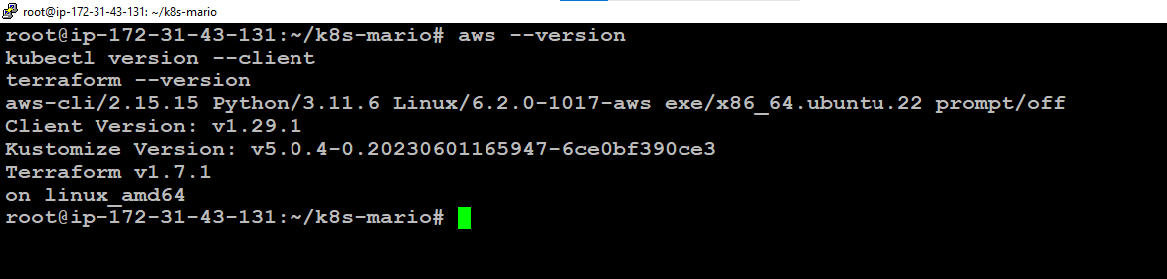

Change directory by: cd EKS-TF/

Alongside create an S3 bucket with allow public access and pass that bucket name in the

“vim backend.tf” file along with the az you created your bucket in.

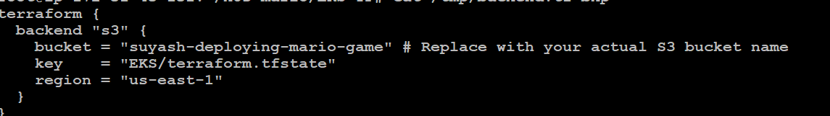

Change you reion in provider.tf by: vi provider.tf, that is “us-east-1”

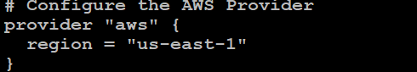

Note: If you are choosing: us-east-1 and dflt vpc through main.tf then you must login to vpc console dflt vpc and delete us-east-1e subnet as it will be barrier when provisioning the aws resources, honestly had same experience with it.Had to trouble shoot through it so save your time. Here,

Then Initialize your terraform inside “EKS-TF/” with the help of:

terraform init.

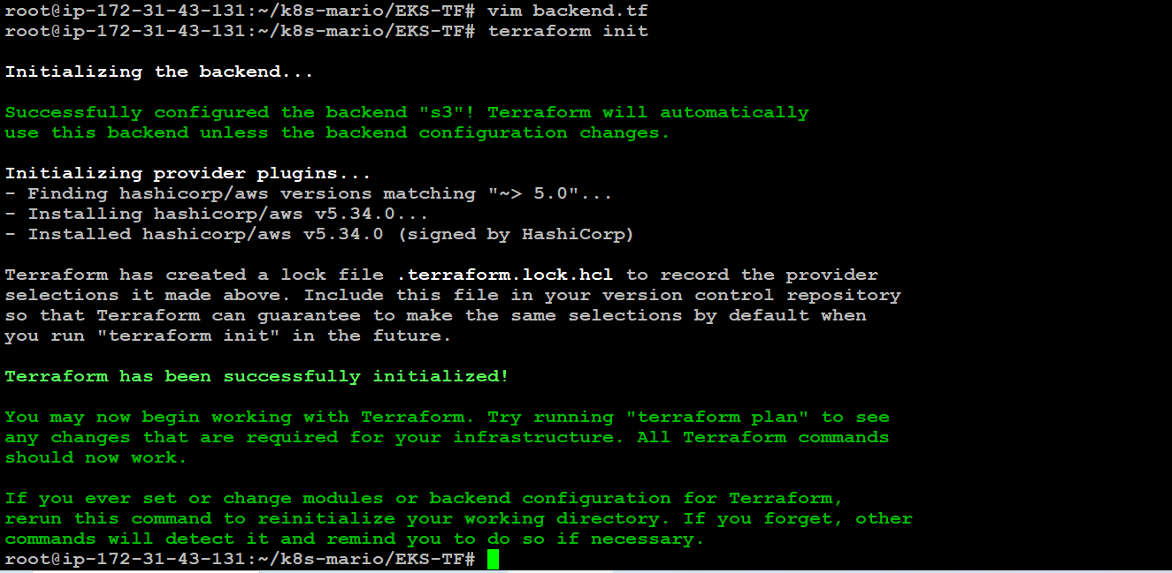

Now run terraform validate and terraform plan:

terraform validate

terraform plan

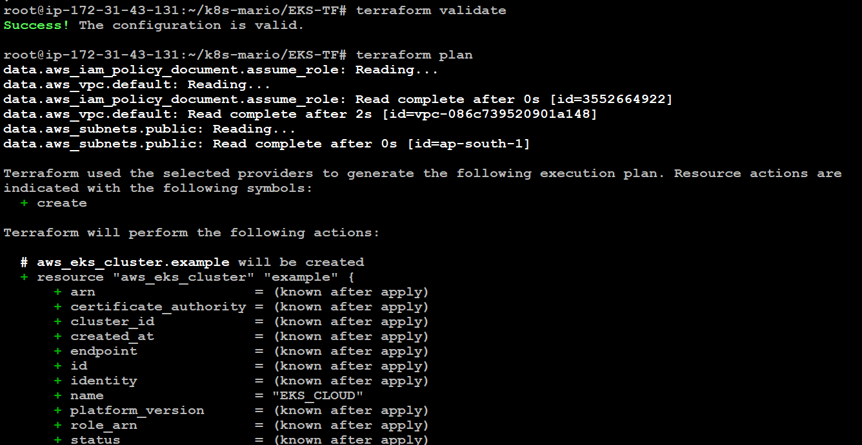

Now Run terraform apply to provision cluster.

terraform apply --auto-approve

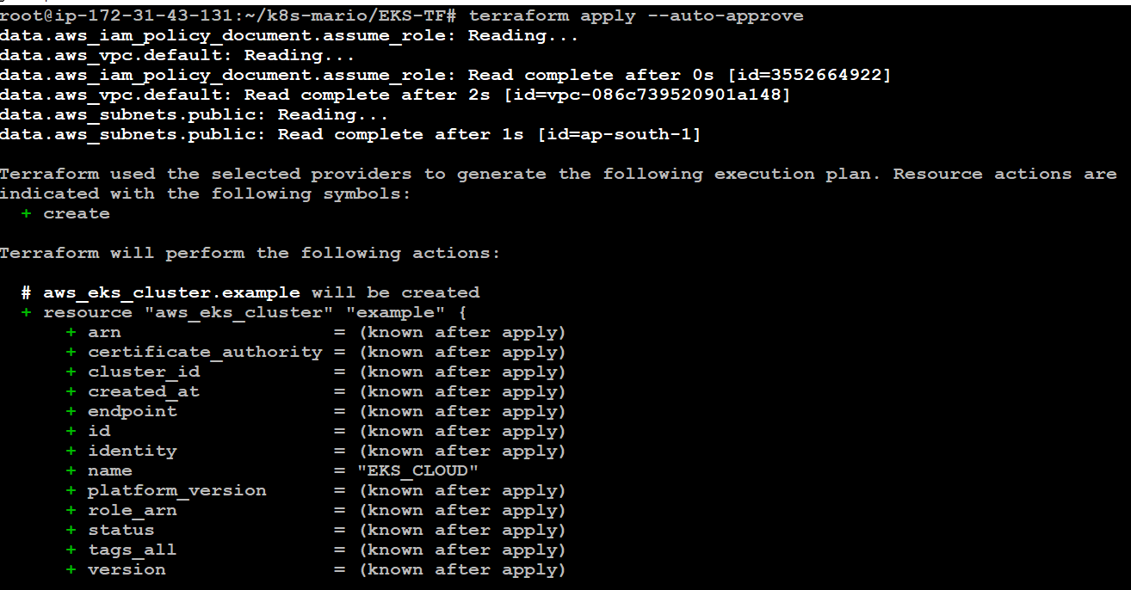

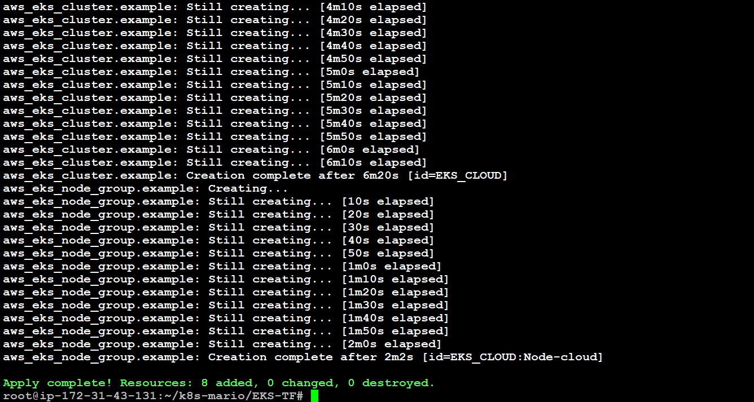

Update the Kubernetes configuration; make sure change your desired region.

aws eks update-kubeconfig --name EKS_CLOUD --region us-east-1



Let’s apply the deployment and service

**Deployment:**

kubectl apply -f deployment.yaml

#to check the deployment

kubectl get all

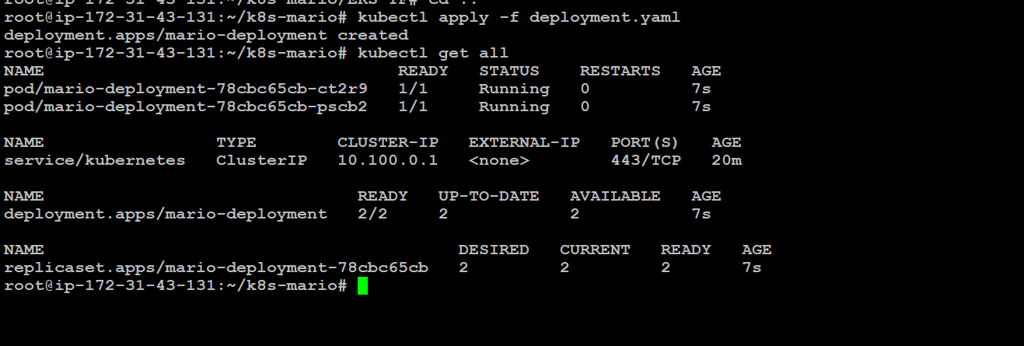

Now let’s apply the service.

**Service:**

kubectl apply -f service.yaml

kubectl get all

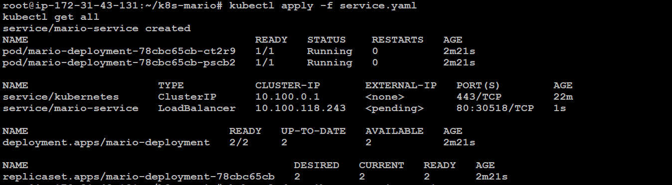

Now let’s describe the service and copy the LoadBalancer Ingress;

kubectl describe service mario-service

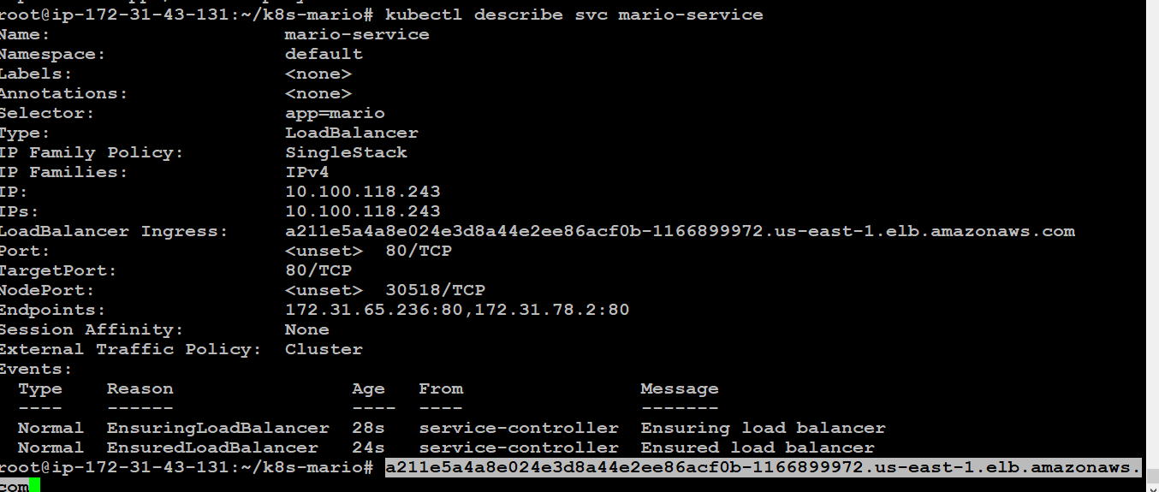

Copy and paste the ingress link in a browser and you will see the Mario game:

