**Results for Collaborative Filtering**

Our recommendation model is trained with the help of Binary Cross-Entropy Loss (BCELoss) and Stochastic Gradient Descent (SGD). We trained the model with different batch sizes of 32, 64, 128, 256, and 512 to see how they affected its performance. We are also measuring the hit rate, which is the average number of times the model recommends a product to a user. This is in addition to tracking the training and validation loss and accuracy during training. We use these metrics to look at how well the model works.  Following are the results obtained from these experiments.

Fig 1: 20 epochs and 32 batch size

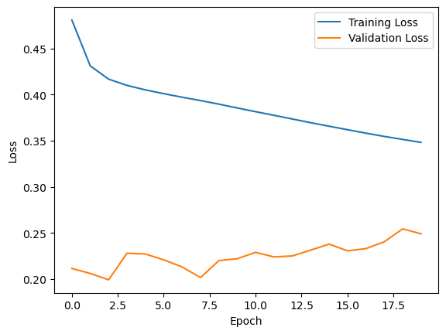

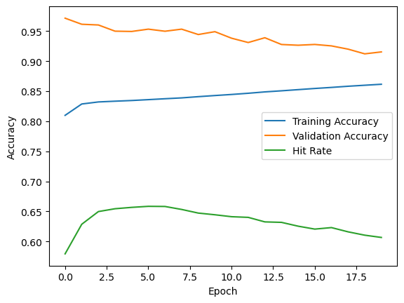

The model was trained with a batch size of 32 and 20 epochs using the BCELoss and SGD optimisation algorithms. The training accuracy started at 80.99% and gradually went up to 86.17%, while the validation accuracy started at 97.16% and peaked at 95.34% after the 6th epoch before going down to 91.55% on the last epoch.

The hit rate was also used to plot the graphs along with training and validation loss and accuracy. The hit rate, which is the average number of times a product is recommended, started at 0.5794 and went up to 0.6067 after the last epoch. Overall, the model did well in terms of accuracy and hit rate, but the validation accuracy changed a little bit after the sixth epoch.

Fig 2: 20 epochs and 64 batch size

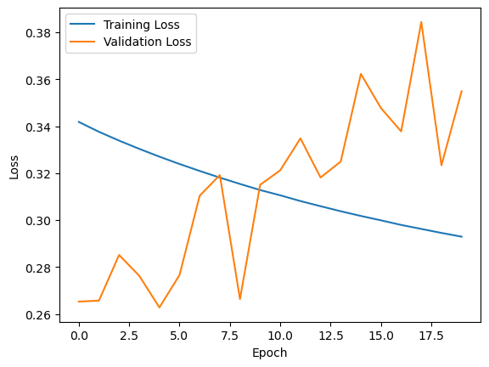

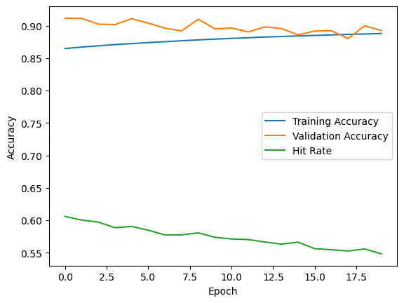

The model was trained for 20 iterations with 64-person batches. With each epoch, the training loss and accuracy got better. By the end, the training loss was 0.2929 and the accuracy was 0.8879. Both the validation loss and the validation accuracy changed over time. In the first epoch, the best validation loss was 0.2628 and the best validation accuracy was 0.9115.

It's important to note that the hits metric also went up and down, but not as much as the accuracy metric. Overall, the model did pretty well. Its final validation accuracy was 0.8925, which shows that it can work pretty well with new data. But the changes in validation loss and accuracy suggest that the model could do better with more tuning or regularisation.

Fig 3: 20 epochs and 128 batch size

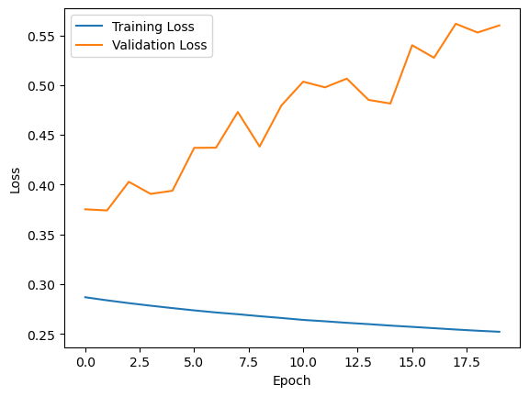 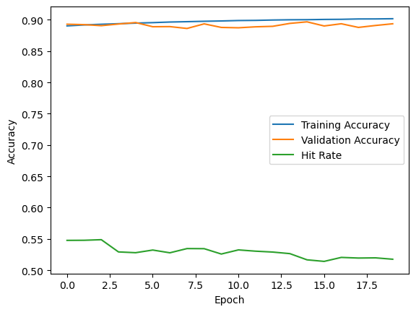

The model was trained for 20 epochs with 128  batch size. For each epoch, the training and validation accuracy and loss are shown.

Overall, both the training set and the validation set show that the model is very accurate, with the highest validation accuracy of 0.8968 being reached in the 15th epoch. In later epochs, however, it looks like the model may have started to overfit to the training data, as the validation accuracy starts to go down while the training accuracy keeps going up.

The hits metric also follows a similar pattern. In the second epoch, the hits score was 0.5478, which was the highest it ever got.

Overall, the model is very accurate based on the data, but there may be some overfitting in later epochs, which could affect how well it works with new data.

Fig 4: 20 epochs and 256 batch size

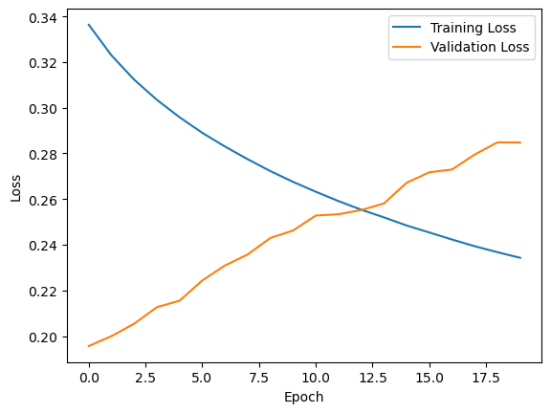

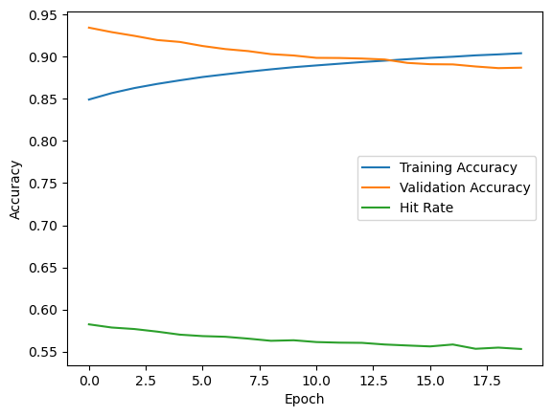

These are the results for a model that was trained for 20 iterations with 256-person batches. For each epoch, the training loss, validation loss, and accuracy are given.

The model starts out with a high training accuracy of about 85%, and this steadily gets better with each epoch until it reaches 90% in the last epoch. But the validation accuracy starts out at a high of 93.47 percent and goes down to 88.71 percent by the end.

The number of hits can also tell you how well the model is doing. The hits metric is another way to measure how accurate a model is. It is calculated by taking the sum of the product of the predicted and true labels and dividing it by the total number of examples. The hits value is also going down with each epoch, which shows that the model isn't as good at correctly classifying the examples as it used to be.

Fig 5: 20 epochs and 512 batch size

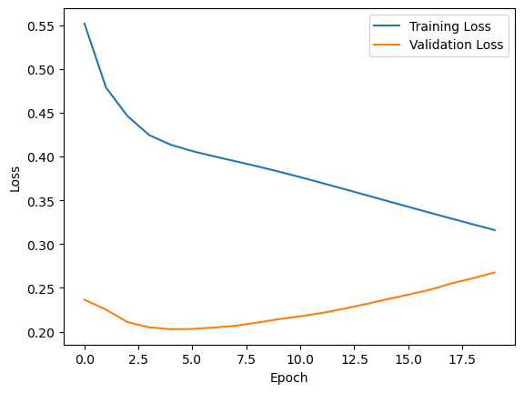

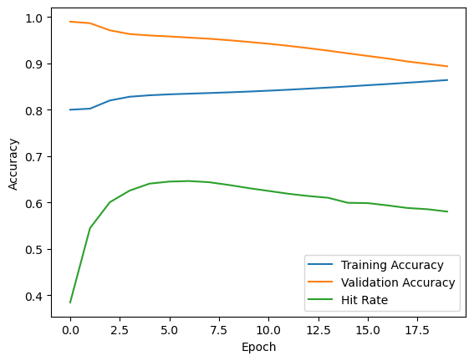

The model was trained for 20 epochs, and each batch had 512 data points. Over 20 iterations, the training accuracy starts at 80% and slowly goes up to 86.4%, while the validation accuracy starts at 99% and goes down to 89.4%. Both the training loss and the validation loss go down as time goes on. The hits metric, on the other hand, which measures how well the protection system works, starts at 0.38 and goes up to 0.58.

Overall, the model seems to do well on the training data, with a high level of accuracy and a lower loss. But the accuracy of validation drops a lot over time, which could be a sign of overfitting. The rise in the number of hits is a good sign that the recommendation system is getting better.

Content Based Filtering Results

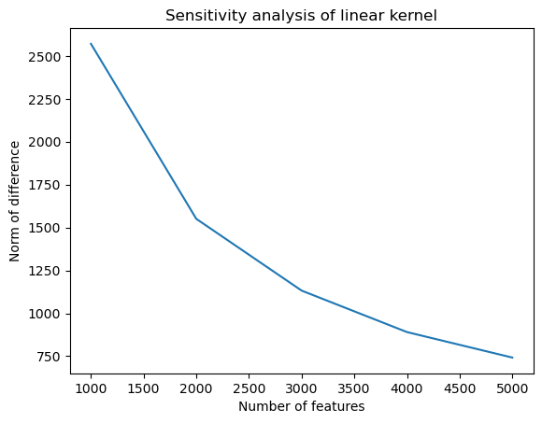

The graph shows that as the number of features goes up, the average difference between the original and modified kernels goes down. This means that the linear kernel is less sensitive to changes in the number of features. But the rate at which the norm of the difference goes down slows down as the number of features goes up. This suggests that adding more features past a certain point doesn't make a big difference in how well the linear kernel works.

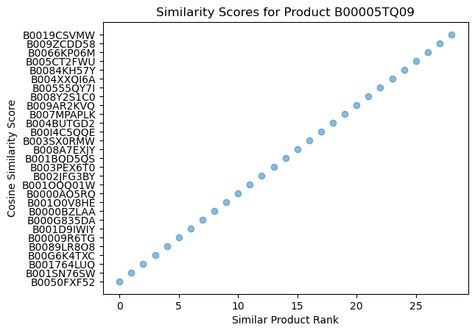

The graph shows the cosine similarity scores for the products that are most like the product with the given product ID. The x-axis shows how similar the products are, with 0 being the most similar. The cosine similarity score between the product and the similar products is shown on the y-axis.

Result Comparison of all algorithms

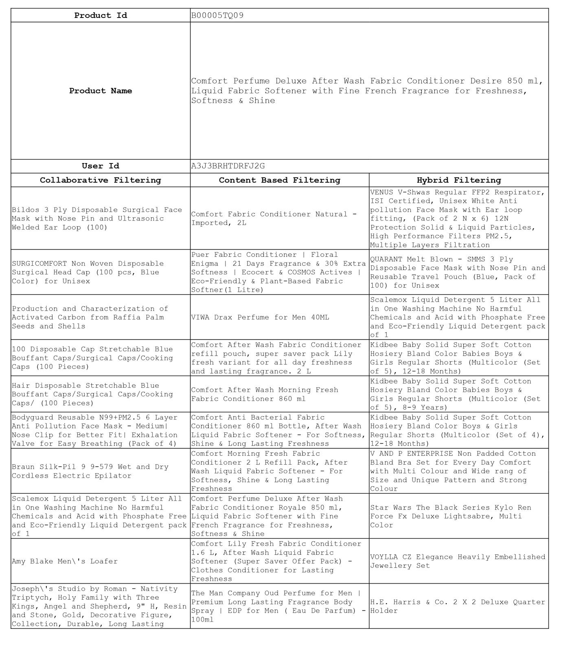

|  |  |  |
| --- | --- | --- |
| **Product Id** | B00005TQ09 | |
| **Product Name** | Comfort Perfume Deluxe After Wash Fabric Conditioner Desire 850 ml, Liquid Fabric Softener with Fine French Fragrance for Freshness, Softness & Shine | |
| **User Id** | A3J3BRHTDRFJ2G | |
| **Collaborative Filtering** | **Content Based Filtering** | **Hybrid Filtering** |
| Bildos 3 Ply Disposable Surgical Face Mask with Nose Pin and Ultrasonic Welded Ear Loop (100) | Comfort Fabric Conditioner Natural - Imported, 2L | VENUS V-Shwas Regular FFP2 Respirator, ISI Certified, Unisex White Anti pollution Face Mask with Ear loop fitting, (Pack of 2 N x 6) 12N Protection Solid & Liquid Particles, High Performance Filters PM2.5, Multiple Layers Filtration |
| SURGICOMFORT Non Woven Disposable Surgical Head Cap (100 pcs, Blue Color) for Unisex | Puer Fabric Conditioner | Floral Enigma | 21 Days Fragrance & 30% Extra Softness | Ecocert & COSMOS Actives | Eco-Friendly & Plant-Based Fabric Softner(1 Litre) | QUARANT Melt Blown - SMMS 3 Ply Disposable Face Mask with Nose Pin and Reusable Travel Pouch (Blue, Pack of 100) for Unisex |
| Production and Characterization of Activated Carbon from Raffia Palm Seeds and Shells | VIWA Drax Perfume for Men 40ML | Scalemox Liquid Detergent 5 Liter All in One Washing Machine No Harmful Chemicals and Acid with Phosphate Free and Eco-Friendly Liquid Detergent pack of 1 |
| 100 Disposable Cap Stretchable Blue Bouffant Caps/Surgical Caps/Cooking Caps (100 Pieces) | Comfort After Wash Fabric Conditioner refill pouch, super saver pack Lily fresh variant for all day freshness and lasting fragrance. 2 L | Kidbee Baby Solid Super Soft Cotton Hosiery Bland Color Babies Boys & Girls Regular Shorts (Multicolor (Set of 5), 12-18 Months) |
| Hair Disposable Stretchable Blue Bouffant Caps/Surgical Caps/Cooking Caps/ (100 Pieces) | Comfort After Wash Morning Fresh Fabric Conditioner 860 ml | Kidbee Baby Solid Super Soft Cotton Hosiery Bland Color Babies Boys & Girls Regular Shorts (Multicolor (Set of 5), 8-9 Years) |
| Bodyguard Reusable N99+PM2.5 6 Layer Anti Pollution Face Mask - Medium| Nose Clip for Better Fit| Exhalation Valve for Easy Breathing (Pack of 4) | Comfort Anti Bacterial Fabric Conditioner 860 ml Bottle, After Wash Liquid Fabric Softener - For Softness, Shine & Long Lasting Freshness | Kidbee Baby Solid Super Soft Cotton Hosiery Bland Color Boys & Girls Regular Shorts (Multicolor (Set of 4), 12-18 Months) |
| Braun Silk-Pil 9 9-579 Wet and Dry Cordless Electric Epilator | Comfort Morning Fresh Fabric Conditioner 2 L Refill Pack, After Wash Liquid Fabric Softener - For Softness, Shine & Long Lasting Freshness | V AND P ENTERPRISE Non Padded Cotton Bland Bra Set for Every Day Comfort with Multi Colour and Wide rang of Size and Unique Pattern and Strong Colour |
| Scalemox Liquid Detergent 5 Liter All in One Washing Machine No Harmful Chemicals and Acid with Phosphate Free and Eco-Friendly Liquid Detergent pack of 1 | Comfort Perfume Deluxe After Wash Fabric Conditioner Royale 850 ml, Liquid Fabric Softener with Fine French Fragrance for Freshness, Softness & Shine | Star Wars The Black Series Kylo Ren Force Fx Deluxe Lightsabre, Multi Color |
| Amy Blake Men\'s Loafer | Comfort Lily Fresh Fabric Conditioner 1.6 L, After Wash Liquid Fabric Softener (Super Saver Offer Pack) - Clothes Conditioner for Lasting Freshness | VOYLLA CZ Elegance Heavily Embellished Jewellery Set |
| Joseph\'s Studio by Roman - Nativity Triptych, Holy Family with Three Kings, Angel and Shepherd, 9" H, Resin and Stone, Gold, Decorative Figure, Collection, Durable, Long Lasting | The Man Company Oud Perfume for Men | Premium Long Lasting Fragrance Body Spray | EDP for Men ( Eau De Parfum) - 100ml | H.E. Harris & Co. 2 X 2 Deluxe Quarter Holder |