|  |  |  |  |
| --- | --- | --- | --- |
| **EDUCATION** | | | |
| AISSCE (Class XII) | 2015 | Kendriya Vidyalaya, Ambarnath | 95% |
| AISCE (Class X) | 2013 | Kendriya Vidyalaya, Ambarnath | 95% |

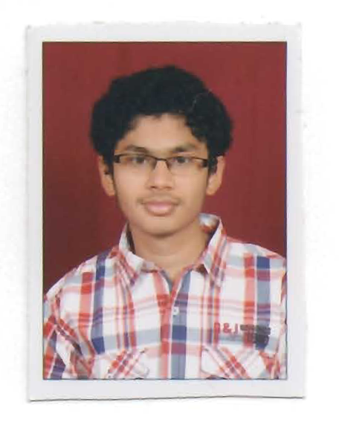

**Suyash Patel**

MALE,20 YEARS

**B.E.(Hons.)Computer Science** (2015-2019)

**CGPA: 7.34**

|  |
| --- |
| Electives: Cryptography, Number Theory |
| **INTERNSHIPS** |
| Summer Intern, **Delta Step Learning,** Kolkata May 2017-July 2017  **Delta Step Learning** – An e-education startup   * Was involved in the Android app development process as a developer   + Developing the app involved making use of OkHttp(external Android Http client) for calling the API, displaying data in a ListView, parsing JSON data, making use of Intents etc. * Developed algorithms for tasks like checking spellings, checking factorization etc.   + The product could provide a better user experience   ***Professional Recognition***   * Received a letter of appreciation from the Managing Director of the company. |
| **ACADEMIC PROJECTS** |
| * Project 1: Designed a batch weighing machine around the 8086 microprocessor. The system measured the average weight of 3 objects and displayed it on a seven-segment display. If the average weight happened to be beyond a threshold, an alarm went off. Wrote the assembly level program along with a team member. Learned to interface input and output devices to a processor. * Project 2: Wrote a critique on the paper "Data Structures for Range Minimum Queries in Multidimensional Arrays" as a part of the Data Structures and Algorithms course. * Project 3(Ongoing) : Working on a paper that involves extensive study of Elliptic Curve Cryptography. |
| **ACADEMIC ACHIEVEMENTS AND AWARDS** |
| * Scored 415/450 in BITSAT 2015 and was in the top 20 candidates all over India. * Was awarded the Major S.Chakraborty prize for academic and non-academic achievements by Kendriya Vidyalaya, Ambarnath in 2015. |
| **POSITIONS OF RESPONSIBILITY** |
| * As **Member** of Sports Financial Committee for **BOSM 2016**- all India inter-collegiate sports festival of BITS   + Overlooked the financial transactions that occurred in view of BOSM 2016.   + BOSM 2016 completed successfully without any major hiccups. * As **Member** of the Department of Photography   + Managed a workforce of 15 people to collect substantial revenue for all three fests in the academic year 2016-17 |
| **EXTRA-CURRICULAR ACTIVITIES** |
| * An amateur chess player who has participated in numerous chess tournaments. |
| **OTHER PROJECTS** |
| * Developed a weather command line application in Node.js. It displays weather details for multiple cities from the comfort of a terminal. Learned to work with REST APIs. * Developed a complete blogging platform with authentication and authorization using Node.js, Express framework and MongoDB. Emphasis was on developing the backend. * Predicted Boston Housing prices using Linear Regression. The project required cleaning the data and feature selection to reduce the Mean Squared Error. This project got me acquainted with basic algorithms in machine learning. External libraries used were Matplotlib, Pandas, Seaborn and sklearn. * Developed a basic "Did You Know?" Android application to get started with Android application development. It had one activity and one layout file and on a click of a button it displayed a fact. * Implemented the "Snake" game in Java to get comfortable with making graphical user interfaces and object oriented programming. Also implemented a desktop widget that would direct a user to a social networking site, to learn how to use external libraries.   Code for few of the above projects can be found at https://github.com/suyashpatel98. |