**Implementation of a Recommender System Using Item Based Collaborative Filtering Method**

**Suyash Tandon (standon1@binghamton.edu)**

1. **INTRODUCTION**

This paper describes the algorithm used to implement my semester long project of a Recommender System. In general, a recommender system is considered in the scenario where we have m different users and n different items in a specific application (e.g., in an E-commerce application we have n different customers potentially intending to buy m different commercial items) where a user i may give an item j a rating value k based on this user’s preference (i ∈ [1,… , m]; j ∈[1,…,n]; k∈[1,…,K]) where a higher rating value indicates that this user likes this item better.

The Algorithm used for my implementation is Item Based Collaborative filtering.

1. **ITEM BASED COLLABORATIVE FILTERING METHOD**

This approach looks into the set of items a particular user has rated and computes how similar they are to the target item and then selects most similar ones. At the same time their corresponding similarities are calculated. Once the most similar items are found the prediction is then calculated by taking the weighted mean of the target user’s rating on these similar items.  
This Algorithm is divided in two major steps:

* **Item Similarity Computation**

Two items are selected. Those users who have rated both these items are isolated and the similarity is calculated between the two items using a similarity computation technique.  
In my implementation, the technique used is the cosine based similarity computation method.  
Here, two items are thought of as two vectors in m dimensional user space.  
The cosine of the angle between the two vectors is used to calculate the similarity between them. The formula for which is given, here i and j represents 2 items

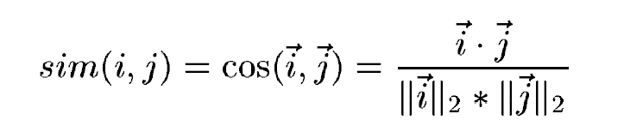

* **Prediction Computation**

After isolating the set of most similar items, we look into the target user’s ratings and predict the values using a prediction technique.  
In my implementation, the technique used is the weighted sum prediction technique.  
It computes the prediction on an item i for a user u, by computing the sum of ratings given by the user on the items similar to i. Each rating is then weighted by a corresponding similarity si,j between item i and j using the following formula

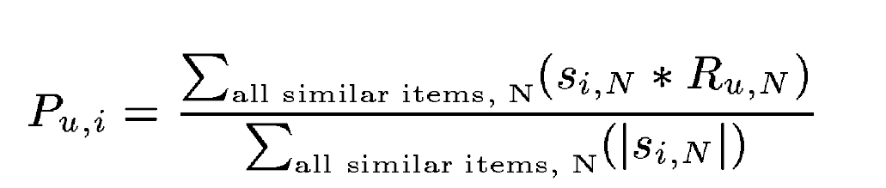

1. **REFERENCES**

* Han - Data Mining Concepts and Techniques 3rd Edition – 2012
* Wikipedia