// Calculator.java

package Assign7;

import java.util.Arrays;

public class Calculator {

    // Method to add two numbers

    public static double add(double n1, double n2){

        return n1 + n2;

    }

    // Method to subtract two numbers

    public static double subtract(double n1, double n2){

        return n1 - n2;

    }

    // Method to multiply two numbers

    public static double multiply(double n1, double n2){

        return n1 \* n2;

    }

    // Method to divide two numbers

    public static double divide(double n1, double n2) throws CustomException {

        // Check if the divisor is zero

        if(n2 == 0){

            throw new CustomException("Division by zero error");

        } else {

            return n1 / n2;

        }

    }

    // Method to calculate the mean (average) of an array of numbers

    public static double mean(double[] arr){

        return Arrays.stream(arr).sum() / arr.length;

    }

    // Method to calculate the square root of a number

    public static double sqrt(double n){

        return Math.pow(n, 0.5);

    }

    // Method to calculate the standard deviation of an array of numbers

    public static double stddev(double[] arr){

        double standardDeviation = 0.0;

        // Calculate the sum of squared differences from the mean

        for (double num : arr) {

            standardDeviation += Math.pow(num - mean(arr), 2);

        }

        // Calculate the square root of the average of squared differences

        return Math.sqrt(standardDeviation / arr.length);

    }

    // Method to calculate the variance of an array of numbers

    public static double variance(double[] arr){

        // Variance is the square root of the standard deviation

        return sqrt(stddev(arr));

    }

    // Method to calculate the power of a number raised to another number

    public static double power(double n1, double n2){

        return Math.pow(n1, n2);

    }

}

// CustomException.java

package Assign7;

// CustomException class extends Exception to handle custom exceptions

public class CustomException extends Exception {

    // Default constructor for CustomException class

    public CustomException(){

        super("Division by 0 error"); // Set default message for division by zero error

    }

    // Parameterized constructor for CustomException class to handle custom error messages

    public CustomException(String msg){

        super(msg); // Set custom error message

    }

    // Nested class NonNumericInputException extends Exception to handle non-numeric input errors

    public static class NonNumericInputException extends Exception {

        // Default constructor for NonNumericInputException class

        public NonNumericInputException() {

            super("Non-numeric input error"); // Set default message for non-numeric input error

        }

        // Parameterized constructor for NonNumericInputException class to handle custom error messages

        public NonNumericInputException(String msg) {

            super(msg); // Set custom error message

        }

    }

}

// UserInput.java

package Assign7;

import java.util.Scanner;

public class UserInput {

    private Scanner scanner;

    // Constructor initializes the Scanner object for user input

    public UserInput() {

        scanner = new Scanner(System.in);

    }

    // Method to get a double input from the user with a prompt message

    // Throws NonNumericInputException if input is not a valid double

    public double getDoubleInput(String message) throws CustomException.NonNumericInputException {

        System.out.println(message);

        String input = scanner.next();

        if (!isNumeric(input)) {

            throw new CustomException.NonNumericInputException("Non-numeric input error");

        }

        return Double.parseDouble(input);

    }

    // Method to get a string input from the user with a prompt message

    public String getStringInput(String message) {

        System.out.println(message);

        return scanner.next();

    }

    // Method to get an array input from the user with a prompt message

    public double[] getArrayInput() {

        System.out.println("Enter the size of the array:");

        int size = scanner.nextInt();

        double[] array = new double[size];

        System.out.println("Enter elements:");

        for (int i = 0; i < size; i++) {

            if (scanner.hasNextDouble()) {

                array[i] = scanner.nextDouble();

            }

        }

        return array;

    }

    // Method to close the Scanner when it is no longer needed

    public void closeScanner() {

        scanner.close();

    }

    // Method to check if a string can be parsed as a double

    private boolean isNumeric(String str) {

        try {

            Double.parseDouble(str);

            return true;

        } catch (NumberFormatException e) {

            return false;

        }

    }

}

/\*Suyash Tambe

AIML-B2

2022-26

22070126117

\*/

//Main.java

package Assign7;

public class Main {

    public static void main(String[] args) {

        // Create an instance of UserInput to handle user input

        UserInput userInput = new UserInput();

        try {

            // Prompt the user to choose an operation

            String choice = userInput.getStringInput("Choose Operation: +, -, /, \*, ^, var, stddev, avg");

            // Check if the chosen operation is a basic arithmetic operation or a statistical operation

            if (choice.equals("+") || choice.equals("-") || choice.equals("\*") || choice.equals("/") || choice.equals("^")) {

                // For basic arithmetic operations, prompt the user to enter two numbers

                double n1 = userInput.getDoubleInput("Enter First Number:");

                double n2 = userInput.getDoubleInput("Enter Second Number:");

                userInput.closeScanner(); // Close the scanner since input is complete

                // Perform the chosen operation and display the result

                if (choice.equals("+")) {

                    System.out.println(Calculator.add(n1, n2));

                } else if (choice.equals("-")) {

                    System.out.println(Calculator.subtract(n1, n2));

                } else if (choice.equals("\*")) {

                    System.out.println(Calculator.multiply(n1, n2));

                } else if (choice.equals("/")) {

                    // Handle division by zero exception

                    try {

                        System.out.println(Calculator.divide(n1, n2));

                    } catch (CustomException e) {

                        System.out.println(e.getMessage());

                    }

                } else if (choice.equals("^")) {

                    System.out.println(Calculator.power(n1, n2));

                } else {

                    System.out.println("Invalid Operation");

                }

            } else {

                // For statistical operations, prompt the user to enter an array of numbers

                double[] arr = userInput.getArrayInput();

                userInput.closeScanner(); // Close the scanner since input is complete

                // Perform the chosen statistical operation and display the result

                if (choice.equals("var")) {

                    System.out.println(Calculator.variance(arr));

                } else if (choice.equals("stddev")) {

                    System.out.println(Calculator.stddev(arr));

                } else if (choice.equals("avg")) {

                    System.out.println(Calculator.mean(arr));

                } else {

                    System.out.println("Invalid Operation");

                }

            }

        } catch (CustomException.NonNumericInputException e) {

            // Handle non-numeric input exception

            System.out.println(e.getMessage());

        }

    }

}

Output:

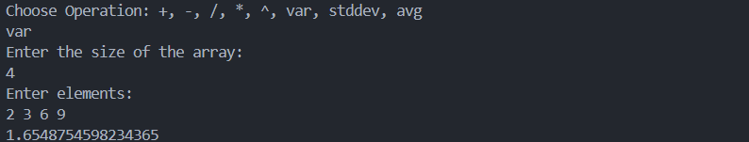

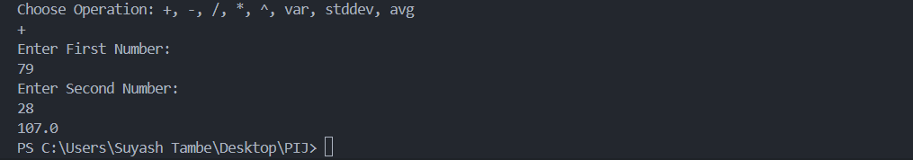

Github : <https://github.com/suyashtambe/PIJ>