FINPULSE | Bank Transaction & Financial Analytics
Data Analysis Report — Cash Flow, Transaction Behaviour and Dashboard Insights
Suyash Verma • Python · Pandas · Power BI • github.com/suyashverma0/FinPulse

1. Executive Summary
FinPulse analyses 116,153 bank transactions across 10 accounts to explain how money moves in and out, when activity peaks, and where a small number of very large transactions distort the totals. The raw data was cleaned and enriched in Python, then delivered as a two-page interactive Power BI dashboard.
Headline: deposits and withdrawals are almost perfectly balanced, with withdrawals exceeding deposits by 1.85 bn (about 0.8% of total deposits). Deposits dominate by count (53.8%), withdrawals are larger on average, and a small number of very large transactions can materially move the totals.

116,153  Transactions analysed | 238.43 bn  Total deposits | 240.28 bn  Total withdrawals | −1.85 bn  Net cash flow | 10  Accounts

2. Business Questions
- How much money is deposited and withdrawn, and what is the net cash flow?
- How are transactions split by type, and how does activity vary by weekday and month?
- Which transactions are unusually large, and how much do they influence the totals?
- Which financial variables move together?

3. Data and Method
Item | Detail
Dataset | Synthetic banking transactions; 8 source fields (account, date, description, cheque no., value date, withdrawal, deposit, balance)
Volume | 116,202 raw records → 116,153 after removing 49 duplicates (0.04%)
Cleaning | Duplicate check (zero remaining), dates parsed to datetime, missing deposit/withdrawal amounts set to 0
Engineered features | Transaction Type (Deposit / Withdrawal / Other), Net Amount = Deposit − Withdrawal, Transaction Value = Deposit + Withdrawal, Year, Month, Day, Weekday
Analysis | Aggregations by type, weekday and month; cash-flow and balance trends; 99th-percentile outlier threshold; correlation matrix
Delivery | Processed CSV imported into Power BI: KPI cards, year slicer, transaction-type filtering, two report pages

4. Key Findings
- Cash flow is nearly neutral, with a slight outflow. Total deposits of 238.43 bn against total withdrawals of 240.28 bn give a net cash flow of −1.85 bn.
- Deposits lead by count; withdrawals lead by size. There are 62,467 deposit transactions (53.80%) and 41,572 withdrawals (35.79%), while 12,114 (10.43%) carry no monetary amount. Average value per transaction works out to roughly 3.8 M for deposits and 5.8 M for withdrawals.
- A few very large transactions can move the totals. The 99th-percentile threshold is 42.05 M per transaction, against a largest deposit of 544.8 M and a largest withdrawal of 459.4 M. The biggest items include a 544.8 M deposit, a 500 M draw-down, and a 459.4 M loan recovery.
- Activity follows a business-week rhythm. Volume is highest on Monday and declines steadily through the week. Saturday runs at roughly half of Monday, and Sunday is close to zero.
- Monthly net flow swings both ways. Aggregated by calendar month, net amount ranges from about +0.5 bn (February) to about −0.95 bn (June), while deposits and withdrawals track each other closely month to month.
- Net amount is driven mainly by withdrawals. Correlation with net amount is −0.767 for withdrawals and +0.670 for deposits. Balance shows almost no linear relationship with any flow variable (|r| < 0.08). Correlation indicates association, not causation.

5. Dashboard
The Power BI report separates high-level monitoring from behavioural analysis. Long account identifiers are deliberately not used as chart categories, which keeps the visuals readable.
Page 1 – Financial Overview: ending balance, net cash flow, deposits, withdrawals and transaction count; monthly deposits vs withdrawals; monthly net amount; balance trend by year; transaction-type split.
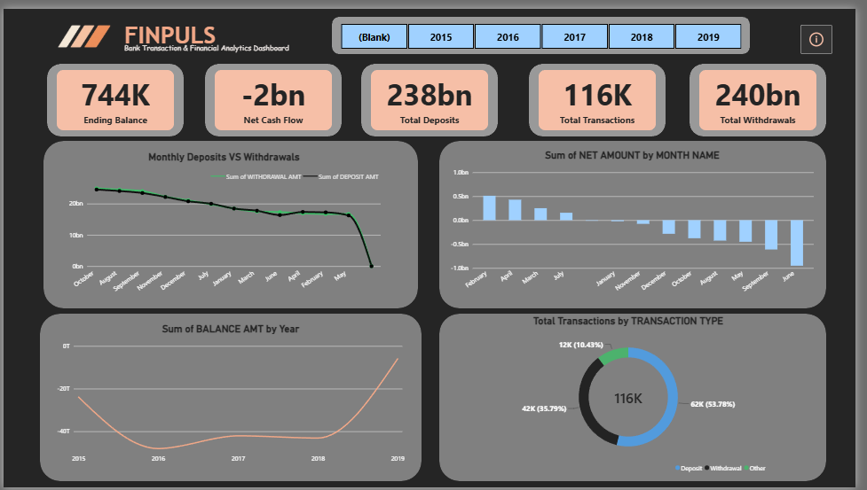
Figure 1 — Financial Overview
Page 2 – Transaction Intelligence: active accounts, average deposit, deposit and withdrawal counts, average transaction value; activity and type mix by weekday; average value and deposit vs withdrawal by month.
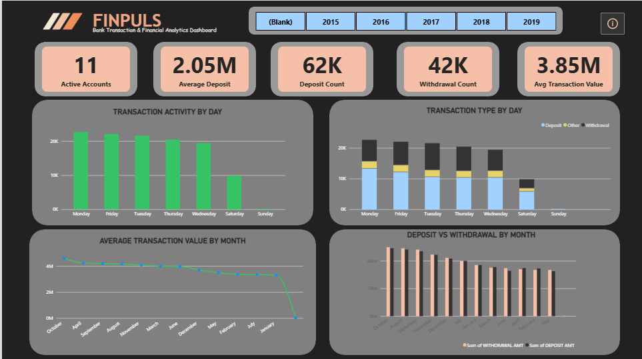
Figure 2 — Transaction Intelligence

6. Data Quality Notes and Limitations
- The dataset is synthetic, so findings demonstrate method and do not describe real banking behaviour.
- The final balance record is missing, so an overall ending balance could not be verified and is not reported here.
- Monetary values are in the units recorded in the dataset; no currency conversion was applied.
- The analysis is descriptive. No forecasting or predictive modelling is included.

7. Recommended Next Steps
- Balance reconciliation: rebuild the running balance from transaction flows and flag breaks.
- Anomaly detection: extend the 99th-percentile rule to account-level and time-aware outlier detection.
- Cash-flow forecasting: model monthly net flow to anticipate outflow months.
- Account segmentation: profile each of the 10 accounts by frequency, size and net position.

