AndroidViewHover
An elegant way to show your menu or messages.

In my opinion, jumping to a new activity to show your menu is a kind of wasting time and life.
So,
I think, we need a hover view, to show menu, to show messages.

Usage

Step0
Set up RenderScript
- Eclipse, please visit official tutorial.

Android Studio, add

renderscriptTargetApi 19
renderscriptSupportMode true

in build.gradle defaultConfig, here is a sample

Step1

Gradle
dependencies {
compile "com.android.support:support-v4:20.+"
compile 'com.nineoldandroids:library:2.4.0'
compile 'com.daimajia.easing:library:1.0.0@aar'
compile 'com.daimajia.androidanimations:library:1.1.2@aar'
compile 'com.daimajia.androidviewhover:library:1.0.4@aar'
}

Maven
<dependency>
<groupId>com.nineoldandroids</groupId>
<artifactId>library</artifactId>
<version>2.4.0</version>
</dependency>
<dependency>
<groupId>com.daimajia.androidanimation</groupId>
<artifactId>library</artifactId>
<version>1.1.2</version>
<type>apklib</type>
</dependency>
<dependency>
<groupId>com.daimajia.easing</groupId>
<artifactId>library</artifactId>
<version>1.0.0</version>
<type>apklib</type>
</dependency>
<dependency>
<groupId>com.daimajia.androidviewhover</groupId>
<artifactId>library</artifactId>
<version>1.0.4</version>
<type>apklib</type>
</dependency>

Eclipse
- SupportLibrary v4
- NineOldAndroids-2.4.0
- AndroidViewAnimations-1.1.2
- AndroidEasingFunctions-1.0.0
- AndroidViewHover-1.0.3

Step2
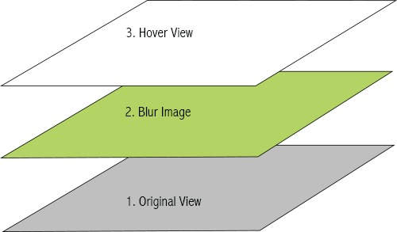

Create an original view, and make sure it was wrapped by BlurLayout

for example:

<com.daimajia.androidviewhover.BlurLayout
android:id="@+id/sample"
android:layout_width="wrap_content"
android:layout_height="wrap_content">
<ImageView
android:layout_centerInParent="true"
android:scaleType="fitXY"
android:src="@drawable/kid"
android:layout_width="match_parent"/>
</com.daimajia.androidviewhover.BlurLayout>

Note: BlurLayout is entended from RelativeLayout. You can use the RelativeLayoutrules to layout your view.

Create a hover view, there is no rules to obey. Just please remember that this view will be stretched as large as the original view you have created.

Bind a hover view to BlurLayout

BlurLayout sampleLayout = (BlurLayout)findViewById(R.id.sample);
View hover = LayoutInflater.from(mContext).inflate(R.layout.hover, null);
sampleLayout.setHoverView(hover);

and don't forget that you can add various animations just in one line code. For example:

//View (R.id.heart) appear animation.
sampleLayout.addChildAppearAnimator(hover, R.id.heart, Techniques.FlipInX);
//View (R.id.heart) disappear animation.
sampleLayout.addChildDisappearAnimator(hover, R.id.heart, Techniques.FlipOutX);

You can view the samples in my preset examples.

Animations
This project provides a lot of animations you can choose. Animations are from my another open-source project AndroidViewAnimations. And you can aslo using easing funcitons to make your animations more real. Please enjoy it.

Thanks
- NineOldAndroids by JakeWharton
- AndroidViewAnimations by me
- AnimationEasingFunctions by me

About me
A student in mainland China.
Welcome to offer me an internship. If you have any new idea about this project, feel free to contact me.

