android-swipelistview
An Android List View implementation with support for drawable cells and many other swipe related features

THIS PROJECT IS DISCONTINUED — USE AT YOUR OWN RISK
It has been a fun and great project but it's time for us to move on. Check out our recent work that we are doing with Scala on Android. http://47deg.github.io/translate-bubble-android/ and follow us on Github and Twitter for new and exciting open source projects. Thanks for your continuing support. If you wish to take on maintenance of this library please contact us through the issue tracker.

SwipeListView (Play Store Demo)
An Android List View implementation with support for drawable cells and many other swipe related features.
We are actively seeking help from People that want to contribute to this OS project. Please open an issue indicating you want to help out. Thanks!
- Introduction
- Download
- Demo
- XML Usage
- License
Click to watch video
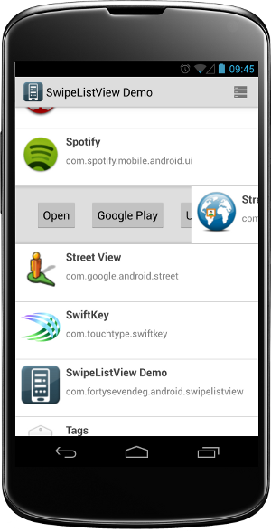

Introduction
SwipeListView was born out of the need to add swipe gestures to ListView on Android for @ 47 Degrees Clients. Contributions and constructive feedback are welcome.

Download
Gradle
repositories {
maven { url 'http://clinker.47deg.com/nexus/content/groups/public' }
}

dependencies {
compile ('com.fortysevendeg.swipelistview:swipelistview:1.0-SNAPSHOT@aar') {
transitive = true
}
}

Demo
You can see a demo SwipeListView in action on Google Play Google Play

XML Usage
If you decide to use SwipeListView as a view, you can define it in your xml layout like this:
<com.fortysevendeg.swipelistview.SwipeListView
xmlns:swipe="http://schemas.android.com/apk/res-auto"
android:id="@+id/example_lv_list"
android:listSelector="#00000000"
android:layout_width="fill_parent"
android:layout_height="wrap_content"
swipe:swipeFrontView="@+id/front"
swipe:swipeBackView="@+id/back"
swipe:swipeActionLeft="[reveal | dismiss]"
swipe:swipeActionRight="[reveal | dismiss]"
swipe:swipeMode="[none | both | right | left]"
swipe:swipeCloseAllItemsWhenMoveList="[true | false]"
swipe:swipeOpenOnLongPress="[true | false]"
swipe:swipeAnimationTime="[miliseconds]"
swipe:swipeOffsetLeft="[dimension]"
swipe:swipeOffsetRight="[dimension]"
/>
- swipeFrontView - Required - front view id.
- swipeBackView - Required - back view id.
- swipeActionLeft - Optional - left swipe action Default: 'reveal'
- swipeActionRight - Optional - right swipe action Default: 'reveal'
- swipeMode - Gestures to enable or 'none'. Default: 'both'
- swipeCloseAllItemsWhenMoveList - Close revealed items on list motion. Default: 'true'
- swipeOpenOnLongPress - Reveal on long press Default: 'true'
- swipeAnimationTime - item drop animation time. Default: android configuration
- swipeOffsetLeft - left offset
- swipeOffsetRight - right offset

Continuous Integration
CI and Artifact Repository hosted in ClinkerHQ.com


License
Copyright (C) 2012 47 Degrees, LLC http://47deg.com hello@47deg.com
Licensed under the Apache License, Version 2.0 (the "License"); you may not use this file except in compliance with the License. You may obtain a copy of the License at
http://www.apache.org/licenses/LICENSE-2.0
Unless required by applicable law or agreed to in writing, software distributed under the License is distributed on an "AS IS" BASIS, WITHOUT WARRANTIES OR CONDITIONS OF ANY KIND, either express or implied. See the License for the specific language governing permissions and limitations under the License.

