android-percent-support-lib-sample
Just a sample of the android percent support lib

I made a sample of the new percent support library.
It will be documented soon on android dev website so it's just a proof of concept :)
You can check official docs reference聽here
This library provide percentage based layouts, horizontal and vertical at the same time.

simple result
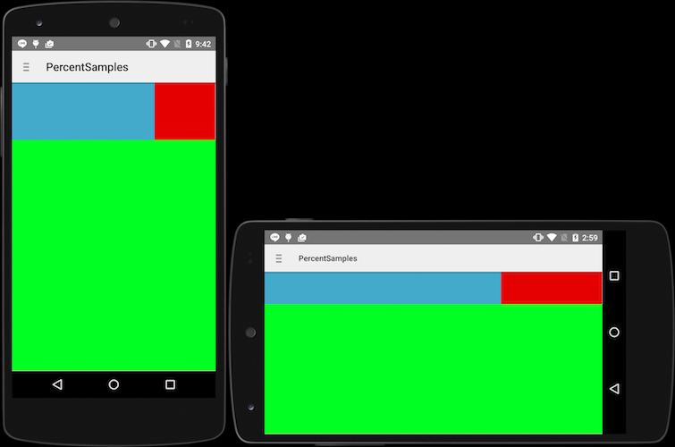

complex result
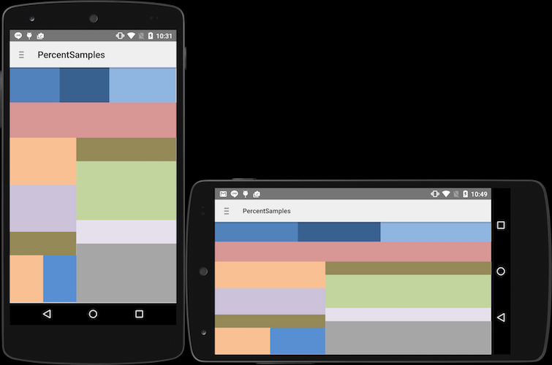
from聽https://gist.github.com/shekarshine/5458f697c02e5619b0e2

How to use :
just add percent support library to your project
dependencies {
compile 'com.android.support:percent:22.2.0'
}

Supported Layouts :

PercentRelativeLayout
<android.support.percent.PercentRelativeLayout
xmlns:android="http://schemas.android.com/apk/res/android"
xmlns:app="http://schemas.android.com/apk/res-auto"
android:layout_width="match_parent"
android:layout_height="match_parent">

<View
android:id="@+id/top_left"
android:layout_width="0dp"
android:layout_height="0dp"
android:layout_alignParentTop="true"
android:background="#ff44aacc"
app:layout_heightPercent="20%"
app:layout_widthPercent="70%" />

<View
android:id="@+id/top_right"
android:layout_width="0dp"
android:layout_height="0dp"
android:layout_alignParentTop="true"
android:layout_toRightOf="@+id/top_left"
android:background="#ffe40000"
app:layout_heightPercent="20%"
app:layout_widthPercent="30%" />

<View
android:id="@+id/bottom"
android:layout_width="match_parent"
android:layout_height="0dp"
android:layout_below="@+id/top_left"
android:background="#ff00ff22"
app:layout_heightPercent="80%" />
</android.support.percent.PercentRelativeLayout>

PercentLinearLayout
<com.juliengenoud.percentsamples.PercentLinearLayout
xmlns:android="http://schemas.android.com/apk/res/android"
xmlns:app="http://schemas.android.com/apk/res-auto"
android:layout_width="match_parent"
android:layout_height="match_parent"
android:orientation="vertical">
<View
android:layout_width="0dp"
android:layout_height="0dp"
android:background="#ff44aacc"
app:layout_heightPercent="10%"
app:layout_widthPercent="60%"/>

<View
android:layout_width="0dp"
android:layout_height="0dp"
android:background="#ff4400cc"
app:layout_heightPercent="10%"
app:layout_widthPercent="70%"/>
</com.juliengenoud.percentsamples.PercentLinearLayout>

PercentFrameLayout
<android.support.percent.PercentFrameLayout
xmlns:android="http://schemas.android.com/apk/res/android"
xmlns:app="http://schemas.android.com/apk/res-auto"
android:layout_width="match_parent"
android:layout_height="match_parent">
<!-- ... XML CODE -->
</android.support.percent.PercentFrameLayout>

Stylable :
- heightPercent
- widthPercent
- marginBottomPercent
- marginEndPercent
- marginLeftPercent
- marginPercent
- marginRightPercent
- marginStartPercent
- marginTopPercent

Pre-requisites
- Android SDK v22
- Android Build Tools v22.0.1
- Android Percent Support Repository v22.2.0
- Android Support v4 Repository v22.2.0
according to the the manifest minsdk is v7 (android 2.1)

License Mit

