Android ViewPagerIndicator
Paging indicator widgets that are compatible with the ViewPager from the Android Support Libraryto improve discoverability of content.
Try out the sample application on the Android Market.
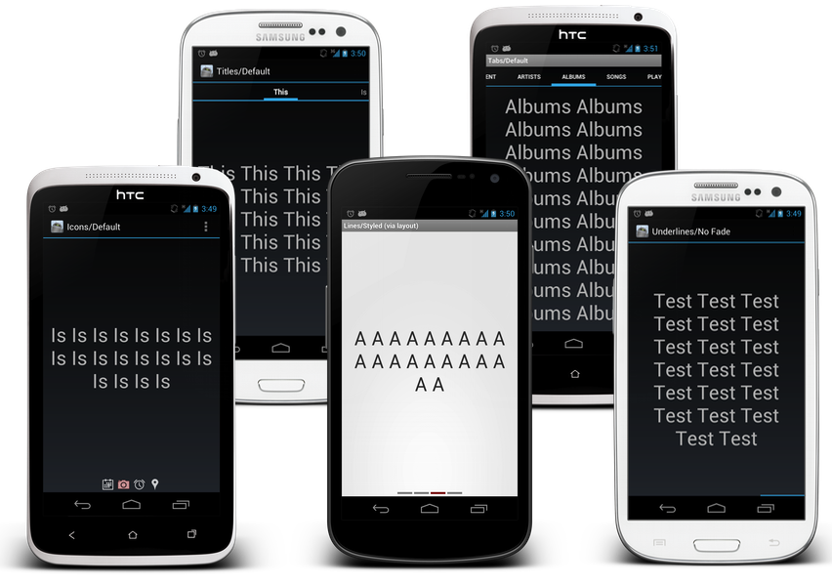
These widgets can also be used in conjunction with ActionBarSherlock!

Usage
For a working implementation of this project see the sample/ folder.

Include one of the widgets in your view. This should usually be placed adjacent to theViewPager it represents.

<com.viewpagerindicator.TitlePageIndicator
android:id="@+id/titles"
android:layout_height="wrap_content"
android:layout_width="fill_parent" />

In your onCreate method (or onCreateView for a fragment), bind the indicator to theViewPager.

//Set the pager with an adapter
ViewPager pager = (ViewPager)findViewById(R.id.pager);
pager.setAdapter(new TestAdapter(getSupportFragmentManager()));

//Bind the title indicator to the adapter
TitlePageIndicator titleIndicator = (TitlePageIndicator)findViewById(R.id.titles);
titleIndicator.setViewPager(pager);

(Optional) If you use an OnPageChangeListener with your view pager you should set it in the indicator rather than on the pager directly.

//continued from above
titleIndicator.setOnPageChangeListener(mPageChangeListener);

Theming
There are three ways to style the look of the indicators.
- Theme XML. An attribute for each type of indicator is provided in which you can specify a custom style.
- Layout XML. Through the use of a custom namespace you can include any desired styles.
- Object methods. Both styles have getters and setters for each style attribute which can be changed at any point.
Each indicator has a demo which creates the same look using each of these methods.

Including In Your Project
Android-ViewPagerIndicator is presented as an Android library project. A standalone JAR is not possible due to the theming capabilities offered by the indicator widgets.
You can include this project by referencing it as a library project in Eclipse or ant.
If you are a Maven user you can easily include the library by specifying it as a dependency:
<dependency>
<groupId>com.viewpagerindicator</groupId>
<artifactId>library</artifactId>
<version>2.4.1</version>
<type>apklib</type>
</dependency>
This project depends on the ViewPager class which is available in the Android Support Library orActionBarSherlock. Details for including one of those libraries is available on their respecitve web sites.

Developed By
- Jake Wharton - jakewharton@gmail.com

Credits
- Patrik Åkerfeldt - Author of ViewFlow, a precursor to the ViewPager, which supports paged views and is the original source of both the title and circle indicators.
- Francisco Figueiredo Jr. - Idea and first implementation for fragment support via ViewPager.

License
Copyright 2012 Jake Wharton
Copyright 2011 Patrik Åkerfeldt
Copyright 2011 Francisco Figueiredo Jr.

Licensed under the Apache License, Version 2.0 (the "License");
you may not use this file except in compliance with the License.
You may obtain a copy of the License at

http://www.apache.org/licenses/LICENSE-2.0

Unless required by applicable law or agreed to in writing, software
distributed under the License is distributed on an "AS IS" BASIS,
WITHOUT WARRANTIES OR CONDITIONS OF ANY KIND, either express or implied.
See the License for the specific language governing permissions and
limitations under the License.

