# 新建maven-web工程

在Eclipse中新建Maven工程（Maven插件安装）

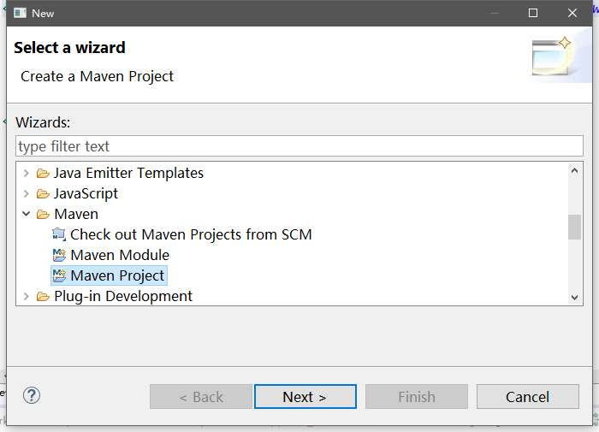

勾选Create a simple project

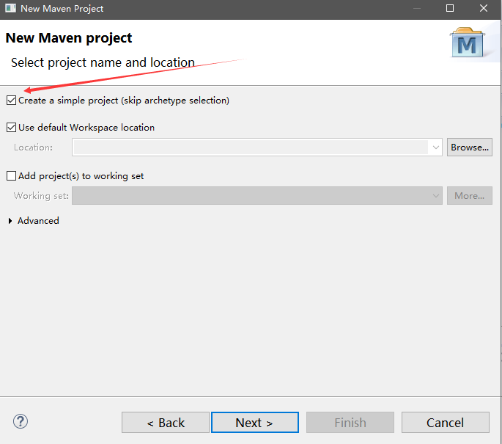

填写项目信息

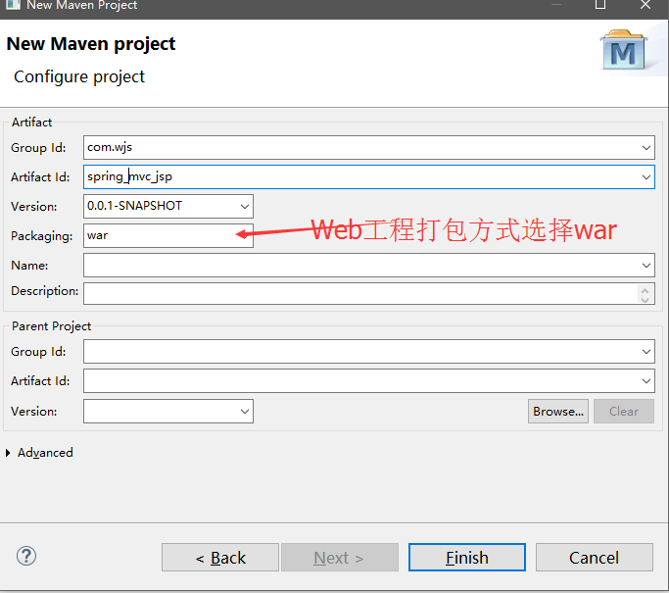

工程创建好后，提示没有web.xml信息

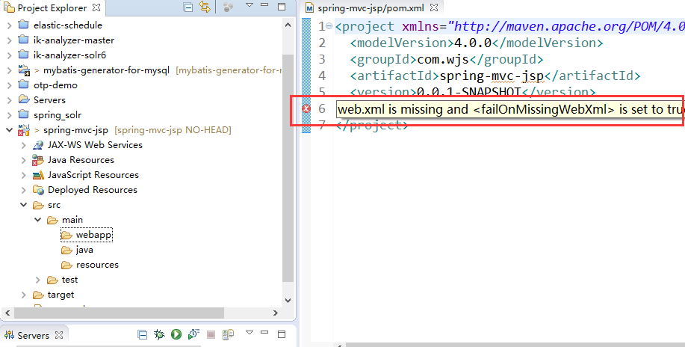

在webapp目录下手动添加WEB-INF/web.xml信息

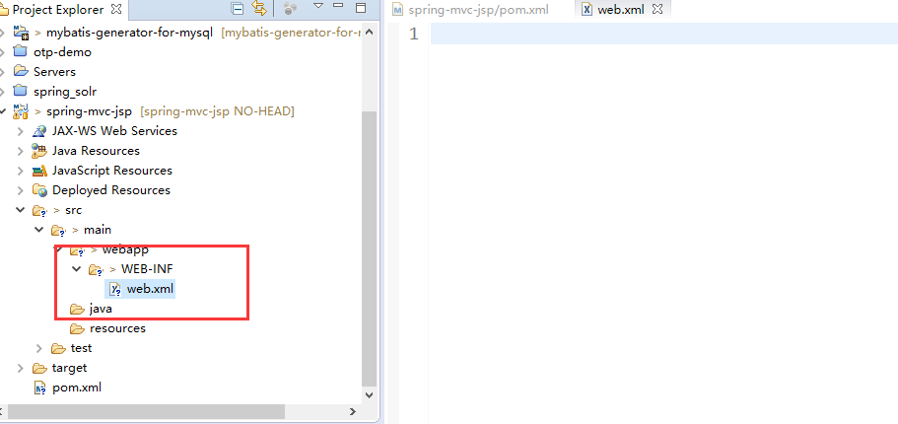

# 引入必须的jar包

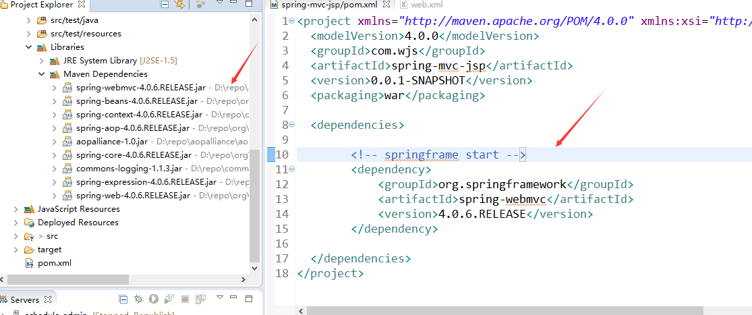

配置web.xml

<?xml version="1.0" encoding="UTF-8"?>

<web-app xmlns:xsi="http://www.w3.org/2001/XMLSchema-instance"

xmlns="http://java.sun.com/xml/ns/javaee" xmlns:web="http://java.sun.com/xml/ns/javaee/web-app_2_5.xsd"

xsi:schemaLocation="http://java.sun.com/xml/ns/javaee http://java.sun.com/xml/ns/javaee/web-app_2_5.xsd"

id="WebApp_ID" version="2.5">

<display-name>cuckoo-job-admin</display-name>

<context-param>

<param-name>webAppRootKey</param-name>

<param-value>spring-mvc-jsp</param-value>

</context-param>

<servlet>

<servlet-name>springmvc</servlet-name>

<servlet-class>org.springframework.web.servlet.DispatcherServlet</servlet-class>

<!-- MVC模式中的controller层，负责web接口的分发

主要作用：

1、文件上传解析，如果请求类型是multipart将通过MultipartResolver进行文件上传解析；

2、通过HandlerMapping，将请求映射到处理器（返回一个HandlerExecutionChain，它包括一个处理器、多个HandlerInterceptor拦截器）；

3、通过HandlerAdapter支持多种类型的处理器(HandlerExecutionChain中的处理器)；

4、通过ViewResolver解析逻辑视图名到具体视图实现；

5、本地化解析；

6、渲染具体的视图等；

7、如果执行过程中遇到异常将交给HandlerExceptionResolver来解析。 -->

<init-param>

<param-name>contextConfigLocation</param-name>

<param-value>classpath*:/spring/spring-mvc-context.xml</param-value>

<!-- 定义controller相关配置 -->

</init-param>

<load-on-startup>1</load-on-startup>

</servlet>

<servlet-mapping>

<servlet-name>springmvc</servlet-name>

<url-pattern>/</url-pattern>

</servlet-mapping>

<welcome-file-list>

<welcome-file>index.html</welcome-file>

</welcome-file-list>

</web-app>

配置控制层spring文件

<?xml version="1.0" encoding="UTF-8"?>

<beans xmlns="http://www.springframework.org/schema/beans"

xmlns:xsi="http://www.w3.org/2001/XMLSchema-instance"

xmlns:aop="http://www.springframework.org/schema/aop"

xmlns:c="http://www.springframework.org/schema/c"

xmlns:cache="http://www.springframework.org/schema/cache"

xmlns:context="http://www.springframework.org/schema/context"

xmlns:jdbc="http://www.springframework.org/schema/jdbc"

xmlns:jee="http://www.springframework.org/schema/jee"

xmlns:lang="http://www.springframework.org/schema/lang"

xmlns:mvc="http://www.springframework.org/schema/mvc"

xmlns:p="http://www.springframework.org/schema/p"

xmlns:task="http://www.springframework.org/schema/task"

xmlns:tx="http://www.springframework.org/schema/tx"

xmlns:util="http://www.springframework.org/schema/util"

xsi:schemaLocation="http://www.springframework.org/schema/beans http://www.springframework.org/schema/beans/spring-beans.xsd

http://www.springframework.org/schema/aop http://www.springframework.org/schema/aop/spring-aop.xsd

http://www.springframework.org/schema/cache http://www.springframework.org/schema/cache/spring-cache.xsd

http://www.springframework.org/schema/context http://www.springframework.org/schema/context/spring-context.xsd

http://www.springframework.org/schema/jdbc http://www.springframework.org/schema/jdbc/spring-jdbc.xsd

http://www.springframework.org/schema/jee http://www.springframework.org/schema/jee/spring-jee.xsd

http://www.springframework.org/schema/lang http://www.springframework.org/schema/lang/spring-lang.xsd

http://www.springframework.org/schema/mvc http://www.springframework.org/schema/mvc/spring-mvc.xsd

http://www.springframework.org/schema/task http://www.springframework.org/schema/task/spring-task.xsd

http://www.springframework.org/schema/tx http://www.springframework.org/schema/tx/spring-tx.xsd

http://www.springframework.org/schema/util http://www.springframework.org/schema/util/spring-util.xsd">

<mvc:annotation-driven />

<context:component-scan base-package="com.wjs.demo.controller" />

<!-- 静态资源文件直接访问 -->

<mvc:resources mapping="/favicon.ico" location="/favicon.ico" />

<mvc:resources mapping="/static/**" location="/static/" />

<!-- html请求自动搜寻视图文件 -->

<bean name="/**/*.html" class="org.springframework.web.servlet.mvc.UrlFilenameViewController">

</bean>

<!-- 视图文件路径配置 -->

<bean class="org.springframework.web.servlet.view.InternalResourceViewResolver">

<property name="prefix" value="/WEB-INF/views/"/>

<property name="suffix" value=".jsp"/>

</bean>

</beans>