Broken Backup 🔐

Category | MISC – Cryptography / XOR
Difficulty | Easy–Medium
Flag | OWASP{xor_is_not_encryption}

1. Challenge Description
A suspicious backup has been recovered from a compromised system. The backup contains multiple files, including logs, configuration data, and a binary backup file. At first glance, everything appears normal, but something in the configuration may reveal how the backup data was protected.
Task: Investigate the provided files, identify the weakness, and recover the hidden flag.

2. Challenge Files
- backup.log – Contains information about the backup process.
- config.ini – Contains configuration values.
- backup.dat – Contains the protected/hidden data.

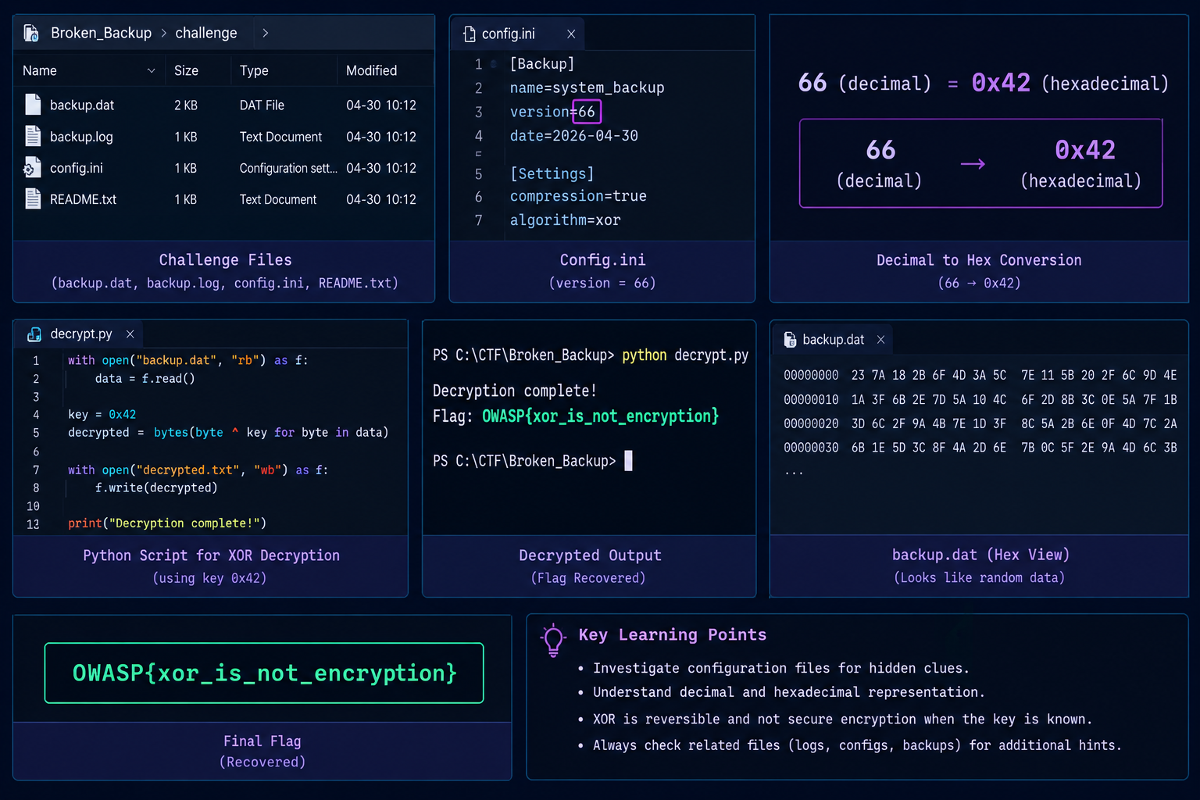

3. Intended Solve Path
Inspect files → Examine config.ini → Find suspicious value: 66 → Convert decimal 66 to hexadecimal 0x42 → Use 0x42 as XOR key → Decrypt backup.dat → Recover the flag

4. Step-by-Step Solution

Step 1 – Inspect the Files
The first step is to examine all the files provided with the challenge. The configuration file contains an unusual value:
version=66
The value 66 looks like an ordinary version number, but it is worth investigating further.

Step 2 – Convert the Value
The number 66 can also be represented in hexadecimal:
66 (decimal) = 0x42 (hexadecimal)
This is an important clue because 0x42 can be used as a byte value in XOR operations.

Step 3 – Investigate backup.dat
Opening backup.dat directly does not reveal the flag. This suggests that the data may have been transformed or obfuscated.
The challenge points toward XOR. XOR is reversible:
Encrypted Data XOR Key = Original Data
Since the suspicious value from the configuration is 0x42, it can be tested as the XOR key.

Step 4 – XOR Decryption
Each byte of backup.dat is XORed with 0x42.
with open("backup.dat", "rb") as f:
data = f.read()
decrypted = bytes(byte ^ 0x42 for byte in data)
print(decrypted.decode())
The decrypted output reveals:
OWASP{xor_is_not_encryption}

5. Flag
OWASP{xor_is_not_encryption}

6. Key Learning Points
- Investigating configuration files for hidden clues
- Decimal and hexadecimal representation
- XOR-based data obfuscation
- Byte-level manipulation
- Recognizing that XOR is reversible
- Understanding the difference between encoding, obfuscation, and encryption

Important Security Concept
XOR by itself is not secure encryption when a simple, predictable key is used. If the key is known or can be discovered, the original data can easily be recovered.
Ciphertext XOR Key = Plaintext

7. Challenge Design
Broken Backup is a beginner-friendly, file-based MISC challenge designed to encourage participants to investigate relationships between different artifacts.
The configuration file does not directly contain the flag. Instead, it provides a clue that becomes useful when analyzing the backup data.
The intended learning progression is:
Observation → Configuration Analysis → Number Representation → XOR → Decryption → Flag

8. Skills Required
- File investigation
- Configuration files
- Decimal/hexadecimal conversion
- XOR operation
- Basic Python or another scripting language
No network exploitation is required.

9. Participant Hints
HINT 1: Inspect all the provided backup files carefully.
HINT 2: Check the configuration file for unusual values.
HINT 3: A number can have another representation. Think hexadecimal.
HINT 4: The backup data is protected using XOR.
HINT 5: The value you discovered may be the XOR key.

10. Challenge Summary
Broken Backup is a file-based MISC challenge where participants investigate a suspicious backup and discover that a seemingly ordinary configuration value contains the key to recovering the hidden data.
Obfuscating data with a simple XOR operation does not make it secure.

Final Flag: OWASP{xor_is_not_encryption}

