Stego_SoulStone 👻
OWASP CTF Challenge Write-up

Category | MISC – Steganography
Difficulty | Medium–Hard
Flag | OWASP{the_soul_remembers}

1. Challenge Description
Stego_SoulStone is a file-based MISC steganography challenge based on the Ghost Protocol / Soul Stone theme. The participant is given a seemingly ordinary server log. The visible log does not directly reveal the flag; hidden information is embedded using trailing whitespace.
The challenge requires the participant to identify the hidden whitespace channel, extract the binary data, convert it to ASCII, decode the resulting Base64 data, and finally recover the flag using an XOR key revealed by a clue in the log.
Task: Investigate the provided artifact, uncover the hidden data, and recover the flag.

2. Challenge Files
- README.txt – Provides the challenge scenario and instructions.
- server.log – The main artifact containing the hidden data.
- hints.txt – Provides progressive hints for participants.

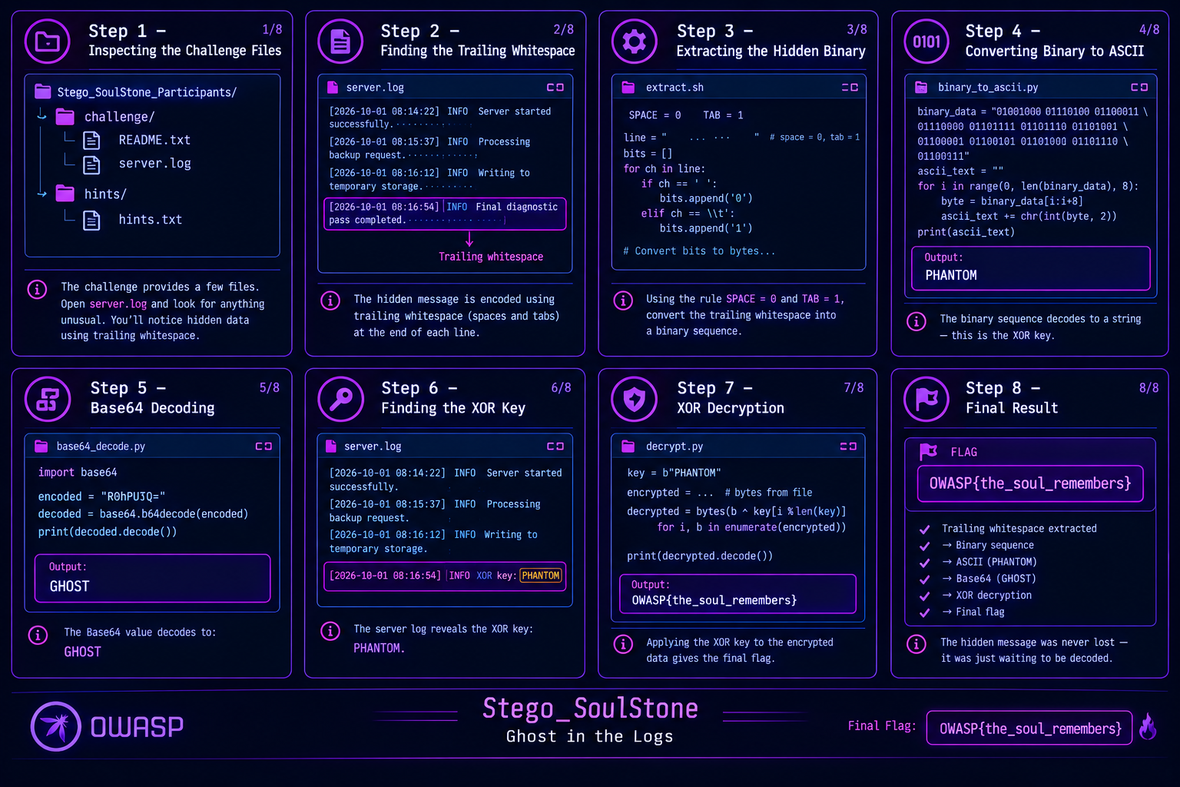

3. Intended Solve Path
server.log → Trailing spaces/tabs → Binary → ASCII → Base64 → Base64 decode → XOR with PHANTOM → Flag

4. Step-by-Step Solution

Step 1 – Inspect the Log
The participant first opens server.log. The visible content appears to be a normal server log containing routine INFO and DEBUG messages.
The README states that the log was copied exactly as it was found and that nothing was cleaned. This encourages the participant to inspect details beyond the visible text.

Step 2 – Inspect Whitespace
The important clue is hidden at the end of selected log lines. Trailing spaces and tabs are used as the covert channel.
A participant can enable whitespace rendering in an editor such as VS Code to make the otherwise invisible characters visible.
The encoding rule is:
SPACE = 0 TAB = 1

Step 3 – Extract the Binary
The trailing spaces and tabs are extracted from the log lines and converted according to the rule SPACE = 0 and TAB = 1.
The resulting bit stream is grouped into 8-bit bytes.

Step 4 – Convert Binary to ASCII
Each group of eight bits is converted from binary to an ASCII character.
This produces the following text:
Hx8AHQQ0OTgtHiI7KBInKTIROio7NToeKzk/OSk1
The extracted text has the appearance of Base64-encoded data.

Step 5 – Base64 Decode
The extracted ASCII string is Base64 decoded. The result is not readable text; instead, it produces encrypted/obfuscated bytes.
The decoded byte sequence is:
b'\x1f\x1f\x00\x1d\x04498-\x1e\";(\x12\')2\x11:*;5:\x1e+9?9)5'

Step 6 – Identify the XOR Key
The decoded bytes are still not the final message. The challenge contains another clue in the server log:
Legacy diagnostic codename: PHANTOM.
This reveals the XOR key:
PHANTOM

Step 7 – XOR Decryption
The Base64-decoded bytes are XORed with the repeating key PHANTOM.
key = "PHANTOM"
key_bytes = key.encode()
decrypted = bytearray()
for i, byte in enumerate(encrypted):
decrypted.append(byte ^ key_bytes[i % len(key_bytes)])
print(decrypted.decode())

5. Final Flag
OWASP{the_log_was_never_empty}

6. Complete Solve Chain
The complete intended solving process is:
1. Open server.log.
2. Inspect the log beyond its visible content.
3. Notice trailing spaces and tabs.
4. Use SPACE = 0 and TAB = 1.
5. Extract the resulting binary.
6. Group the binary into 8-bit values.
7. Convert the binary to ASCII.
8. Recognize the Base64 string.
9. Base64 decode the string.
10. Find the PHANTOM clue in server.log.
11. Use PHANTOM as the repeating XOR key.
12. Recover the final OWASP flag.

7. Key Learning Points
- Invisible whitespace can be used as a covert communication channel.
- Spaces and tabs can represent binary data.
- Binary data can be converted into ASCII characters.
- Base64 is an encoding technique, not encryption.
- XOR can be reversed when the key is known.
- Logs can contain information outside their visible text.
- Small formatting details can be important during digital investigation.

8. Security Concept
The challenge demonstrates how covert channels can hide information in data that appears harmless. Trailing whitespace is particularly useful for this purpose because spaces and tabs are normally invisible in standard text viewers.
It also demonstrates the difference between encoding and cryptographic transformation. The hidden data passes through binary representation and Base64 encoding before XOR is used to recover the final plaintext.

9. Challenge Design
Stego_SoulStone is designed as an offline, file-based MISC challenge. No network service or client-server interaction is required.
The challenge combines several investigation steps so that participants must first notice the covert channel and then progressively interpret the recovered data.
The intended difficulty is Medium–Hard because the participant must recognize whitespace steganography and chain multiple transformations together.

10. Skills Required
- Basic file and log analysis
- Understanding of spaces and tabs as data
- Binary-to-ASCII conversion
- Base64 decoding
- Basic XOR concepts
- Basic Python/scripting skills

11. Participant Hints
HINT 1: Inspect the artifact carefully.
HINT 2: Look for hidden or unusual data.
HINT 3: Pay attention to encoded strings.
HINT 4: Decode the suspicious Base64 value.
HINT 5: The decoded data needs another step.
HINT 6: Look for an XOR key clue in the log.
HINT 7: Use the discovered key to recover the flag.

12. Challenge Summary
Stego_SoulStone challenges participants to investigate a normal-looking server log and uncover a hidden message embedded in trailing whitespace. The recovered data passes through binary conversion, ASCII, Base64, and XOR decryption before the final flag is revealed.
Final Flag: OWASP{the_soul_remembers}

