The core purpose of Pointer Authentication (PA) is to verify whether pointers (such as return addresses, function pointers, etc.) have been maliciously tampered with. It achieves this by adding a Pointer Authentication Code (PAC) to the pointer and verifying its validity before use.
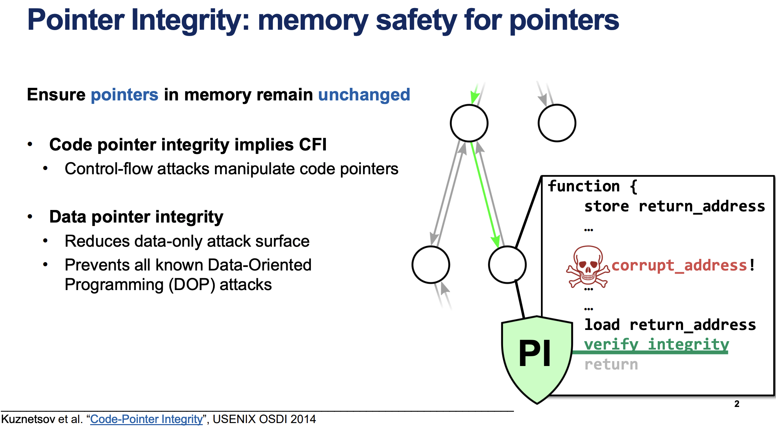

Working principle
- Generate PAC (signature):
  - Using a key (stored in a CPU register), the pointer's virtual address, and additional context information (such as a stack pointer), a short PAC is generated for the pointer via an encryption algorithm (ARM uses the QARMA algorithm).
  - The PAC is stored in the highest unused bit of the pointer value. This is because in a 64-bit architecture, the virtual address is typically not fully used (e.g., in a 48-bit architecture), leaving the high-order bits free.
- Verification and Recovery (Verification):
  - Before using a pointer (such as before a function returns), the CPU executes a verification instruction (e.g., ... AUT*).
  - The system will recalculate the PAC using the same key and context, and compare it with the PAC stored in the pointer.
  - If a match is found, the PAC is removed, the original pointer is restored, and the program executes normally.
  - If there is a mismatch, the pointer will be set to an invalid value, which will typically trigger an exception (such as a segmentation fault) to prevent attacks.

Pointer Authentication in ARMv8.3-A
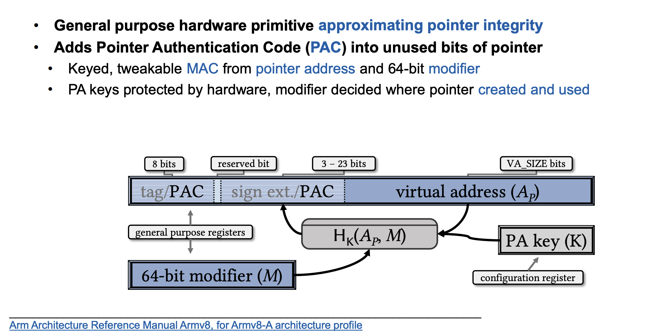
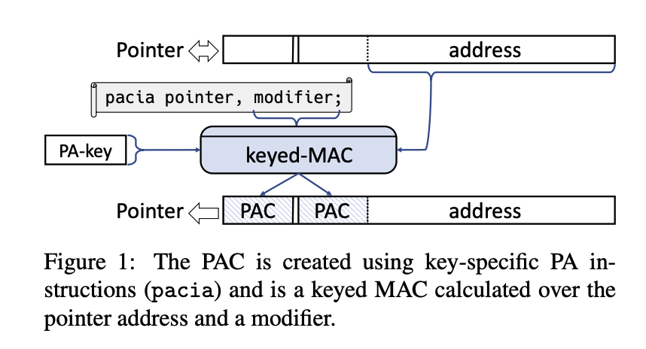
PA is intended for checking the integrity of pointers with minimal size and performance impact. It is available when the processor executes in 64-bit ARM state(AArch64). PA adds instructions for creating and authenticating pointer authentication codes (PACs). The PAC is a tweakable message authentication code (MAC) calculated over the pointer value and a 64-bit modifier as the tweak. Different combinations of key and modifier pairs allow domain separation among different classes of authenticated pointers. This prevents authenticated pointer values from being arbitrarily interchangeable with one another.
PA provides five different keys for PAC generation: two for code pointers, two for data pointers, and one for generic use. The keys are stored in hardware registers configured to be accessible only from a higher privilege level: e.g., the kernel maintains the keys for a user space process, generating keys for each process at process exec. The keys remain constant throughout the process lifetime, whereas the modifier is given in an instruction-specific register operand on each PAC creation and authentication (i.e., MAC verification). Thus it can be used to describe the run-time context in which the pointer is created and used. The modifier value is not necessarily confidential but ideally such that it 1) precisely describes the context of use in which the pointer is valid, and 2) cannot be influenced by the attacker

Example: PA-based return address signing
