Suyog Daga

EMI-HW5

UFID:5773 5749

Q1)

* Initially checking the data, we see that there are 3 varieties of flowers: setosa, versicolor and virginica. This gives an idea that, k=3 might be a good guess for clusters in such data set.
* Starting with k=3 and setting initial means to zero vectors, we get following graph for objective function magnitude versus iterations:

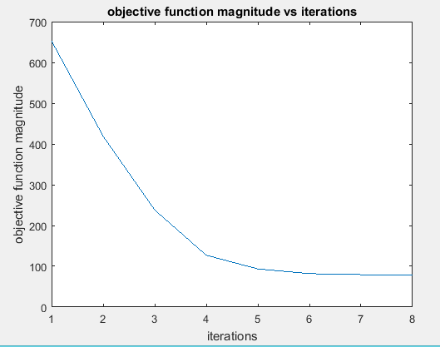

* Note the cost is approximately 650 when we start with means initialized to zero.
* Now, we try to plot the above graph for some random mean with respect to data.

Here are the three plots of Objective Function Magnitude versus the number of Iterations for 3 different set of means:

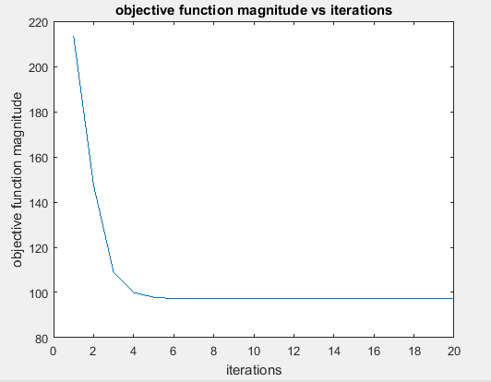

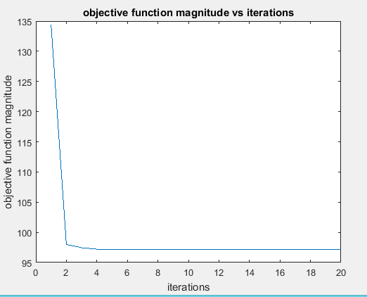

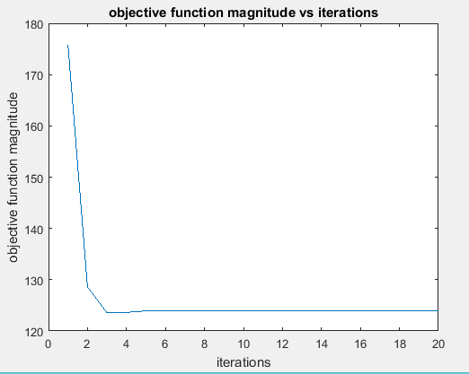

* In all the three above plots, we see that function converges fast when means are assigned in the neighborhood of data, as compared to mean which were initialized to zero.
* We clearly can distinguish Iris-Setosa when compared to Iris-Versicolor and Iris-Virginica.
* Iris-Versicolor and Iris-Virginica have overlapping, where there is misclassification and therefore we don’t have well separated clusters. Still majority of flowers in both the categories are classified properly.

Q2)

* Here is the table for Dunn’s Index and Davies-Bouldin Index.



For Dunn’s index, the number of clusters that maximizes Vd is taken as best solution, which in this case is k =3

For David-Bouldin’s index, optimal number of clusters corresponds to minimum value of Vdb, which in this case is k=2.

* Dunn’s index gives us correct number of clusters(k=3), while David-Bouldin’s index gives one less cluster (k=2) for data. The overlap in two flowers (versicolor and virginica) is too strong for Davies-Bouldin index to enumerate the cluster.

Dendrogram:

The clusters below for k=3 could be 6-8 , 14 to 26 and 1 to 3 . This clusters seems to have highest Euclidean distance between each other.

