Noise canceling in audio signal with adaptive filter

John Christakis
Logothetis Antonis
Mpalolakis Antonis
Boulgaris Konstantinos
Gogornas Ioannis
Theodore P. Chinis
Electronic Engineering
Technological Educational Institute of Athens
Agiou Spyridonos
12210
Egaleo
GREECE

Abstract: - In this paper, an adaptive noise canceller will be presented and some useful observations will be done with the canceling process over the audio signal

1 Introduction
All the physical systems when they operate, they produce physical noise, which is a mixing of an infinitive number of sinusoidal harmonics with different frequencies. So, the initial signal information is corrupted with this noise. This complex signal, may be very noisy, so much that the human ear or other system which may follow it, cannot receive correct the initial signal.
So, an algorithm has to be invented which must be able to separate the physical noise from the information signal and to output the information signal without noise. This is not possible, as there is not a perfect system. So, this algorithm should have the ability to reduce the noise level as much as it can.
A good noise-canceling algorithm is the algorithm, which is presented in this paper. This algorithm is based on the Least Mean Square algorithm. This system, operates like an automatic control system with feedback where the feedback performs an adaptation to the filter coefficients, otherwise it adjust the filtering of the noise in each sample.

2 Problem formulation
A simple audio signal is represented by the following mathematical equation
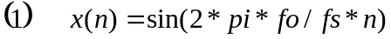
Where 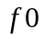 is the frequency of the audio signal, 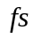 is the sampling frequency and
is the discrete time base.
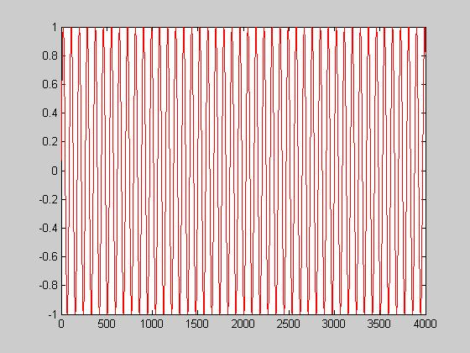

Fig.1 The simple audio signal without noise

When white noise is added to this signal then it becomes
So, the problem is to extract the useful signal from this complex signal.
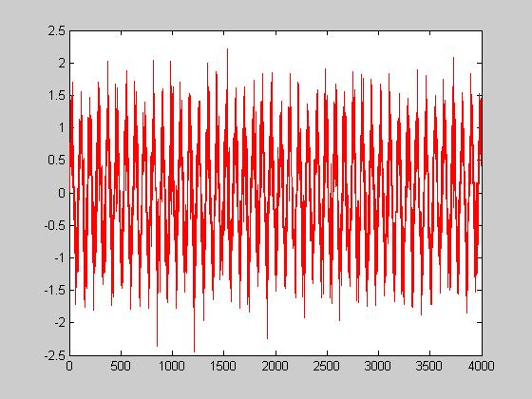
Fig.2 The audio signal with noise

A simple adaptive filter noise canceller is presented in the following diagram.

+

Audio signal with noise c(n)- u_{k} Output - y_{k}

Noise(n) - d(n)
Adaptive Filter
W_{k+1}

error(n)- e_{k}

Fig.3 Adaptive filter noise canceller

2.1 Brief adaptive filter theory
One of the most successful adaptive algorithms is the LMS algorithm developed by Widrow and his coworkers. Instead of computing 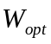 which is the optimal solution of the wiener filter, the LMS coefficients are adjusted from sample to sample in such a way as to minimize the MSE (mean square error).

The LMS is based on the steepest descent algorithm where the weight vector is updated from sample to sample as in the next equation.
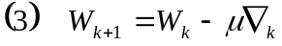
Where W_{k} and 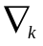are the weight or the impulse response w (n) of the filter and the true gradient vectors respectively, at the 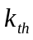 sampling instant.  Controls the stability and rate of convergence.

The steepest descent algorithm in the previous equation still requires knowledge of  and , since is obtained by the next equation.
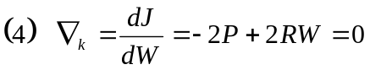
The LMS algorithm is a practical method of obtaining estimations of the filter weights W_{k} in real time without the matrix inversion of the next equation 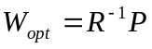 or the direct computation of the autocorrelation and cross correlation. The Widrow – Hopf LMS algorithm for updating the weights from sample to sample is given by
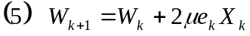
Where: 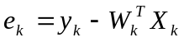
Clearly, the LMS algorithm above does not require prior knowledge of the signal statistics (that is the correlations and ), but instead uses their instantaneous estimations. The weights obtained by the LMS algorithm are only estimations, but these estimations improve gradually with time as the weights are adjusted and the filter learns the characteristics of the signal. Eventually, the weights converge. The condition of convergence is:
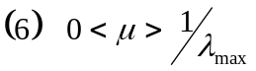
Where 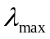is the maximum eigenvalue of the input data covariance matrix In practice, 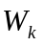 never reaches the theoretical optimum (the Wiener solution), as the algorithm iteration step can never be zero but it has a discrete value.
Furthermore, the LMS algorithm can be summarized in the next equation for the implementation of the filter.
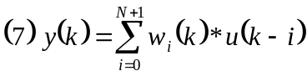
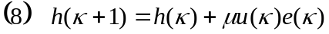
In which: 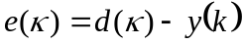
In the above equation, denotes the transpose of the vector 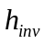. The desired response 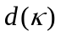can be found from the adaptive filter scheme to be
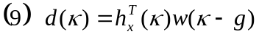

The notation 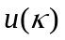denotes a vector of samples arranged as
Where is the order of the filter.

3 Problem solution
The problem solution may be based on standard adaptive techniques and especially on the adaptive filter noise canceller.
This filter gets the physical noise and filters it in such a way that the algebraic addition with the complex signal produces a new signal with a very low level of noise. The schematic diagram of the adaptive filter noise canceller was given above and it is presented again in the following diagram.

+
Audio signal with noise x(n) Output – y(n)

Noise d(n)
Adaptive Filter
W_{k+1}

error(n)

Fig.4 The used adaptive noise canceller

As it can be observed, the adaptive filter noise canceller is a system with feedback as a system with automatic control. For this reason, there is stability problem. The problem arises when the error signal’s amplitude increases in accordance with time or when no convergence is obtained.
The mathematical algorithm, which is used by the adaptive filter for the filter’s coefficients update, is called LMS (Least mean square) algorithm. This algorithm tries to minimize the square of the error signal so; the audio signal has been reconstructed quite well.
The system output is the error signal. The error signal is the algebraic subtraction between the audio signal with noise and the noise. When the LMS algorithm performs a good convergence then the only error signal is the audio signal. So, the error signal must be the noise canceller output.
The LMS algorithm has also an initial step variable μ, which is the step of the convergence in each iteration. In the matlab code where the adaptive filter noise canceller is built, the NLMS algorithm used. The only difference is that the step variable μ, changes in each iteration with the next equation:
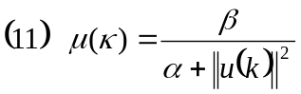
where  is a positive constant, usually less than , and is a small positive constant. The symbol 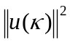 is the energy of the signal in a predefined buffer.

3.1 Implementation of the adaptive filter noise canceller in matlab and waveforms
The adaptive noise canceller was implemented in matlab as it offers the opportunity for a quick and very professional way to study the whole operation of the system.
The matlab code, which was written, is presented now.

function [x] = noice_canceller
clear all;
%**********************
%**** Time Base *******
%**********************
N = 2000;
n = 1:1:N;
%***********************
%**** System Vars
%***********************
fo = 500;
Fs = 44100;
db = 5;
%***********************
%***** Signal Generation
%***********************
audio = sin(2*pi*fo/Fs*n); %+ 0.7*sin(2*pi*5*fo/Fs*n));
%**********************
%**** Noise Generation
%*********************
%noise_plus_audio = awgn(audio,db);
noise = wgn(1,N,db)/2;
%noise = 0.1*randn(1,N);
for i=1:1:N
noise_plus_audio(i) = (audio(i) + noise(i)/2);
end
%**************************************
%**** Initialization of Noise Canceller
%**************************************
w0 = zeros(1,32); % Initial filter coefficients
%wi = zeros(1,255);
mu = 0.4; % LMS step size
S = initnlms(w0,mu,[],1);
%***************************************
%***** Apply Noise Canceller over signal
%***************************************
for i=1:1:N
[y,canceller_output(i),S] = adaptnlms(noise(i),noise_plus_audio(i),S);
%***************************************
%***** Calculate FFT of Signals
%***************************************
ff_mix = abs(fft(noise_plus_audio,1024));
ff_output = abs(fft(canceller_output,1024));
%***************************************
%***** Calculate Error
%***************************************
error(i) = audio(i) - canceller_output(i);
%***********************
%*** Plots *************
%***********************
subplot(6,1,1);
plot(noise_plus_audio,'r');
axis([0 N -2 2]);
title('Signal and Noise');
subplot(6,1,2);
plot(audio,'g');
axis([0 N -2 2]);
title('Audio Signal');
subplot(6,1,3);
plot(canceller_output,'b');
title('Canceller Output');
axis([0 N -2 2]);
subplot(6,1,4);
plot(ff_mix,'r');
title('FFT of Mixed Signal');
subplot(6,1,5);
plot(ff_output,'r');
title(' FFT of Output');
subplot(6,1,6);
plot(error,'g');
axis([0 N -2 2]);
title('Error of FFT');
drawnow;
end

The output waveforms of the system are plotted in the next figure.
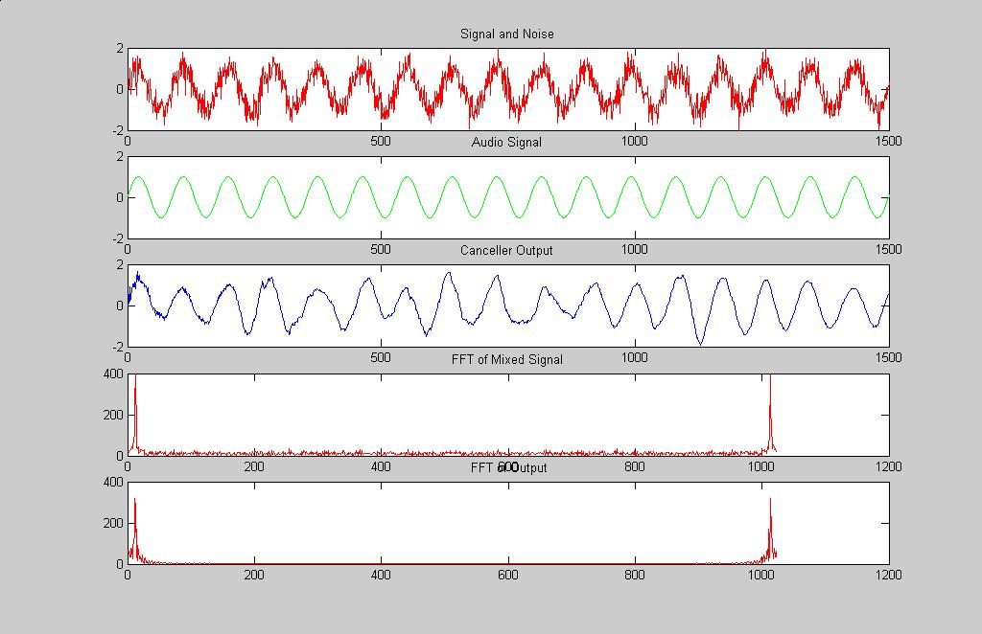
Fig.5 Noise canceller output waveforms

4 Conclusion
To sum up, the adaptive noise canceller is a very efficient and useful system in many applications with sound, video etc. The only disadvantage is that it needs digital signal processor DSP for its operation.

References:
1. Simon Haykin, Adaptive Filter Theory, Prentice Hall 2002

