Project Name : Farmer’s MarketPlace

Guide : Mr.Nilesh Shirke

Project Members :

# 230940420071 Saurabh Shahaji Jadhav

# 230940420069 Satya Prakash dutt

# 230940420063 Ganesh Pandurang Shelke

# 230940420052 Suyog Dhavdekar

# 

# Abstract

Our system offers one stop solution to all fresh food needs. Users can log into their accounts and then they will be taken to the produces offered by the farmer. Now they can pick what foods they want to order and add to the cart. Once they are done selecting what they require, they can simply click on check out button to pay the bill and their cart will be delivered to their houses. This can be done from any place, at any time all from the internet, thus making it easy to get your daily need of fresh foods.

# Existing System

While there are many options available online, They are just fresh food service in name. in reality most of their produce is either Vaccumed sealed or Frozen foods. And they concentrate mainly on packaged and small commodities. Also if middle man is included the freshness of commodities is affected. Also the cost is increased.

# Proposed System

THE FARMERS MARKETPLACE, as the name suggested is about farmers. It is about connecting farmers directly to the customers, thereby cutting the middle man. This ensures that the customers get fresh foods at a very cheap price. This also ensures that all the farmers get a fair chance at gaining customers so that they don’t have to rely on any middle man.

# Future Scope

* Rating for products
* Reviews for farmers
* Top Selling products
* Top Farmers

5. UML Diagram:

1. DFD

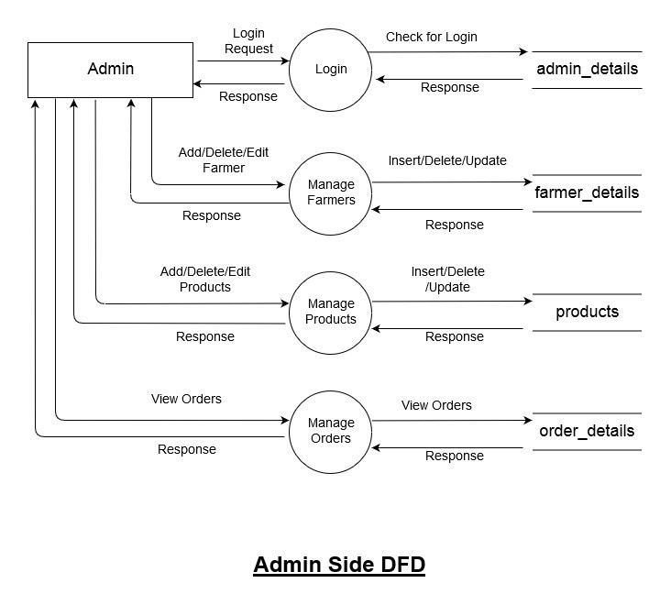

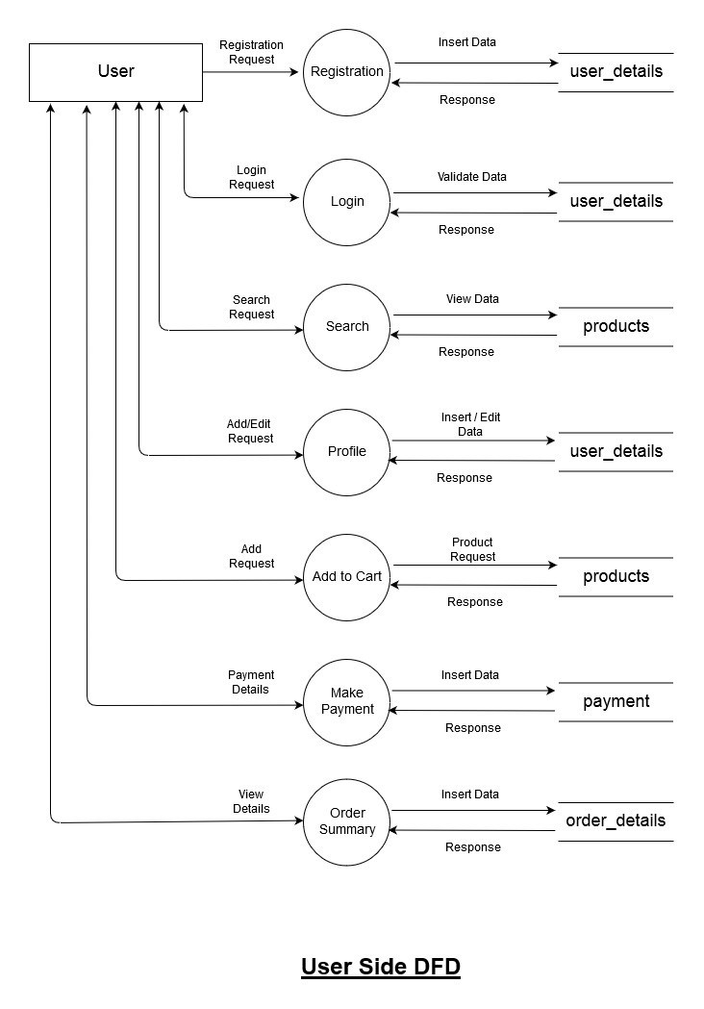

1. Class Diagram

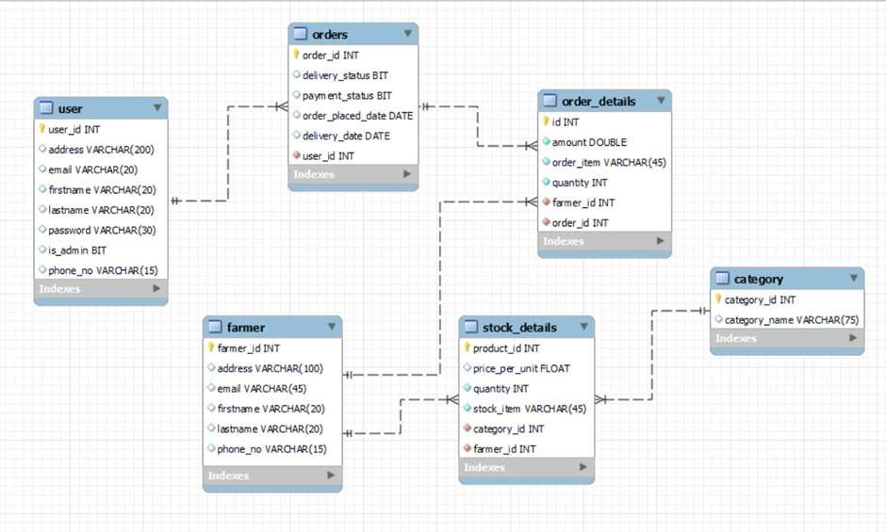

1. Use Case Diagram

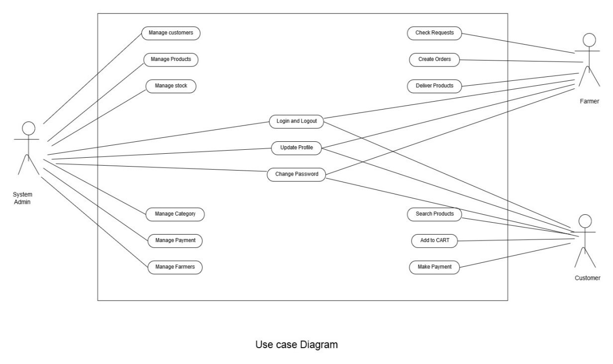

1. ER Diagram

