**ASSIGNMENT COVER SHEET**

|  |  |  |  |  |  |  |  |
| --- | --- | --- | --- | --- | --- | --- | --- |
| **Course: BSc Computing (SE)** | | | | **Year: 2** | | **CSY2038** | |
| **Group Project** | | **Title:** Design, create and test methods for building an object relational database with useful data abstraction and automatizing useful processes in Pl/SQL | | | | | |
| Date due out: | Date due in: 13th Nov, 2022 | | Extension date: | | | | Extension agreed by: |
| **Team: 19**  **Group Members:**   1. Miraj Thapa 2. Rupak Upreti 3. Sakshyam Aryal 4. Suyog Kadariya | | | | | | **Tutor: Ankit Thapa** | |
| Student comment, specific request for feedback etc. | | | | | Marker’s General View of the work | | |

Video Demo Link:

Contents

Abstract

But I must explain to you how all this mistaken idea of denouncing pleasure and praising pain was born and I will give you a complete account of the system, and expound the actual teachings of the great explorer of the truth, the master-builder of human happiness. No one rejects, dislikes, or avoids pleasure itself, because it is pleasure, but because those who do not know how to pursue pleasure rationally encounter consequences that are extremely painful. Nor again is there anyone who loves or pursues or desires to obtain pain of itself, because it is pain, but because occasionally circumstances occur in which toil and pain can procure him some great pleasure. To take a trivial example, which of us ever undertakes laborious physical exercise, except to obtain some advantage from it? But who has any right to find fault with a man who chooses to enjoy a pleasure that has no annoying consequences, or one who avoids a pain that produces no resultant pleasure. But I must explain to you how all this mistaken idea of denouncing pleasure and praising pain was born and I will give you a complete account of the system, and expound the actual teachings.

1. Database Schema Design

Schema design is the initial step in the database design process. The database schema refers to the overall layout of the database. It stands for the logical overview of the entire database architecture. The database schema that we used is provided below.

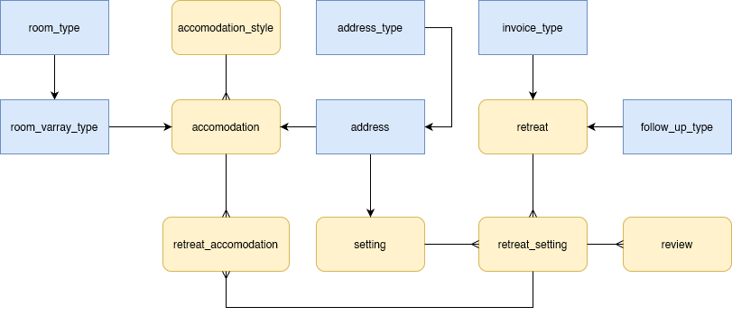

*Fig: Database Schema Design*

1. Skeleton Table Design

To comprehend the database structure at its most fundamental level, a skeleton table is required. Based on the schema design, the skeleton table that follows shows all the specifics of the database tables, including their characteristics, keys, datatypes, constraints and default values.

| **Tables** | **attribute** | | **Key** | **Datatype** | **Constraints \**  **Defaults** |
| --- | --- | --- | --- | --- | --- |
| **Retreats** | retreat_id | | *pk* | NUMBER(6) |  |
|  | retreat_name | |  | VARCHAR2(30) | NOT NULL |
|  | invoice | |  | invoice_type |  |
|  | follow_up | |  | follow_up_type |  |
| **Settings** | setting_id | | *pk* | NUMBER(6) |  |
|  | setting_name | |  | VARCHAR2(30) | NOT NULL |
|  | address | |  | address_type |  |
| **retreat_setting** | | retreat_setting_id | *pk* | NUMBER(6) |  |
|  | setting_id | | *FK* | NUMBER(6) | NOT NULL |
|  | retreat_id | | *FK* | NUMBER(6) | NOT NULL |
| **accomodation_style** | accomodation_style_id | | *pk* | NUMBER(6) |  |
|  | accomodation_style_name | | *pk fk* | NUMBER(6) | NOT NULL |
| **accomodations** | accommodation_id | | *pk* | NUMBER(6) |  |
|  | accommodation_name | |  | VARCHAR2(50) | NOT NULL |
|  | room | |  | room_varray_type |  |
|  | no_of_room | |  | VARCHAR2(12) |  |
|  | address | |  | address_type |  |
|  | description | |  | VARCHAR2(100) |  |
|  | accommodation_style_id | | *FK* | NUMBER(6) | NOT NULL |
| **retreat_accommodation** | retreat_setting_id | | *pk*  *FK* | NUMBER(6) | NOT NULL |
|  | accommodation_id | | *pk fk* | NUMBER(6) | NOT NULL |

UDT’s used are as follows:

|  |  |  |  |  |
| --- | --- | --- | --- | --- |
| **address_type** | street |  | VARCHAR2(50) |  |
|  | city |  | VARCHAR2(50) |  |
|  | country |  | VARCHAR2(50) |  |
|  |  |  |  |  |

|  |  |  |  |  |
| --- | --- | --- | --- | --- |
| **follow_up_type** | start_time |  | VARCHAR2(12) |  |
|  | duration |  | VARCHAR2(12) |  |
|  | date |  | DATE |  |
|  |  |  |  |  |

|  |  |  |  |  |
| --- | --- | --- | --- | --- |
| **invoice_type** | invoice_holder |  | NUMBER(6) |  |
|  | amount |  | VARCHAR2(10,2) |  |
|  | release_date |  | DATE |  |
|  | due_date |  | DATE |  |

Varray_type used are as follows:

|  |  |  |  |  |
| --- | --- | --- | --- | --- |
| **room_type** | room_id |  | NUMBER(6) |  |
|  | capacity |  | VARCHAR2(10,2) |  |
|  | description |  | VARCHAR2(100) |  |

1. Database tables

To make clear of all the tables, separate tables have been made for good understandings. Attributes, keys, datatypes, constraints and default values are also included.

**Table no 1)** retreat

|  |  |  |  |  |
| --- | --- | --- | --- | --- |
| **TABLE** | **ATTRIBUTE** | **KEY** | **DATATYPE** | **CONSTRAINTS/DEFAULTS** |
| retreats | retreat_id | *pk* | NUMBER(6) | NOT NULL |
|  | retreat_name |  | VARCHAR2(30) | NOT NULL |
|  | invoice |  | invoice_type |  |
|  | follow_up |  | follow_up_type |  |

**Table no 2)** setting

|  |  |  |  |  |
| --- | --- | --- | --- | --- |
| **TABLE** | **ATTRIBUTE** | **KEY** | **DATATYPE** | **CONSTRAINTS/DEFAULTS** |
| settings | setting_id | *pk* | NUMBER(6) | NOT NULL |
|  | setting_name |  | VARCHAR2(30) | NOT NULL |
|  | address |  | address_type |  |

**Table no 3)** retreat_setting

|  |  |  |  |  |
| --- | --- | --- | --- | --- |
| **TABLE** | **ATTRIBUTE** | **KEY** | **DATATYPE** | **CONSTRAINTS/DEFAULTS** |
| retreat_settings | retreat_setting_id | *pk* | NUMBER(6) | NOT NULL |
|  | setting_id | *fk* | NUMBER(6) | NOT NULL |
|  | retreat_id | *f*k | NUMBER(6) | NOT NULL |

**Table no 4)** accommodation_style

|  |  |  |  |  |
| --- | --- | --- | --- | --- |
| **TABLE** | **ATTRIBUTE** | **KEY** | **DATATYPE** | **CONSTRAINTS/DEFAULTS** |
| accommodation_styles | accommodation_style_id | *pk* | NUMBER(6) | NOT NULL |
|  | accommodation_style_name | *pk, fk* | NUMBER(6) | NOT NULL |

**Table no 5)** accommodation

|  |  |  |  |  |
| --- | --- | --- | --- | --- |
| **TABLE** | **ATTRIBUTE** | **KEY** | **DATATYPE** | **CONSTRAINTS/DEFAULTS** |
| accommodations | accommodation_id | *pk* | NUMBER(6) | NOT NULL |
|  | accommodation_name |  | VARCHAR2(50) |  |
|  | room |  | room_varray_type |  |
|  | no_of_rooms |  | VARCHAR2(12) |  |
|  | address |  | address_type |  |
|  | description |  | VARCHAR2(100) |  |
|  | accomodation_style_id | *fk* | NUMBER(6) | NOT NULL |

**Table no 6)** retreat_accommodation

|  |  |  |  |  |
| --- | --- | --- | --- | --- |
| **TABLE** | **ATTRIBUTE** | **KEY** | **DATATYPE** | **CONSTRAINTS/DEFAULTS** |
| retreat_accommodations | retreat_setting _id | *pk, fk* | NUMBER(6) | NOT NULL |
|  | accommodation_id | *pk, fk* | NUMBER(6) | NOT NULL |

1. Skeleton Table Design