**CSP 586 A20402686**

**Assignment #2**

1. **System Sequence Diagram**
2. Customer order equipment online

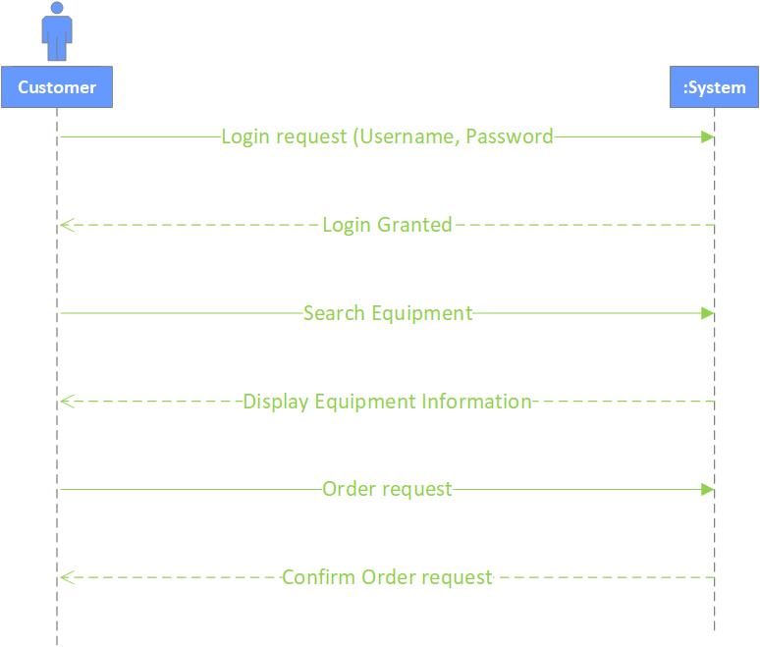

1. Store manager offers special deals

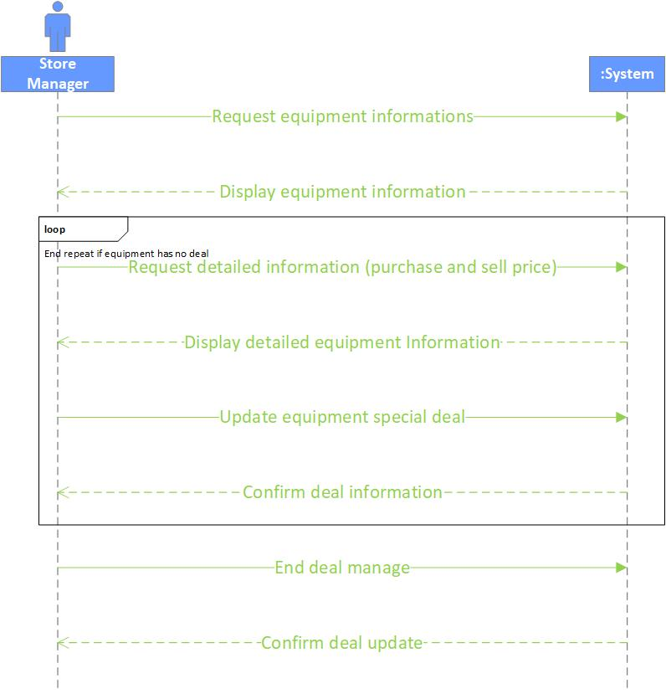

1. Salesman update customer transaction

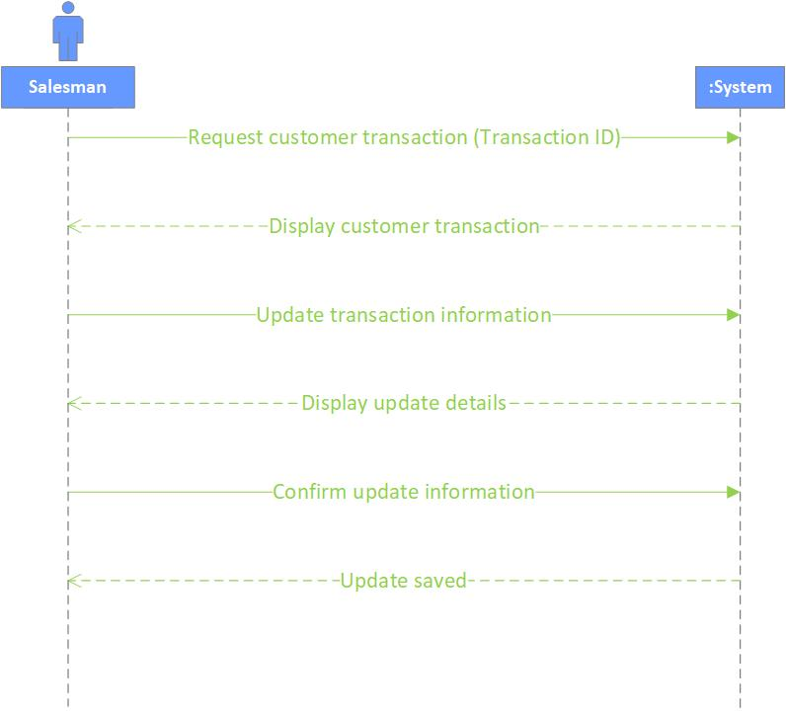

1. **Class Diagram for Analysis Model**

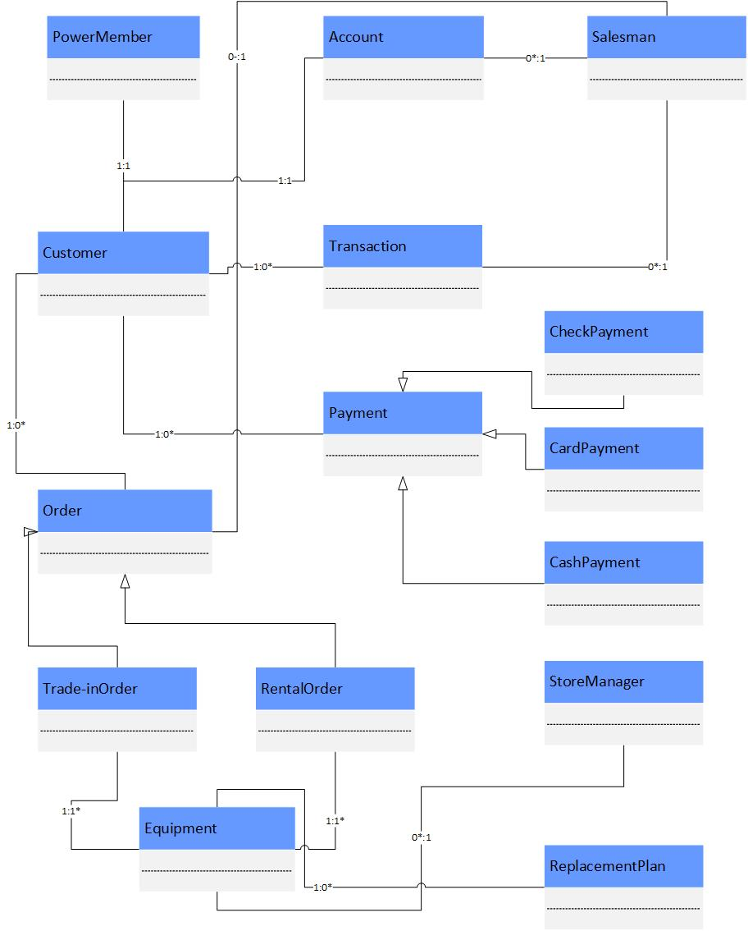

1. **Class Diagram and Package Diagram for Design Model**

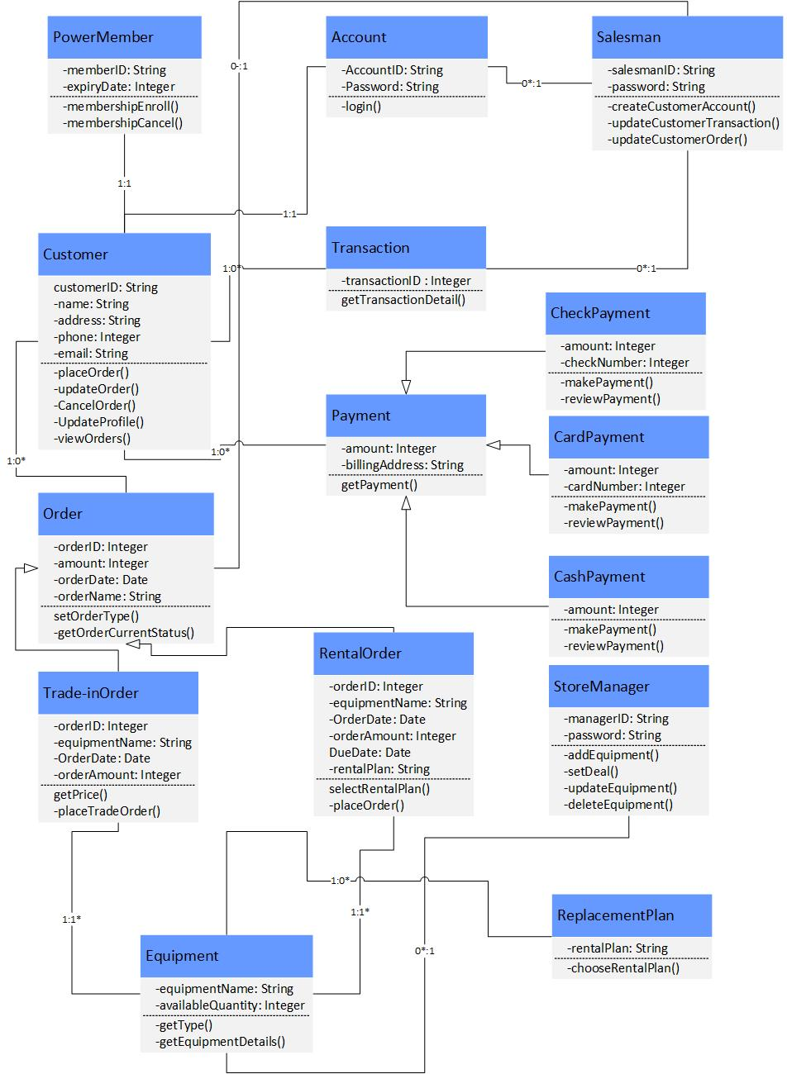

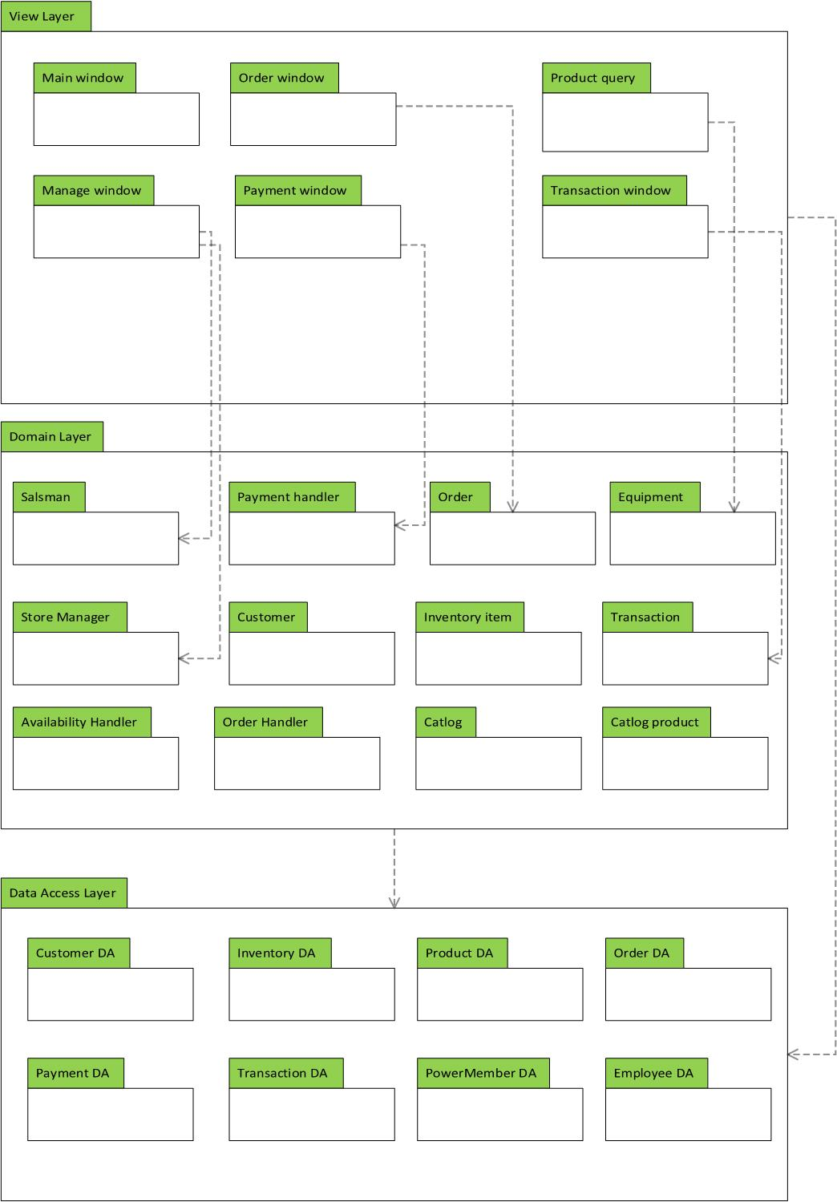

1. **Sequence Interaction Diagram**
2. Salesman create new customer account

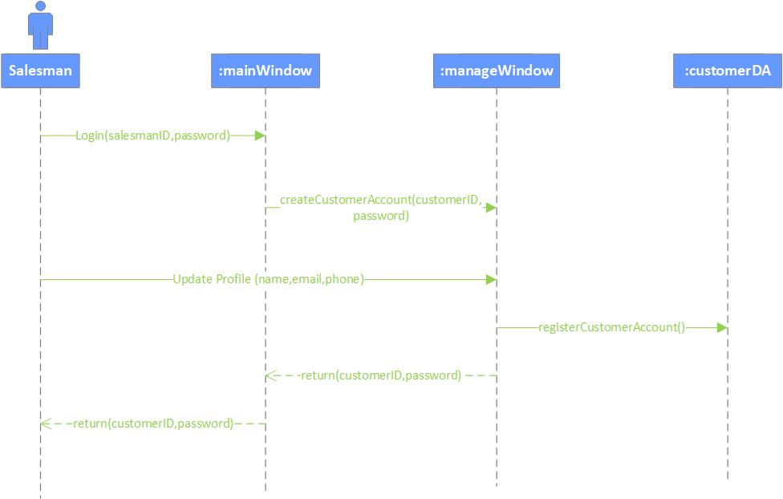

1. Customer order equipment

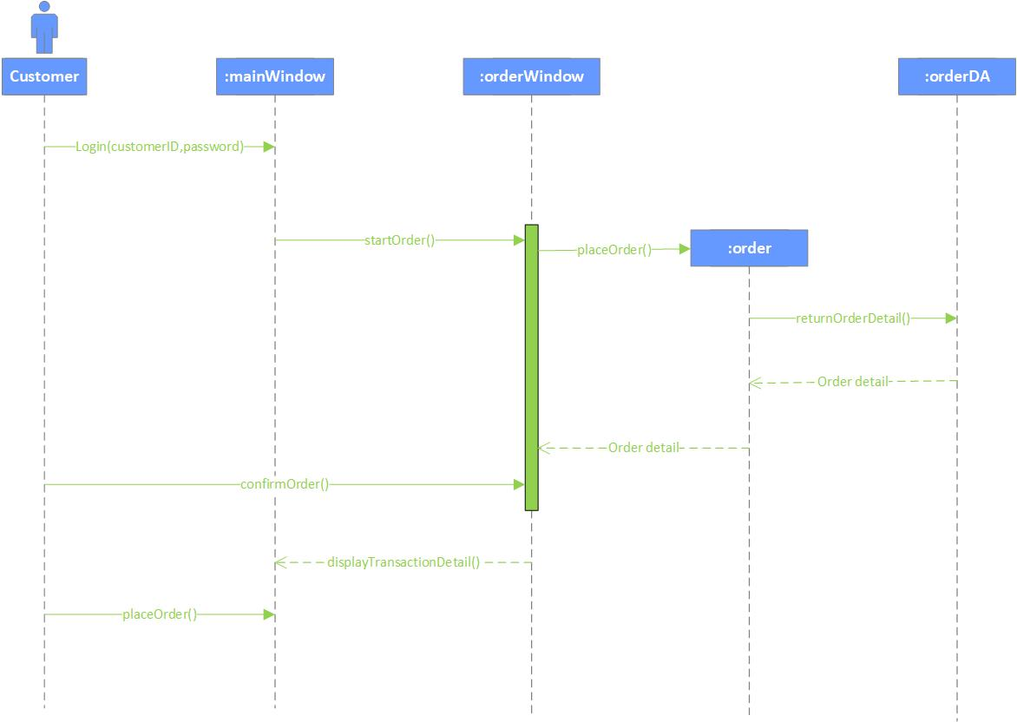

1. Make payment

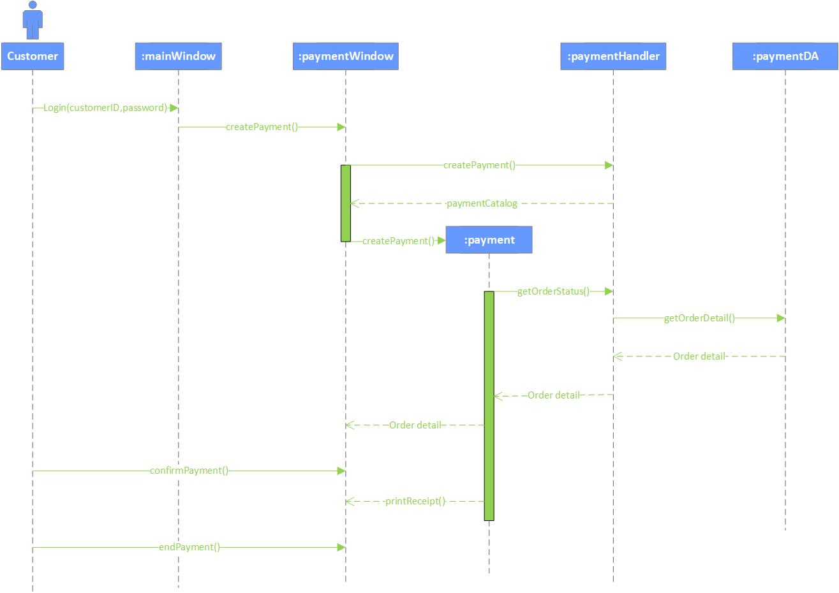

1. Store manager adds special deal

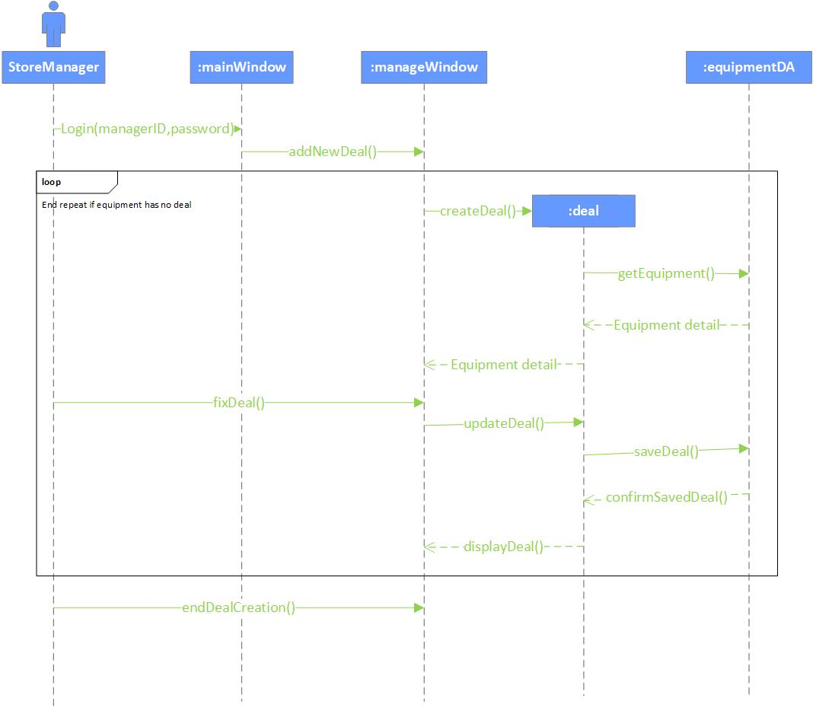

1. Enroll into power member

