CSP 586 A20402686 Assignment #1

**1. List of actors**

1. Customer

2. Store Manager

3. Salesman

**2. List of Use Cases**

1. The store manager can add products
2. The store manager can delete products
3. The store manager can update products
4. The store manager can sell, trade-in and lease new and pre-owned products
5. Customer can shop number of equipment with different manufacturers
6. Customer can shop number of equipment with different models of manufacturers
7. Customer can get extended warranty plan from retailer
8. Customer can buy new equipment with no replacement
9. Customer can buy new equipment with 1 year replacement for 50% fee of the equipment’s retails price
10. Customer can buy new equipment with lifetime replacement for 65% fee of the equipment’s retails price
11. Customer can trade-in equipment
12. Customer can rent equipment only if
13. Customer is at least 25 years old
14. Customer have valid ID card
15. Customer have valid credit card
16. Customer can rent equipment with number of following rent plans
    1. Customer can rent equipment for limited number of days (2 days)
    2. Customer can rent equipment for single season (for example, snow blower for entire winter)
    3. Customer can rent equipment for all seasons
17. Customer can place and manage an order like tracking and cancelling an order
18. Customer or salesman can determine the current market-value of trade-in equipment
19. Customer can choose between home delivery or in-store pickup for rental
20. Customer can pay for equipment by following methods:
21. Cash
22. Check
23. Credit card
24. Customer can enroll or cancel for powerMember with annual fee of 30$ to get 5% discount on every equipment.
25. Customer can get store special discount on some equipment
26. Customer can get manufacturer rebates on some equipment
27. Store manager can send email of 25% discount on lease if store has more than 50% of equipment stored in it.
28. Store manager can send email of 20% discount on clearance event to minimize restocking cost.

**3. UML Use-Case Diagram**

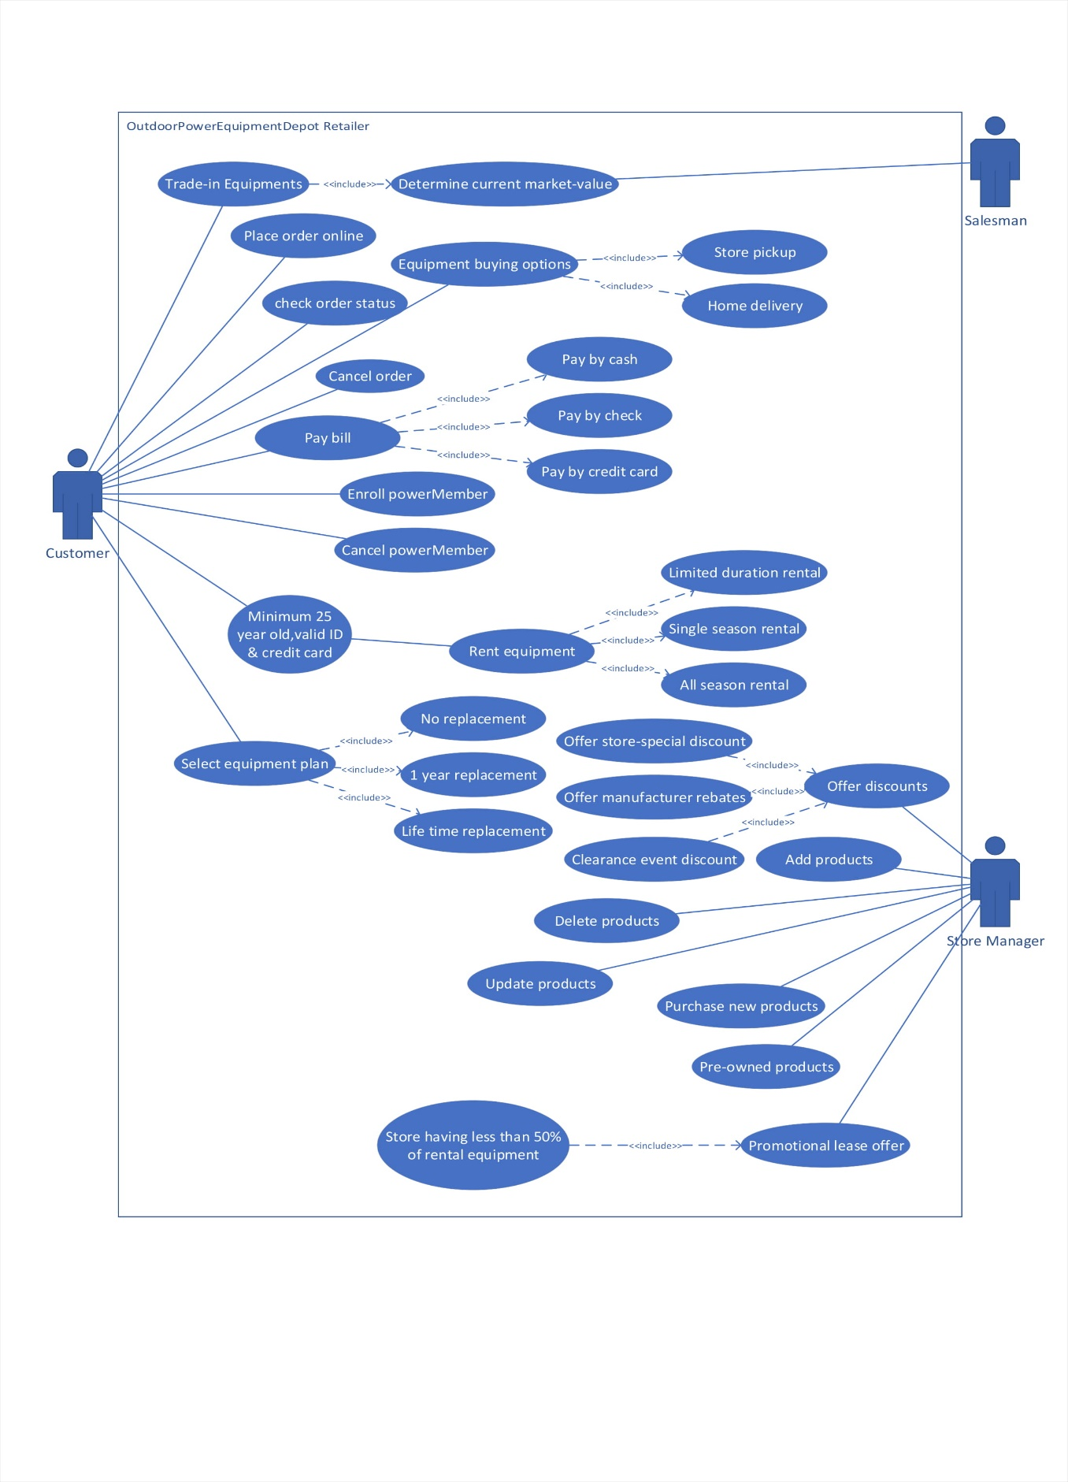

**4. Activity Diagram**

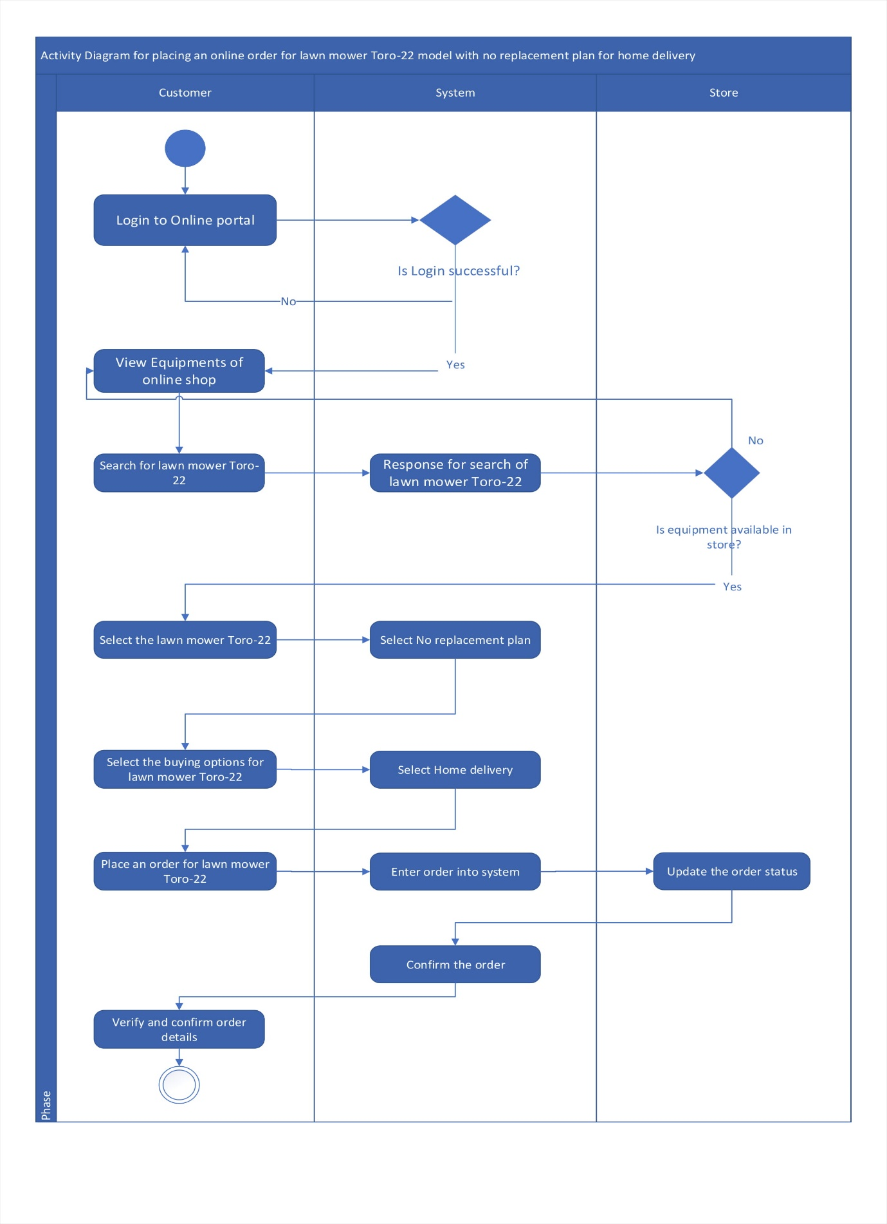

**5. Fully dressed format Use-Case**

Use case: Place an online order

|  |  |  |
| --- | --- | --- |
| Use case | Place an online order | |
| Scenario | Customer place an order online | |
| Triggering event | Customer wants to buy equipment online | |
| Description | Customer view equipment at online portal and choose one of it to purchase. Customer verifies it and places an order. | |
| Actors | Customer | |
| Stakeholder | Salesmen, store manager | |
| Pre-conditions | * Customer must have account * Customer profile must be valid | |
| Post-conditions | * Product must exist * Order must be linked with customer | |
| Event flow | Customer | System |
| 1. Login 2. Customer view equipment 3. Customer select and request to order | 1.1 System logs in customer  2.1System responses the result  3.1 System confirms the order |
| Exception Conditions | 1. Customer unable to login into system 2. Product not available 3. System crashed | |