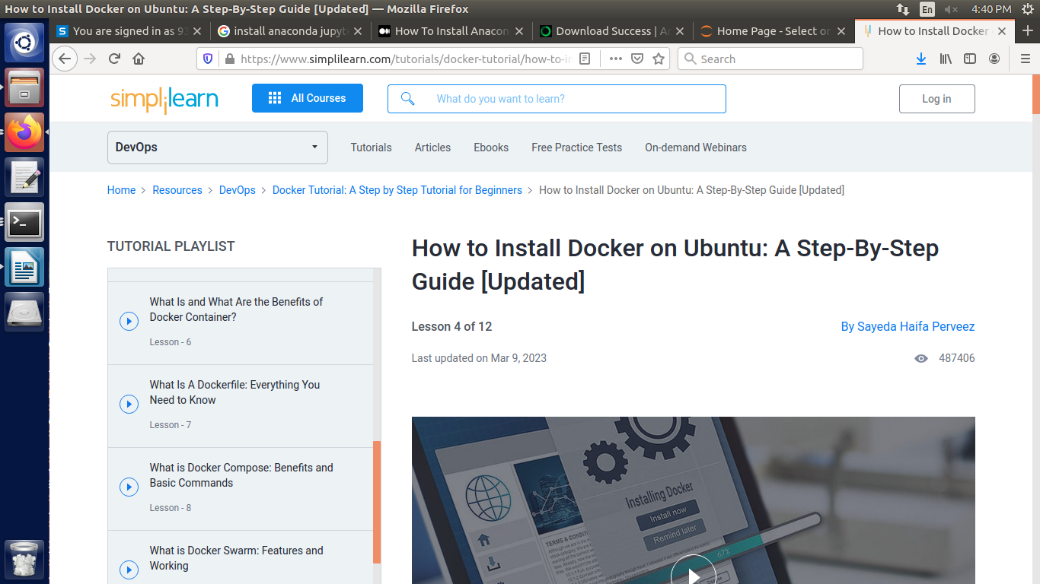

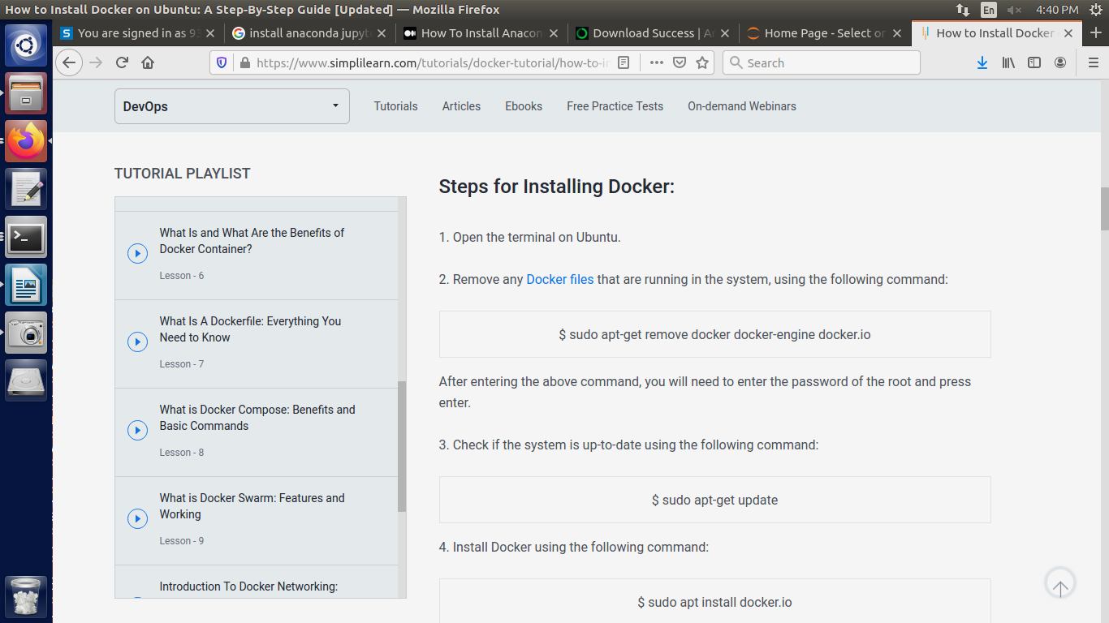

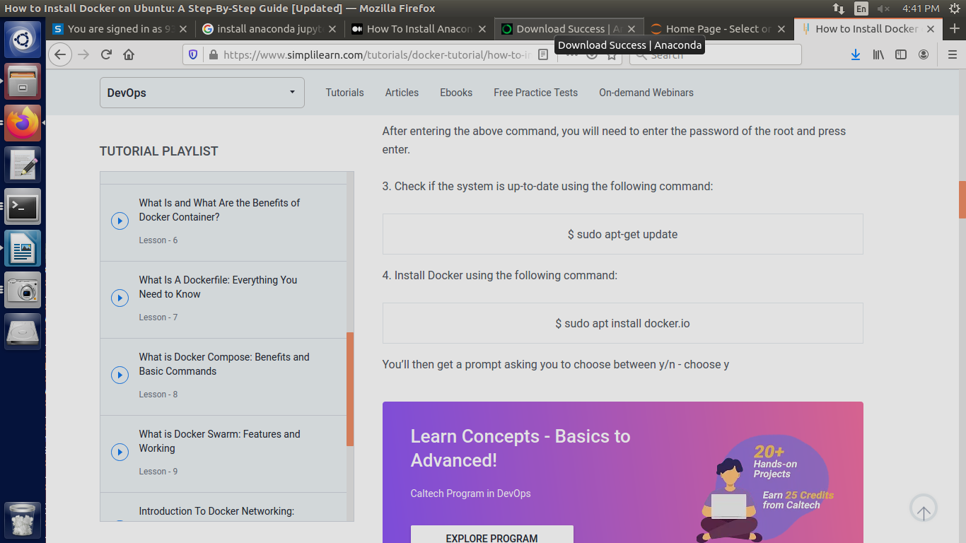

Simplylearn docker installation:
https://www.simplilearn.com/tutorials/docker-tutorial/how-to-install-docker-on-ubuntu

Owncloud Installation:
https://doc.owncloud.com/server/next/admin_manual/installation/docker/#introduction

