Planning

Notes:

//After making level 1, If we think it’s too difficult or too time consuming, remove level 4)

**Actual Game:**

Main settings:

* Player’s prison cell
* Hallway outside prison cell (with bars)
* Emma’s cell (player stands outside)
* Maze to get to kitchen
* Kitchen
* Emma’s cell (cell is open)
* Digging through wall to outside of prison

//beginning of story line to give player context as to what's going on before actual game play

Storyline Idea for the beginning before starting game: (Black screen with explanation?)

* You were framed for a crime and are sentenced to life in prison. You don’t think you deserve this. It’s time to escape.

**Level 1** //somewhat of a tutorial level

//Start game with setting of hallway outside prison cell (with bars)

Goal: Steal Master key from prison warden (as a label in the top, keep for entire level)

1 NPC (Ms. French)

* Prison Warden

//When player moves to screen with view of their cell (as a label in the top, keep for entire level)

Goal: Fill a cup with water to spill onto warden to distract her

Key elements to the level:

Instructions:

//Overall Goal: Get to the main doors to escape the prison using the master key

* Steal Master key from her using items in the cell to be able to leave your cell to do level 2 stuff.
* 2 rooms (Cell Bar, Cell Bedroom (seeing the bars and then seeing the inside of the cell)) //rooms user will access during this level.
* Incorporate tutorial aspects to help player understand basics of the game

Ideas:

* + (1) Have a sink in the cell. Have the sink dispense water when you click it (Maybe puzzles to fix broken parts of the faucet? A spot the difference game). Have there be a cup in the cell. Once user fills up cup with water from sink, they will have option to spill water onto themselves. Spill water. Ask warden for new clothes. Warden leaves. User can grab key and move onto level 2.
  + (2) Have puzzles that lead to user finding a cup. Once user finds cup, option to ask warden for water will appear. Ask warden for a glass of water. Warden leaves. User can grab key and move onto level 2.
  + //Going with idea 1
* Have the user click the faucet first to find that its broken, then have them find the pieces //incorporate instructions
* Mini Games (2 for now, can add more later if there's time):
  + Fix broken faucet with moving picture boxes
    - Find broken parts of the faucet around the room (under the pillow, in the towels, in the drawers)
      * Put them all together //Puzzle
    - Use cup with toothbrushes to fill with water (will have to put cup into player’s inventory) then spill water on prison warden so she leaves
  + Spot the difference game //when user clicks on Cabinet for a faucet piece
    - Spot the difference of the cabinet (One object could be different, or the colour of one object in the cabinet) //have it say it's a spot the difference game to get the piece of the faucet for user-friendliness.
    - User clicks on different object
    - Unlocks cabinet, gets piece of faucet

Goal:

Get Warden to leave her post at the master key long enough for user to grab it and escape

//

**Level 2**

NPC: Emma

Some Dialogue:

//player will be ‘responding’ by clicking a button with the player's dialogue

//Make Emma appear as ‘???’ Before she reveals her name

-after hearing player talk about escaping- ???: “Hey...! Pssst! I wanna leave too!”

(Player ‘responds’ with ‘who are you?’)

Emma: “I’m Emma, and I've been stuck here far too long! I’ll help you escape if you let me come with you... I have good items!”

(Player ‘responds’ with ‘what items?’)

Emma: “You’ll find out. It will be a surprise! Get me some poutine from the kitchen and I'll give them to you!”

(Player ‘responds’ with ‘ok’)

Emma: “Here’s how to make it!” -Emma hands player instructions to make poutine-

Emma: “...also... could you maybe... unlock my cell? I can't get out and I hear that you have the master key!”

(Player ‘responds’ with ‘ok’)

Key elements to this level:

* Emma gives player the SPOON.
* Spoon allows user to dig down to downstairs. //access level 3
* Incorporate having to make food from kitchen and Emma will give player the spoon. //Will incorporate minigames, puzzles and/or riddles.
* (Cell Hallway, Cell Shower Booth, kitchen, Cell storage) //Rooms user can access during this level

Goal:

Unlock Emma’s cell and give her the poutine so she will give you the items (spoons to get to next level)

Mini games:

* Small maze (like the assignment with the sprite not being allowed in certain parts of the map) to get to the kitchen //orange circle as a sprite (because we can't just assume what the player looks like and getting them to make their own character is a whole other thing) //going to kitchen
* Clicking the ingredients in the correct order: Player has to cut and fry the fries, put them in a bowl, heat up some gravy, add cheese in the bowl, add the gravy into the bowl, add ketchup into the bowl (Order on the slip of paper Emma gave the Player) //Making the poutine for Emma
* Clicking to dig through the ground //minigame to dig out the prison (but they actually end up in the crazy guy’s room)?

/*(idea)If we do not have time for level 3. ending where Emma and player dig through wall (keep clicking to reach end of wall*//This would include another mini game to get the next items(?)

**Level 3**

NPC: Crazy riddle guy

Dialogue:

//Make the user type in the responses, rather than a button with the response as seen in Emma’s conversation with player. This will make the game a little more challenging, but still easy to code.

I'm the word you say when you meet someone new, a simple way to show respect too. What am I? **Answer:** Greetings/Hello (crazy guy says hello to the player)

I can carry you across the water, I can be rowed or powered by a motor. What am I? **Answer:** Boat

I open doors with a lock, yet I am not a door. What am I? **Answer: Key**

**Key elements of this level:**

* Access to Key for boat
* Starts off in Solitary confinement room. (Meet the crazy guy here)
* (Solitary Confinement Room, Cell hallway, Staff Room) //Rooms for this level

//Crazy guy will join you in the escape

//if removing level 4 we will just add the ending here. ***

Level 4 //extra if we have time

NPC: Rich Cellmate who has his own prison business and he sells stuff for the boat trip)

Key elements to this level:

* Mini game: Riddles and puzzles to solve to gain coins. //Coins used to buy stuff at his business (Gathering boat Item/Food/Drink/Books from library (get Emma’s favorite book as a quest))
* Ending: ***
  + Pulling the fire alarm down as a cover to escape
  + (Ending Scene: First person POV in the boat, u see Emma reading book and Crazy riddle Guy)

Things to have all throughout the game:

* A ‘current quest’ indicator at the top of the screen (user friendliness, helps player know what to do)
* A “Help” tab that helps the player understand basic game mechanics (controls, how things work, the user interface, etc...)
* Skip button during dialogue //not during riddles because that will interfere with players ability to understand what they have to do after they click it.
* Puzzles
  + Hints on the wall
  + 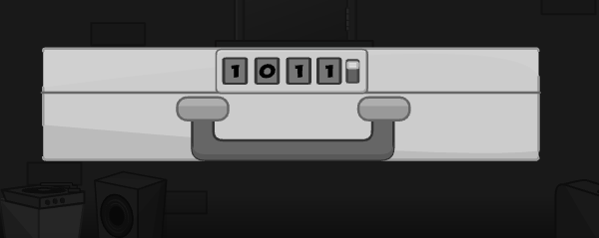 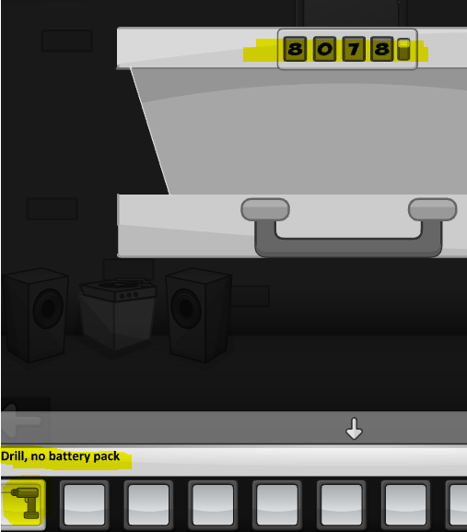 Clues on walls or stuff can lead to users being able to open these boxes, which can give them objects to escape. Also have puzzles (draw the same shape as something) instead of numbers to unlock these boxes
  + Spot the difference games
  + Rock paper scissors (between user and Emma) (Might be hard to code so this can be something we add later on)
  + Interactions with objects