软件工程系项目/实验报告
姓名 | 苏宇 | 学号 | 15180600220
专业班级 | 软件15002班 | 指导教师 | 彭志豪
课程名称 | Object Oriented System Analysis and Design
项目/实验  名称 | The Decorator Pattern

一、目的
To apply the Decorator Pattern into the design the Transformer System.

二、过程与步骤
Step1: To analyze the requirement of the project and identify business objects
Step2: To design the class diagram according to the identified business objects based on the understanding of the definition and general class diagram of the Decorator Pattern.
Step3: To create a new package to program according to the class diagram in the Eclipse
Step4: To code a test main class to debug and run the program to verify it.

三、结果
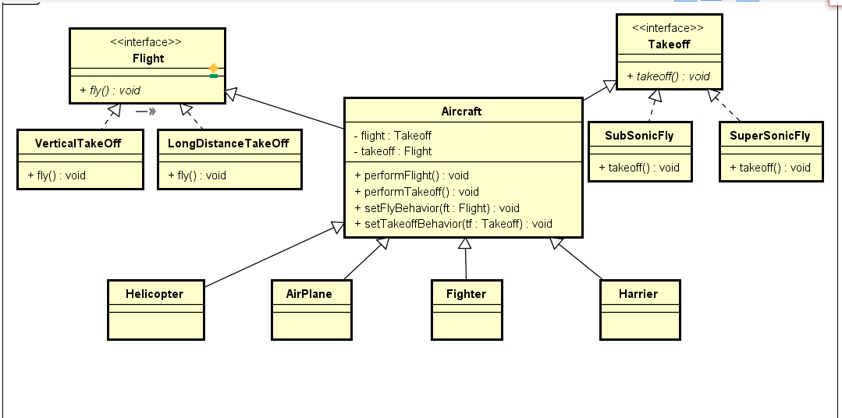

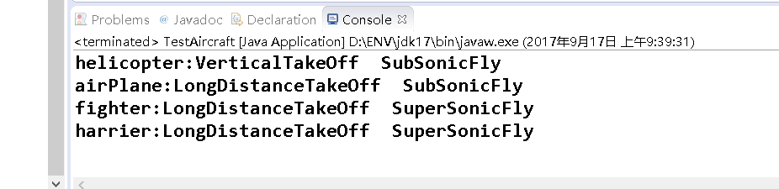

评阅成绩：
成绩
评语 | （可选）

