T. M. Blackwell

Particle swarms and population diversity
Published online: 13 May 2005
�Springer-Verlag 2005
Abstract The optimisation of dynamic optima can be a diﬃcult problem for evolutionary algorithms due to diversity loss. However, another population based search technique, particle swarm optimisation, is well suited to this problem. If some or all of the particles are ‘charged’, an extended swarm can be maintained, and dynamic optimisation is possible with a simple algorithm. Charged particle swarms are based on an electrostatic analogy—inter-particle repulsions enable charged particles to swarm around a nucleus of neutral particles. This paper proposes a diversity measure and examines its time development for charged and neutral swarms. These results facilitate predictions for optima tracking given knowledge of the amount of dynamism. A number of experiments test these predictions and demonstrate the eﬃcacy of charged particle swarms in a simple dynamic environment.
1 Introduction
Particle swarm optimisation (PSO) is a population based optimisation technique inspired by models of swarm and ﬂock behaviour (Kennedy and Eberhart 1995). Although PSO has much in common with evolutionary algorithms, it diﬀers from other approaches by the inclusion of a solution (or particle) velocity. New potentially good solutions are generated by adding the velocity to the particle position. Particles interact with other particles in the population (swarm) through two accelerations. These accelerations are spring-like: each particle is attracted to its previous best position, and to
T. M. Blackwell Department of Computing Goldsmiths College, University of London, New Cross, London, SE14 6NW, UK E-mail: t.blackwell@gold.ac.uk Tel.: +44-20-79197859 Fax: +44-20-79197853
the global best position attained by the swarm, where ‘best’ is quantiﬁed by the value of an objective function at that position. These swarms have proven to be very successful in ﬁnding global optima in various static contexts such as the optimisation of certain benchmark functions (Eberhart and Shi 2001).
Evolutionary techniques have been applied to the dynamic problem (Branke 2001, 2003). The application of PSO techniques is a new area and results for environments of low spatial severity are encouraging (Eberhart and Shi 2001; Carlisle and Dozier 2000). Evolutionary and PSO algorithms, in a dynamic context, can suﬀer from over-specialization. In general, they require further adaptations so that they can detect change, and then respond to it. Some possible adaptations of the PSO have been studied (Hu and Eberhart 2002), but these adaptations remain arbitrary. A diﬀerent extension of PSO, which solves the problem of change detection and response, has been suggested by Blackwell and Bentley (Blackwell and Bentley 2002). In charged-PSO (CPSO), some or all of the particles have, in analogy with electrostatics, a ‘charge’. A third collision-avoiding acceleration is added to the particle dynamics, by incorporating electrostatic repulsion between charged particles. This repulsion maintains population diversity, enabling the swarm to automatically detect and respond to change, yet does not diminish greatly the quality of solution. In particular, it works well in certain spatially severe environments (Blackwell and Bentley 2002). Entirely charged swarms and swarms with 50% of their members charged have been compared with adapted PSO and random search in a variety of dynamic contexts, including cases of very high spatial and temporal severity (Blackwell 2003).
Much of the understanding of the behaviour of particle swarms is of an empirical nature, but a paper by Clerc and Kennedy advances theoretical knowledge by proving convergence for a simpliﬁed model (Clerc and Kennedy 2002). This simpliﬁed one-dimensional model is for non-interacting particles and hence does not optimise anything. For optimisation, particle interactions need to be included so that knowledge of a good posi-In the particle update, v is a constriction factor, tion found by a particle (i.e. potentially good solutions) chosen to ensure convergence, and n1,2 are random can be communicated to other particles. numbers drawn uniformly from the interval [0, 1] ef-
This paper extends the work of Clerc and Kennedy to fectively randomising the spring constants in the interval include particle interactions. It is suggested here that the [0, /1, 2 ] at each iteration. Table 1 also shows an ad-
maximum component separation of the particle positions ditional repulsive acceleration ai =
P
k „ i ai (k), where
in the swarm is a suitable diversity measure. For neutral
(i.e. uncharged) swarms, the rate of contraction of |S|can
then be compared to the change in optimum position. aiðkÞ¼
A limit is also suggested for |S+ |, the diversity of a
charged swarm. The balance of electrostatic repulsion
8>< >:
QiQk
jxi �xk j3 ðxi �xk Þ; rc �jxi �xk j�rp ð1aÞ
QiQk ðxi�xk Þ
jxi�xk j;
r2
c
ð1Þjxi �xk j\rc ð1bÞ jxi �xk j> rp
0;
ð1cÞ
between charged particles and the attraction to the best positions will maintain the charged population diversity at a ﬁxed level, so that hopefully optimum jumps on any time scale can be tracked, if they occur within |S+|.
The CPSO algorithm is deﬁned and the background to Clerc and Kennedy’s proof is covered in the next section. Section 3 deﬁnes |S| and obtains estimates for the simpliﬁed model of Clerc and Kennedy, and also for the inclusion of particle interactions and spring randomisation (PSO). Some qualitative predictions about charged swarm diversity are also made in this section and some upper and lower bounds calculated. Experiments to illustrate PSO and CPSO diversity and performance in a dynamic environment are presented in Sect. 4. The paper ends with a discussion of the theoretical and experimental results.
2 Particle swarm algorithms and convergence
2.1 CPSO algorithm
A swarm of i = 1,...,N particles is a set of positions xi and velocities vi, S={xi, vi} where each vector xi, vi, has j=1,...,d components. Throughout this paper, d-dimensional vectors will always be written in bold lower case
(e.g. a) with (Euclidean) norm |a|= a and xij, vij refer to the j’th component of xi and vi respectively. Particle update consists of updating the particle velocity by adding an acceleration to the current velocity and adding this updated velocity to the current position. The acceleration is a simple spring-like attraction to an at-tractor pi (spring constant u1), which may diﬀer for each particle, and to the attractor pg (spring constant u2)of the best performing particle (index g) in some neighbourhood (which may be the whole swarm). The particles interact by modifying attractors pi.This modiﬁcation, which is the essence of what may be termed swarm intelligence, arises from the evaluation of an objective function f at xi, and is labelled attractor update in Table 1.
The outline of the CPSO algorithm is given in Table 1. Positions and velocities are initialised in a search space [-X/2, X/2]d where X is the dynamic range of the variables in each dimension. A single iteration (numerated by the variable t) consists of a complete pass through the swarm, updating positions and velocities and attractors.
and i, k are particle indices. The PSO algorithm is therefore a special case of CPSO, where every particle is uncharged, Qi=0 (neutral CPSO).
Avoidance is only between pairs of particles that have non zero charge Q, and is Coulomb-like in the shell rc £ r £ rp (Eq. 1a). At separations less than the core radius rc, the repulsion is ﬁxed at the value at the core radius (Eq. 1b), and there is no avoidance for separations beyond the perception limit of each particle, rp(Eq. 1c). The core radius serves to tame the repulsion at small separations and prevent large accelerations which would place charged particle outside the search space. Notice that the particle repulsion ai is determined before the update of each component xi. This is because the Coulomb law, unlike the spring laws used for the attractive accelerations, depends on the Euclidean separation |xi �xk| and not on the component separation |xij �xkj|, and so cannot be implemented inside the loop indexed by j in Table 1.
2.2 Convergence proof for the simpliﬁed model
The convergence proof of Clerc and Kennedy is for a simpliﬁed one-dimensional model without interaction and with ﬁxed springs (Clerc and Kennedy 2002).
Table 1 Particle swarm algorithm for charged and neutral swarms
CPSO
initialise S(0) = {xi,vi} in cube [-X/2, X/2]d g=1, t=1 for i=1 to population size N
pi = xi
if f(pi)< f(pg) then g = i next i do
for i = 1 to population size N calculate ai(t) // particle update for j=1 to dimension size d
vij(t+1)=v{vij(t)+n1u1[pij(t)�xij(t)]+n2u2[pgj(t)�xij(t)]}+aij(t)
xij(t+1)=xij(t)+vij(t+1) next j // attractor update if f(xi(t+1)) <f(pi(t+1)) then pi(t+1) = xi(t+1)
else pi(t+1)=pi(t)
if f(pi(t+1)) < f(pg) then g=i t++ next i
until termination criterion is met
The algorithm is set out in Table 2.
Since there are no interactions in this model, the dynamics can be analysed by considering a one-dimensional dynamic system with ﬁxed attractor p and ﬁxed spring constant u
vðt þ1Þ¼vðtÞþ/½p �xðtÞ�
xðt þ1Þ¼xðtÞþvðtÞþ/½p �xðtÞ� ð2Þ
Velocity constriction, which takes the place of velocity clamping in older versions of PSO, is applied by scaling v(t+1) by a factor v<1:
vðt þ1Þ¼vfvðtÞþ/½p �xðtÞ�g
xðt þ1Þ¼xðtÞþvfvðtÞþ/½p �xðtÞ�g ð3Þ
For simplicity, this is rewritten by Clerc and Kennedy as
vðt þ1Þ¼vfvðtÞþ/yðtÞg
yðt þ1Þ¼yðtÞþvf�vðtÞ�/yðtÞg ð4Þ
or in matrix form as
Pðt þ1Þ¼MPðtÞð5Þ
where y(t)= p �x(t), P(t)=[ v(t), y(t)]T and M is the 2 · 2 transformation matrix deﬁned by the matrix equation
vðt þ1Þ v v/ vðtÞ
¼ : ð6Þ
yðt þ1Þ�v 1 �v/ yðtÞ
M is diagonalized by the similarity transform A,
e10
AMA�1 ¼L ¼ : ð7Þ
0 e2
The convergence conditions for v and / are obtained by noting that ||P(t)|| increases as ||MtP(0)||= ||Lt AP(0)|| where ||Æ|| is, for example, the Euclidean norm. Clerc and Kennedy show that the eigenvalues e1,2
pﬃﬃﬃ
are complex and of modulus vfor u>4, with v given by
2
v ¼ qﬃﬃﬃﬃﬃﬃﬃﬃﬃﬃﬃﬃﬃﬃﬃﬃﬃ: ð8Þ / �2 þ /2 �4/
Convergence will follow if the constriction factor for a given spring constant / is given by Eq. 8.
3 Diversity measure for particle swarms
3.1 Simpliﬁed model
The above result can be used to estimate the maximum component separation of the swarm S of N non-interacting particles (labelled i =1,...,N) moving in j=1,...,d dimensions. The diversity of S at iteration t will be written |S| (not a norm) and is deﬁned as the maximum distance between position components j:
Sðmax ð9Þjj¼max fxijg�minfxijgÞ:
ji i
Introducing now a set of ﬁxed attractors {pi}, one for each particle, then each component xijis subject to the simpliﬁed model and convergence entails that yij = pij � xij ﬁ 0.
In this paper, a point at y is considered to be inside a set of points {xi} if each component yj satisﬁes
minfxijg�yj �maxfxijg; ð10Þ
ii
and the set {yi} is inside {xi} if (Eq. 10) is true for each yi.
The distance of particle i, position component j, from attractor pi provides an estimate of |S|:
jjS�maxð2jyijjÞ: ð11Þ
ij
If {pi} are within the swarm, and the attractors are tightly bunched then (Eq. 11) will be a good estimate of |S|. A typical conﬁguration with tightly bunched attractors (triangles) is illustrated in Fig. 1. If, though, {pi} are outside the swarm, maxij(2|yij|) will over-estimate |S|. This would be the case for unusual conﬁgurations where the swarm is undergoing collective oscillations about {pi} (Fig. 2). (Conﬁgurations can also be imagined where (Eq. 11) underestimates | S|, for example if each particle is close to its attractor, but the swarm is very diﬀuse.)
In the non-interacting simpliﬁed model, each |yij|is
�pﬃﬃﬃ�t
converging to 0 as v ; which leads to a prediction for |S| as a function of time t (measured in iterations):
Sjj¼const � ﬃﬃﬃv �p�t | : | ð12Þ
This can also be written as a scaling law:
Sðt þ1Þj j¼const � ﬃﬃﬃvp SðtÞj j: |  |  | ð13Þ

3.2 Interacting particles
In PSO, interactions amongst the particles lead to at-tractor updates and the analysis of Sect. 3.1 does not apply. The particle update rules given in Eq. 3 become, for interacting particles (see Table 1 for neutral particles),
Table 2 The simpliﬁed model one-dimensional non-interacting model
Simpliﬁed model
initialise S ={xi, vi} in cube [-X/2, X/2]d do for i=1 to population size (N) for j=1 to dimension size (d) vij = v(vij + u(pj �xij)) xij = xij + vij next j next i until termination criterion is met
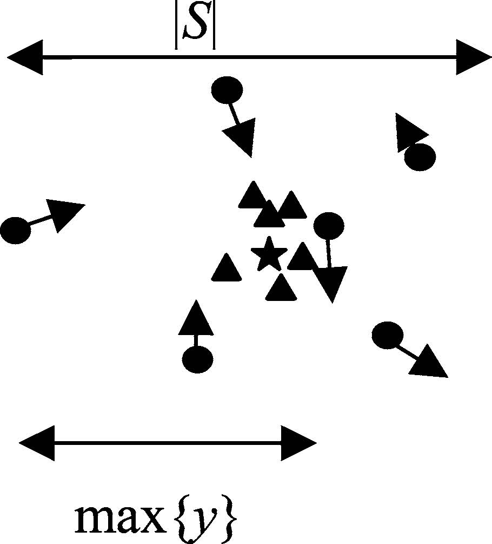

n1/1 þ/2n2 towards the attracting group.
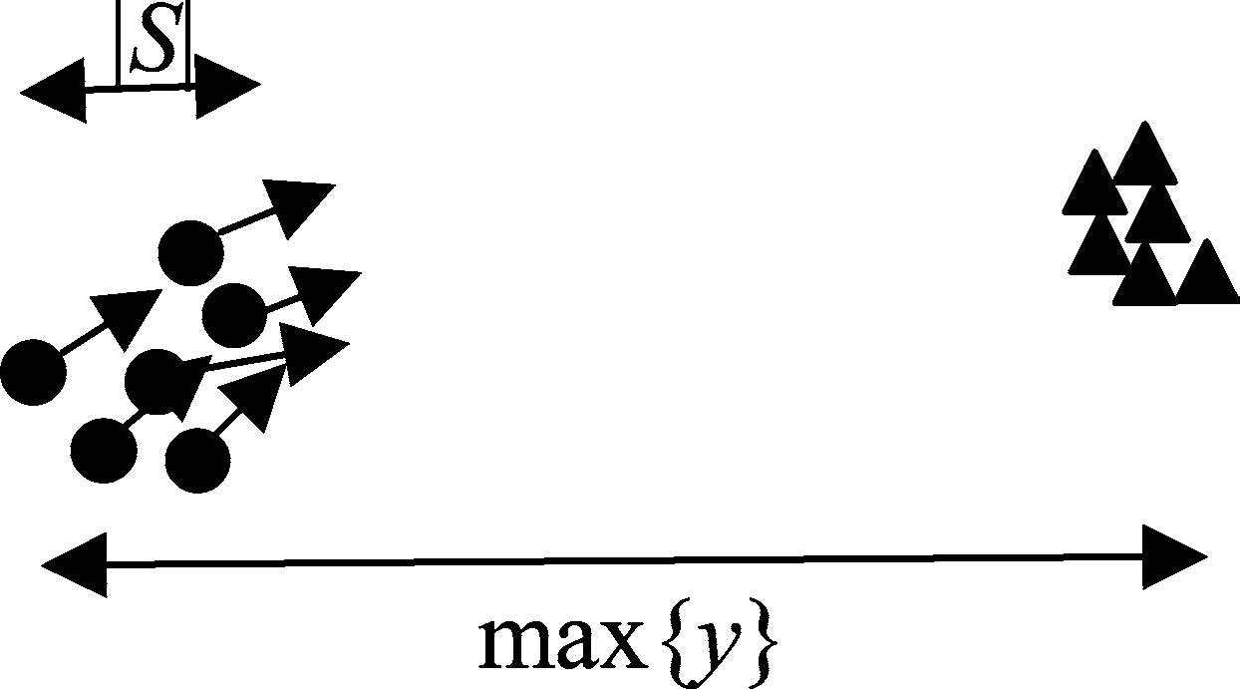
Fig. 1 Attractors lying within swarm. An optimum (star) lies within the attracting group
viðtþ1Þ¼vfviðtÞþ/1n1½pi �xiðtÞ�þ/2n2½pg �xiðtÞ�g xiðtþ1Þ¼xiðtÞþvfviðtÞþ/1n1½pi �xiðtÞ�þ/2n2½p�xiðtÞ�g
g
ð14Þ
In fact each particle component xij satisﬁes the simpliﬁed form of Eq. 2; deﬁne
pi ¼/ ¼
~ ~
Fig. 2 Collective oscillation of particles about an attracting group lying outside the swarm
arbitrarily large. In order to proceed, therefore, two assumptions will be made.
1. Spherical symmetry: suppose at an iteration t0 the conﬁguration of the swarm and attractors resembles Fig. 1. The optimum xa of f is surrounded by a spherically symmetric neighbourhood Da which the swarm does not leave for subsequent iterations, and xa is the only stationary point in Da. Spherical symmetry then implies that pi will only be updated to a particle position xi2Da if |xi -xa|<|pi -xa |. In other
n1 /1 piþ/2n2pg words, any updates cause the attracting group to
n1/1þ/2n2
ð15Þ shrink in towards xa, and the swarm to shrink in
2. Scale invariance: this is the assumption that the at
pij !p; / !/: For the moment,
tracting group and the swarm shrink at the same rate
sider the case of ﬁxed springs, n1,2=1. (PSO is in-
so that a scaling law similar to Eq. 13 applies. In
variably run with equal spring constants, u2= u1 so
~
~
and substitute
con-
order to motivate this assumption, note that, near
that
tions mean that the
~
pij is midway between pij and pgj.) Particle interac
0 spherically symmetry optima, the problem is not
change due to information
p
sharing, and the analysis which follows Eq. 2 does not
~
is
characterised by any external length scale. This is
because attractor update only depends on ﬁnding a
hold. In order to account for information sharing,
position closer to xa; the details of f are unimportant
~
consider particle i at iteration t; pi and/or pg may have piðtÞ
within Da. If the swarm and the attracter group are
shrinking, then this would imply that the
changed due to updates to attractors i,...,N at iteration
t-1 and attractors 1,...,i-1 at iteration t so that
dimensionless quantity dt is, on average, independent
changes by an amount
of time. In other words, when averaged over initial
/1 /2 conﬁgurations S(t0), dt is time (and scale)
dpiðtÞ¼
~
dpi þdpg
; ð16Þ
independent, Ædtæ = d.
/
/
To summarise, it is conjectured that convergence in
j\maxfjdpij; jdpjg: This change can be im
g
plemented mathematically by holding {p}i ﬁxed and
~
piðtÞ
~
shifting coordinates yi yi þdpiðtÞby multiplying Pi(t)by D (t) where and jd
locally spherically symmetric environments follows a
scaling law,
or in matrix form
jjPðtÞjj\ð1 þdÞjjMPðt �1Þjj; ð19Þ
10
so that |S| decreases as
pﬃﬃﬃpﬃﬃﬃﬃﬃ
Sv�t ¼ð gvÞt: ð20Þ
jj�½ð1 þdÞ
DijðtÞ¼ ;
01 þdijðtÞ
ð17Þ
d~pijðtÞ
dijðtÞ¼
:
yijðtÞ
where g= (1+d)2 is a constant positive (renormalisa
tion) factor which multiplies the constriction v. Con-
Particle update is therefore represented in matrix form
as Pi(t+1) = MD(t)Pi(t). Hence, with the deﬁnition vergence therefore requires that gv <1. dt ” maxij dij(t),
So far, the discussion has been restricted to ﬁxed springs. If random springs are used, Eq. 15 becomes, for
jjPiðt þ1Þjj\ð1 þdtÞjjMPiðtÞjj: ð18Þ
It is hard to place bounds on dt for a general objective
~~
u2= u1,
pi ¼
/ ¼
n1pi þn2pg n1þn2
function f due to the chaotic motion of the particles and
ð21Þ
the variety of neighbourhoods around the critical points
/1ðn1 þn2Þ
of f. For example, a particle may approach
~
piðtÞ
would become
arbi
~
trarily closely, and, for ﬁnite dpiðtÞ; dt where n1,2 2U(0, 1).
Spring randomisation places
between pij and pgj The amplitude of large ﬂuctuations around the average
pij
/ in[0, 2u1]. The former amounts to another coordinate shift and a similar analysis leading the largest electrostatic acceleration that a charged up to Eq. 20 would ensue, except that ÆÆæ would be an particle might experience. This would occur in the (unaverage over starting conﬁgurations and sequences of likely) instance that M+�1 particles are within rc of a
~~
swarm size <| S+
and randomises
|> can be estimated by considering
random numbers. Randomisation of
particle close to the edge of the swarm, and all the
/ is more diﬃcult to consider in the present formalism; however Clerc and acceleration vectors are parallel. The maximum accel
~
tions, random spring and particle charge on the diversity
Kennedy demonstrate that
/\4 for the simpliﬁed model leads to cyclic or quasi-cyclic particle trajectories. This could have the eﬀect of slowing swarm contraction in the interacting case or inducing ﬂuctuations around exponential collapse, or possibly both.
3.3 Charged particles
All charged particles mutually repel according to the modiﬁed Coulomb-like accelerations of Eq. 1. In ad
~
dition, each particle is attracted towards its
pi:
Suppose that the attractors are converging on the op
~
own
eration is M+�1 times the core acceleration, ac= c c rc,
which gives an upper bound
SþSþMþ
jj�hiþð�1Þac: ð23Þ
upper
4 Experiments
A series of experiments was devised to test some of the conjectures of the proceeding section. There are three groups of experiments. In group 1, four experiments (numbers 1–4) investigate the eﬀects of particle interac
timum xa. The charged sub-swarm will not collapse
of neutral swarms. The second group, experiments 5 and
because as the particles get closer to xa, they will also
6, measure charged swam size for two diﬀerent core
get closer to each other, thus increasing the inverse
radii. Finally, two experiments examine the eﬃcacy of
square repulsions between the particles. It is expected,
neutral and charged swarms in tracking a moving
therefore, that the diversity of the charged swarm will
optimum.
settle into an ‘equilibrium’ value where the attractive
Swarm composition is described as (N, M+
) where
and repulsive accelerations are, on average, in balance.
N(M+) is the number of neutral (charged) particles. All
However, the charged particles are involved in multiple
experiments are in d=3 dimensions and for a dynamic
interactions (a many-body problem) so the dynamics
range X=10. The spring constants in all experiments are
will be very unpredictable, chaotic even, and there
set to the ‘standard values’ commonly found in the lit-
could be large ﬂuctuations about the average charged
swarm size |S+| on small time scales. Here we can only erature [Clerc and Kennedy 2002], u1, 2=2.05. The
constriction factor for these standard values is
make some general comments about the charged swarm
v=0.729843788 (Eq. 8). The parameter settings and
diversity.
experimental details are summarised in Tables 3 and 4.
Consider two particles, one of which is stationary and
The objective function f for all experiments involving
close to xa = O. The equilibrium position, R, for the
particle interactions is the sphere function fsph(x)= x.x.
second particle is the solution of aattraction(x)+
arepulsion(x)=0, where aattraction ¼
~
ux and arepulsion (x)is given by Eq. 1. There are three possibilities, depending
v
4.1 Diversity measure for neutral particles
~
/; and the electrostatic
33
constants cc=Q2/rc and cp=Q2/rp:
4.1.1 Experiment design
on the neutral spring constant v
c
\v
c
~
/ :
c
c
1.
there is an equilibrium position at
The ﬁrst experiment in this group sets up the conditions
R ¼
R\rc
rc
~
;
v/
for Clerc–Kennedy convergence by implementing the
~
~
/\c
��1=3
R ¼Q2 with a 20 particle neutral swarm and a ﬁxed attractor p
/ ; rc \R\rp
\v
2.
there is an equilibrium position at
:
c
simpliﬁed model (no interactions between the particles)
p c
at O. Experiments 2 and 3 examine the eﬀects of in-
v
~
v/\c
p
: R ¼rp divides regions of repulsion, x<rp, troducing particle interactions or spring randomisation
3.
from attraction, x>rp.
R is an estimate of the inter-particle spacing in a charged swarm of M+ particles. It underestimates the average spacing because the above analysis does not take into account particle velocity and many body eﬀects which would increase R. This estimate therefore suggests a lower bound to |S+|:
1=d
Sþ
jj�ðMþÞR: ð22Þ
lower
and into the simpliﬁed model. The fourth experiment examines diversity change when both particle interactions and randomisation are included (standard PSO).
The swarms were released with a random conﬁguration in [�X/2, X/2]3 and the swarm size, |S|, was recorded at the end of each iteration t for a total of 1,000 iterations. This constitutes a single run. In total, 50 runs were conducted for each experiment, with diﬀerent initial swarm conﬁgurations and, for experiments 3 and 4, different sequences of pseudo-random numbers n (Eq. 21).
Table 3 Description of experiments 1–8
ID | Swarm | Description
1 | (20, 0) | Simpliﬁed model
2 | (20, 0) | Particle interactions
3 | (20, 0) | Simpliﬁed model + random springs
4 | (20, 0) | Particle interactions + random springs
5 | (20, 20+) | Particle interactions, charged swarm
 |  | (rc=1.0) (CPSO)
6 | (20, 20+) | Particle interactions, charged swarm
 |  | (rc=0.1)(CPSO)
7 | (40, 0) | Optimum tracking (PSO)
8 | (20, 20+) | Optimum tracking (CPSO) (rc=1.0)

Table 4 Fixed CPSO parameters
dX u1,2 vn1, 2 rpQi
3 10 2.05 0.729843788 U(0, 1) 10 1.0
4.1.2 Results and analysis
Figures 3, 4, 5, and 6 show |S(t)| for a single run of experiments 1–4. The ﬁgure caption gives the equation of the best ﬁt straight line.
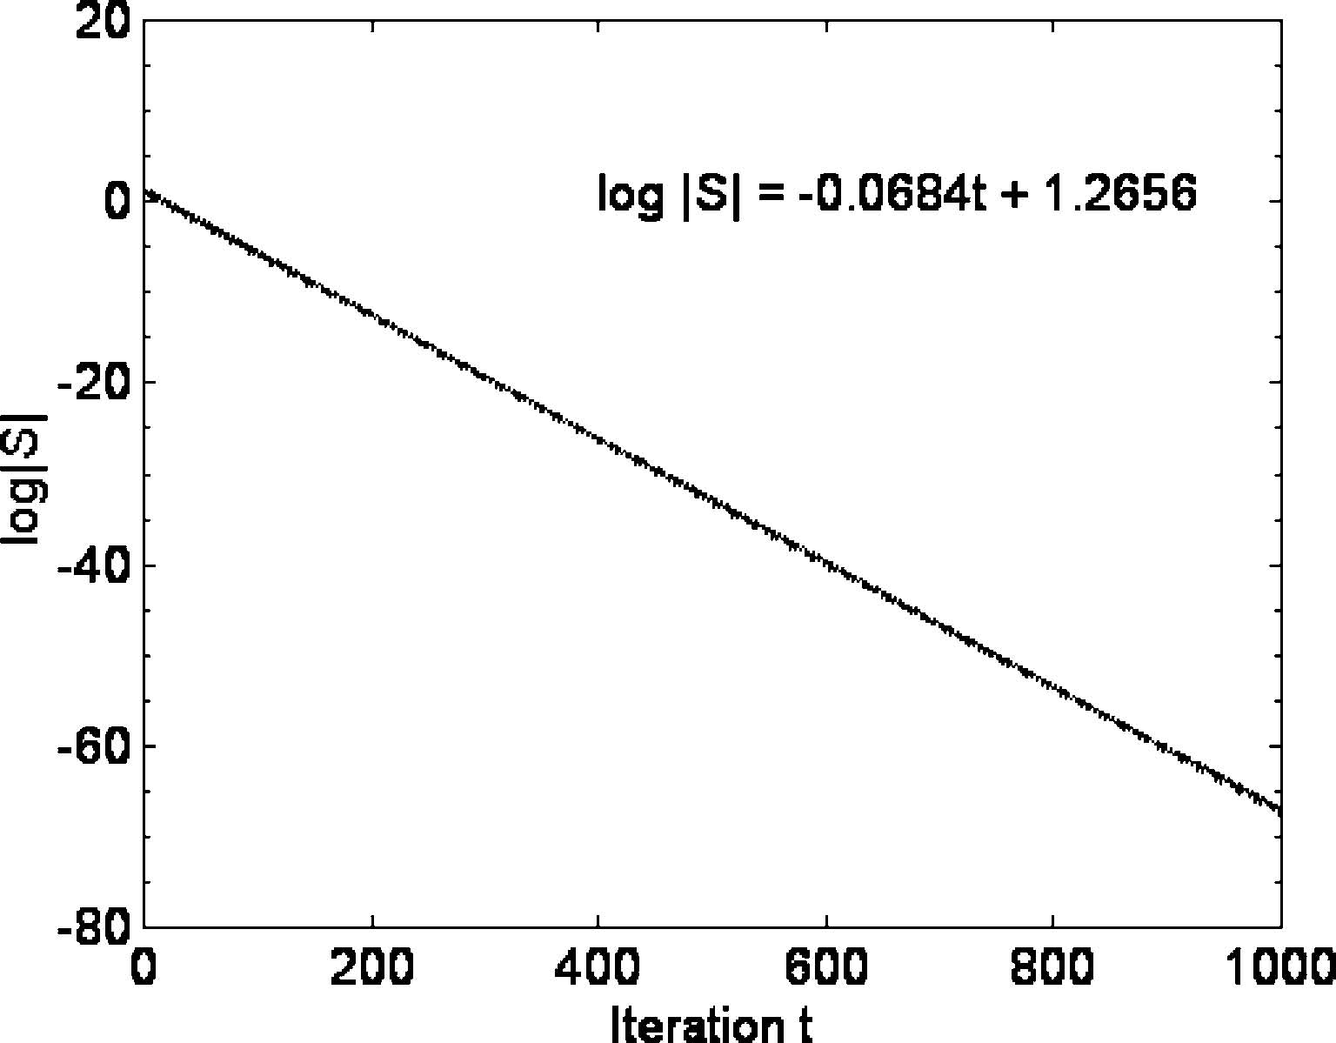
Fig. 3 Experiment 1—simpliﬁed model
These ﬁgures are typical of any of the 50 runs. Table 5 shows the gradient (standard error) and convergence factor of the best ﬁt straight line when averaged over all runs. There is clear evidence of exponentially decaying neutral swarm size with spring randomisation inducing more ﬂuctuations. The empirical law derived from these results is
t
S; 24Þjj¼kað
k and a constants, which agrees with the predicted form of Eqs. 12 and 20. a is related to the renormalized
2
constriction by gv = a . Table 5 shows the gradient (standard error) and convergence factor of the best ﬁt straight line when averaged over all runs.
Experiment 1 (simpliﬁed model) is in very good agreement with the prediction of Eq. 12: jj¼
S
�pﬃﬃﬃﬃﬃﬃﬃﬃ ﬃﬃﬃﬃﬃﬃﬃﬃﬃﬃﬃﬃﬃﬃﬃﬃﬃﬃ�tk � 0:729843788 ¼k �0:854308953t: Experiments 2–4 show that when spring randomisation, or particle interactions, or both, are included back into the simpliﬁed model, convergence is slowed down, and in fact is quite close to non-convergence, a=0.92–0.93. For a particular run, spring randomisation induces ﬂuctuations around scaling which helps explain why randomisation has already proven to be beneﬁcial for static optimisation (Kennedy and Eberhart 1995).
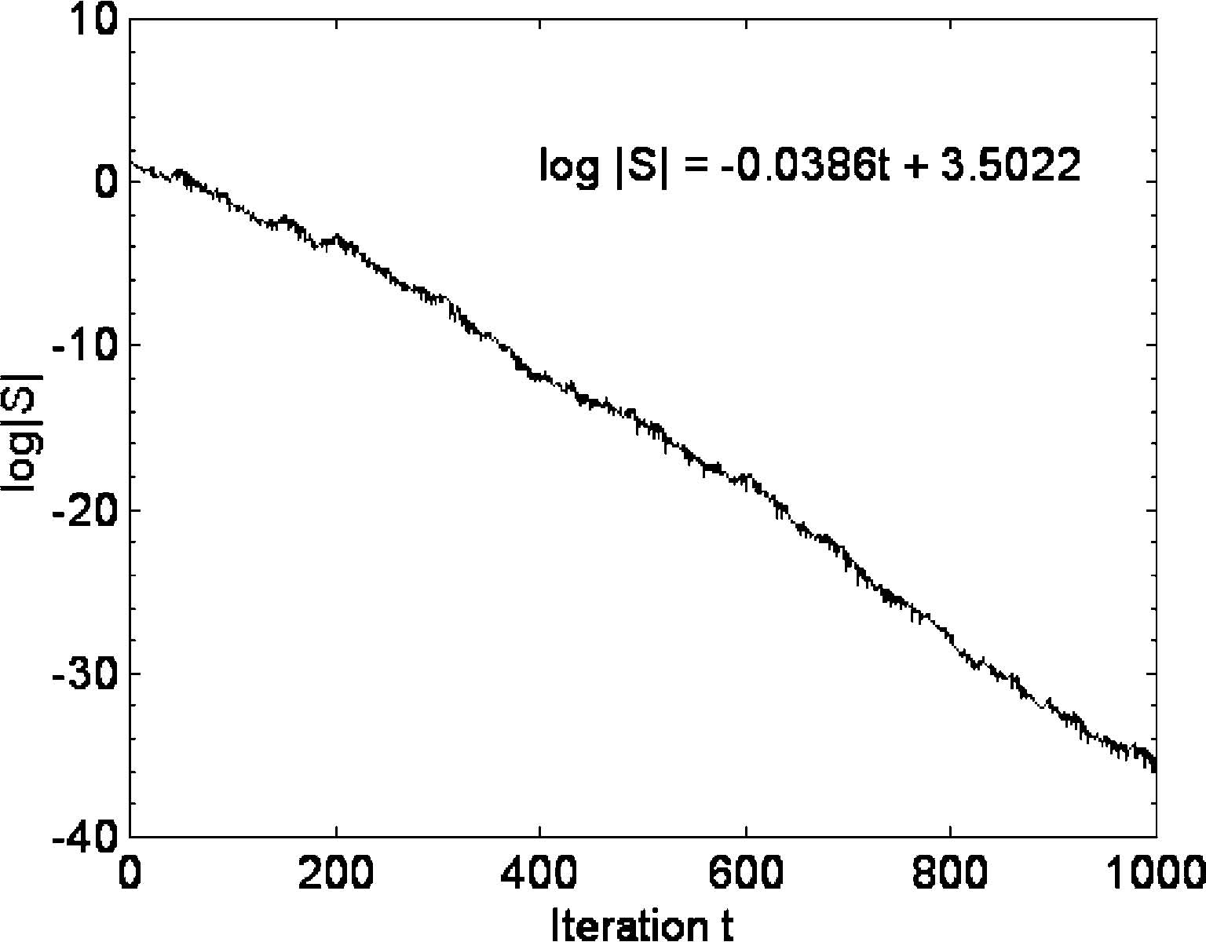
Fig. 5 Experiment 3—random springs
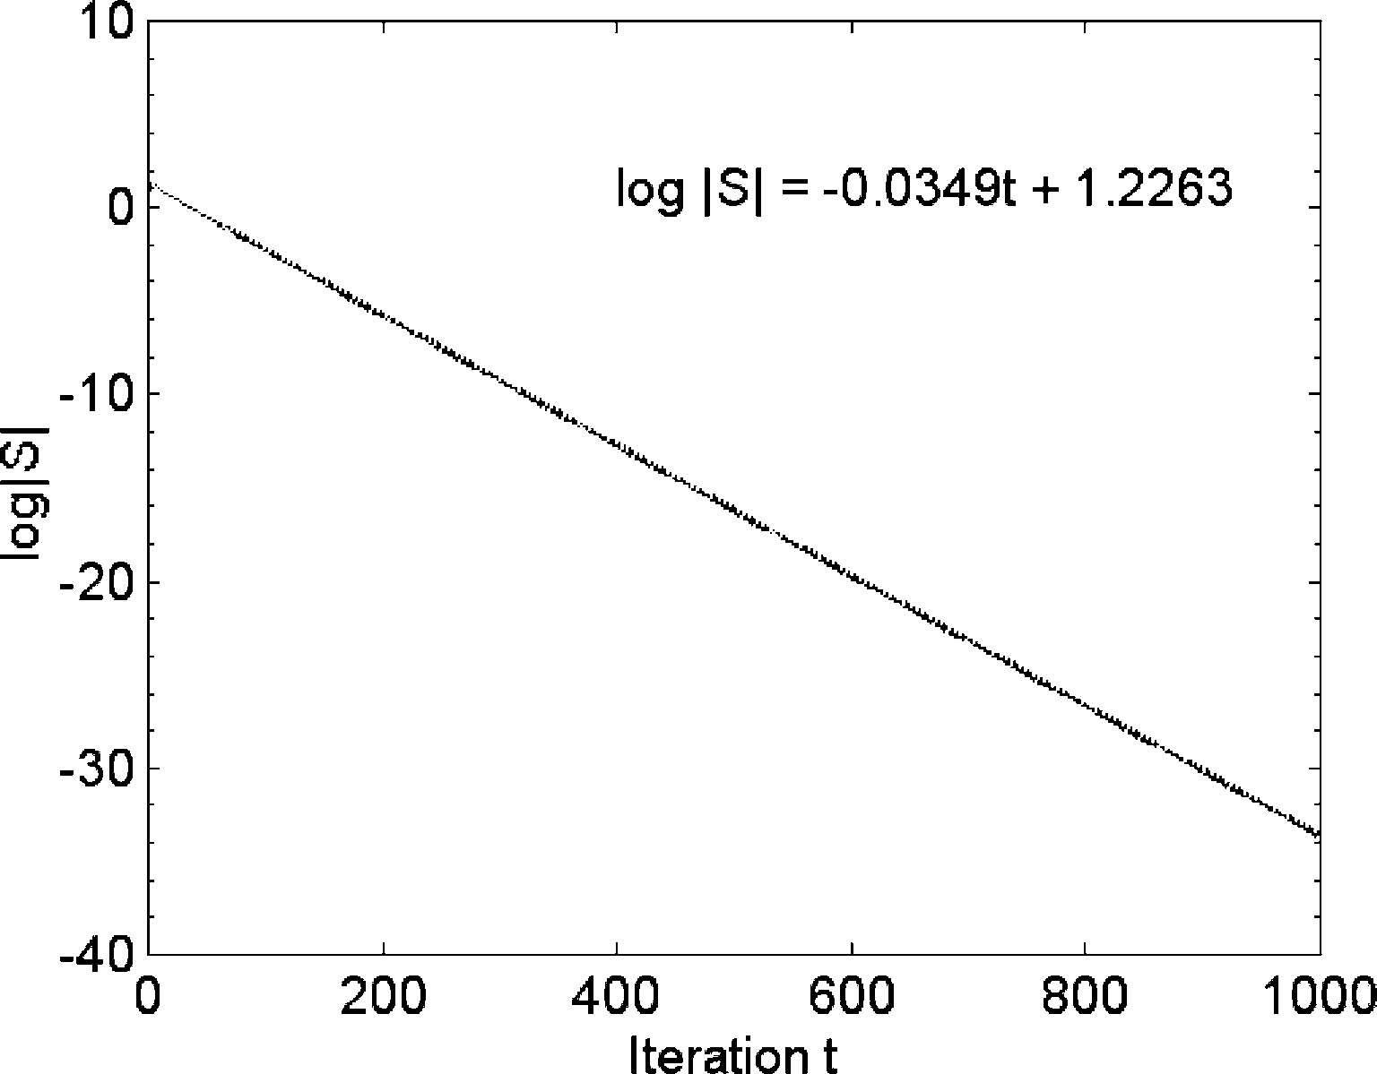
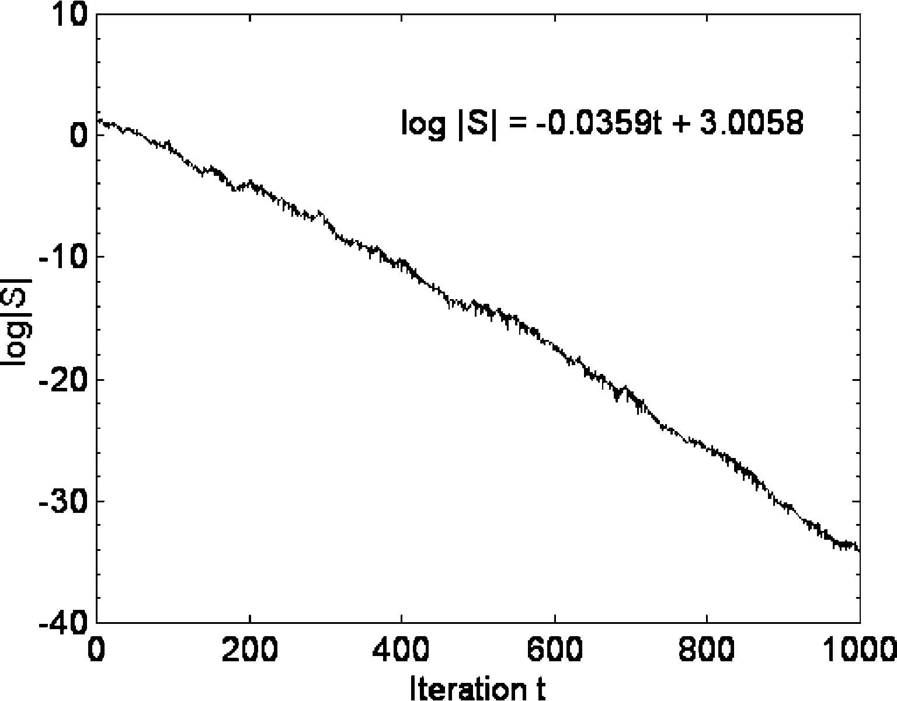
Fig. 4 Experiment 2—particle interactions Fig. 6 Experiment 4—PSO
Table 5 Gradient (standard error) and convergence factor a for neutral swarm experiments 1–4, averaged over 50 runs
Experiment 1: SM Experiment 2: PI Experiment 3: SM + RS Experiment 4: RS, PI
m �0.0684 (0.0) �0.0328 (0.0005) �0.0360 (0.0003) �0.0334 (0.003) a 0.8542 0.9273 0.9204 0.9260

Randomisation can slow convergence in a single run, but, when averaged over many runs, convergence is very similar to ﬁxed spring convergence.
The result that, when particle interactions and/or randomisation is included, the convergence factor a is close to the limiting value for convergence (a=1.0), may explain why a clamping velocity is often used in PSO implementations. For example, Eberhart and Shi (2000) recommend that each particle velocity is clamped, immediately after velocity update, to the dynamic range.
4.2 Diversity measure for charged particles
4.2.1 Experiment design
Experiments 5 and 6 investigate swarm spatial size for
M+
charged swarms (swarms with N neutral and charged particles of charge Q) for core radii rc= 1.0 and
0.1 respectively. A (20, 20+) swarm was used in both experiments, and 50 runs were completed in each case.
4.2.2 Results and analysis
Figures 7, 8, 9 and 10 show charged swarm size plotted against iteration. The mean, standard error, minimum and maximum values of |S+| are computed from iterations 100–1,000 to allow the charged swarm to stabilise. Figures 7 and 9 show |S+| for a single run. The ﬁgures demonstrate that the charged swarm, unlike the neutral swarm, is not contracting; however the charged swarm size is subject to large ﬂuctuations, and the ﬂuctuations are larger for smaller core radius. Figures 8 and 10 show the average |S+| over 50 runs. Fluctuations about the
Fig.8Experiment5,50runs,rc=1.0,meansize=8.6080(0.3353),min=7.7166,max=9.7166
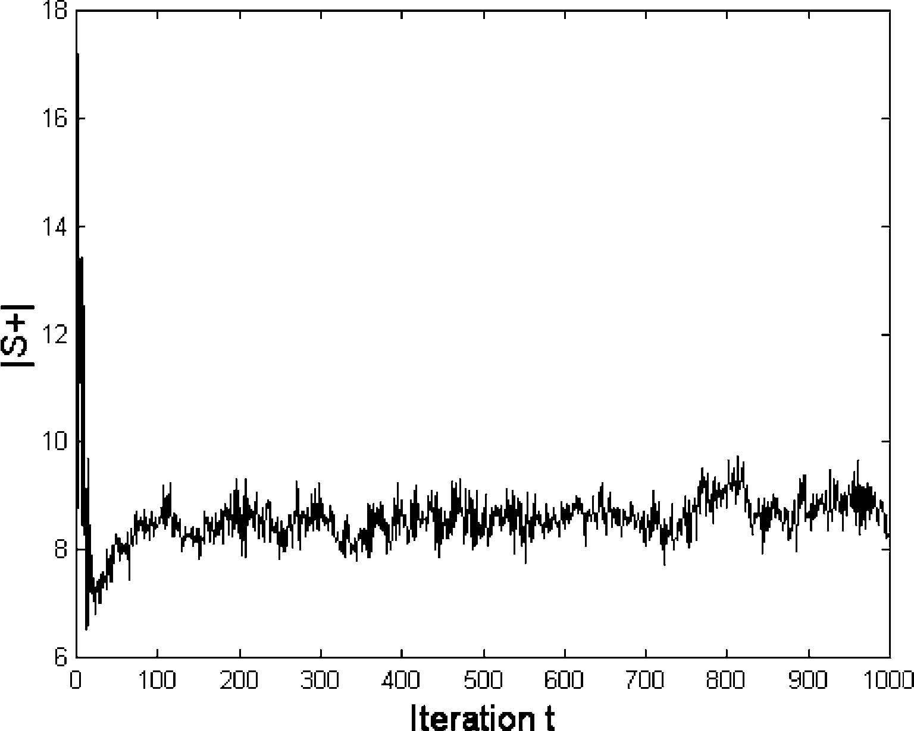
Fig.9Experiment6,1run,rc=0.1,meansize=41.6626(29.0906),min=8.4555,max=140.4039
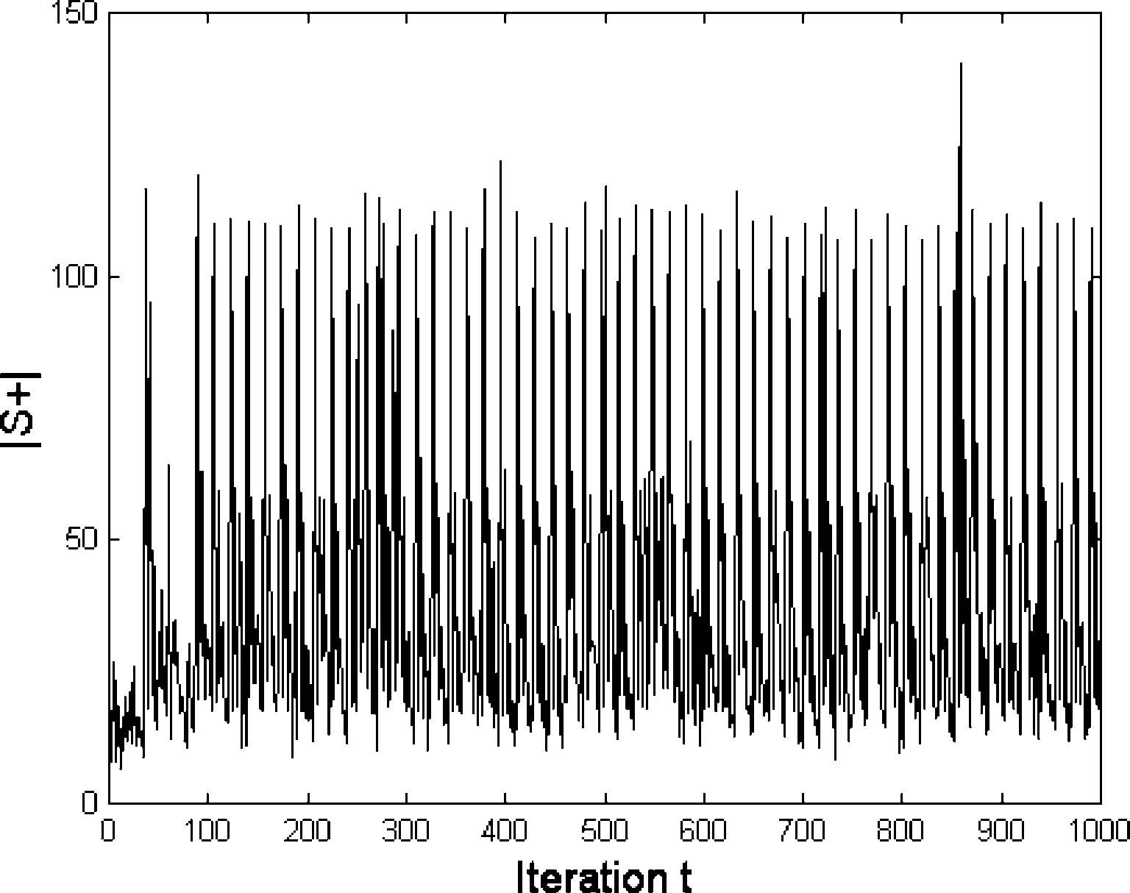
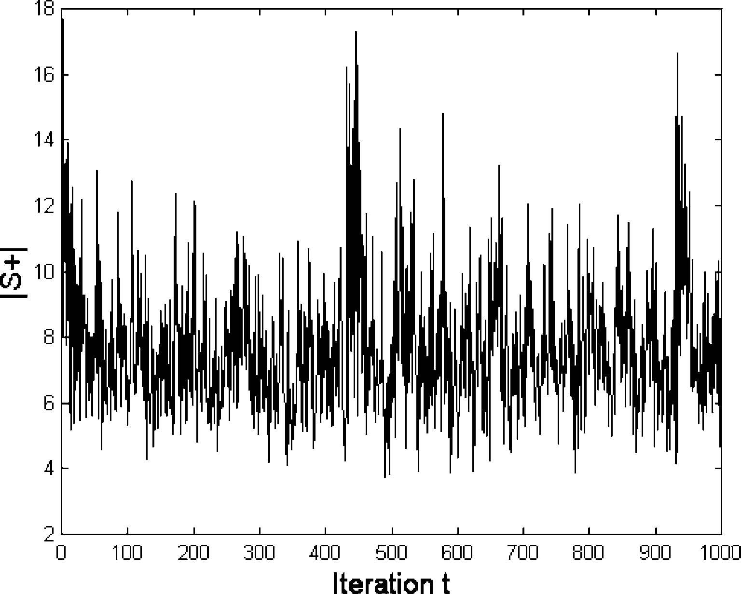
Fig.10Experiment6,50runs,rc=0.1,meansize=30.3736(3.6213),min=22.0341,max=43.7421
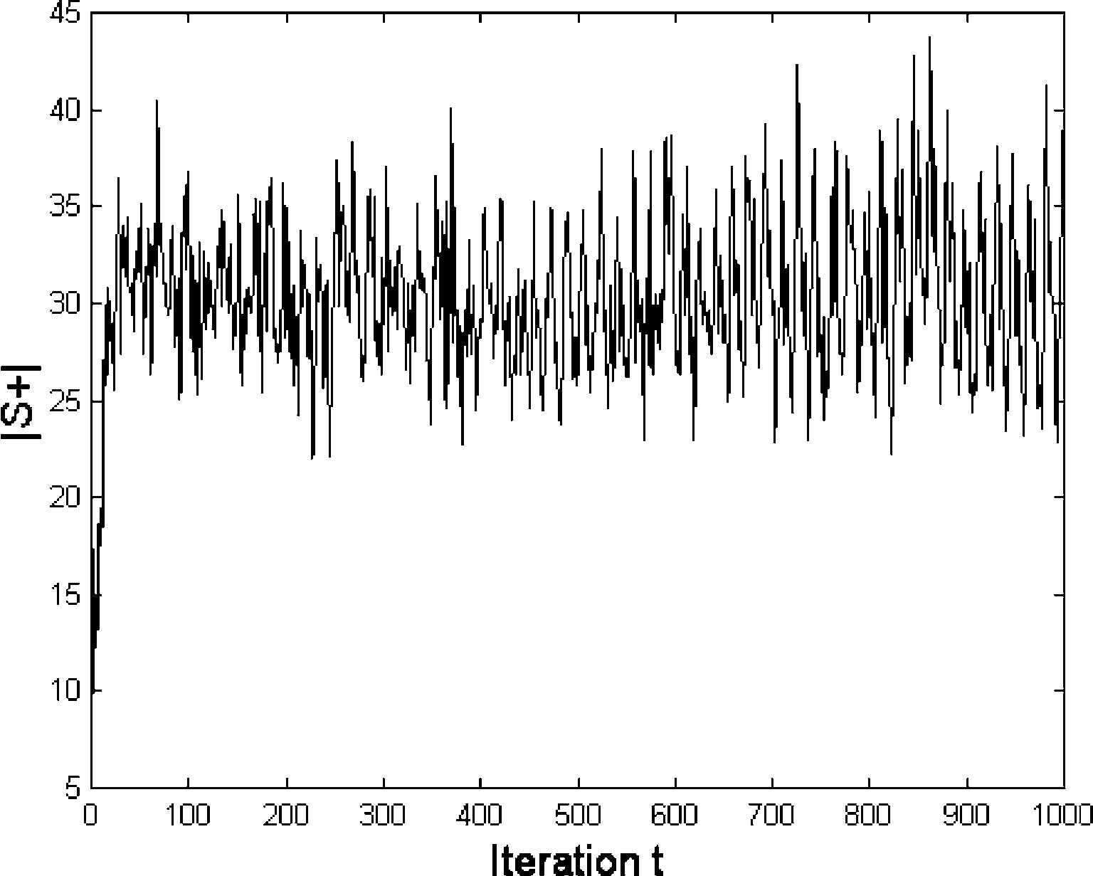
Fig. 7 Experiment 5, 1 run, rc=1.0, mean size=7.6186 (2.0013), min=3.7150, max=17.2935
Table 6 Charged swarm size for experiments 5 and 6
Experiment | rc | rp | <|S+|> | |S+|min | S+|max | |S+|lower | S+|upper
5 | 1.0 | 10.0 | 8.61 (0.07) | 3.25 | 24.34 | 0.91 | 28
6 | 0.1 | 10.0 | 30.4 (0.5) | 4.6 | 602.7 | 1.9 | 1,900

<| S+ |> is the mean size averaged over all 50 runs (standard error). The minimum and maximum swarm sizes achieved over the whole set of 50 runs is also shown. The ﬁrst 100 iterations in each run are ignored. The ﬁnal two columns show theoretical upper and lower
bounds

mean |S+| are reduced when averaged, and this reduction is greater for rc=1.0.
Equations 22 and 23 provide estimates of the ﬂuctuations in swarm size. Table 6 shows the results of computing these bounds for experiments 5 and 6. In order to obtain |S+|min, the estimated inter particle se
~
paration R is found by comparing v/ð¼2:992Þwith rc and rp, according to conditions 1–3 of Sect. 3.3.
The observed values for |S+|min/maxare within the predicted bounds. The lower bound underestimates by factors of 2.4 and 3.6 due to R underestimating mean particle separations (velocity and many body eﬀects are ignored). The upper bound for the rc=1.0 swarm is consistent with observations, but the same bound for the rc=0.1 swarm is 3.2 times too big. This is because the upper bound estimate is very sensitive to the core acceleration ac which is large for the rc=0.1 swarm (ac=100).
The choice between these two swarms (or another swarm with a diﬀerent rc) depends on the extent of diversity required. In this case, the dynamic range is 10, and the rc=1.0 swarm covers some 80% of the search space in each dimension. However, the rc=0.1 swarm is very ineﬃcient in this context since it extends far beyond the edge of the search space.
4.3 Optimum tracking
4.3.1 Experiment design
Two experiments, 7 and 8, test the ability of a (40, 0) neutral swarm and a (20, 20+) swarm to track a moving optimum in environments of diﬀerent severity. In each experiment, an oﬀset vector (s, s, s) was added to the global minimum xa of the sphere function fsph(x) at every 100th iteration. An oﬀset of s=0.1 was chosen for experiment 7. This is a mild change, representing a shift of just 1% of the dynamic range. Experiment 8 is more severe with s=5.0, corresponding to a shift of 50% of the dynamic range. The experiments were repeated 50 times with diﬀerent random number seeds. A subsidiary series of experiments, similar to experiment 2, was run in order to ﬁnd the convergence factor, a, for the (40, 0) neutral swarm.
4.3.2 Results and analysis
The convergence factor for the neutral swarm was found to be 0.94. With an initial swarm size of 10, the expected swarm size at the 100th iteration is 10(0.94)100=0.021. The optimum jump in experiment 7 is about ﬁve times the neutral swarm diversity and about 250 times for experiment 8.
The results for the dynamic experiments are shown in Figs. 11, 12, 13 and 14. The ﬁgures show the average over 50 runs of |pg(t)�xa(t)|, the Euclidean distance of the entire swarm’s best position at iteration t, pg(t), from the global minimum at xa.
Figures 11 and 12 show the results for the mild environment. The best position obtained by the neutral swarm improves between jumps, but overall the performance deteriorates. The charged swarm is better at tracking the optimum, and the performance is stable after the ﬁfth jump. The results for the severe environment (Figs. 13, 14) show similar behaviour. The charged swarm performs relatively better in the severe environment because it has the same absolute error (|pg � xa|=0.1) in the two environments. This is because optimum jump is always within the charged swarm—the swarm does not distinguish between the two environments.
5 Conclusions
If PSO is to be applied to a dynamic problem, then some knowledge of the rate of convergence of the swarm compared to the average jump in optimum position is desirable. If the swarm has a small diversity compared to the optimum change it will be diﬃcult for the swarm to re-diversify and track the change. A simple diversity increasing mechanism, inter-particle repulsion between ‘charged’ particles, has been suggested and shown to work well in some severe environments.
Fig.11Experiment7—Neutralswarm,severity=0.1
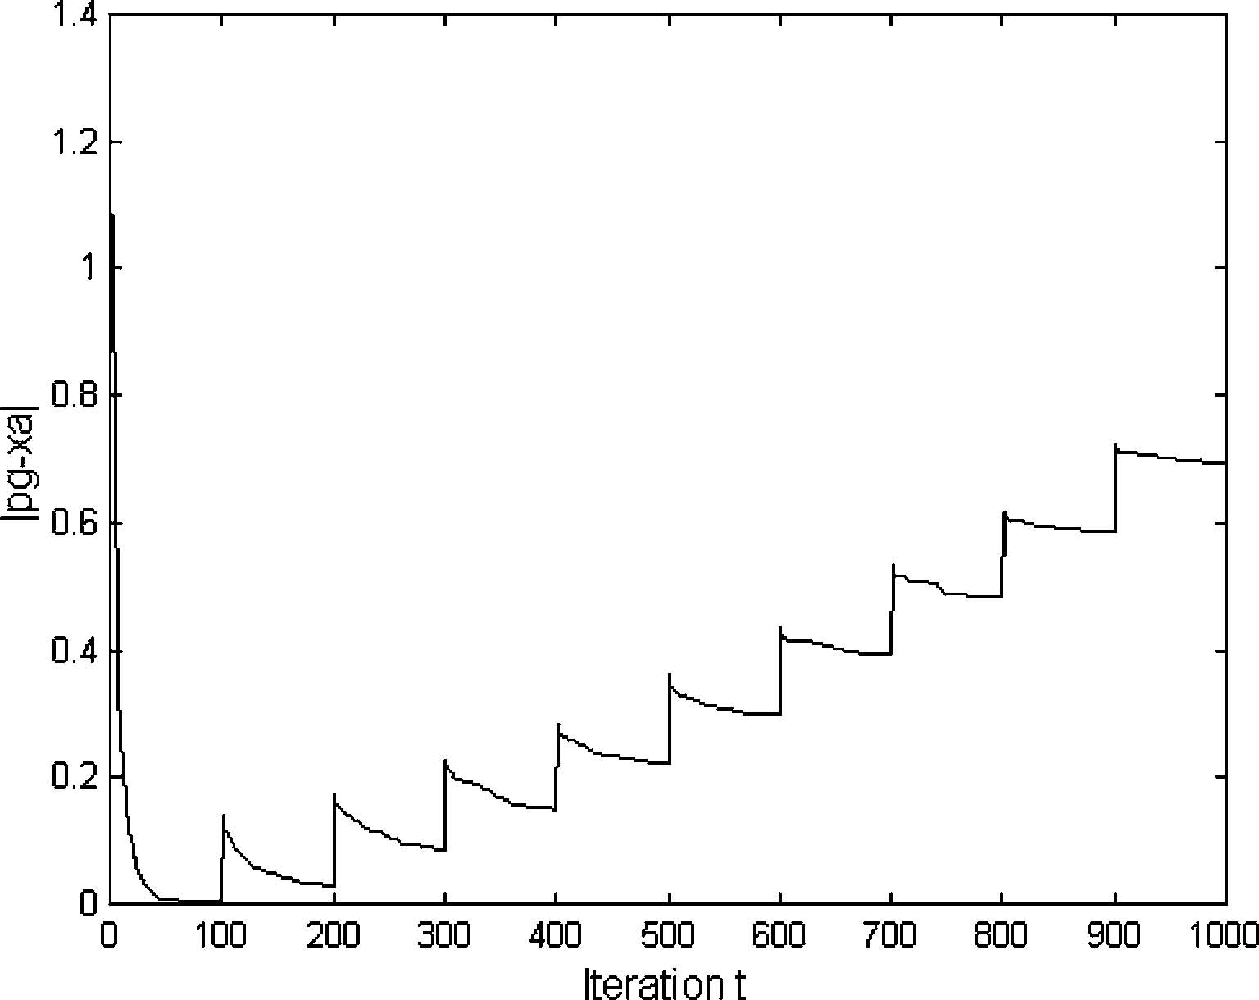
To help understand how a swarm of neutral particles—classic PSO—loses diversity, and how the inclusion of some charged particles to the swarm maintains diversity (CPSO), the maximum spatial extent of the swarm along any axis, swarm size |S|, is proposed as a suitable diversity measure.
Fig.12Experiment7—Chargedswarm,severity=0.1
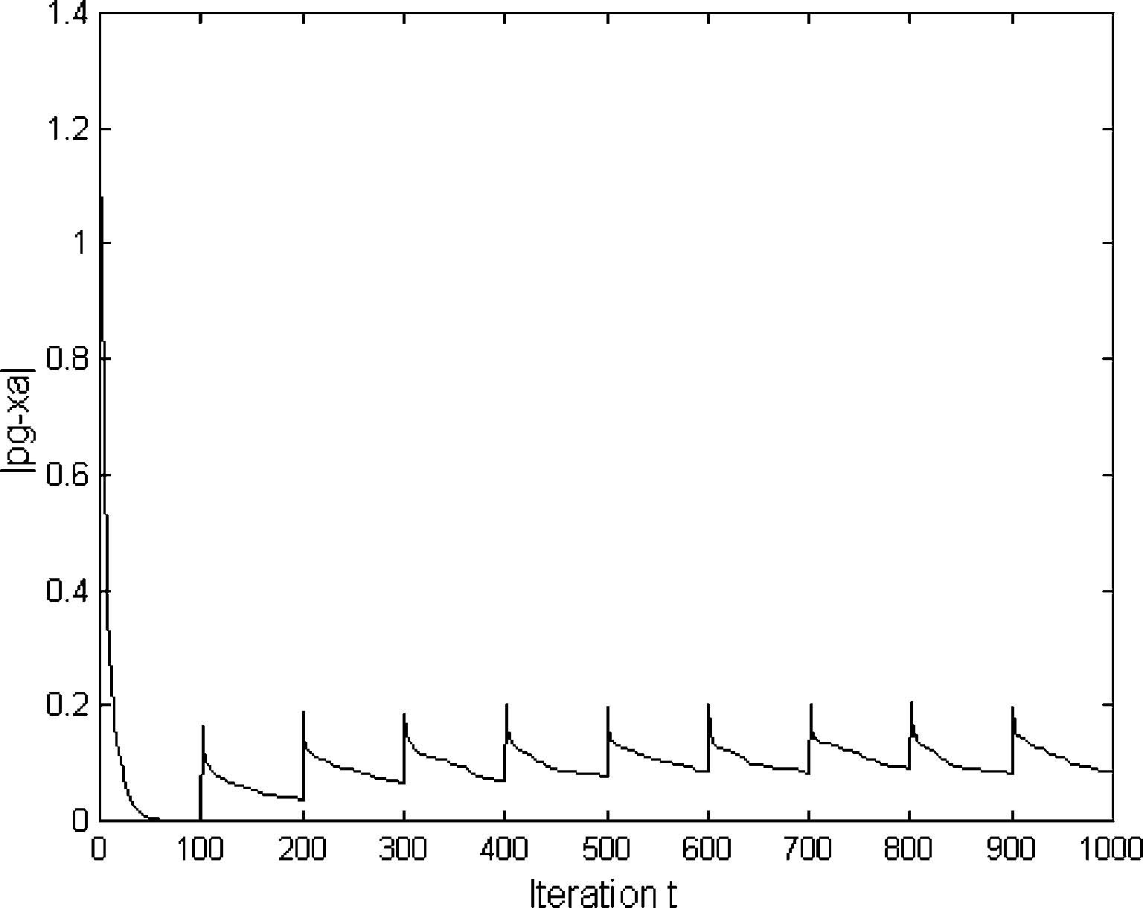
Fig.13Experiment8—Neutralswarm,severity=5
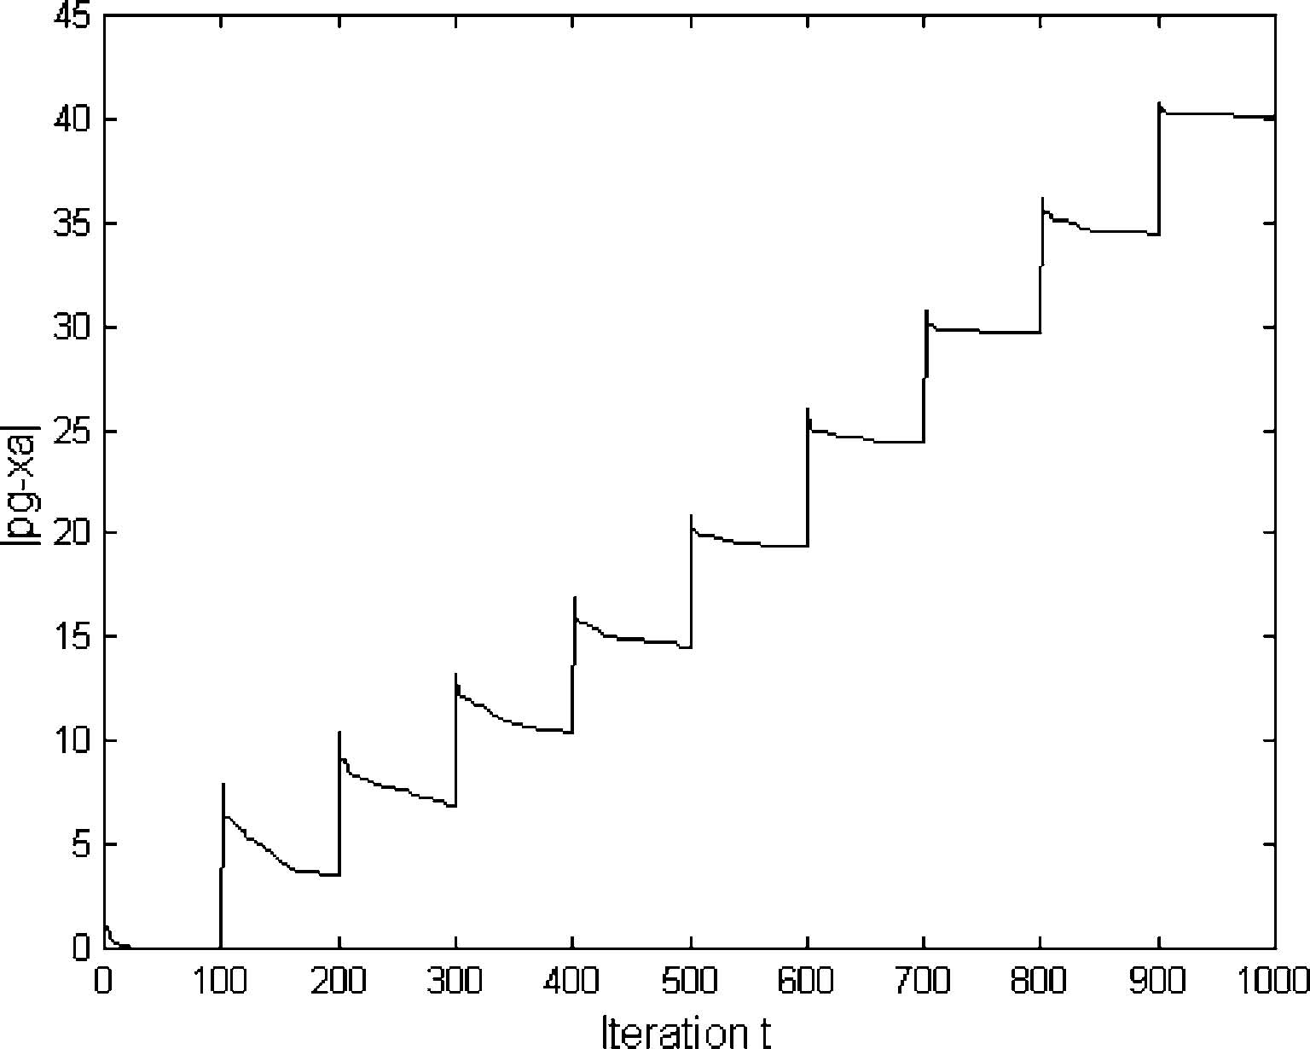
Fig.14Experiment8–Chargedswarm,severity=5
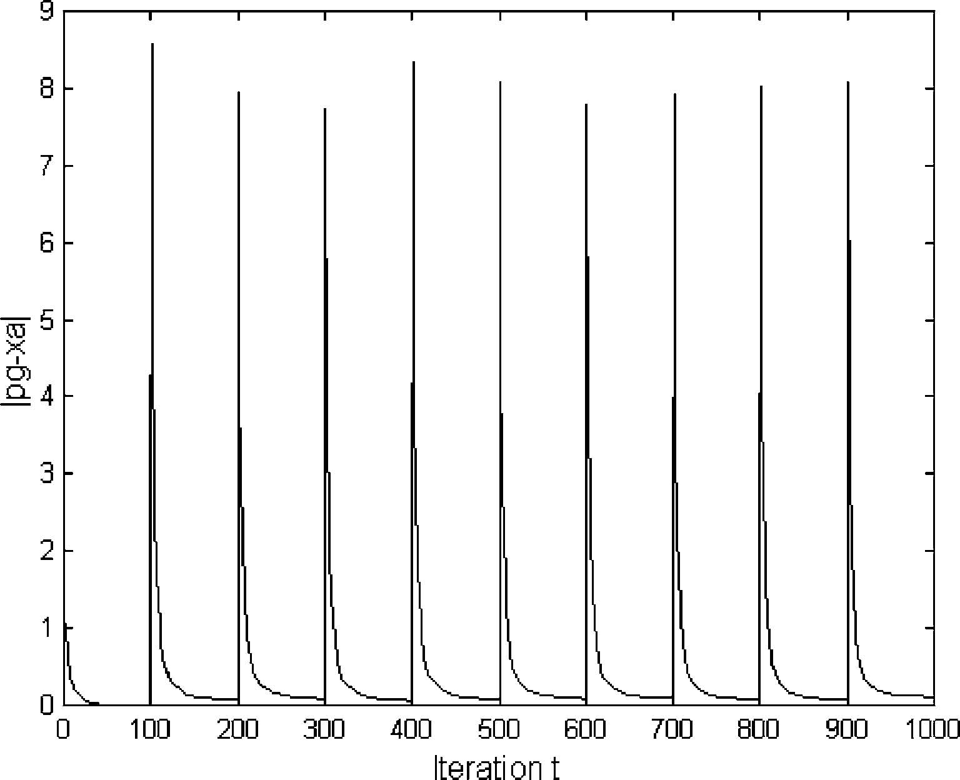
Some analysis motivates, under conditions when convergence is towards a spherically symmetric opti
t
mum, a scaling law |S|=ka . The convergence factor a is related to the constriction v by a =(gv)2 where g=1 for the simpliﬁed model, g>1 otherwise.
The scaling law was demonstrated with a 20 particle swarm and the three-dimensional sphere function for four models: a simpliﬁed non-interacting model, the simpliﬁed model with interactions, the simpliﬁed model with spring randomisation and the full PSO.
The theoretical prediction g=1 was veriﬁed for the simpliﬁed model. It was also discovered that the eﬀects of particle interactions, random springs or both together
(i.e. neutral PSO) were similar, each slowing convergence from a=0.8542 to a=0.92–0.93. The near critical convergence sheds light on the PSO folk-lore that velocity clamping is helpful even under constriction. Spring randomisation induces small ﬂuctuations around scaling, slightly slowing convergence. It is already known that spring randomisation aids PSO convergence for harder objective functions, presumably due to diversity ﬂuctuations.
It was predicted that the charged swarm would not collapse due to the balance between attraction towards the best positions found by the neutral particles, and repulsion amongst the charged particles. This was observed in experiments. Analysis of the charged swarm diversity suggested quite large ﬂuctuations in swarm size |S+| and upper and lower bounds were proposed. These bounds depend on particle charge Q and two parameters of the modiﬁed Coulomb law, the core radius rc and perception limit rp.
Experiments with a 40 particle swarm, half of which are charged, reveal large ﬂuctuations in |S+|, although the average over 50 runs is smoother. At rc=1.0 the charged swarm covers the whole of the dynamic range X, but at rc=0.1 the charged particles spend much time outside this range. Although the smallest swarm sizes observed were similar for both parameters, the rc=0.1 swarm has very large ﬂuctuations at some 60 times X.It would seem, therefore that the rc=1.0 charged swarm would be more eﬃcient for problems where dynamism occurs within X. The calculated upper and lower limits give broad indications of these ﬂuctuations.
Charged and neutral swarms were tested in a simple dynamic optimisation problem. As expected by the picture emerging from the theoretical and empirical study of diversity loss, the neutral swarm performed poorly in comparison with the charged swarm, both for mild and severe dynamism. The charged swarm tracked the jumping optimum to within the same absolute error in position for both environments, suggesting its potential versatility in environments of unknown diversity. It should be noted that predictions for |S| do not take into account asymmetric optima neighbourhoods. In such cases, an analysis using the maximum spatial extent along each axis, |Sj|, j=1,...,d, might be more appropriate. Although analysis did proposed upper and lower limits for |S+|, and these were veriﬁed in the experiments, the best settings for Q, rc, rp and the relative number of charged particles is undetermined by theory and remains empirical.
References
Blackwell TM, Bentley PJ (2002) Dynamic search with charged swarms. In: Proceedings of genetic and evolutionary computation conference, pp 19–26
Blackwell TM (2003) Swarms in dynamic environments. In: Proceedings of genetic and evolutionary computation conference, pp 1–12
Branke J (2001) Evolutionary optimization in dynamic environments. Kluwer, Boston
Branke J (2003) Evolutionary approaches to dynamic optimization problems—introduction and recent trends. In: Branke J (ed) GECCO workshop on evolutionary algorithms for dynamic optimization problems, pp 2–4
Carlisle A, Dozier G (2000) Adapting particle swarm optimisation to dynamic environments. In: Proceedings of international conference on artiﬁcial intelligence, pp 429–434
Clerc M, Kennedy J (2002) The particle swarm: explosion, stability and convergence in a multi-dimensional complex space. IEEE Trans Evol Comput 6:158–73
Eberhart R, Shi Y (2000) Comparing inertia weights and constriction factors in particle swarm optimisation. In: Proceedings of congress on evolutionary computation, pp 84–88
Eberhart RC, Shi Y (2001) Particle swarm optimisation: developments, applications and resources. In: Proceedings of congress on evolutionary computation, pp 81–86
Eberhart RC, Shi Y (2001) Tracking and optimizing dynamic systems with particle swarms. In: Proceedings of congress on evolutionary computation, pp 94–97
Hu X, Eberhart RC (2002) Adaptive particle swarm optimisation: detection and response to dynamic systems. In: Proceedings of congress on evolutionary computation, pp 1666–1670
Kennedy J, Eberhart RC (1995) Particle swarm optimisation. Proc IEEE Int Conf Neural Netw 4:1942–1948
䘀椀最⸀㠀䔀砀瀀攀爀椀洀攀渀琀㔀Ⰰ㔀 爀甀渀猀Ⰰ爀挀㴀㄀⸀ Ⰰ洀攀愀渀猀椀稀攀㴀㠀⸀㘀 㠀 ⠀ ⸀㌀㌀㔀㌀⤀Ⰰ洀椀渀㴀㜀⸀㜀㄀㘀㘀Ⰰ洀愀砀㴀㤀⸀㜀㄀㘀㘀
䘀椀最⸀㤀䔀砀瀀攀爀椀洀攀渀琀㘀Ⰰ㄀爀甀渀Ⰰ爀挀㴀 ⸀㄀Ⰰ洀攀愀渀猀椀稀攀㴀㐀㄀⸀㘀㘀㈀㘀⠀㈀㤀⸀ 㤀 㘀⤀Ⰰ洀椀渀㴀㠀⸀㐀㔀㔀㔀Ⰰ洀愀砀㴀㄀㐀 ⸀㐀 ㌀㤀
䘀椀最⸀㄀ 䔀砀瀀攀爀椀洀攀渀琀㘀Ⰰ㔀 爀甀渀猀Ⰰ爀挀㴀 ⸀㄀Ⰰ洀攀愀渀猀椀稀攀㴀㌀ ⸀㌀㜀㌀㘀⠀㌀⸀㘀㈀㄀㌀⤀Ⰰ洀椀渀㴀㈀㈀⸀ ㌀㐀㄀Ⰰ洀愀砀㴀㐀㌀⸀㜀㐀㈀㄀
䘀椀最⸀㄀㄀䔀砀瀀攀爀椀洀攀渀琀㜀ᐠ一攀甀琀爀愀氀猀眀愀爀洀Ⰰ猀攀瘀攀爀椀琀礀㴀 ⸀㄀
䘀椀最⸀㄀㈀䔀砀瀀攀爀椀洀攀渀琀㜀ᐠ䌀栀愀爀最攀搀猀眀愀爀洀Ⰰ猀攀瘀攀爀椀琀礀㴀 ⸀㄀
䘀椀最⸀㄀㌀䔀砀瀀攀爀椀洀攀渀琀㠀ᐠ一攀甀琀爀愀氀猀眀愀爀洀Ⰰ猀攀瘀攀爀椀琀礀㴀㔀
䘀椀最⸀㄀㐀䔀砀瀀攀爀椀洀攀渀琀㠀ጠ䌀栀愀爀最攀搀猀眀愀爀洀Ⰰ猀攀瘀攀爀椀琀礀㴀㔀

