POLICY IMPACT ANALYSIS
Digital Public Service Expansion in India (Illustrative Study)
DATA DISCLAIMER: This project uses a generated hypothetical dataset for demonstration and learning. It is not official Government of India data.

1. Executive Summary
This report demonstrates how data analytics can be used to assess a public-sector digital service initiative. The illustrative dataset covers 10 Indian states over five years (2021–2025), giving 50 cleaned state-year observations. Across the period, total annual service transactions increased from 629,813 in 2021 to 1,073,668 in 2025, a change of 70.5%. The average online-service share changed by 28.7 percentage points, average processing time changed by -4.3 days, and average citizen satisfaction changed by 18.9 percentage points. These results are illustrative patterns in simulated data and should not be interpreted as measured outcomes of an actual government programme.

2. Background and Policy Context
Digital public services aim to make government services easier to access, reduce paperwork and travel, improve processing speed, and increase transparency. Examples include online certificates, land-record services, public distribution services, tax services, and digital grievance systems. This report models a hypothetical multi-state expansion of digital service delivery. The analysis focuses on service usage, online adoption, processing time, citizen satisfaction, complaint resolution, and digital access.
India's Open Government Data Platform (data.gov.in) publishes datasets from ministries, departments and states. The eTaal portal provides e-transaction statistics for integrated e-governance projects. These are suitable places to locate real data when replacing the synthetic training dataset with official observations.

3. Objectives and Research Questions
- Measure the change in digital public service transaction volumes from 2021 to 2025.
- Assess whether online-service adoption and citizen satisfaction improve over time.
- Examine whether average service processing time decreases.
- Compare state-level service usage and service-quality indicators.
- Identify performance gaps and recommend practical policy improvements.

4. Dataset Description
The workbook contains 51 raw rows (including intentionally inserted data-quality issues) and 50 cleaned rows, representing 10 states across 2021–2025. The dataset is synthetic and was created solely to demonstrate the analytical workflow. It includes service transaction volume, online-service share, average processing days, citizen satisfaction, complaint resolution percentage, and a digital access index.
Field | Meaning | Unit
State | Indian state represented in the scenario | Category
Year | Observation year | Year
Service_Transactions | Number of digital service transactions | Count
Online_Service_Share_Pct | Share of services completed online | Percent
Average_Processing_Days | Average service completion time | Days
Citizen_Satisfaction_Pct | Illustrative citizen satisfaction result | Percent
Complaints_Resolved_Pct | Share of registered complaints resolved | Percent
Digital_Access_Index | Illustrative access/readiness score | 0–100 index

5. Tools and Technologies
- Dataset collection: data.gov.in and eTaal (official sources to consult when obtaining real data).
- Data cleaning: Microsoft Excel (filters, TRIM, Remove Duplicates, missing-value checks).
- Data analysis and KPI calculations: Excel and Python (Pandas, NumPy).
- Statistical analysis and visualisation: Python (Pandas, NumPy, Matplotlib).
- Dashboard: Power BI (recommended build steps are included in the workflow section).
- Final documentation: Microsoft Word.

6. Data Cleaning Methodology
- Imported the Raw_Data sheet and checked row count, column names, data types and missing values.
- Standardised state names by removing extra spaces and applying consistent title case.
- Checked for exact duplicate records and removed duplicate rows.
- Converted transaction volume to numeric format and checked percentage/day fields for valid numeric values.
- Filled missing citizen-satisfaction and complaint-resolution values using the median for the same state.
- Sorted the cleaned dataset by State and Year and retained the original Raw_Data sheet for auditability.
Note: Median imputation is used here only as a transparent training choice. For real policy evaluation, investigate why values are missing, document the treatment, and consider sensitivity analysis rather than automatically imputing.

7. Analysis Methodology and KPIs
The analysis is descriptive. Annual totals and averages were calculated, followed by year-over-year transaction growth and state comparisons.
KPI | Calculation | Interpretation
Total transactions | Sum of Service_Transactions | Higher volume can indicate greater usage, but does not alone prove better outcomes.
Online service share | Mean of Online_Service_Share_Pct | Higher share indicates greater digital adoption.
Average processing days | Mean of Average_Processing_Days | Lower processing time generally indicates faster service.
Citizen satisfaction | Mean of Citizen_Satisfaction_Pct | Higher values indicate better reported experience in this simulated scenario.
Complaint resolution | Mean of Complaints_Resolved_Pct | Higher values indicate a larger share of complaints resolved.
Digital access index | Mean of Digital_Access_Index | Higher score indicates stronger assumed access/readiness.

8. Findings and Visual Analysis
Annual transactions rose by 70.5% between the first and final year in this synthetic dataset. Online-service share increased by 28.7 percentage points, while average processing time changed by -4.3 days. Citizen satisfaction changed by 18.9 percentage points. Review the Yearly_KPIs and State_Analysis sheets for exact values.
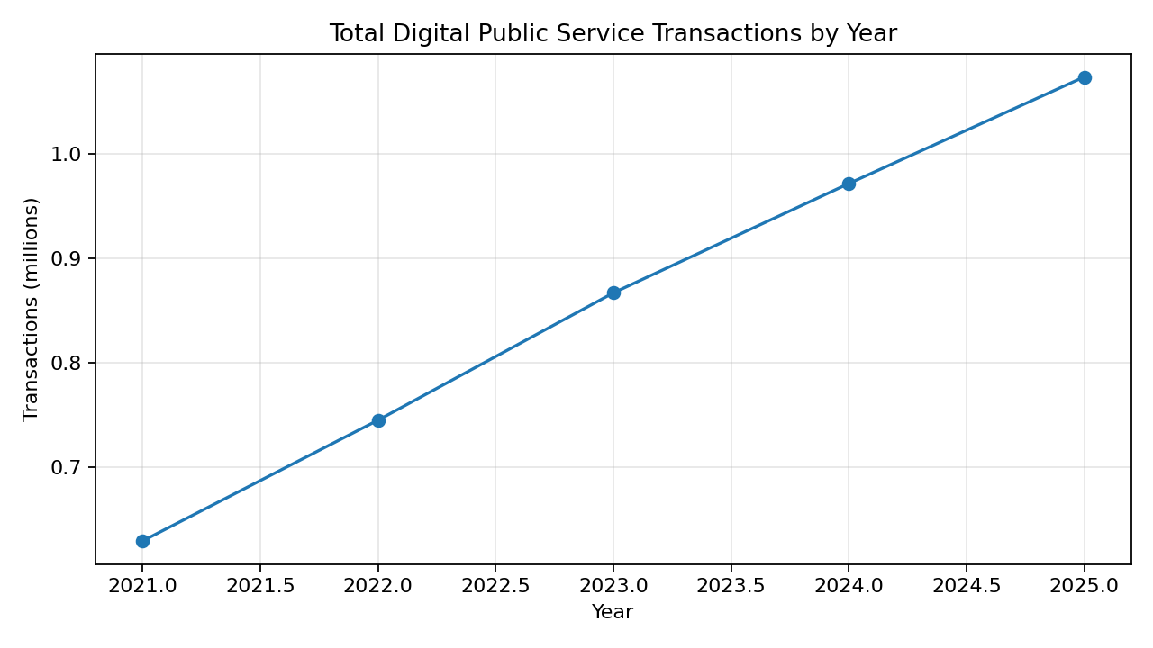
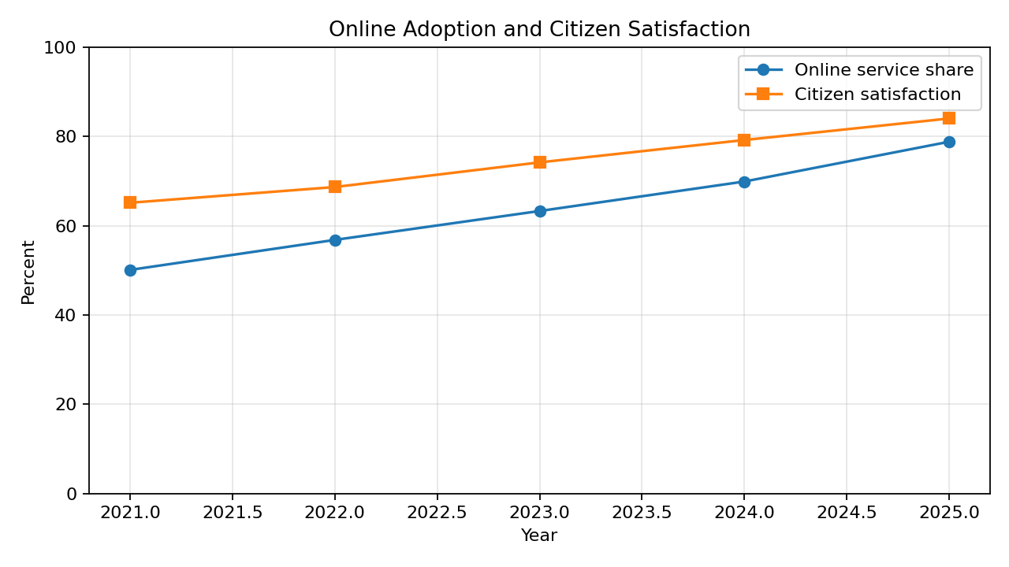
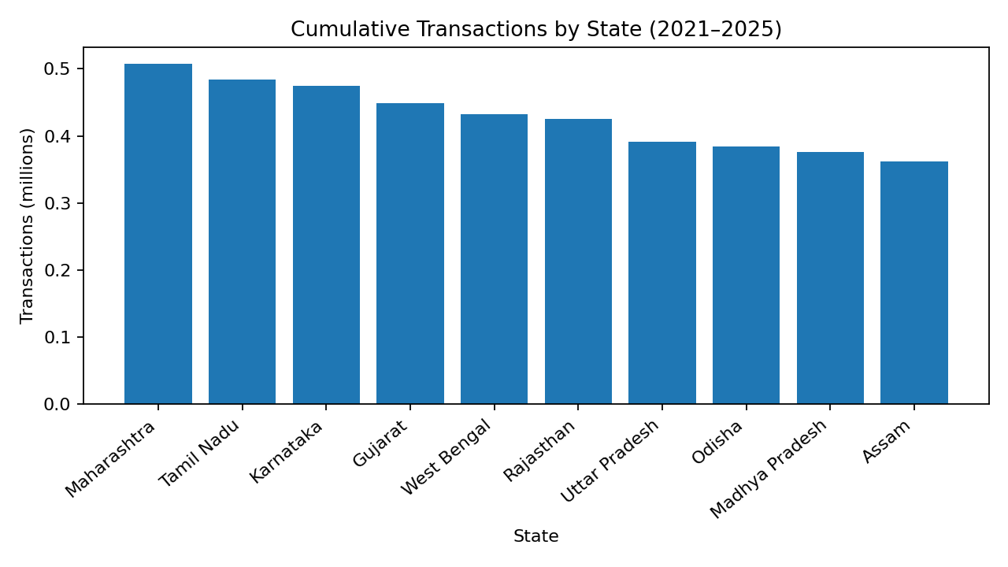

9. Interpretation and Limitations
- Higher transaction volume may reflect increased awareness, service availability or population size; it should be normalised by population or eligible users for fair comparison.
- Online adoption and satisfaction moving together does not establish that digital adoption caused satisfaction to improve.
- The dataset does not include a control group, pre-defined treatment intensity, implementation dates, programme expenditure or demographic breakdowns.
- State averages can hide district, rural/urban, gender, age, disability and connectivity gaps.
- Because all observations are synthetic, the numerical results are examples only and must not be presented as official findings.

10. Policy Recommendations
- Improve assisted digital access through Common Service Centres and local help desks for citizens with limited connectivity or digital skills.
- Track service-level turnaround-time targets and publish monthly dashboards for departments.
- Collect citizen feedback after service completion and analyse satisfaction by service type and district.
- Monitor grievance resolution ageing, not only the overall percentage resolved.
- Publish standardised, regularly updated and machine-readable datasets with clear metadata and definitions.
- For rigorous impact evaluation, compare implementation areas with similar non-implementation areas and control for population, internet access and other confounding factors.

11. Step-by-Step Project Execution Guide

Step 1 – Find a real dataset (recommended upgrade)
Open data.gov.in and search for e-governance, digital services, e-District, public service delivery or state-wise indicators. Also review eTaal for e-transaction statistics. Download a CSV/XLSX dataset and record its exact title, department, date accessed, update date and licence. Replace the synthetic workbook data only after checking that the fields and time periods are comparable.

Step 2 – Inspect the data in Excel
Open Policy_Impact_Analysis.xlsx. Review Raw_Data first. Check headers, blank cells, duplicate rows, data types and unusual values. Keep the raw sheet unchanged as an audit copy.

Step 3 – Clean the data in Excel
Use TRIM to remove extra spaces from text fields; use consistent case for state names; use Data > Remove Duplicates for exact duplicates; use filters and COUNTBLANK to inspect missing values; validate numeric fields and percentage ranges. The Cleaned_Data sheet shows the completed example.

Step 4 – Analyse with Excel
Use PivotTables with Year in Rows and transaction totals / average indicators in Values. Add State as a filter or slicer. Use formulas such as SUM, AVERAGE and year-over-year growth. Compare annual and state-level results.

Step 5 – Run Python analysis
Install Python, then run: pip install pandas numpy matplotlib openpyxl. Keep the Excel workbook and policy_impact_analysis.py in the same folder. Run: python policy_impact_analysis.py. The script reads Cleaned_Data, calculates annual and state summaries, exports CSV files and saves charts in python_outputs.

Step 6 – Create a Power BI dashboard
Open Power BI Desktop > Get Data > Excel workbook > select Cleaned_Data and Yearly_KPIs > Load. Create Card visuals for total transactions, average online share, processing days and satisfaction. Add a line chart with Year and Total Transactions; a clustered column chart with State and Service_Transactions; and line charts for online share and satisfaction. Add Year and State slicers. Format titles, units and data labels. Add a note that the sample data is synthetic.

Step 7 – Validate your results
Compare Power BI totals with Excel Yearly_KPIs and Python output. Check that filters work and that percentages are formatted as percentages. Confirm that all visuals use the same cleaned dataset.

Step 8 – Complete the report
Use this DOCX report as the structure. Replace synthetic results with results from your chosen official dataset if you download one. Insert screenshots of your Power BI dashboard, explain each chart, cite the exact dataset and describe limitations.

Step 9 – Prepare submission
Submit the final DOCX report as requested by the portal. If the task is technical/software-related, add a GitHub repository containing the workbook, Python script and README. Do not upload private information or claim synthetic data is official.

12. Conclusion
This project demonstrates a complete public-sector policy analysis workflow: dataset preparation, cleaning, KPI calculation, descriptive analysis, visualisation and evidence-based recommendations. The simulated results illustrate how service usage and service-quality indicators can be monitored. A real-world conclusion about policy effectiveness requires verified official data, clear programme exposure information and a stronger evaluation design.

13. References and Data Sources
- Open Government Data Platform India (data.gov.in), Government of India: https://data.gov.in/ (accessed 11 November 2026).
- eTaal – Electronic Transaction Aggregation & Analysis Layer, Ministry of Electronics & Information Technology: https://etaal.gov.in/ (accessed 11 November 2026).

