WEEK 2 TASK
Data Visualization and Communication
in Digital Services
E-Governance Service Performance Analysis

Prepared by | Sujeep Shaikh
Project type | Data Analytics Internship – Week 2
Tools | Microsoft Excel; data visualization
Dataset | Simulated teaching dataset – 300 records

DATA INTEGRITY NOTICE
This report uses a simulated dataset created solely for educational demonstration. The figures do not represent actual government transactions, state performance, or citizen survey results.

Executive Summary
This project demonstrates how data visualization can turn operational records into clear information for digital public-service monitoring. A simulated dataset containing 300 records was developed across five Indian states, five digital services and twelve months. The analysis examines application demand, resolution performance, processing time, complaints and indicative citizen satisfaction. Across the simulated period, 328,435 applications were received and 286,533 were resolved, giving an overall resolution rate of 87.2%. The weighted average satisfaction score was 81.6%, while weighted average processing time was 3.8 days. A bar chart, line chart and heat map were selected because they answer different analytical questions: category comparison, change over time, and comparison across two categorical dimensions. The findings are illustrative only and should not be used as evidence of actual government performance.

1. Introduction
Digital public services allow residents to apply for selected government services through online channels. As service delivery becomes increasingly digital, administrators need understandable ways to monitor demand, completion, delays and user experience. Raw tables can contain many records and may be difficult to interpret quickly. Data visualization helps communicate patterns, exceptions and areas that may deserve further investigation. This assignment applies basic analytical and visualization techniques to an illustrative e-governance dataset.

2. Project Objectives
- Measure and compare application volumes across five digital public services.
- Review monthly changes in applications received and applications resolved.
- Compare indicative satisfaction scores across states and services.
- Calculate pending applications, resolution rates and complaint rates.
- Explain how visual evidence can inform practical improvements in digital public-service delivery.

3. Dataset Description
The dataset contains 300 simulated records: 12 months × 5 states × 5 services. Each row represents one month–state–service combination. The dataset is structured to resemble a service-monitoring table, but all values are generated for this assignment and are not collected from government systems or real citizens.
Field | Description
Month / Month Number | Reporting month and its numeric sequence.
State | One of five illustrative state categories.
Digital Service | Birth Certificate, Income Certificate, Residence Certificate, Pension Services or License Renewal.
Applications Received | Illustrative count of applications received.
Applications Resolved | Illustrative count of applications completed.
Average Processing Days | Illustrative average processing duration in days.
Citizen Satisfaction (%) | Simulated satisfaction indicator; not a real survey result.
Complaints | Illustrative count of complaints associated with the records.
Pending Applications | Applications received minus applications resolved.
Resolution Rate (%) | Applications resolved divided by applications received × 100.
Complaint Rate (%) | Complaints divided by applications received × 100.

4. Methodology
- Dataset design: created a balanced structure covering five states, five service categories and twelve months.
- Data validation: checked that application counts were non-negative, resolved applications did not exceed received applications, and processing/satisfaction values stayed within plausible illustrative ranges.
- Calculated measures: derived pending applications, resolution rate and complaint rate using formulas in Excel.
- Aggregation: summarized application and resolution totals by service and month, and calculated average satisfaction by state and service.
- Visualization selection: used a bar chart for comparing service categories, a line chart for monthly trends, and a heat map for a state-by-service matrix.
- Interpretation: described what each chart shows and connected the patterns to possible service-management actions while avoiding causal claims.

5. Key Performance Indicators
Indicator | Simulated result
Total applications received | 328,435
Total applications resolved | 286,533
Pending applications | 41,902
Overall resolution rate | 87.2%
Weighted average processing time | 3.8 days
Weighted average satisfaction | 81.6%
Total complaints | 14,415
Weighted averages use applications received as weights where applicable. Figures are calculated from the simulated records.

6. Visualizations and Findings

6.1 Bar Chart – Applications by Digital Service
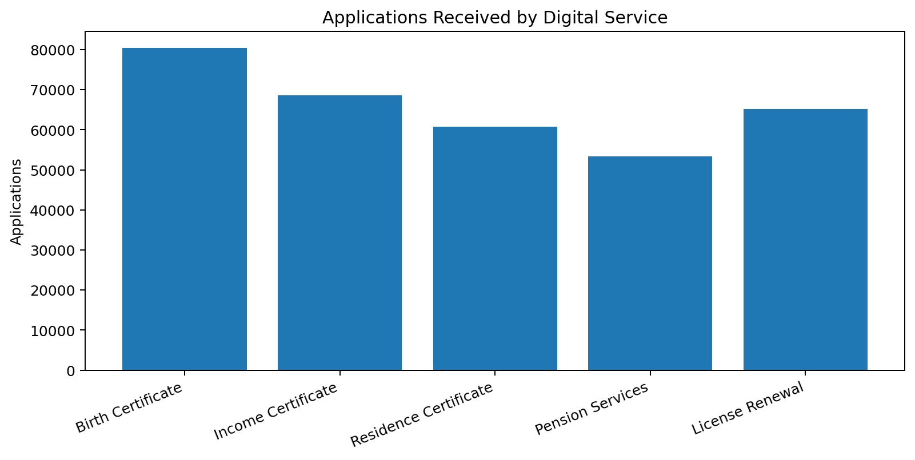
What it shows: total application volume for each of the five digital services across all states and months.
Finding: Birth Certificate recorded the highest simulated application volume (80,481), while Pension Services recorded the lowest (53,400). This comparison can help service managers understand relative demand and consider whether staffing, help-desk capacity and system capacity are aligned with usage.
Why this chart was selected: a bar chart makes differences between discrete service categories easy to compare. It is more suitable than a line chart because service names are categories rather than a continuous time sequence.

6.2 Line Chart – Monthly Applications Received vs Resolved
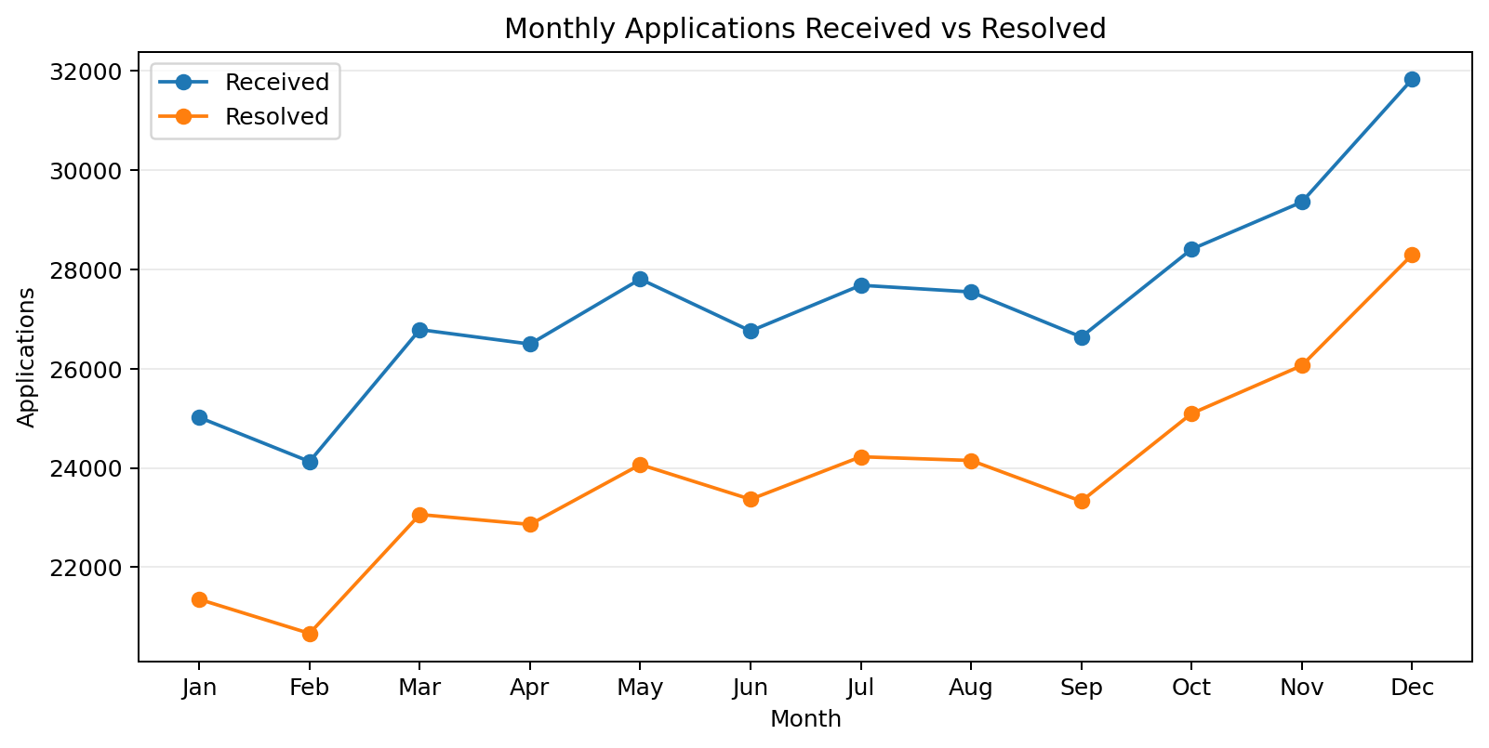
What it shows: monthly totals for applications received and resolved across all five states and services.
Finding: monthly applications received changed from 25,016 in January to 31,826 in December, while monthly resolved applications changed from 21,353 to 28,291. The two series allow readers to see whether completion volumes broadly keep pace with incoming demand. A sustained gap between received and resolved applications can increase the pending workload and should trigger a closer operational review.
Why this chart was selected: a line chart is effective for showing direction, movement and possible seasonality across ordered monthly observations.

6.3 Heat Map – Satisfaction by State and Service
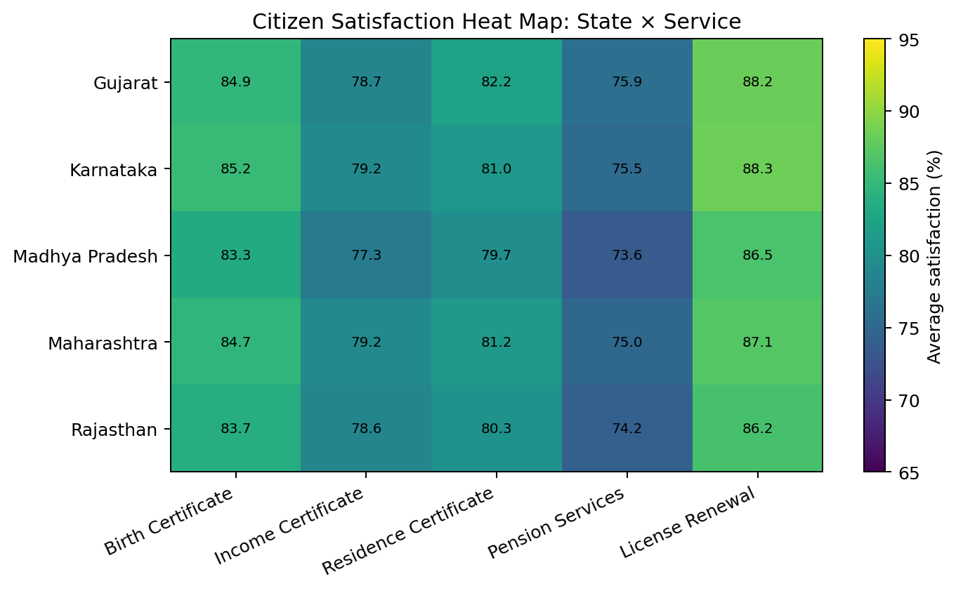
What it shows: average simulated satisfaction scores for each state–service combination. The colour scale makes relatively higher and lower values easy to scan.
Finding: the highest average score in the matrix was 88.3% for License Renewal in Karnataka; the lowest was 73.6% for Pension Services in Madhya Pradesh. These differences are signals for further investigation, not proof of service quality or causes. In a real deployment, administrators should validate results with representative citizen feedback and operational data.
Why this chart was selected: a heat map makes a two-dimensional matrix easier to scan and helps identify combinations that may warrant attention.

7. Discussion and Public-Policy Relevance
The three visualizations provide complementary views of service performance. The bar chart supports comparison of demand between service categories. The line chart helps monitor whether processing activity changes alongside incoming applications. The heat map can direct attention to state–service combinations where feedback indicators are relatively lower. Together, they demonstrate how a compact monitoring view can support evidence-informed discussion about digital service delivery.
- Capacity planning: use application volumes and pending workloads to review staffing, infrastructure and service support requirements.
- Process improvement: investigate services with longer processing times or a persistent gap between applications received and resolved.
- Citizen experience: examine low satisfaction indicators alongside complaint themes, accessibility feedback and service usability testing.
- Equity and access: disaggregate real service data carefully to identify whether particular regions or groups face access barriers, while protecting privacy.
- Performance monitoring: review indicators regularly and define clear operational thresholds rather than relying on one-time snapshots.

8. Recommendations
- Develop a regularly refreshed dashboard using verified administrative data rather than simulated values.
- Track both volume and quality: application counts alone do not show whether services are timely, accessible or satisfactory.
- Monitor pending cases and ageing of unresolved applications, not only overall resolution percentages.
- Collect citizen feedback using transparent, accessible and representative methods; publish the survey method and sample size.
- Investigate outliers with frontline staff and service users before deciding on policy or resource changes.
- Protect personal information through aggregation, access controls and data minimization.

9. Limitations
The dataset is simulated and intentionally simplified. It does not contain actual transactions, actual state performance, verified service-level agreements, demographic attributes, geography below state level, or a real citizen survey. The satisfaction and complaint values are generated indicators and cannot support claims about real citizens. The analysis is descriptive; it does not establish that one factor caused another. Before using a similar dashboard operationally, the data definitions, completeness, collection process, time period, denominator choices and privacy safeguards would need to be validated.

10. Conclusion
This assignment demonstrates the process of transforming structured data into visual information that can be communicated to decision-makers. The bar chart compares demand across service categories, the line chart presents monthly movement in received and resolved applications, and the heat map highlights differences in a state-by-service satisfaction matrix. The exercise shows that choosing a visualization should depend on the analytical question and the structure of the data. Most importantly, visualizations should be accompanied by clear explanations, transparent data limitations and practical recommendations. With verified administrative data and appropriate safeguards, similar methods can contribute to more responsive and accountable digital public services.

11. References and Data Note
Dataset: Simulated dataset generated for this assignment; no official administrative records or personal data were used.
Background portals for contextual understanding (not used as sources for the simulated figures):
- Digital India programme: https://www.digitalindia.gov.in/
- National Portal of India: https://www.india.gov.in/
- National e-Governance Division: https://negd.gov.in/
The quantitative findings in this report are calculated exclusively from the simulated workbook dataset.

