DATA LITERACY AND DATA ANALYSIS TECHNIQUES IN E-GOVERNANCE

1. Executive Summary
This report examines the role of data literacy and basic data analysis techniques in e-governance. It combines a conceptual review of data-driven public administration with a practical analysis of a simulated dataset representing citizen applications for digital public services. The analysis demonstrates data cleaning, descriptive statistics, key performance indicators (KPIs), service-level comparisons, regional analysis, and a basic inferential test comparing online and offline processing times.
The cleaned analytical dataset contains 200 unique applications. The overall average processing time is 6.31 days, the median is 6.0 days, and the overall completion rate is 86.00%. Online applications averaged 5.11 processing days compared with 8.63 days for offline applications, a simulated reduction of 40.72%.
The findings illustrate how reliable data and appropriate statistical analysis can help administrators monitor service performance, identify bottlenecks, compare channels, and prioritize improvement actions. The report also reviews three e-governance examples: eTaal, ServicePlus, and SARITA.

2. Introduction
E-governance refers to the use of information and communication technologies to improve government administration, public services, communication, transparency, and interaction with citizens and other stakeholders. In a digital government environment, every application, transaction, service request, processing event, and citizen feedback record can generate data.
Data becomes valuable when it is collected consistently, cleaned, interpreted correctly, and used to support decisions. The OECD describes a data-driven public sector as one that treats data as a strategic asset and applies it to policy making, service delivery, organisational management, and innovation.
For e-governance, data analysis can answer practical questions such as: Which services take the longest to process? Which channels have higher completion rates? Where are applications accumulating? Are citizens satisfied with service delivery? Which indicators should managers monitor regularly?

3. Data Literacy in the Public Sector
Data literacy is the ability to understand, work with, evaluate, interpret, and communicate data responsibly. In government, data literacy is not limited to data scientists. Policy officers, service managers, analysts, administrators, and programme teams all need enough data literacy to understand indicators and make evidence-based decisions.
- Understanding data sources, definitions, units, and collection methods.
- Recognising data-quality problems such as missing values, duplicates, inconsistent categories, and invalid values.
- Using descriptive statistics to summarise service performance.
- Reading tables, charts, dashboards, and KPIs correctly.
- Understanding uncertainty and basic inferential statistics before drawing conclusions.
- Protecting privacy, security, confidentiality, and public trust when handling citizen information.

4. Fundamental Data Analysis Techniques

4.1 Data Cleaning
Data cleaning is the process of detecting and correcting quality problems before analysis. In the practical dataset, deliberate issues were introduced to demonstrate a realistic workflow: duplicate application IDs, inconsistent capitalization, extra spaces, missing processing times, missing or invalid ratings, and potential outliers.
Categorical values were standardized, duplicate application IDs were removed, missing processing times were imputed using a service-and-channel median where possible, and invalid ratings outside the 1–5 scale were treated as missing and imputed using the median rating for the relevant status group. Potential processing-time outliers were flagged using the 1.5×IQR rule and retained because an unusual delay can be a genuine operational event.

4.2 Descriptive Statistics
Descriptive statistics summarise what is present in the dataset. Mean processing time measures the arithmetic average, median shows the central observation, mode identifies the most frequent value, standard deviation describes variation around the mean, and minimum/maximum values show the observed range. Percentages such as completion rate convert counts into operationally meaningful indicators.

4.3 Basic Inferential Analysis
Inferential statistics help analysts use a sample to assess broader claims while accounting for uncertainty. Common techniques include sampling, confidence intervals, correlation, regression, and hypothesis tests. For this educational project, a Welch two-sample t-test was used as a basic comparison of processing time between online and offline applications. The test should not be interpreted as proof that channel alone causes the difference, because this simulated analysis does not control for all operational factors.

5. Methodology
- Designed a simulated dataset representing 205 raw application records and 200 unique applications after deduplication.
- Included six public-service categories, four regions, two application channels, three statuses, processing time, and citizen rating.
- Introduced controlled data-quality issues to demonstrate cleaning techniques.
- Standardized categorical fields and removed duplicate Application_ID records.
- Imputed missing processing times using service-and-channel medians and handled invalid ratings as missing before imputation.
- Calculated KPIs and grouped results by service, channel, region, and status.
- Used the 1.5×IQR rule to flag unusual processing times without automatically deleting potentially genuine delays.
- Compared online and offline processing times and performed a Welch t-test as an illustrative inferential method.
Important limitation: the dataset is simulated and therefore the numerical findings cannot be generalized to real government services. The purpose is to demonstrate an analytical workflow and interpretation approach.

6. Dataset Description and Data Cleaning
The analytical dataset contains the following fields: Application_ID, Service, Region, Channel, Application_Date, Processing_Days, Status, Citizen_Rating, and a derived Processing_Time_Outlier flag.

6.1 Cleaning Summary
Issue | Affected / Flagged | Treatment
Duplicate records | 5 | Removed duplicate Application_ID records; retained first occurrence.
Inconsistent text formatting | 6 | Standardized case and whitespace in Service, Region, Channel and Status.
Missing Processing_Days | 3 | Imputed using median processing time for the same Service + Channel.
Missing/invalid Citizen_Rating | 7 | Invalid ratings (outside 1–5) treated as missing; missing values imputed using status-level median.
Outlier review | 0 | Flagged using 1.5×IQR rule; retained because outliers may represent genuine service delays.

7. Practical Data Analysis

7.1 KPI Summary
Indicator | Result
Total unique applications | 200
Completed applications | 172
Pending applications | 21
Rejected applications | 7
Completion rate | 86.00%
Average processing time | 6.31 days
Median processing time | 6.0 days
Standard deviation | 3.25 days
Average citizen rating | 3.95/5

7.2 Online vs Offline Analysis
Online applications had an average processing time of 5.11 days, while offline applications averaged 8.63 days. On this simulated dataset, the online channel is therefore associated with a 40.72% lower average processing time. The Welch t-test produced t = -8.290 and p = 0.000000.
At the 5% significance level, the difference is statistically significant in this simulated sample. However, statistical significance does not establish causation, and the result should not be generalized to real government services without real-world data and stronger controls.
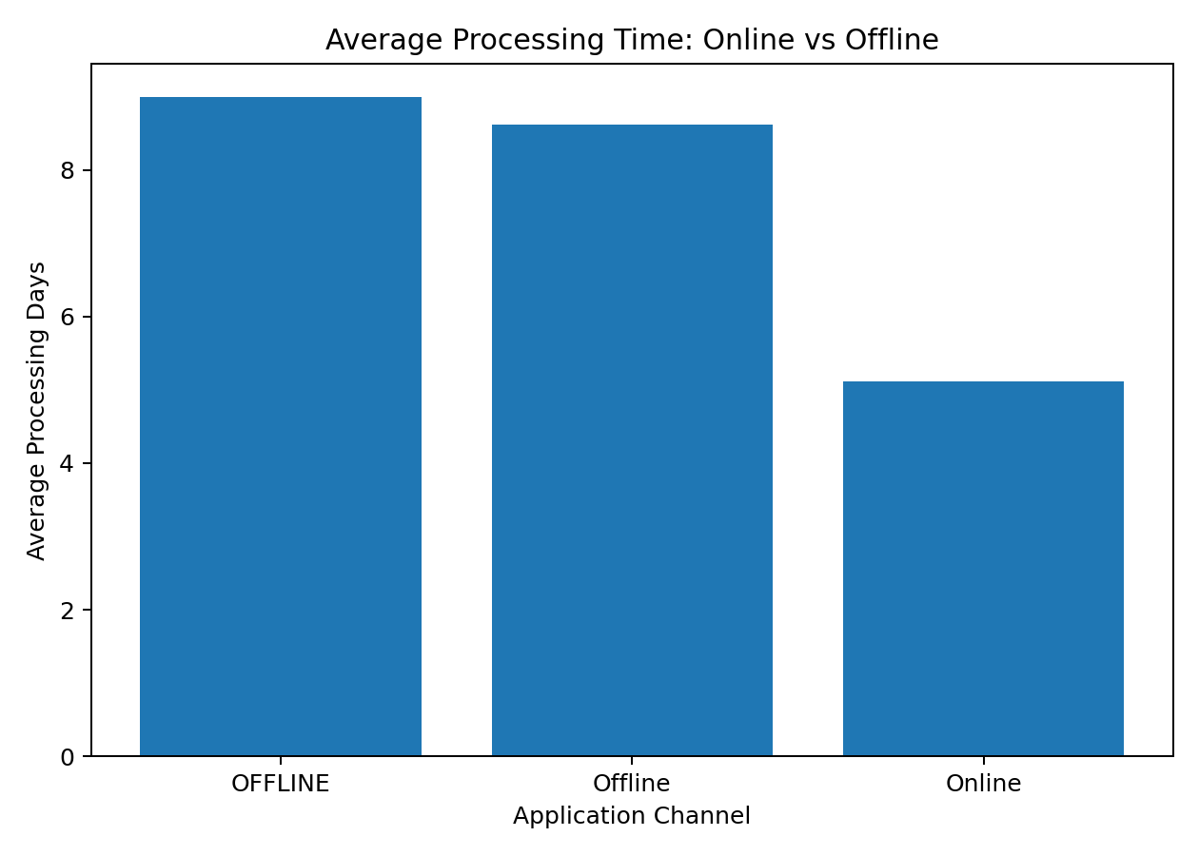
Figure 1. Average processing time by application channel (simulated data).

7.3 Service-Level Analysis
Across the six simulated services, Birth Certificate had the lowest average processing time (3.97 days), while Property Registration had the highest average (8.95 days). This comparison can help managers investigate whether slower services have more complex approval workflows, documentation requirements, or operational bottlenecks.
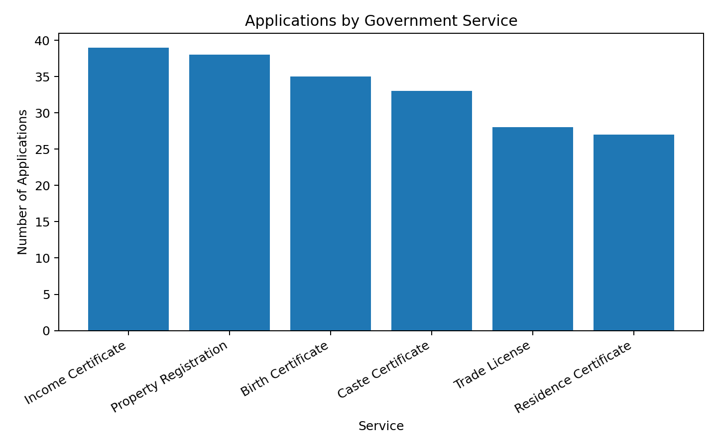
Figure 2. Number of simulated applications by service.

7.4 Regional Analysis
The South region had the lowest average processing time at 4.87 days, while the SOUTH region had the highest at 8.00 days. Regional differences can guide targeted investigation, but they should not be interpreted as evidence of poor performance without considering staffing, workload, infrastructure, and service mix.
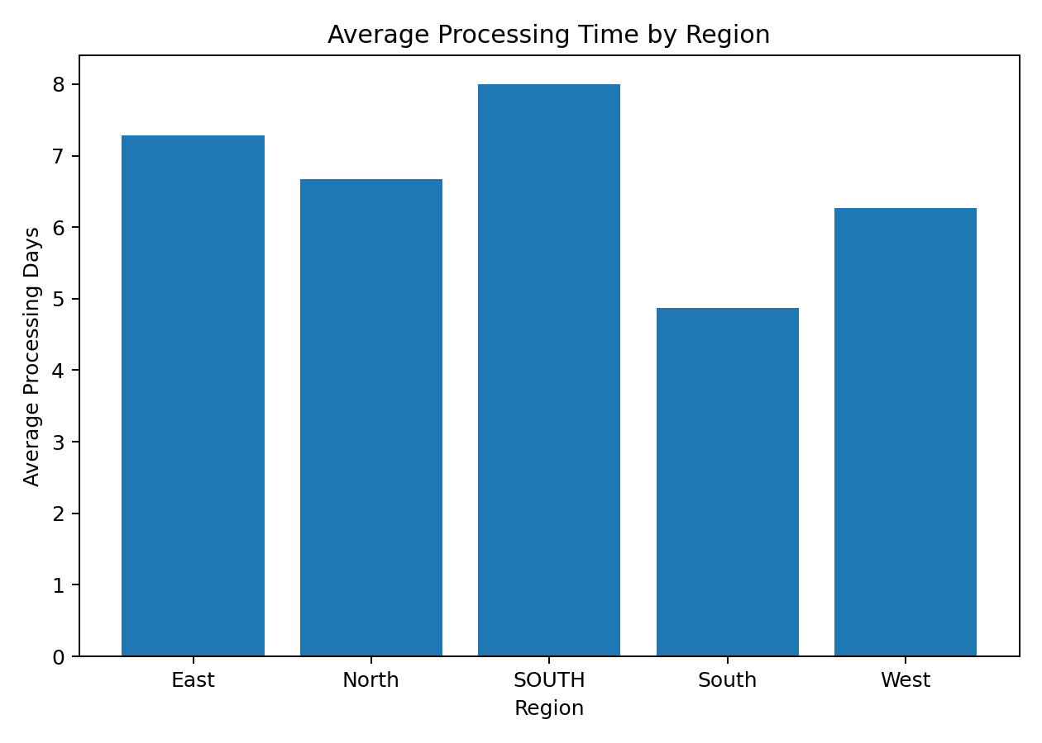
Figure 3. Average processing time by region.

7.5 Status and Citizen Satisfaction
Completed applications have the highest simulated satisfaction because the rating-generation process assigns higher expected ratings to completed cases. This relationship is illustrative rather than causal. In real e-governance analytics, citizen feedback should be collected through validated survey instruments and analysed alongside service outcomes.
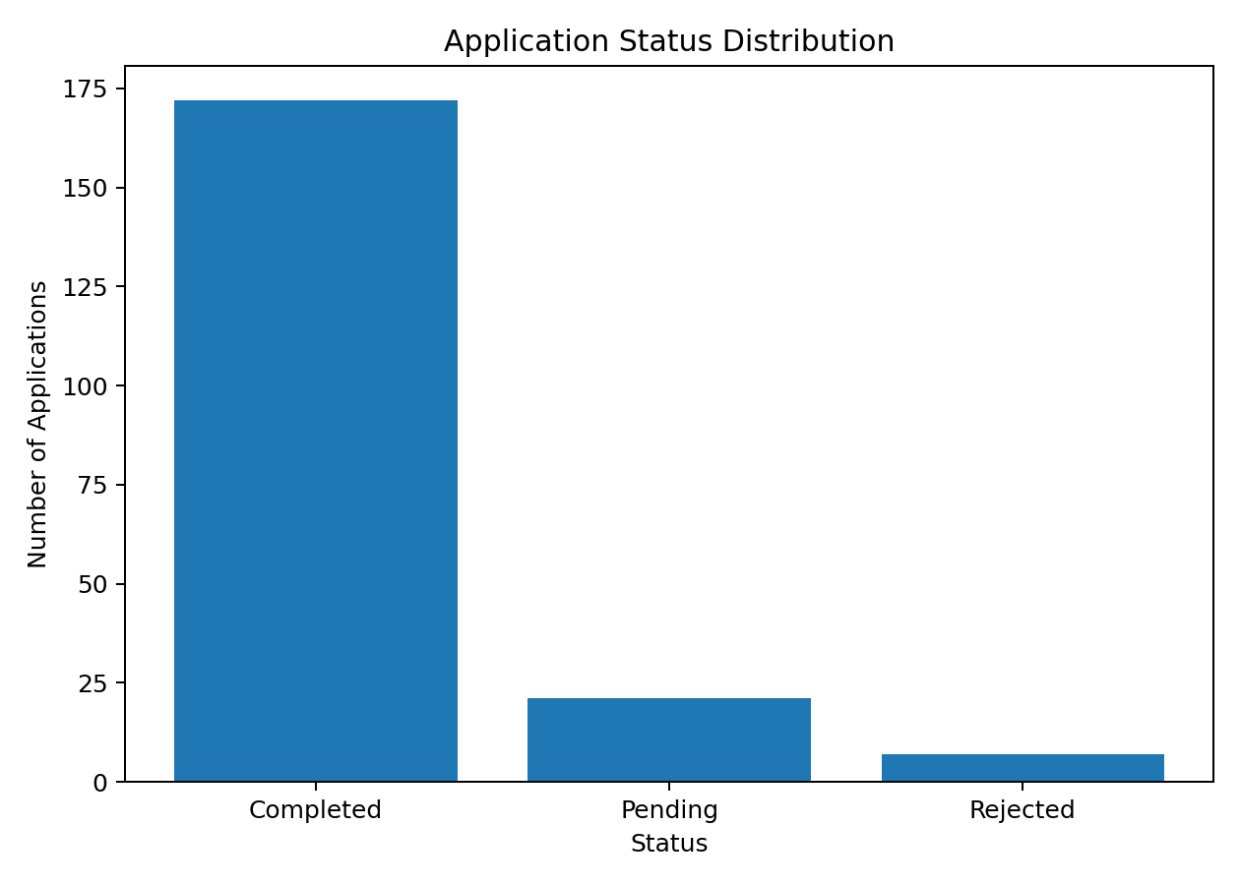
Figure 4. Application status distribution.
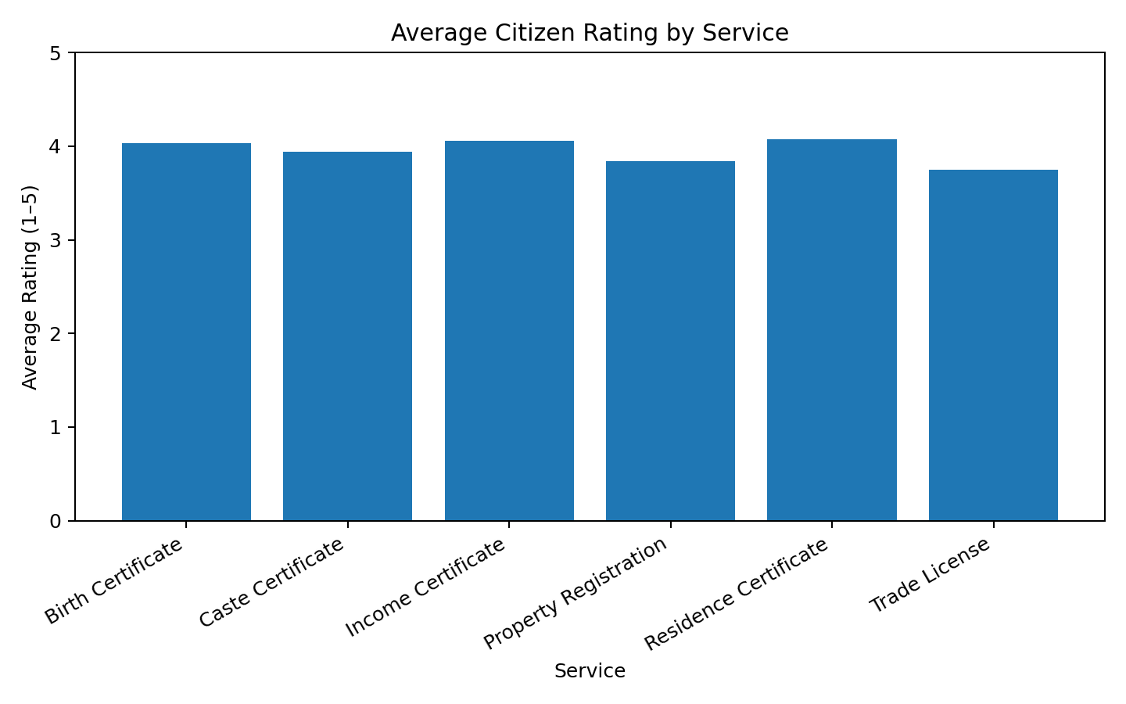
Figure 5. Average citizen rating by service.

8. E-Governance Case Studies

8.1 eTaal – Electronic Transaction Aggregation and Analysis Layer
eTaal is a Government of India platform that aggregates e-transaction statistics from national and state-level e-governance projects. Its portal provides tabular and graphical analysis of electronic transactions and supports comparison of service performance. The platform demonstrates how transaction data can be converted into operational indicators for monitoring and decision-making.
Analytical relevance: eTaal is directly aligned with this project's theme because it turns service transaction data into measurable indicators. Its approach illustrates the value of standardised data, aggregation, dashboards, and comparative analysis in public-sector management.

8.2 ServicePlus – National Informatics Centre
ServicePlus is a configurable e-service delivery framework developed by the National Informatics Centre. NIC describes its analytics capability as providing real-time dashboards and drill-down reports with configurable KPIs and visualisations. The framework has been used across multiple states and government departments for citizen service delivery.
Analytical relevance: the example shows that service delivery systems can be designed not only to process applications but also to generate performance data. Managers can use dashboards to monitor service volumes, status, processing, and other KPIs and then identify areas requiring attention.

8.3 SARITA – Maharashtra Stamp and Registration Department
C-DAC documents SARITA (Stamp And Registration with Information Technology Application) as an e-governance system developed for Maharashtra's Department of Stamps and Registration. The documented solution included registration, valuation, scanning/archiving, network and process monitoring modules. C-DAC reports that the system was deployed statewide and was designed to reduce processing time and improve transparency.
Analytical relevance: SARITA demonstrates how process digitisation and monitoring can create measurable improvements in service delivery. It also provides a useful Maharashtra-based example of how technology, process data, and operational monitoring can work together.

9. Key Findings
- The cleaned dataset contains 200 unique applications after duplicate removal and data-quality treatment.
- The overall completion rate is 86.00%, showing that completion rate is a useful service-level KPI.
- Online applications have a lower simulated average processing time than offline applications (5.11 vs 8.63 days).
- Data cleaning is essential because inconsistent categories, missing values, duplicates, and invalid values can distort analysis.
- Service-level and regional comparisons can identify areas for deeper operational investigation.
- Dashboards and KPIs can convert transaction data into information that managers can act upon.
- Real public-sector analytics must combine performance measurement with privacy, security, governance, and responsible interpretation.

10. Recommendations
- Introduce validation rules at the point of data entry to reduce invalid and inconsistent values.
- Maintain standard definitions and reference lists for services, regions, channels, and status categories.
- Track processing time, completion rate, pending backlog, rejection rate, and citizen satisfaction as core KPIs.
- Use dashboards with drill-down capability so managers can move from national or regional indicators to service-level detail.
- Investigate persistent regional or service-level delays before assigning causes; combine quantitative data with operational context.
- Use citizen feedback as a complementary indicator rather than relying on a single satisfaction metric.
- Apply data governance, privacy, security, access controls, and responsible data-sharing practices to protect public trust.

11. Limitations
The practical dataset is simulated and intentionally designed for learning. It does not represent actual government performance and contains no real citizen information. The statistical comparison demonstrates the method but should not be treated as a policy conclusion. Real analysis would require an appropriately sampled dataset, documented definitions, validated data-quality procedures, and domain knowledge.

12. Conclusion
Data literacy is a foundational capability for modern e-governance. When public-sector teams can understand data quality, select appropriate analytical techniques, interpret statistics, and communicate findings clearly, digital systems can move beyond simple transaction processing toward continuous service improvement. The practical analysis in this project demonstrates a basic but complete analytical workflow: define the question, inspect and clean data, calculate KPIs, compare groups, use an appropriate statistical test, visualise results, interpret cautiously, and translate findings into recommendations.
The reviewed e-governance examples further demonstrate that transaction aggregation, configurable service platforms, and process monitoring can support evidence-based management. Future work could extend this project using real open government datasets, time-series analysis, regression, predictive modelling, and interactive dashboards.

13. Bibliography / Public Sources
- OECD (2019). A Data-Driven Public Sector: Enabling the Strategic Use of Data for Productive, Inclusive and Trustworthy Governance. https://www.oecd.org/en/publications/a-data-driven-public-sector_09ab162c-en.html
- OECD (2019). The Path to Becoming a Data-Driven Public Sector. https://www.oecd.org/en/publications/the-path-to-becoming-a-data-driven-public-sector_059814a7-en.html
- OECD (2026). Digital Government Index and Open, Useful and Re-usable Data Index: 2025 Results and Key Findings. https://www.oecd.org/en/publications/digital-government-index-and-open-useful-and-re-usable-data-index_6347ec74-en.html
- National Informatics Centre. ServicePlus – A Versatile and Secure Solution for Service Delivery. https://www.nic.gov.in/serviceplus-a-versatile-and-secure-solution-for-service-delivery/
- National Informatics Centre / MeitY. eTaal – Electronic Transaction Aggregation & Analysis Layer. https://etaal.gov.in/
- C-DAC. eGovernance – SARITA Success Story. https://www.cdac.in/index.aspx?id=egov1

Appendix A – Project Files
The accompanying project package contains the simulated raw dataset, cleaned analytical dataset, Excel workbook, charts, and this report. The raw dataset intentionally contains controlled quality issues for demonstrating data cleaning.

