Exercise 10

Student Name: Yuta Nemoto Student ID: s1240234

Problem 1. (25 points) In your own directory create the following Acyclic-Graph Directory Structure:
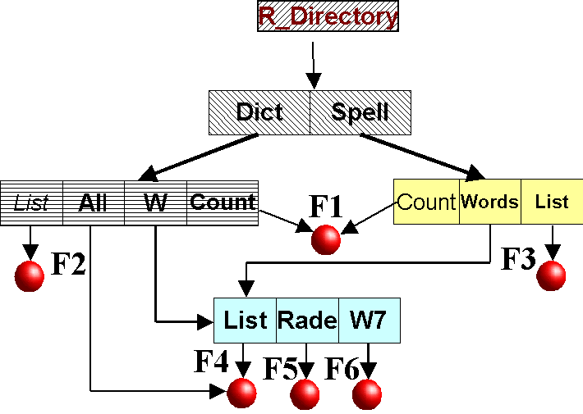
Show the sequence of UNIX-commands realizing this directory.

mkdir R_Directory

cd R_Directory
mkdir Dict Spell
mkdir Spell/Count Spell/Words Spell/List
mkdir Dict/List Dict/All Dict/W Dict/Count

cd Spell
touch Count/F1 List/F3
mkdir Words/List Words/Rade Words/W7
touch Words/List/F4 Words/Rade/F5 Words/W7/F6

cd ..
touch Dict/List/F2
ln -s Spell/Words/List/F4 Dict/All
ln -s Spell/Words/List Dict/W
ln -s Spell/Words/Rade Dict/W
ln -s Spell/Words/W7 Dict/W
ln -s Spell/Count/F1 Dict/Count

Problem 2. (10 points) Explain the purpose of the Open and Close operations.
- Open operation
Prepare a file to be referenced.

- Close operation
Prevent further reference to a file until it is reopened.

Problem 3. (40 points) Consider a system that supports 5000 users. Suppose you want to allow 4990 of these users to be able to access one file.
a) How would you specify this protection scheme in UNIX?
First, add these 10 users except 4990 users will able to access the file to the group. Then, I can allow access to the file only for users not added to the group: these 4990 users.

b) Could you suggest another protection scheme that can be used more effectively for this purpose than the scheme provided by UNIX?
As an another protection scheme, I can set the password to specific file. Then I can allow access only for these 4990 users by giving the password for them.

Problem 4. (25 points) Give an example of an application in which data in a file should be accessed in the following order:

a) Sequentially

Application access sequentially when it access whole content of the file.
For example, text editor such as Emacs access the data sequentially when it loads the program code. When it loads file content, whole part of the program code is loaded.

b) Randomly

Application access randomly when it access a specific part of the file.
For example, database program such as sqlite access the data in database randomly when there's a request with specific key. When the request comes, the database returns the data linked to the key.

