Exercise 5

Student's Name and ID: s1240234 Yuta Nemoto

Problem 1. (25 points) Answer the following questions.
Consider the traffic deadlock depicted in this Figure:

a. Show that the four necessary conditions for deadlock indeed hold in this example.

(1)Mutual exclusion
At least one resource: one of those intersections must be in a non-sharable mode (held by one particular lane).
(2)Hold and wait
There must exist a process: Lane holding at least one intersection and waiting to acquire additional intersection.
(3)No preemption
Intersections cannot be preempted: can be released only voluntary by the lane keeping it, after the lane complete passing this intersection.
(4)Circular wait
There must exist a set of waiting processes: lanes. In this case, there are 4 lanes waiting for acquire another intersection. Such as Lane0 waiting for release of intersection held by lane1, lane1 is waiting for release of intersection held by lane2... lane3 is waiting for release of intersection held by lane0.

b. State a simple rule that will avoid deadlocks in this system.
In this traffic deadlock state, we can avoid deadlock by installing some traffic lights in each intersection. After install the traffic lights, each intersection is not held continuously by particular process: lane. It means those intersections are released periodically, then the conditions for a deadlock to occur aren't satisfied and we can avoid the deadlock in this system.

Problem 2. (25 points). Consider a system consisting of five resources of the same type that are shared by four processes. Each of these processes needs at most two resources. Show that the system is deadlock-free. Draw the resource-allocation graph.
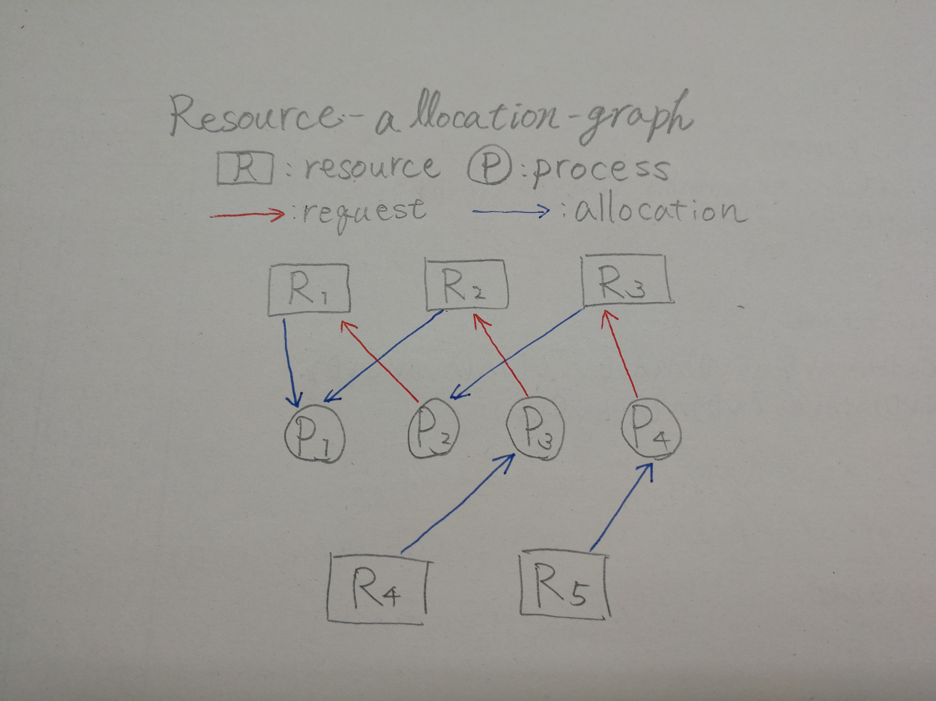
Now, there are 5 resources and 4 processes in this system, and each processes needs two resources to finish them. Consider Two resources are allocated to process P1. The other processes also allocated any other resources, and they request another one resource to complete their process like the graph. Then after the process P1 finished, one resource is released and allocated to the other process. Then the process can finish itself and additional resource is also released and the other process can finish itself... and so on. Then there are no deadlock cycle and it's deadlock-free.

Problem 3. (50 points) Consider the following snapshot of a system with resources A,B,C and D and processes P0 to P4
 | Allocated | Max | Available
 | A B C D | A B C D | A B C D
P0 | 0 0 1 2 | 0 0 1 2 | 1 5 2 0
P1 | 1 0 0 0 | 1 7 5 0
P2 | 1 3 5 4 | 2 3 5 6
P3 | 0 6 3 2 | 0 6 5 2
P4 | 0 0 1 4 | 0 6 5 6

Answer the following questions using the banker's algorithm:
a) What is the content of the matrix Need?
 | Need
 | A B C D
P0 | 0 0 0 0
P1 | 0 7 5 0
P2 | 1 0 0 2
P3 | 0 0 2 0
P4 | 0 6 4 2

b) Is the system in a safe state?
First, the safe state sequence of this system is P0, P2, P3, P4, P1. Then this system is in a safe state because there exists safe sequence of processes.

c) If a request from process P1 arrives for (0,4,2,0) can the request be granted immediately?

If the given request is granted, show the Need matrix below:
 | Allocated | Max | Available | Need
 | A B C D | A B C D | A B C D | A B C D
P0 | 0 0 1 2 | 0 0 1 2 | 1 5 2 0 | 0 0 0 0
P1 | 1 0 0 0 | 1 7 5 0 |  | 0 3 3 0
P2 | 1 3 5 4 | 2 3 5 6 |  | 1 0 0 2
P3 | 0 6 3 2 | 0 6 5 2 |  | 0 0 2 0
P4 | 0 0 1 4 | 0 6 5 6 |  | 0 6 4 2

First, the given request for P1 is exactly granted because the available resource (1, 5, 2, 0) is more bigger than the request (0, 4, 2, 0).
Then after the grant, the Need matrix is like above.

