**Exercise 10. Answer Sheet**

Student's Name: Yuta Nemoto Student's ID: s1240234

***Problem 1.***  (40 points) Consider a 4-queens problem: On a 4x4 chess board put 4 queens in such way that they don't attack each other.

a) (20 points) How many solutions are there? There are **2** solutions.

b) (20 points) Draw your solutions using 4x4 table and put Q at the queen positions.

|  |  |  |  |
| --- | --- | --- | --- |
|  | Q |  |  |
|  |  |  | Q |
| Q |  |  |  |
|  |  | Q |  |

|  |  |  |  |
| --- | --- | --- | --- |
|  |  | Q |  |
| Q |  |  |  |
|  |  |  | Q |
|  | Q |  |  |

***Problem 2.*** (60 points) Write a program implementing the 8-queens problem. Upload your code. Using your program answer the following questions?

a) (30 points) How many solutions are there? There are **92** solutions.

b) (30 points) Draw one of the solutions in the table below.

|  |  |  |  |  |  |  |  |
| --- | --- | --- | --- | --- | --- | --- | --- |
|  |  |  |  |  |  |  | Q |
|  |  |  | Q |  |  |  |  |
| Q |  |  |  |  |  |  |  |
|  |  | Q |  |  |  |  |  |
|  |  |  |  |  | Q |  |  |
|  | Q |  |  |  |  |  |  |
|  |  |  |  |  |  | Q |  |
|  |  |  |  | Q |  |  |  |

<How to compile/run>

Commands:

**javac EightQueensProblem.java**

**java EightQueensProblem**

By executing the program like above, you can see all the solutions.

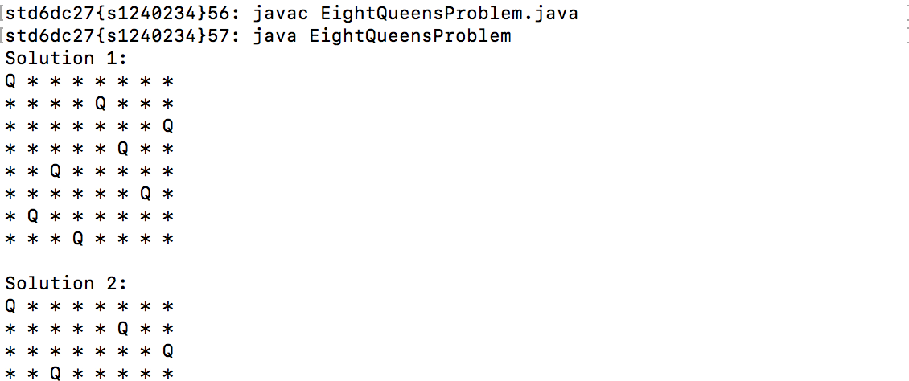

**…(omitted)**

