**Exercise 12. Answer Sheet**

Student's Name: Yuta Nemoto Student's ID: s1240234

***Problem 1.***  (40 points) Implement the randomized algorithm for calculating π given in the lecture.

- Calculate π using your program 10 times using N number of points from the next table. Fill in the results you got.

|  |  |  |  |  |  |  |  |  |  |  |
| --- | --- | --- | --- | --- | --- | --- | --- | --- | --- | --- |
| N | 1 | 2 | 3 | 4 | 5 | 6 | 7 | 8 | 9 | 10 |
| 1 | 4.0 | 4.0 | 0.0 | 0.0 | 4.0 | 4.0 | 4.0 | 4.0 | 4.0 | 4.0 |
| 10 | 2.8 | 3.2 | 3.6 | 2.8 | 2.8 | 3.2 | 3.6 | 3.2 | 4.0 | 3.2 |
| 100 | 2.92 | 3.24 | 3.24 | 3.12 | 2.92 | 3.12 | 3.08 | 3.08 | 3.04 | 3.28 |
| 1000 | 3.064 | 3.076 | 3.144 | 3.056 | 3.108 | 3.088 | 3.112 | 3.048 | 3.036 | 3.092 |
| 10000 | 3.128 | 3.1532 | 3.1468 | 3.158 | 3.1508 | 3.146 | 3.1252 | 3.1664 | 3.1244 | 3.116 |
| 100000 | 3.1382 | 3.14296 | 3.14416 | 3.14768 | 3.14108 | 3.14404 | 3.14212 | 3.14288 | 3.1364 | 3.14988 |

- Upload your code.

<How to compile/run>

Command:

javac RandomizedAlgorithms.java

java RandomizedAlgorithms

Then it automatically output the list above like the screenshot below.

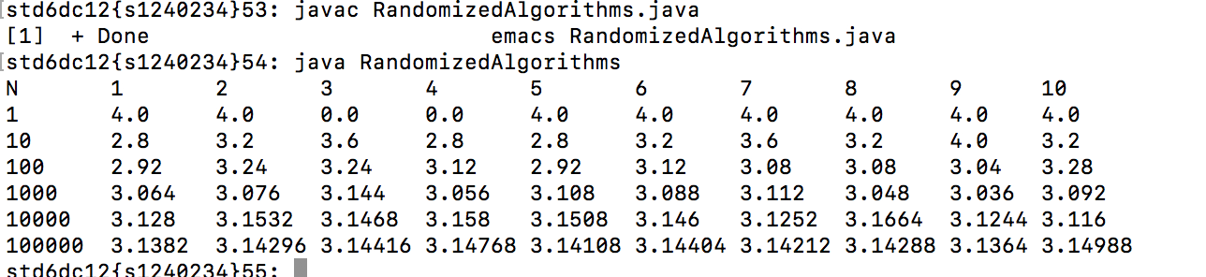

***Problem 2.*** (60 points)Write a program implementing the quicksort algorithm. Make two versions:

a) Randomized quicksort, where the pivot element is chosen at random.

b) Deterministic quicksort, where the pivot element is always the first element of the array.

- Generate random sequence of length N (as given in the Table)

- Measure the time each quicksort version needs to sort the sequences (fill in the average of 100 runs).

|  |  |  |  |  |  |
| --- | --- | --- | --- | --- | --- |
| N | 100 | 1000 | 10000 | 100000 | 1000000 |
| Randomized | 3[ms] | 9[ms] | 41[ms] | 344[ms] | 3217[ms] |
| Deterministic | 2[ms] | 7[ms] | 39[ms] | 333[ms] | 3101[ms] |

- Upload your code.

<How to compile/run>

Command:

javac QuickSortAlgorithms.java

java QuickSortAlgorithms

Then it automatically output the list above like the screenshot below.

(You can change the value of N by changing a constant value in the head of program.)

