**Exercise 3. Answer Sheet**

Student's Name: Yuta Nemoto Student's ID: s1240234

***Problem 1.*** *(25 points)* Consider the following adjacency matrix:

0 1 1 1 0 0

1 0 1 0 0 0

0 0 0 0 1 0

0 1 1 0 1 0

0 1 0 0 0 0

0 0 0 1 1 0

a) Draw a directed graph which corresponds to this adjacency matrix.

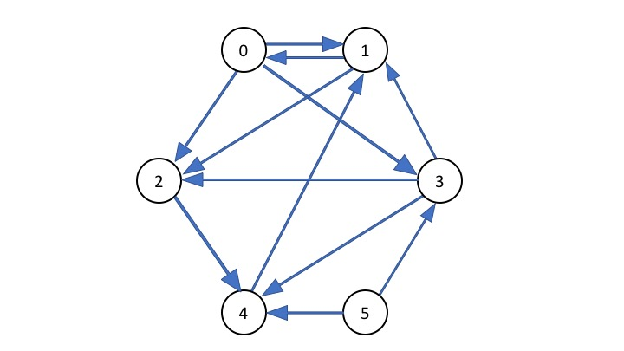

b) Write the adjacency list of the graph from a).

0 → 1, 2, 3

1 → 0, 2

2 → 4

3 → 1, 2, 4

4 → 1

5 → 3, 4

***Problem 2.*** *(25 points)*Consider the following graph:

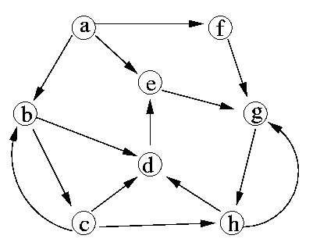

a) Starting from vertex a, in what order the Breath First Search algorithm will traverse the vertices

of this graph?

First,

the nodes at distance 1 from a are **b**, **e**, **f**

the nodes at distance 2 from a are **c**, **d**, **g**

the node at distance 3 from a is **h**.

In Breadth-First Search algorithm, it visits other vertices at increasing distances away from a,

so the order is

**b, e, f → c, d, g → h**

b) Starting from vertex a, in what order the Depth First Search algorithm will traverse the vertices of this graph?

First, the tree generated by the graph is presented below.

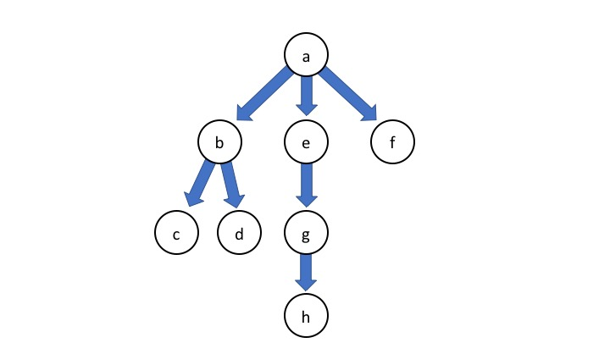

In Depth-First Search algorithm, it explores a path all the way to a leaf before backtracking and exploring another path, so the order is

**a, b, c, d, e, g, h, f**

***Problem 3.*** *(50 points)*Based on the pseudo-code for Depth First Search algorithm given at the lecture, write a program implementing it. Given the following graph, starting from node 1, calculate the discovery and finishing time of each node and fill the table starting from node 1. (Don't forget to upload your program!)

6

5

4

3

2

1

|  |  |  |  |  |  |  |
| --- | --- | --- | --- | --- | --- | --- |
| Node | 1 | 2 | 3 | 4 | 5 | 6 |
| Discovery time | 1 | 2 | 9 | 4 | 3 | 10 |
| Finishing time | 8 | 7 | 12 | 5 | 6 | 11 |

**<Actual Interface>**

bash-3.2$ javac DirectedEdge.java

bash-3.2$ javac Node.java

bash-3.2$ javac Graph.java

bash-3.2$ java Graph

Please enter the number of nodes in the graph:

6

Please enter the adjacency list of this graph

(Elements must be INTEGER, and must be separated by space. Input any alphabet to finish input.):

1 -> 2 4 end

2 -> 5 end

3 -> 5 6 end

4 -> 2 end

5 -> 4 end

6 -> end

Node            1       2       3       4       5       6

Discovery time  1       2       9       4       3       10

Finishing time  8       7       12      5       6       11

bash-3.2$ java Graph

Please enter the number of nodes in the graph:

17

Please enter the adjacency list of this graph

(Elements must be INTEGER, and must be separated by space. Input any alphabet to finish input.):

1 -> 2 3 end

2 -> 4 5 end

3 -> 6 7 end

4 -> end

5 -> 8 9 end

6 -> end

7 -> 10 11 end

8 -> 12 13 14 end

9 -> 15 16 end

10 -> end

11 -> 17 end

12 -> end

13 -> end

14 -> end

15 -> end

16 -> end

17 -> end

Node            1       2       3       4       5       6       7       8       9       10      11      12      13      14      15      16      17

Discovery time  1       2       22      3       5       23      25      6       14      26      28      7       9       11      15      17      29

Finishing time  34      21      33      4       20      24      32      13      19      27      31      8       10      12      16      18      30

**<Output result>**

Node            1       2       3       4       5       6

Discovery time  1       2       9       4       3       10

Finishing time  8       7       12      5       6       11

**<How to compile/run>**

Command: **javac DirectedEdge.java**

**javac Node.java**

**javac Graph.java**

**java Graph**

Input: First, you need to input the number of nodes in the graph.

After that, the numbered nodes are generated automatically and you need to input the adjacency list of the graph.

When you input the data of adjacency list, please enter the numbers separated by space. And after you finished this operation, please input any alphabet character(In the example above, it’s the string “end”) to end the input operation.

**<Source Code>**

Graph.java

import java.util.ArrayList;

import java.util.Scanner;

import java.util.regex.Matcher;

import java.util.regex.Pattern;

public class Graph {

// ArrayList of the Node in this Graph

private ArrayList<Node> nodes = new ArrayList<Node>();

// Time Parameter for Searching

private int time;

/* Constructor */

public Graph() { }

/* Add the element of this Graph */

public void addNode(int number) {

this.nodes.add(new Node(number));

}

/* DFS Method (This time, this method explore the graph from the node '1' by default) */

public void DFS(Graph g){

// Initialization (The color of each vertex(Node) is WHITE as default)

this.time = 0;

// Visit each node

for(int i = 0; i < this.nodes.size(); i++)

if(this.nodes.get(i).getColor() == Node.WHITE)

this.DFS_VISIT(g, nodes.get(i));

}

/* DFS-VISIT Method */

public void DFS_VISIT(Graph g, Node u) {

// Update the time variable

time++;

// Put the discovery time to the Node

u.setDiscoveredTime(time);

// Discover the Node u and set the color of this to GRAY

u.setColor(Node.GRAY);

// If the next Node of u is still not discovered, visit the node.

for(int i = 0; i < u.getDegree(); i++)

if(u.getDest(i).getColor() == Node.WHITE)

this.DFS_VISIT(g, u.getDest(i));

// Finish the exploration of the Node u

u.setColor(Node.BLACK);

// Update the time variable

time++;

// Put the finished time to the Node

u.setFinishedTime(time);

}

/* Require the adjacency list from the standard input and setup the Graph. */

public void setup() {

// Prepare Scanner for input

Scanner scan = new Scanner(System.in);

// Output the message

System.out.println("Please enter the number of nodes in the graph:");

// Get the number of nodes in the Graph

int nodeNum = scan.nextInt();

// Generate the Node in this Graph

for(int i = 1; i <= nodeNum; i++) this.addNode(i);

// Output the message

System.out.println("Please enter the adjacency list of this graph \n(Elements must be INTEGER, and must be separated by space. Input any alphabet to finish input.):");

// Loop for the input

for(int i = 0; i < nodeNum; i++) {

System.out.print((i + 1) + " -> ");

int[] input = new int[nodeNum];

int j;

for(j = 0; j < nodeNum; j++) {

// Read the inputed elements

String temp = scan.next();

// Set the acceptable pattern by the regular expression. Minus value is also acceptable.

Pattern p = Pattern.compile("^-?[0-9]*$");

// Check whether it matches to the pattern p or not.

Matcher m = p.matcher(temp);

// If the input is integer value, add it to the array. Else, end the loop.

if(m.find()) {

// If the inputed node doesn't exist, output an error.

int tempInt = Integer.valueOf(temp);

if(tempInt < 1 || tempInt > nodeNum) {

System.err.println("Node " + tempInt + " doesn't exist!");

break;

}

// if it's exist, put it in the array of input.

input[j] = tempInt;

}

else break;

}

// Create the directed edge to the Nodes in this Graph by following the inputed data

for(int k = 0; k < j; k++) {

this.nodes.get(i).addConnectionTo(this.nodes.get(input[k] - 1));

}

// for(; j >= 0; j--) this.nodes.get(i).addConnectionTo(this.nodes.get(input[j] - 1));

}

}

/* Output the result */

public void outResult() {

System.out.print("Node\t\t");

for(int i = 0; i < this.nodes.size(); i++) System.out.print(this.nodes.get(i).getNumber() + "\t");

System.out.println();

System.out.print("Discovery time\t");

for(int i = 0; i < this.nodes.size(); i++) System.out.print(this.nodes.get(i).getDiscoveredTime() + "\t");

System.out.println();

System.out.print("Finishing time\t");

for(int i = 0; i < this.nodes.size(); i++) System.out.print(this.nodes.get(i).getFinishedTime() + "\t");

System.out.println();

}

/* Main Method */

public static void main(String[] args) {

// Declare the Graph object

Graph graph = new Graph();

// Require input

graph.setup();

// Execute the Depth-First Searching

graph.DFS(graph);

// Output the result

graph.outResult();

}

}

Node.java

import java.util.ArrayList;

public class Node {

// Defined variable for searching in the graph(Judge this node is already searched or not by using this code)

public static final int WHITE = 0; // WHITE means it's unvisited Node while this search

public static final int GRAY = 1;  // GRAY means it's discovered Node while this search

public static final int BLACK = 2; // BLACK means it's finished Node while this search

// The number of this node

private int number;

// Direction pointer to other Node

private ArrayList<DirectedEdge> directionPointer = new ArrayList<DirectedEdge>();

// Variable for searching in the graph(It has the value WHITE, GRAY, or BLACK of this static integer

private int color;

// Variable of Time Stamp(Initialized by -1)

private int discoveredTime = -1;

private int finishedTime = -1;

/* Constructor */

public Node(int number) {

this.number = number;

};

/* Add a new connection to the other Node */

public void addConnectionTo(Node toPoint) {

this.directionPointer.add(new DirectedEdge(this, toPoint));

}

/* Set the color of this node */

public void setColor(int color) {

switch(color) {

case Node.WHITE:

this.color = Node.WHITE;

break;

case Node.GRAY:

this.color = Node.GRAY;

break;

case Node.BLACK:

this.color = Node.BLACK;

break;

default:

System.err.println("Wrong argument is given to Node(" + this.number + ").changeColor(). Please give the integer WHITE, GRAY, or BLACK.");

this.color = Node.WHITE;

break;

}

}

/* Get the number of this node */

public int getNumber() {

return this.number;

}

/* Get the color of this node */

public int getColor() {

return this.color;

}

/* Get the degree of this node */

public int getDegree() {

return this.directionPointer.size();

}

/* Get the destination of the direction edge of this node by the index */

public Node getDest(int index) {

return this.directionPointer.get(index).getDestination();

}

/* Set the discovered time in this search */

public void setDiscoveredTime(int time) {

this.discoveredTime = time;

}

/* Get the discovered time in this search */

public int getDiscoveredTime() {

return this.discoveredTime;

}

/* Set the finished time in this search */

public void setFinishedTime(int time) {

this.finishedTime = time;

}

/* Get the finished time in this search */

public int getFinishedTime() {

return this.finishedTime;

}

}

DirectedEdge.java

public class DirectedEdge {

// The Origin of this Edge

private Node origin;

// The Destination of this Edge

private Node destination;

/* Constructor */

public DirectedEdge(Node from, Node to) {

this.origin = from;

this.destination = to;

}

/* Return the origin of this Edge */

public Node getOrigin() {

return this.origin;

}

/* Return the destination of this Edge */

public Node getDestination() {

return this.destination;

}

}