**Exercise 7. Answer Sheet**

Student's Name: Yuta Nemoto Student's ID: s1240234

***Problem 1.***  (20 point) Consider following sequence of letters:

ABBCACCEACBCCFABCDAFEABFFADBBC

1. (10 points) Construct Huffman encoding tree for the above sequence and show it below

First,

S = {A, B, C, D, E, F}

w(A) = 7, w(B) = 7, w(C) = 8, w(D) = 2, w(E) = 2, w(F) = 4.

Then the shape of tree is constructed like below.

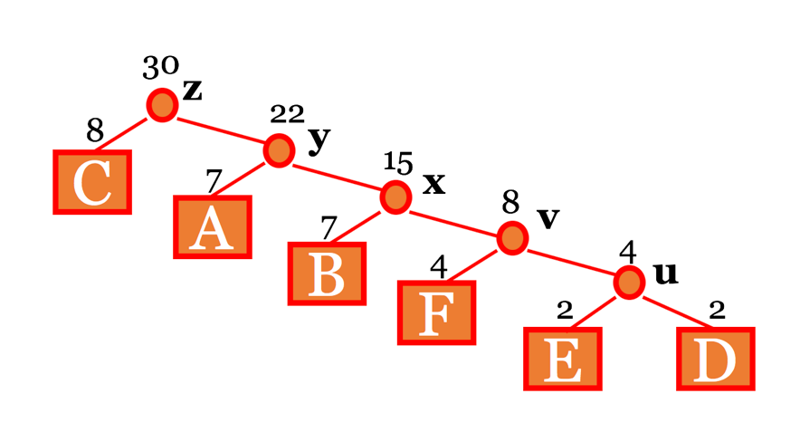

And the **Huffman encoding tree** is presented in the figure below.

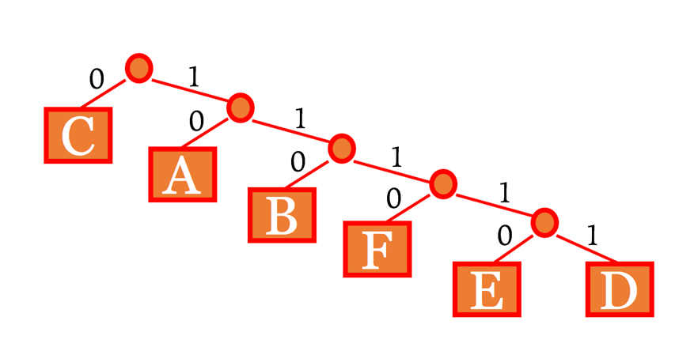

b) (10 points) What is the code for each letter:

A: 10

B: 110

C: 0

D: 11111

E: 11110

F: 1110

***Problem 2.*** (25 points) What is the Huffman code for the following set of frequencies, based on the first 8 Fibonacchi numbers?

A: 1, B: 1, C: 2, D: 3, E: 5, F: 8, G: 13, H: 21

A: 1111110

B: 1111111

C: 111110

D: 11110

E: 1110

F: 110

G: 10

H: 0

-----

First,

S = {A, B, C, D, E, F, G, H}

w(A) = 1, w(B) = 1, w(C) = 2, w(D) = 3, w(E) = 5, w(F) = 13, w(H) = 21

Huffman encoding tree is constructed like the figure below.

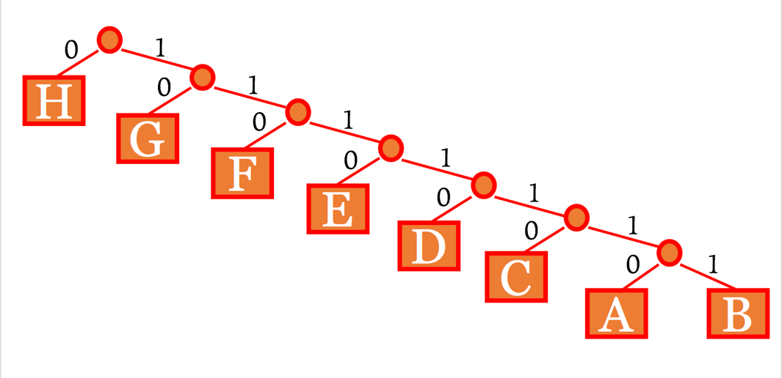

***Problem 3.*** (15 points)Write your name in English letters and construct Huffman tree and code for it. Show your tree and code below.

My name in English letters is “YUTA NEMOTO”

S = {‘A’, ‘E’, ‘M’, ‘N’, ‘O’, ‘T’, ‘U’, ‘Y’,’1‘} ‘1‘ represents the character of space.

w(‘A’) = 1, w(‘E’) = 1, w(‘M’) = 1, w(‘N’) = 1, w(‘O’) = 2,

w(‘T’) = 2, w(‘U’) = 1, w(‘Y’) = 1, w(‘ ‘) = 1.

Huffman encoding tree is constructed like the figure below.

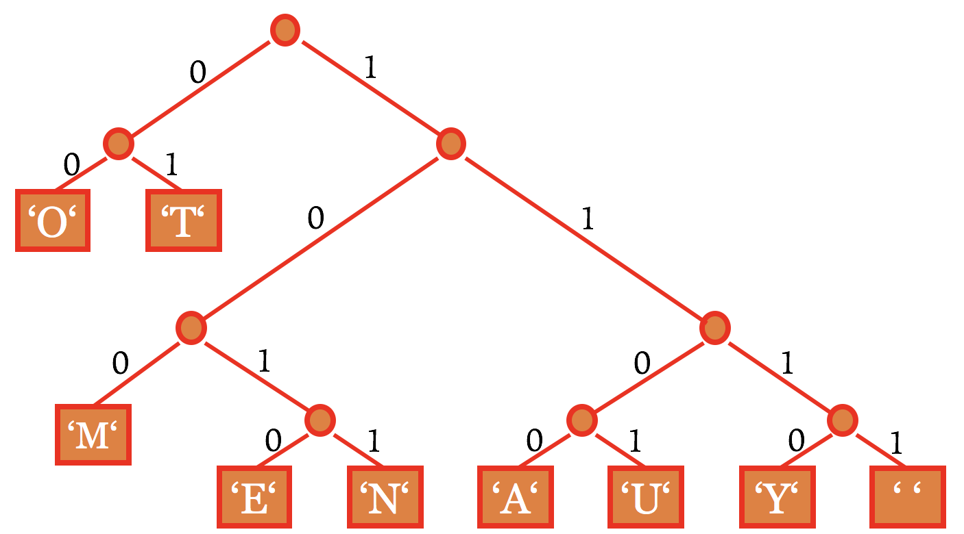

So, the Huffman code for each letter is presented like below.

**‘A’: 1100**

**‘E’: 1010**

**‘M’: 100**

**‘N’: 1011**

**‘O’: 00**

**‘T’: 01**

**‘U’: 1101**

**‘Y’: 1110**

**’1‘: 1111**

Finally, whole of the constructed Huffman code for my name is

**11101101011100111110111010100000100**

***Problem 4.*** (40 points)Make a program implementing Huffman encoding. Upload your code with usage example.

Usage Example:

First, compile the java program by using command:

**javac Huffman.java**

And execute it by using command:

**java Huffman**

Then it asks you to enter the text for encoding so please enter the text.

It automatically outputs the calculation results of probabilities of each letter, the assigned codes for each letter, and the result of encoding, decoding like the screenshot below.

