Exercise 10. Answer Sheet

Student's Name: Yuta Nemoto Student's ID: s1240234

Problem 1. (40 points) Consider a 4-queens problem: On a 4x4 chess board put 4 queens in such way that they don't attack each other.

a) (20 points) How many solutions are there? There are 2 solutions.

b) (20 points) Draw your solutions using 4x4 table and put Q at the queen positions.

Q
Q
Q
Q

Q
Q
Q
Q

Problem 2. (60 points) Write a program implementing the 8-queens problem. Upload your code. Using your program answer the following questions?

a) (30 points) How many solutions are there? There are 92 solutions.

b) (30 points) Draw one of the solutions in the table below.

Q
Q
Q
Q
Q
Q
Q
Q

<How to compile/run>
Commands:
javac EightQueensProblem.java
java EightQueensProblem
By executing the program like above, you can see all the solutions.
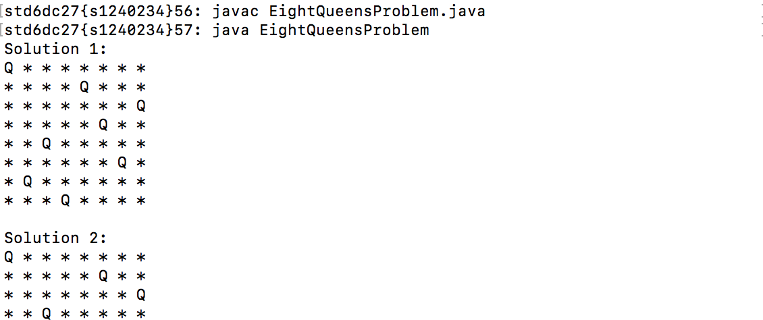

…(omitted)

