Exercise 12. Answer Sheet

Student's Name: Yuta Nemoto Student's ID: s1240234

Problem 1. (40 points) Implement the randomized algorithm for calculating π given in the lecture.
- Calculate π using your program 10 times using N number of points from the next table. Fill in the results you got.

N | 1 | 2 | 3 | 4 | 5 | 6 | 7 | 8 | 9 | 10
1 | 4.0 | 4.0 | 0.0 | 0.0 | 4.0 | 4.0 | 4.0 | 4.0 | 4.0 | 4.0
10 | 2.8 | 3.2 | 3.6 | 2.8 | 2.8 | 3.2 | 3.6 | 3.2 | 4.0 | 3.2
100 | 2.92 | 3.24 | 3.24 | 3.12 | 2.92 | 3.12 | 3.08 | 3.08 | 3.04 | 3.28
1000 | 3.064 | 3.076 | 3.144 | 3.056 | 3.108 | 3.088 | 3.112 | 3.048 | 3.036 | 3.092
10000 | 3.128 | 3.1532 | 3.1468 | 3.158 | 3.1508 | 3.146 | 3.1252 | 3.1664 | 3.1244 | 3.116
100000 | 3.1382 | 3.14296 | 3.14416 | 3.14768 | 3.14108 | 3.14404 | 3.14212 | 3.14288 | 3.1364 | 3.14988

- Upload your code.

<How to compile/run>
Command:
javac RandomizedAlgorithms.java
java RandomizedAlgorithms
Then it automatically output the list above like the screenshot below.
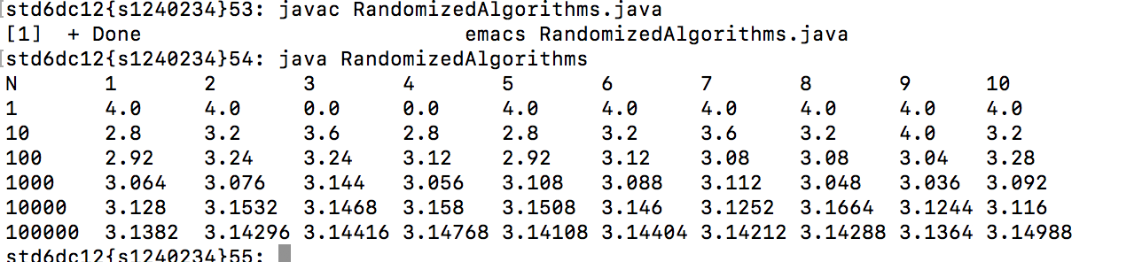

Problem 2. (60 points) Write a program implementing the quicksort algorithm. Make two versions:
a) Randomized quicksort, where the pivot element is chosen at random.
b) Deterministic quicksort, where the pivot element is always the first element of the array.

- Generate random sequence of length N (as given in the Table)
- Measure the time each quicksort version needs to sort the sequences (fill in the average of 100 runs).

N | 100 | 1000 | 10000 | 100000 | 1000000
Randomized | 3[ms] | 9[ms] | 41[ms] | 344[ms] | 3217[ms]
Deterministic | 2[ms] | 7[ms] | 39[ms] | 333[ms] | 3101[ms]

- Upload your code.

<How to compile/run>
Command:
javac QuickSortAlgorithms.java
java QuickSortAlgorithms
Then it automatically output the list above like the screenshot below.
(You can change the value of N by changing a constant value in the head of program.)
