Exercise 8. Answer Sheet

Student's Name: Yuta Nemoto Student's ID: s1240234

Problem 1. Write pseudo-code for the Strassen's algorithm.

STRASSEN(A, B)
// Input: A, B – n x n matrix
// Output: C – n x n matrix
n = |A.rows|
C = new (n×n) matrix
if n == 1
C11 = A11 * B11
else
/* Calculate the sum matrices */
S1 = B12 – B22
S2 = A11 + A12
S3 = A21 + A22
S4 = B21 – B11
S5 = A11 + A22
S6 = B11 + B22
S7 = A12 – A22
S8 = B21 + B22
S9 = A11 – A21
S10 = B11 + B12
/* Calculate the product matrices */
P1 = STRASSEN(A11, S1)
P2 = STRASSEN(S2, B22)
P3 = STRASSEN(S3, B11)
P4 = STRASSEN(A22, S4)
P5 = STRASSEN(S5, S6)
P6 = STRASSEN(S7, S8)
P7 = STRASSEN(S9, S10)
/* Calculate the final product sub matrices */
C11 = P5 + P4 – P2 + P6
C12 = P1 + P2
C21 = P3 + P4
C22 = P1 + P5 – P3 – P7
return C

Problem 2. Use Strassen's algorithm to compute the matrix product:

Show your work below:

Let A = , B = .

To calculate the sum matrices,
S1 = B12 – B22 = 8 – 2 = 6
S2 = A11 + A12 = 1 + 3 = 4
S3 = A21 + A22 = 7 + 5 = 12
S4 = B21 – B11 = 4 – 6 = -2
S5 = A11 + A22 = 1 + 5 = 6
S6 = B11 + B22 = 6 + 2 = 8
S7 = A12 – A22 = 3 – 5 = -2
S8 = B21 + B22 = 4 + 2 = 6
S9 = A11 – A21 = 1 – 7 = -6
S10 = B11 + B12 = 6 + 8 = 14

To calculate product matrices,
P1 = A11S1 = 1 * 6 = 6
P2 = S2B22 = 4 * 2 = 8
P3 = S3B11 = 12 * 6 = 72
P4 = A22S4 = 5 * (-2) = -10
P5 = S5S6 = 6 * 8 = 48
P6 = S7S8 = (-2) * 6 = -12
P7 = S9S10 = (-6) * 14 = -84

To calculate the final product sub matrices,
C11 = P5 + P4 – P2 + P6 = 48 – 10 – 8 – 12 = 18
C12 = P1 + P2 = 6 + 8 = 14
C21 = P3 + P4 = 72 – 10 = 62
C22 = P1 + P5 – P3 – P7 = 6 + 48 – 72 + 84 = 66

Then, the result of C = A * B is

C =

Problem 3. Make two programs implementing the Recursive matrix multiplication and the Strassen's algorithm. Upload your code. Generate two random matrices A and B of size n×n, multiply them using your programs and measure the time needed to get the result. Fill the following table:

Time needed to multiply two n×n matrices. (May depend on the programming language, computer, etc.)

Algorithm | n
Algorithm | 32 | 64 | 128 | 256 | 512 | 1024
Recursive (sec) | 0.021 | 0.130 | 0.820 | 5.678 | 46.595 | 407.868
Strassen (sec) | 0.033 | 0.182 | 1.086 | 7.022 | 50.042 | 340.350

How to compile/run:
- For the Recursive matrix multiplication code, execute the following:
javac RecursiveMatrixMultiplication.java
java RecursiveMatrixMultiplication [n]

Actual interface is like the screenshot below.
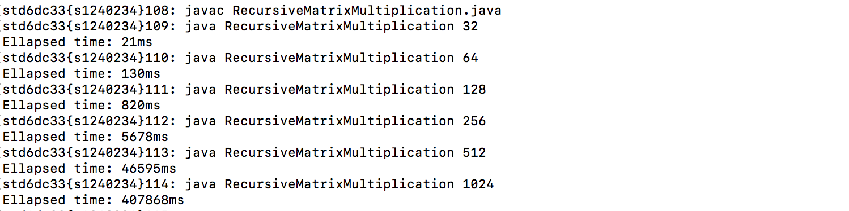

- For the Strassen’s algorithm code, execute the following:
javac StrassenAlgorithm.java
java StrassenAlgorithm [n]

Actual interface is like the screenshot below.
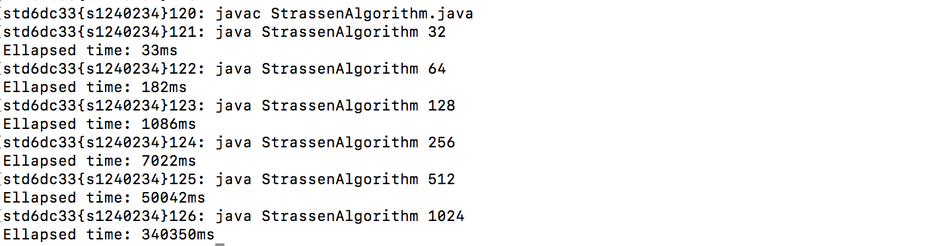

- If you want to check the actual result of the matrix calculation, you can check it by adding “-CHECK” to the second argument like below.
