**L11-Introduction to Computer Networking**

**Homework 4**

**Due Date: Jan.5, 2017 by 23:59PM on Google Drive**

Name: Yuta Nemoto

Students ID: s1240234

**Problem1 (20pts):**

**LANケーボルの構造を整理して、以下の問題を答えてください。**

**UTPケーボルが構成されている線の本数とそれぞれの色を記入してください。(10pts)**

線の本数：8本　（4ペア）

色：

　赤のペア：　赤　と　赤白

　青のペア：　青　と　青白

　緑のペア：　緑　と　緑白

　黒のペア：　黒　と　黒白

**ツイストペアケーブルを利用して、ノイズを抑える原理を図利用して、解釈してください。(10pts)**

**1. 導線が外部へのノイズ影響**

**より対線を流れる信号電流で発生する磁束は、隣同士で反転しているので互**

**いに打ち消し合うため、伝送する信号により外部にノイズを出しにくい。**

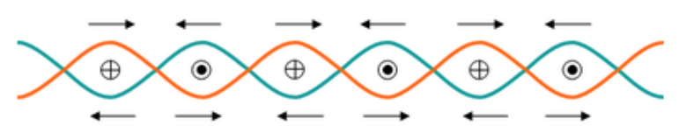

**2. 外部環境から、導線へのノイズ影響**

**より対線を貫通する磁束により発生する電流の向きは隣同士で反転している**

**ため互いに打ち消し合うので、伝送する信号は外部からの影響を受けにくい。**

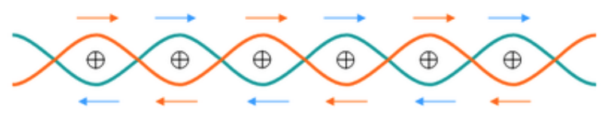

**Problem 1 (20 pts): Judge whether following sentences as “true” or “false”. Circle the correct answer. (5 pts for each correct answer)**

1. (T/ Ⓕ) Error detection code usually requires larger number of redundancy bits than error correction code does

2. (T/ Ⓕ) CRC can correct all burst error with length less than (r+1) bits, where r is the number of CRC bits

3. (Ⓣ/ F) In random access network, collision happens when two or more nodes transmit data simultaneously.

4. (T/ Ⓕ) A device that operates at the physical layer and is used to regenerate signal is called a switch.

**Problem 3 (20 pts): Consider the 4-bit generator, G = 1011, and D = 11010010**

**a. (10 pts) What is the value of redundancy R =? (show your work on the answer sheet)**

**R = 000**

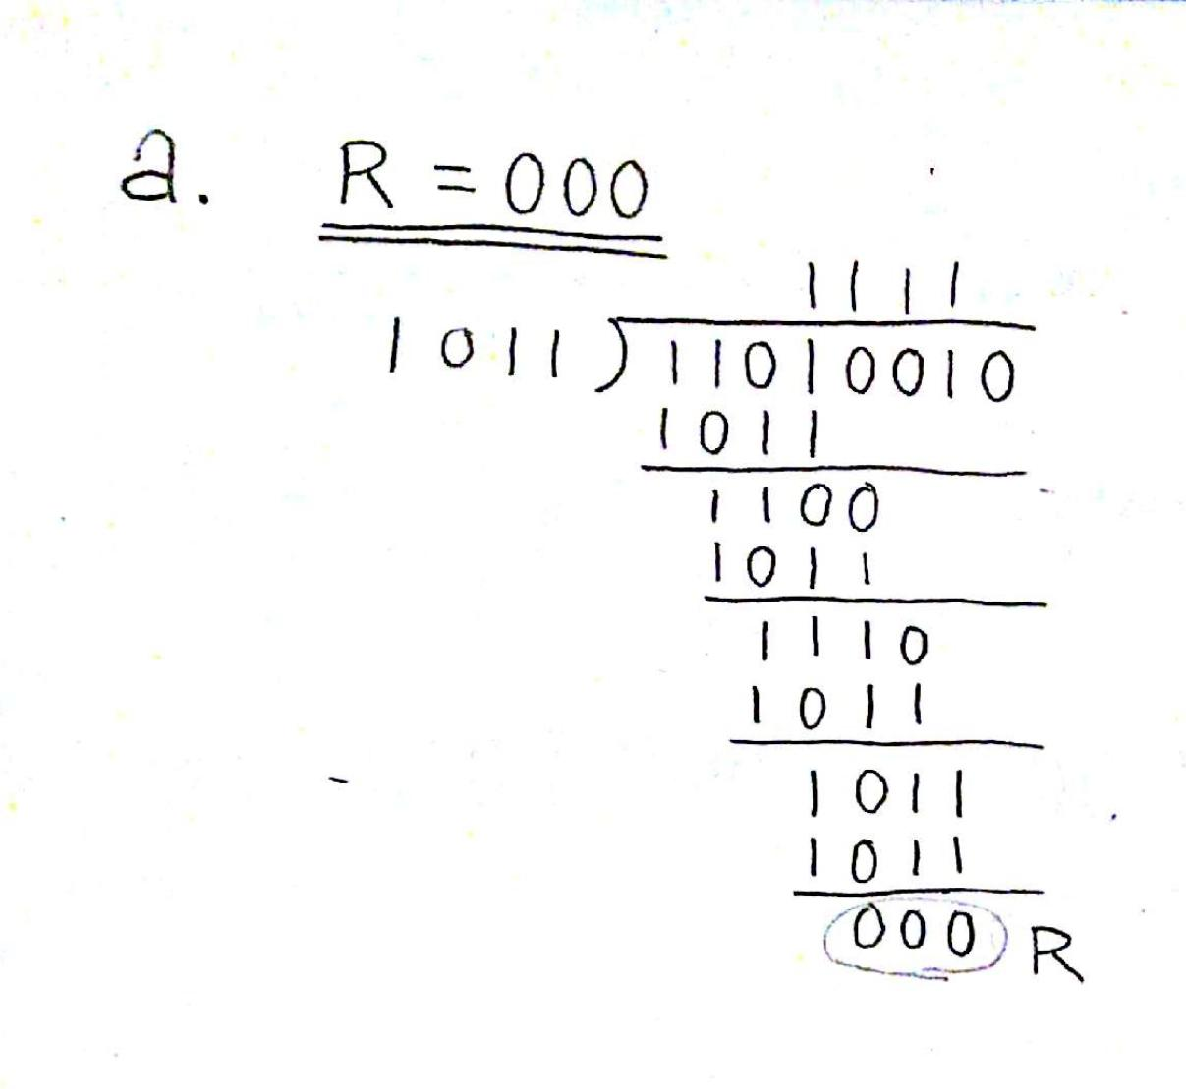

**b. (10 pts) What is the transmitted bit serial?**

**11010010 000**

**D R**

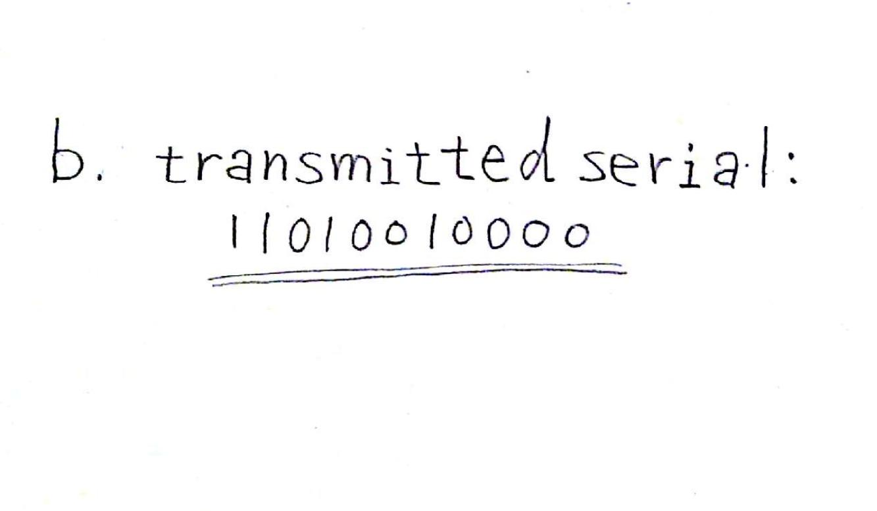

**c. (10 pts) Show the calculation how does the receiver verify the received serial.**

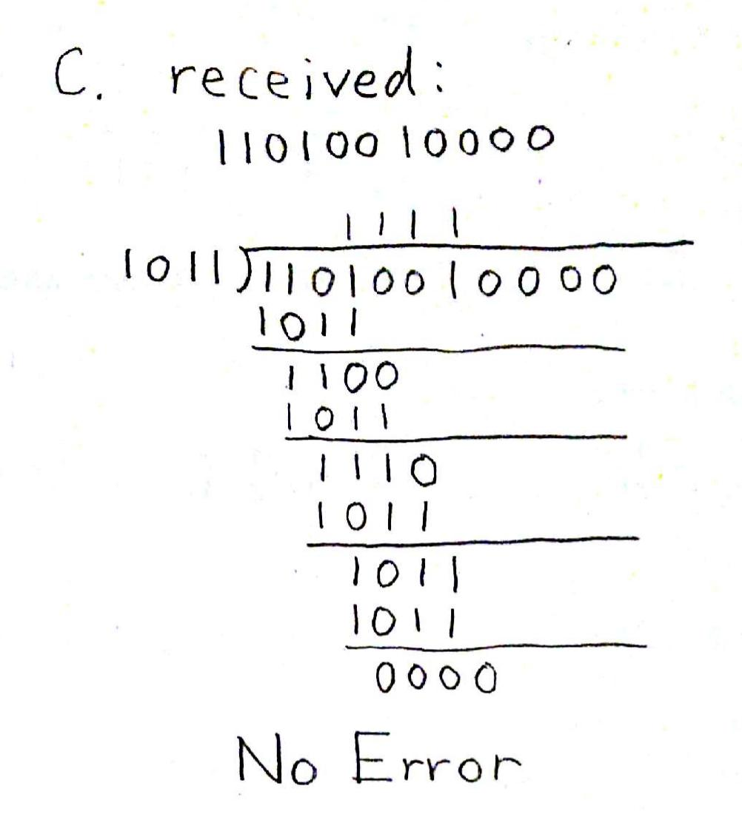

**d. (10 pts) In case the received serial has bit flipped at the 2nd and the 3rd bits, show the calculation how does the receiver detect the error in the received serial.**

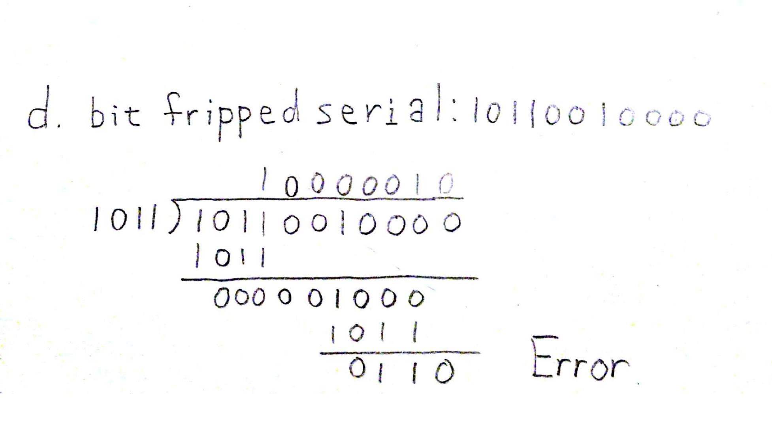

**Problem 4 (20 pts, 5 pts for each correct answer): Complete following sentences**

1. LAN is the network that spans a small geographic area, such as a single building or buildings.

2. Preamble is the 8-byte field located at the beginning of an Ethernet frame and is used for synchronizing receiver, sender clock rates

3. Mac Address has 48 bits and it is used to get frame from one interface to another physically-connected interface in the same network.

4. A device that operates at the network layer and can select the best route for a packet to travel over dissimilar network is called a Router .

**Problem 5: Try to explain why CAT6 is more than 10 times faster than CAT5.(20pts)**

First, transmission rate of CAT6 is about 1Gbps. CAT5’s one is about 100Mbps. So transmission rate of CAT6 is 10 times faster than CAT5’s one. Second, bandwidth of CAT6 is 2.5times of CAT5’s one. We can transmit bigger data with CAT6 than CAT5. For those reason, CAT6 is more than 10 times faster than CAT5.