**Quiz 2**

1. **What are the compiler components?**

From the architecture, the compiler is consists of the components below.

* Scanner ( lexical analysis)
* Parser (syntax analysis)
* Semantic Analysis
* IC generator
* Code Optimizer
* Code Generator

1. **Briefly explain each component of the compilers?**

* **Scanner**: It’s a part of front end processing. It converts the original program’s stream of characters into a stream of tokens. Spaces or comments in the program are removed in this process.
* **Parser**: It’s a part of front end processing. It turns the token sequence into an abstract syntax tree (ATS).
* **Semantic Analysis**: It’s a part of front end processing. It checks the grammar of the program is correct or not. For example, the mistake of type declaration is detected here.
* **IC generator**: It’s a part of front end processing. It produces a flow graph made up of tuples grouped into basic blocks.
* **Code Optimizer**: It’s a part of back end processing. It cleans up and improves the code.
* **Code Generator**: It’s a part of back end processing. It generates the actual target code. For example, the assemble code from the gcc compilation is completed here.

1. **For the following grammar what is the parse tree of the expression (a*b+5*c)-d**

**expression → expression ‘+’ term | expression ‘-‘ term |term**

**term → term ‘*’ factor | term ‘/’ factor | factor**

**factor → identifier | constant | ‘(‘ expression ‘)’**

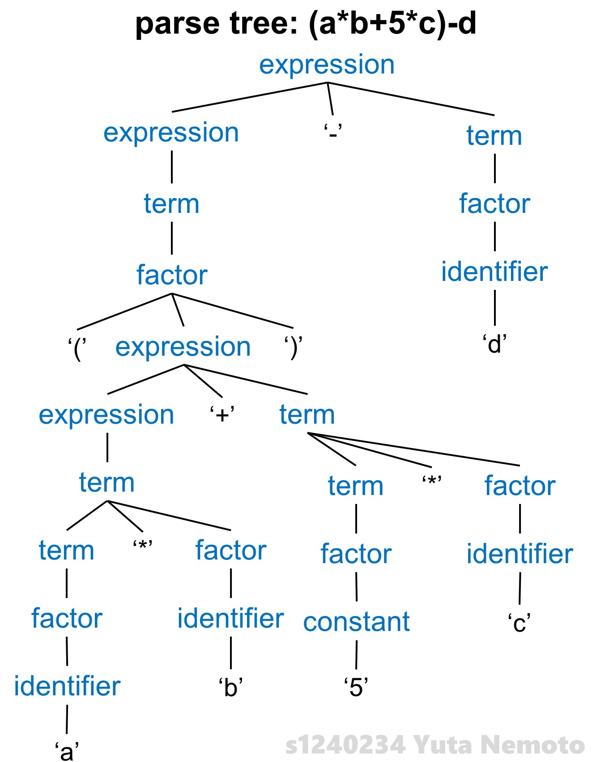

1. **Refer to the above grammar, what is the abstract syntax tree AST for the expression (a*b+5*c)-d?**

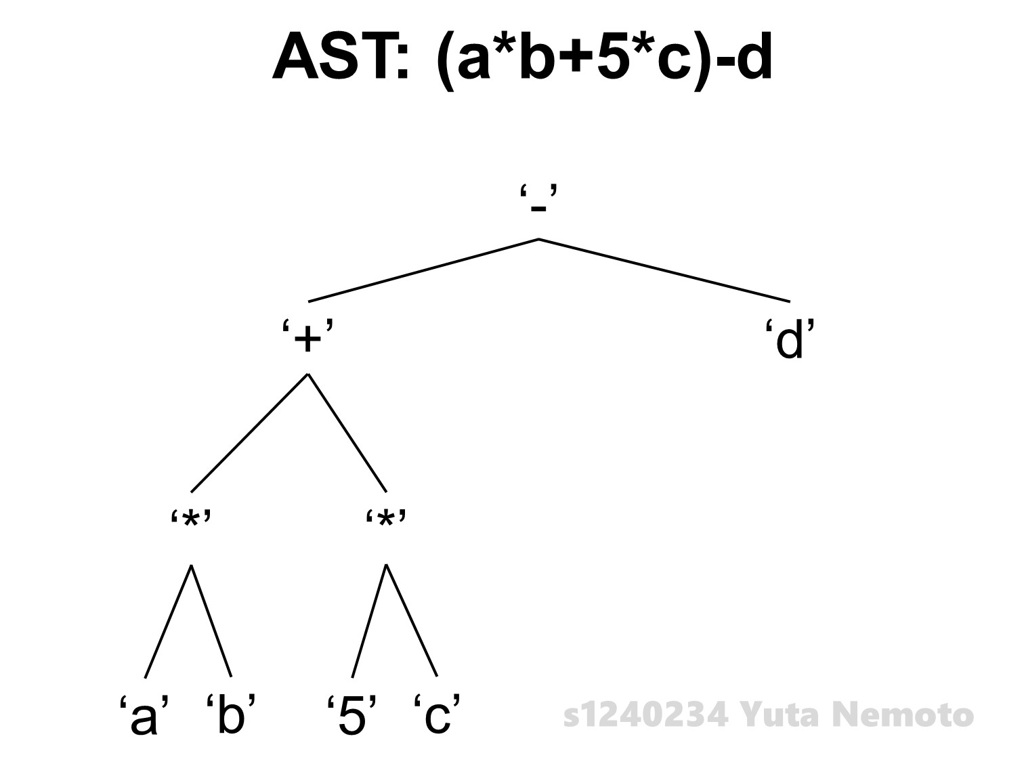

1. **What is the advantage of using the compiler’s front-end and back-end?**

There are 2 principals of advantages: Retargeting and Optimization.

1. **Retargeting**: We can build a compiler for a new machine by attaching a new code generator to an existing front-end.
2. **Optimization**: We can reuse intermediate code optimizers in compilers for different languages and different machines.
3. **Suppose you want to write 4 compilers for 5 computer platforms, how many programs you need to write?**

In case of direct translation, I need to write 4 * 5 = **20** programs.

But by separating the compilation process into 2 levels: Front-end and Back-end and connecting them by Intermediate Representation, we can do this better and we need to write only 4 + 5 = **9** programs.

1. **For the regular expression ((0|1)0(0|1))* give 3 accepted strings of this regular expression?**
2. 000
3. 000000
4. 100001