**Quiz 4**

1. **Briefly define the terms: syntax, syntax analysis, and parsing?**

* **Syntax**: the way in which words are put together to form phrases, clauses, or sentences. The rules governing the formation of statements in a programming language.
* **Syntax analysis**: the task concerned with fitting a sequence of tokens into a specified syntax.
* **Parsing**: to break a sentence down into its component parts of speech with an explanation of the form, function, and syntactical relationship of each part.

1. **Informally explain the syntactic structure of programming languages?**

The syntactic structure of programming languages can be informally expressed by the following diagram.

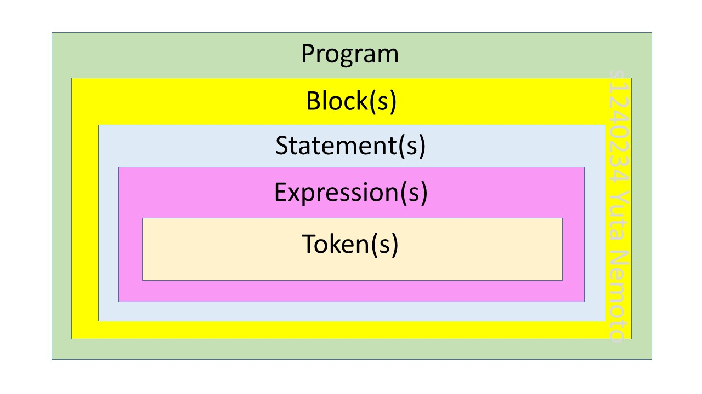

1. **Give 3 examples of parsing (syntax) errors?**
2. Misspelling of identifier, keyword, or operator. For example, the missing of operator in the sentence “x = 5 7 + 3”.
3. Arithmetic expression with unbalanced parentheses. For example, the error in the structure of the sentence (number of closing brackets) “x = ((a+b*c)”.
4. Punctuation errors such as using comma in place of semicolon. For example, the missing of ‘;’ in the sentence “a = 5”.
5. **Define context-free grammars?**

A context-free grammar G = (T, N, S, P) consists of:

1. T, a set of terminals (scanner tokens). Such as the factor of “class” or brackets.
2. N, a set of nonterminals (syntactic variables generated by productions). Generally the definitions of the program rules such as the definition of “program”, “block”, and so on.
3. S, a designated start nonterminal.
4. P, a set of productions. Each production has the form, A::= α, where A is a nonterminal and α is a sentential form, i.e., a string of zero or more grammar symbols (terminals/nonterminals).
5. **Give the definition of left recursive grammar? And give an example of it?**

**Definition**:

A grammar that has at least one production of the form A → Aα is a left recursive grammar.

**Example**:

E → E + T | T

T → T * F | F

F → ( E ) | **id**

1. **Briefly explain (with an example) about left factoring in grammars?**

For example, the grammar: stmt → if expr then stmt else stmt | if expr then stmt

Cannot be parsed by a predictive parser that looks one element ahead. But the grammar can be re-written like: stmt → if expr then stmt stmt’ stmt’ → else stmt |λ

Where λ is the empty string.

Rewriting a grammar to eliminate multiple productions starting with the same token is called **left factoring**.

1. **For the following grammar, find the FOLLOW(T’) and FIRST(S)?**

**S → E $**

**E → T E’**

**E’ → + T E’ | - T E’ | λ**

**T → F T’**

**T’ → * F T’ | / F T’| λ**

**F → id | num | (E)**

**FOLLOW(T’) = {+, -, ), $}**

**FIRST(S) = FIRST(E) = FIRST(T) = FIRST(F) = {id, num, ( }**